Australian Capital Territory
Planning and Development (Plan Variation No 333) Approval 2016*

Notifiable Instrument NI2016—65
made under the
Planning and Development Act 2007, section 76(3)(a) (Minister’s powers in relation to draft plan variations)

1 Name of instrument
This instrument is the Planning and Development (Plan Variation No 333) Approval 2016.
2 Approval of draft plan variation
(1) I APPROVE under section 76(3)(a) of the Planning and Development Act 2007 the draft plan variation No 333 to the Territory Plan.

(2) In this section:

Draft plan variation No 333 to the Territory Plan means the draft plan variation in the schedule.

Mick Gentleman MLA
Minister for Planning and Land Management

Dated this 10th day of February year 2016

Planning and Development Act 2007

Variation to the
Territory Plan
No 333

ACT Public Housing Redevelopments
Griffith section 39 blocks 2 and 8-17 – Stuart Flats and Griffith section 43 block 1, 2 and part block 5

Final variation prepared under s76 of the
Planning and Development Act 2007

This page is intentionally blank.

Contents

1. EXPLANATORY STATEMENT 3
1.1 Background 3
1.1.1 Public Housing Renewal Program 3
1.1.2 Background to the Griffith Site 3
1.2 Summary of the Proposal 3
1.3 The National Capital Plan 3
1.4 Site Description 3
1.5 Current Territory Plan Provisions 3
1.6 Changes to the Territory Plan 3
1.7 Consultation on the Draft Variation 3
1.8 Revisions to the Draft Variation Recommended to the Minister 3
2. VARIATION 3
2.1 Variation to the Territory Plan 3

This page is intentionally blank.

- EXPLANATORY STATEMENT
  - Background
    - Public Housing Renewal Program
Housing is critically important for the ACT community’s overall economic and social well-being. Public housing assists Canberran’s on low incomes to reach their potential, to make a contribution and to share the benefits of our community.
The role of ACT public housing has changed over time through increased targeting to those most in need. As at April 2015 there were 2,323 clients on the public housing waiting list with a further 869 public housing tenants on the transfer waiting list. The number of people on the public housing waiting list has doubled since 2008. Presently, the waiting time on the priority housing waiting list is 238 days. The demand for public housing is expected to grow. As at April 2015 there were 11,826 public housing properties.
Much of the public housing stock was constructed prior to 1988 when the Territory achieved Self-Government. The average age of the ACT’s public housing stock is around 30 years and the Red Hill Housing Precinct is over 50 years old. The ACT has the oldest public housing portfolio in Australia, with consequent impacts on repairs and maintenance requirements.
The dwellings were constructed in response to the requirements of the time, and public housing tenants have different requirements now. The challenge is to renew the public housing stock so that it is better able to meet the needs of public housing tenants.
The Public Housing and Asset Management Strategy 2012 – 2017 provides a response to the challenges facing the public housing portfolio at a number of levels, including a rolling program of disposal of poorly performing Multi Unit Properties with the aim of:
- Providing better housing for existing and future tenants;
- Aligning the public housing portfolio with tenant needs;
- Reducing concentrations of disadvantage;
- Optimising the value of the asset; and
- Improving the ‘look’ and ‘feel’ of the metropolitan area.
Many of the older public housing properties are in prominent locations so their redevelopment will result in significant urban renewal outcomes - improvements to urban design quality, creating economic activity, reduced greenhouse emissions, improved use of infrastructure and variety of the built environment.
The replacement public housing will be better designed, more energy efficient and less costly to operate and maintain. It will better align with tenant demographics, break down aggregations of disadvantage and provide a better distribution of public housing throughout the community. Creating a greater choice of housing across the city makes it easier for people to ‘age in place in the community’.
The redevelopment of these public housing sites has the potential to be an exemplar of best practice, to encourage local improvement and as a catalyst for local neighbourhood renewal and value adding to their environs.
Redevelopment of the public housing sites creates economic activity. There will be investment in the development and construction of replacement public housing and further investment in of the existing sites once the existing public housing is decommissioned.
Renewal of public housing across the Territory will have benefits for public housing tenants. There will be no reduction in public housing stock and replacement housing will be built first. The distribution of housing will be aligned with tenant and applicant preferences.
The redevelopment of Stuart Flats will deliver better design outcomes, improved amenity and provide opportunities for improved revenue returns which will be used to support Government initiatives.
Increasing densities around transport routes and commercial centres provides the opportunity to support their on-going viability. It also presents opportunities to work with industry to make centres more viable, accessible and vibrant, and supports active transport.

    - Background to the Griffith Site
Griffith section 39 blocks 2, 8 – 17 (Stuart Flats) is occupied by Stuart Flats; a multi-unit housing complex that was constructed in 1960 and consists of 146 units, comprising 29 bedsit flats and 117 two bedroom flats.
Section 43, block 5 is an open space area which serves the function of a pocket park with a small playground. Block 2 contains a former ambulance station that is now used by a community organisation. The community facility is managed by Property Group within the Chief Minister, Treasury and Economic Development Directorate.
Section 43, block 1 is occupied by a Telstra Exchange.
The ACT Government intends to redevelop Stuart Flats as part of an overall program of revitalising the public housing portfolio. The reasons for progressing with the redevelopment of multi-unit properties, including Griffith Housing Precinct, are outlined in Part 2.1.1.
The Public Housing Renewal Taskforce has been consulting with the community to determine how best to develop the Stuart Flats and part of section 43.
Rezoning the site will increase the diversity of housing types in Griffith and adjoining suburbs providing these residents with increased housing choice.
The proposal is to vary the Territory Plan to facilitate the construction of a residential development ranging from 2 storeys to 6 storeys.

  - Summary of the Proposal
This draft Territory Plan variation proposes to rezone block 2, 8 to 17 section 39 from residential RZ2 suburban core zone to the residential RZ5 high density zone, block 1 and 2 section 43 Griffith from the transport services TZ2 zone to the residential RZ5 high density zone and part block 5 section 43 Griffith from the urban space PRZ1 zone to the residential RZ5 high density zone.
The site includes Stuart Flats which consists of public housing properties along Captain Cook Crescent, Stuart Street, Light Street and Evans Crescent. The former ambulance station (now used as temporary accommodation for a community organisation) fronts Stuart Street and Light Street. The Telstra Exchange is bounded by Stuart Street and Evans Crescent and the open space area abuts Light Street and Evans Crescent.
Originally it was proposed to incorporate all of section 43 into the proposal. However, in response to community feedback it has been decided that only a small part of the urban open space (part of block 5, section 43) will be rezoned. This allows it to regularise the boundary of block 2 section 43. It will result in a reduction of 860m2. The total area of the park is 6,581m2. The draft variation proposes to change 13% of the park from PRZ1 to RZ5.
The redevelopment of the site will support the Public Housing Renewal Program. It also provides opportunities to develop a diversity of housing stock and types in Griffith. Local residents will be able to maintain established community links whilst moving into housing that better suits their needs. Urban intensification close to the Manuka Group Centre will be achieved whilst maintaining the residential amenity of the surrounding residential areas in accordance with the strategic directions of the Territory Plan.

  - The National Capital Plan
The Australian Capital Territory (Planning and Land Management) Act 1988 established the National Capital Authority (NCA) with two of its functions being to prepare and administer a National Capital Plan (NCP) and to keep the NCP under constant review and to propose amendments to it when necessary.
The NCP, which was published in the Commonwealth Gazette on 21 January 1990 is required to ensure that Canberra and the Territory are planned and developed in accordance with their national significance. The Planning and Land Management Act 1988 also required that the Territory Plan is not inconsistent with the NCP.
In accordance with section 10 of the Australian Capital Territory (Planning and Land Management) Act 1988, the National Capital Plan defines the planning principles and policies for Canberra and the Territory, for giving effect to the object of the NCP and sets out the general policies to be implemented throughout the Territory, including the range and nature of permitted land uses.
It also sets out the detailed conditions of planning, design and development for areas that have special significance to the National Capital known as designated areas and identifies special requirements for the development of some other areas.

  - Site Description
The subject land is Griffith section 39 blocks 2, 8 – 17 (Stuart Flats) and part of section 43 (see location map in Figure 1). It is an area of approximately 30,137m2.
The site includes Stuart Flats which consists of public housing properties along Captain Cook Crescent, Stuart Street, Light Street and Evans Crescent. The former ambulance station (now used as temporary accommodation for a community organisation) fronts Stuart Street and Light Street. The Telstra Exchange is bounded by Stuart Street and Evans Crescent and the open space area abuts Light Street and Evans Crescent.
The Stuart Flats are bounded by Captain Cook Crescent, Light Street and Stuart Street. To the north the site is also bounded by St Paul’s Anglican Church, residential apartments and the Russian Embassy. The Manuka Group Centre is located on the opposite side of Captain Cook Crescent.
Section 43 is bounded by Light Street, Evan Crescent and Stuart Avenue. Section 43 is managed by Territory and Municipal Services Directorate, the Chief Minister, Treasury and Economic Development Directorate and Telstra.
The height of the dwellings that adjoin the site varies. There are 6 storey elements in the Manuka Group Centre and the height of St Paul’s Anglican Church exceeds the equivalent of 8 storeys. There is a mix from single to 3 storeys for the surrounding residential dwellings. The Telstra Exchange is the equivalent of 3 storeys in height.
The site is directly adjacent to the Manuka Group Centre with its broad range of shops, retail, commercial and community services and facilities. The area is well served by public transport. There are a range of public and private pre schools, primary and secondary schools near the site, including Telopea Park School (Primary and High School), Forrest Primary School, Narrabundah College, St Benedict’s Primary School, St Clares College, St Edmund’s College and Girls and Boys Grammar Schools.
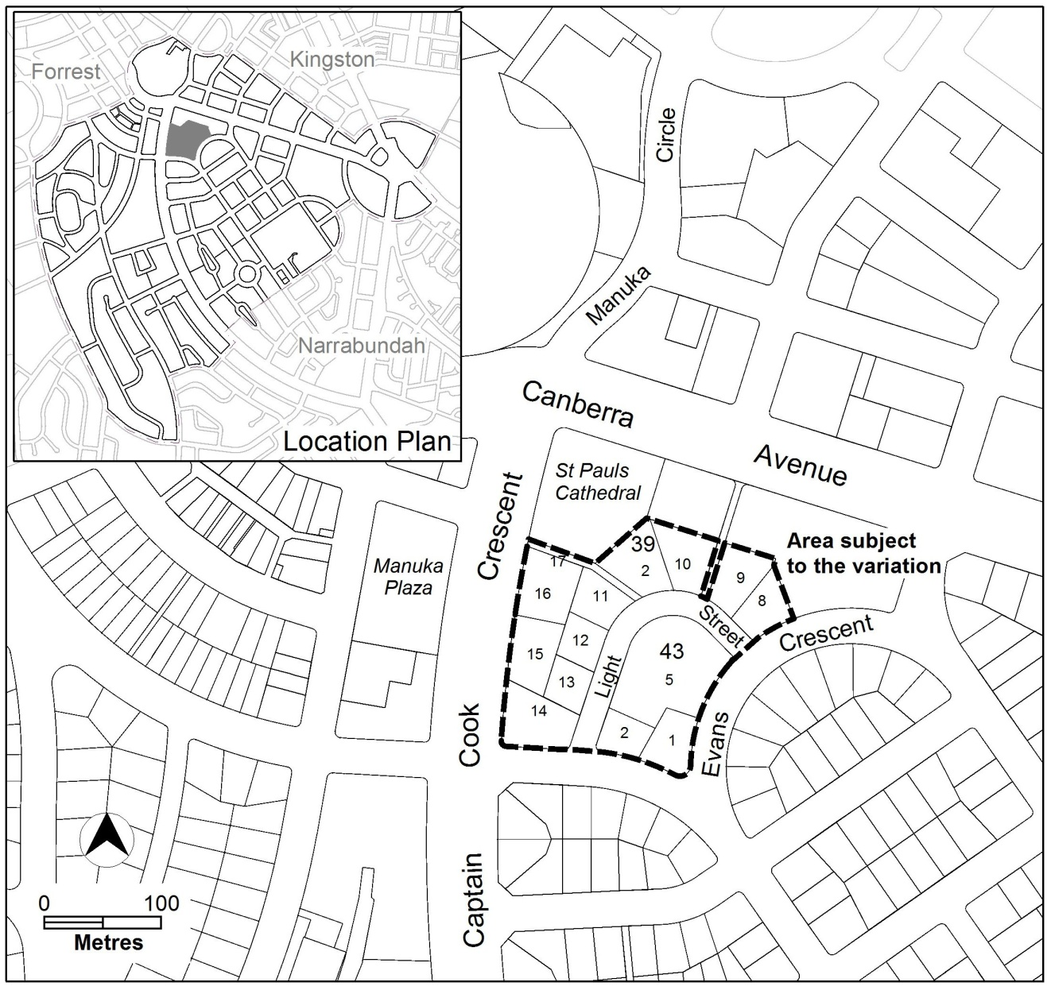
Figure 1 Site Plan

  - Current Territory Plan Provisions
The Territory Plan map zones for the area subject to this draft variation are shown in Figure 2.

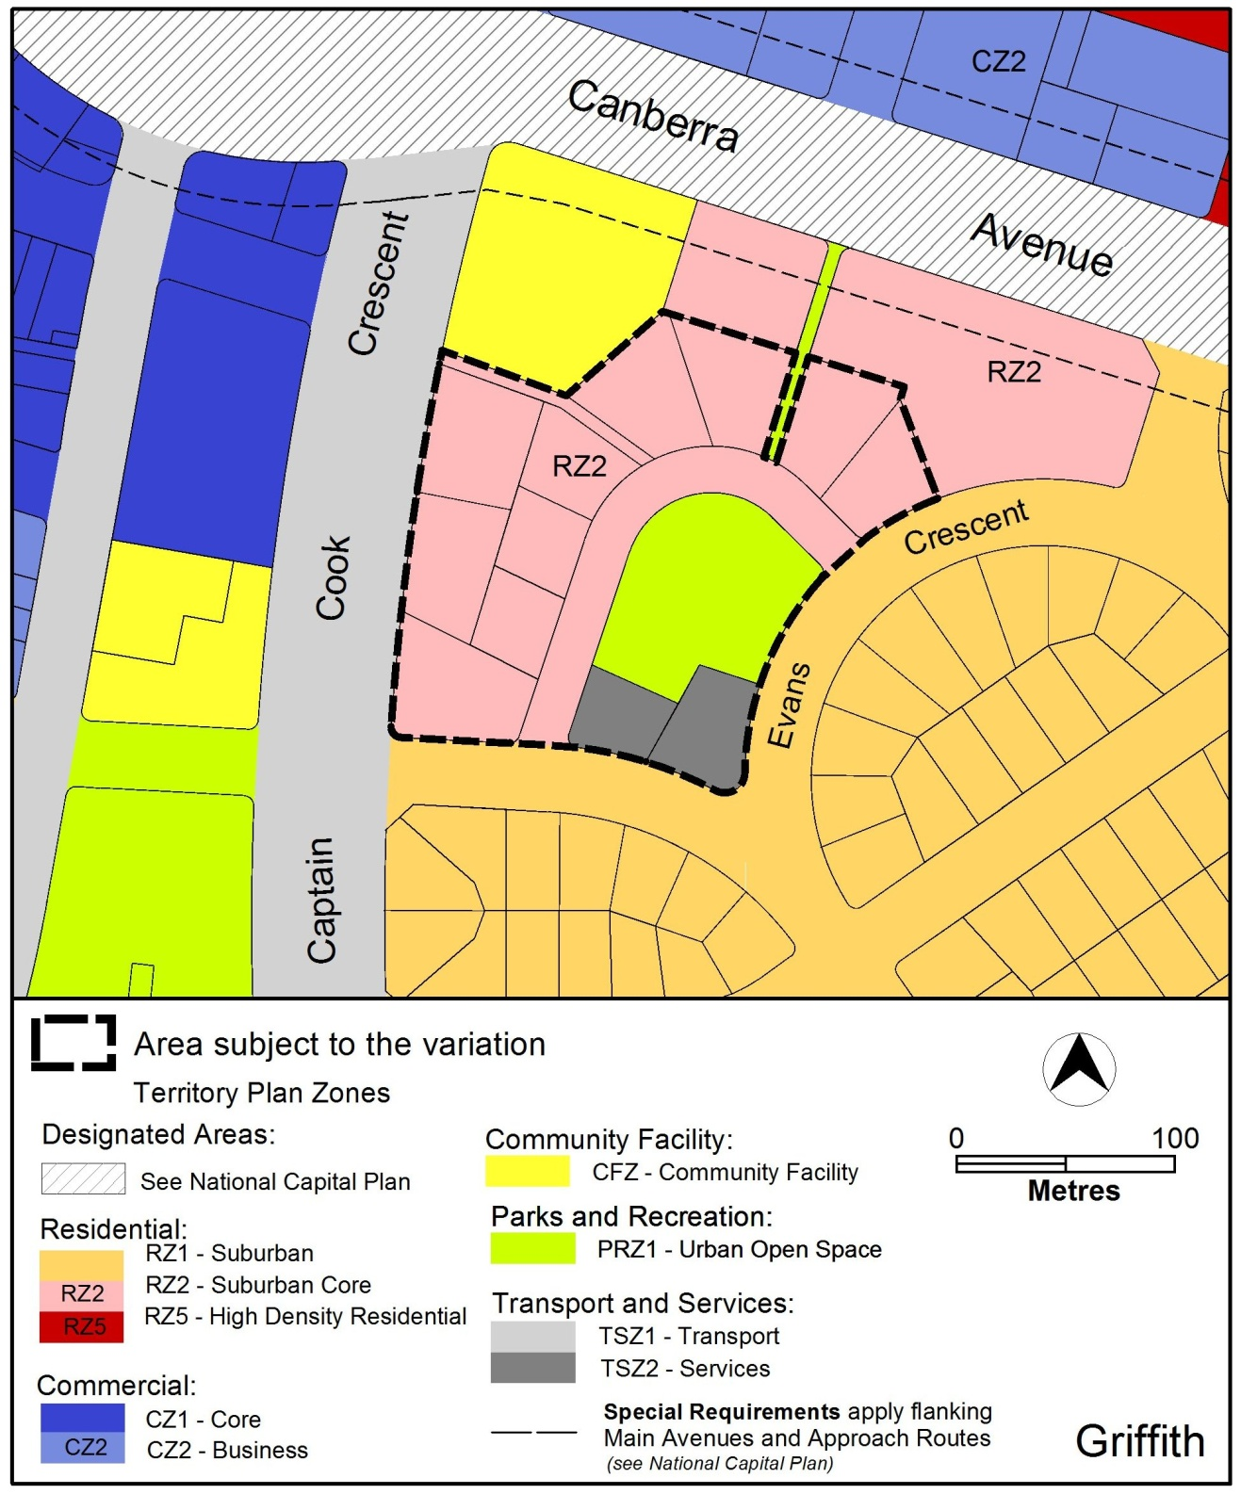
Figure 2 Territory Plan Zones Map
  - Changes to the Territory Plan
Detailed changes to the Territory Plan are noted in section 2 of this document.

  - Consultation on the Draft Variation
Draft Variation No 333 (DV333) was released for public comment between 2 July 2015 and 17 August 2015. A consultation notice under section 63 of the Planning and Development Act 2007 (P&D Act) was published on the ACT Legislation Register on 2 July 2015 and in The Canberra Times on 4 July 2015.
A total of 17 written submissions were received. Of these 17 submissions three (3) were from Community groups and the rest were from members of the public. Although some of the submissions partially supported the proposal, all objected to DV333 in some way.
Main issues raised by submitters included:
- traffic and parking concerns;
- opposition to RZ5 zoning;
- proposed building height;
- concern about increased density; and
- loss of part of Light Street/Evans Crescent urban open space.

The above issues were considered and are detailed in a report on consultation. No changes were made as a result of consultation; however minor changes were made to improve the clarity of the document. The outcomes of consultation were considered by the Minister responsible for planning prior to approval of this variation.

  - Revisions to the Draft Variation Recommended to the Minister
No changes were made to the draft variation recommended to the Minister.

- VARIATION
  - Variation to the Territory Plan
The Territory Plan map is varied in all of the following ways:

Variation to the Territory Plan Map
- Territory Plan Map – Griffith section 39 blocks 2 and 8-17 and section 43 block 1,2 and part block 5

Substitute the current Territory Plan Land Use Policy Area map with the following:
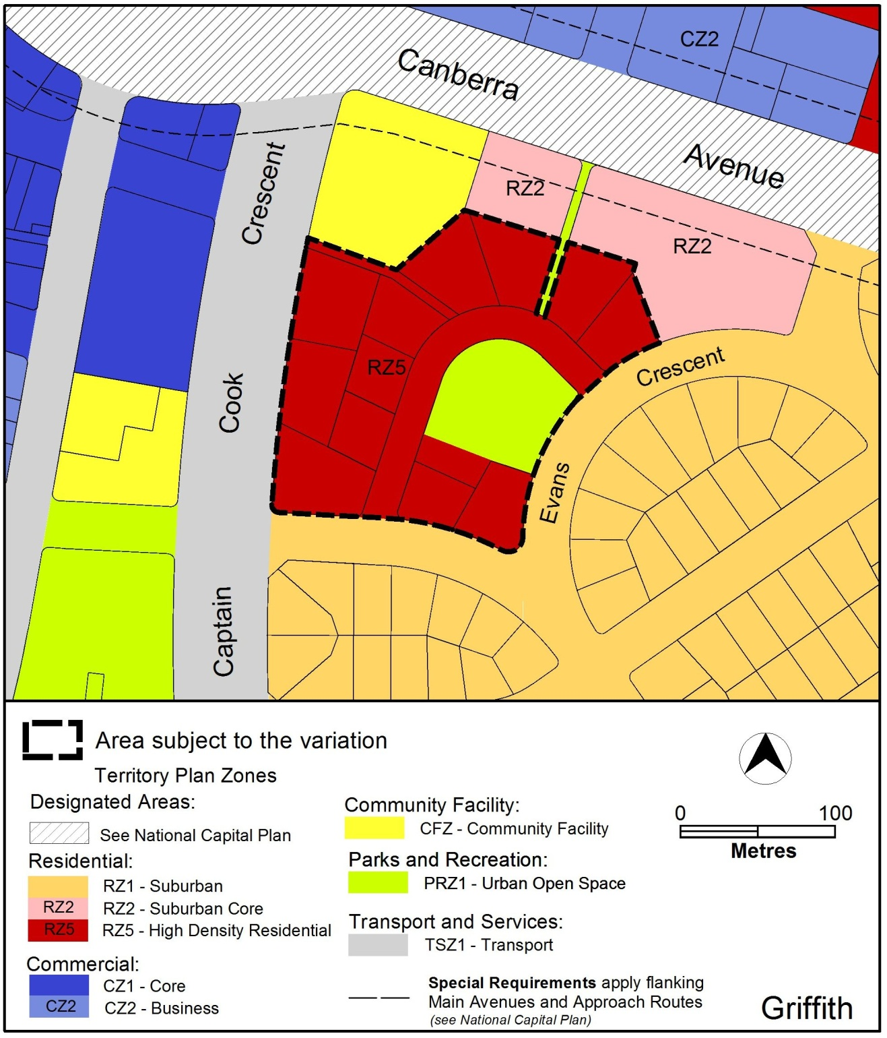

Variation to the Griffith Precinct Map and Code
- Griffith Precinct Map

Substitute the Griffith Precinct Map with the following:
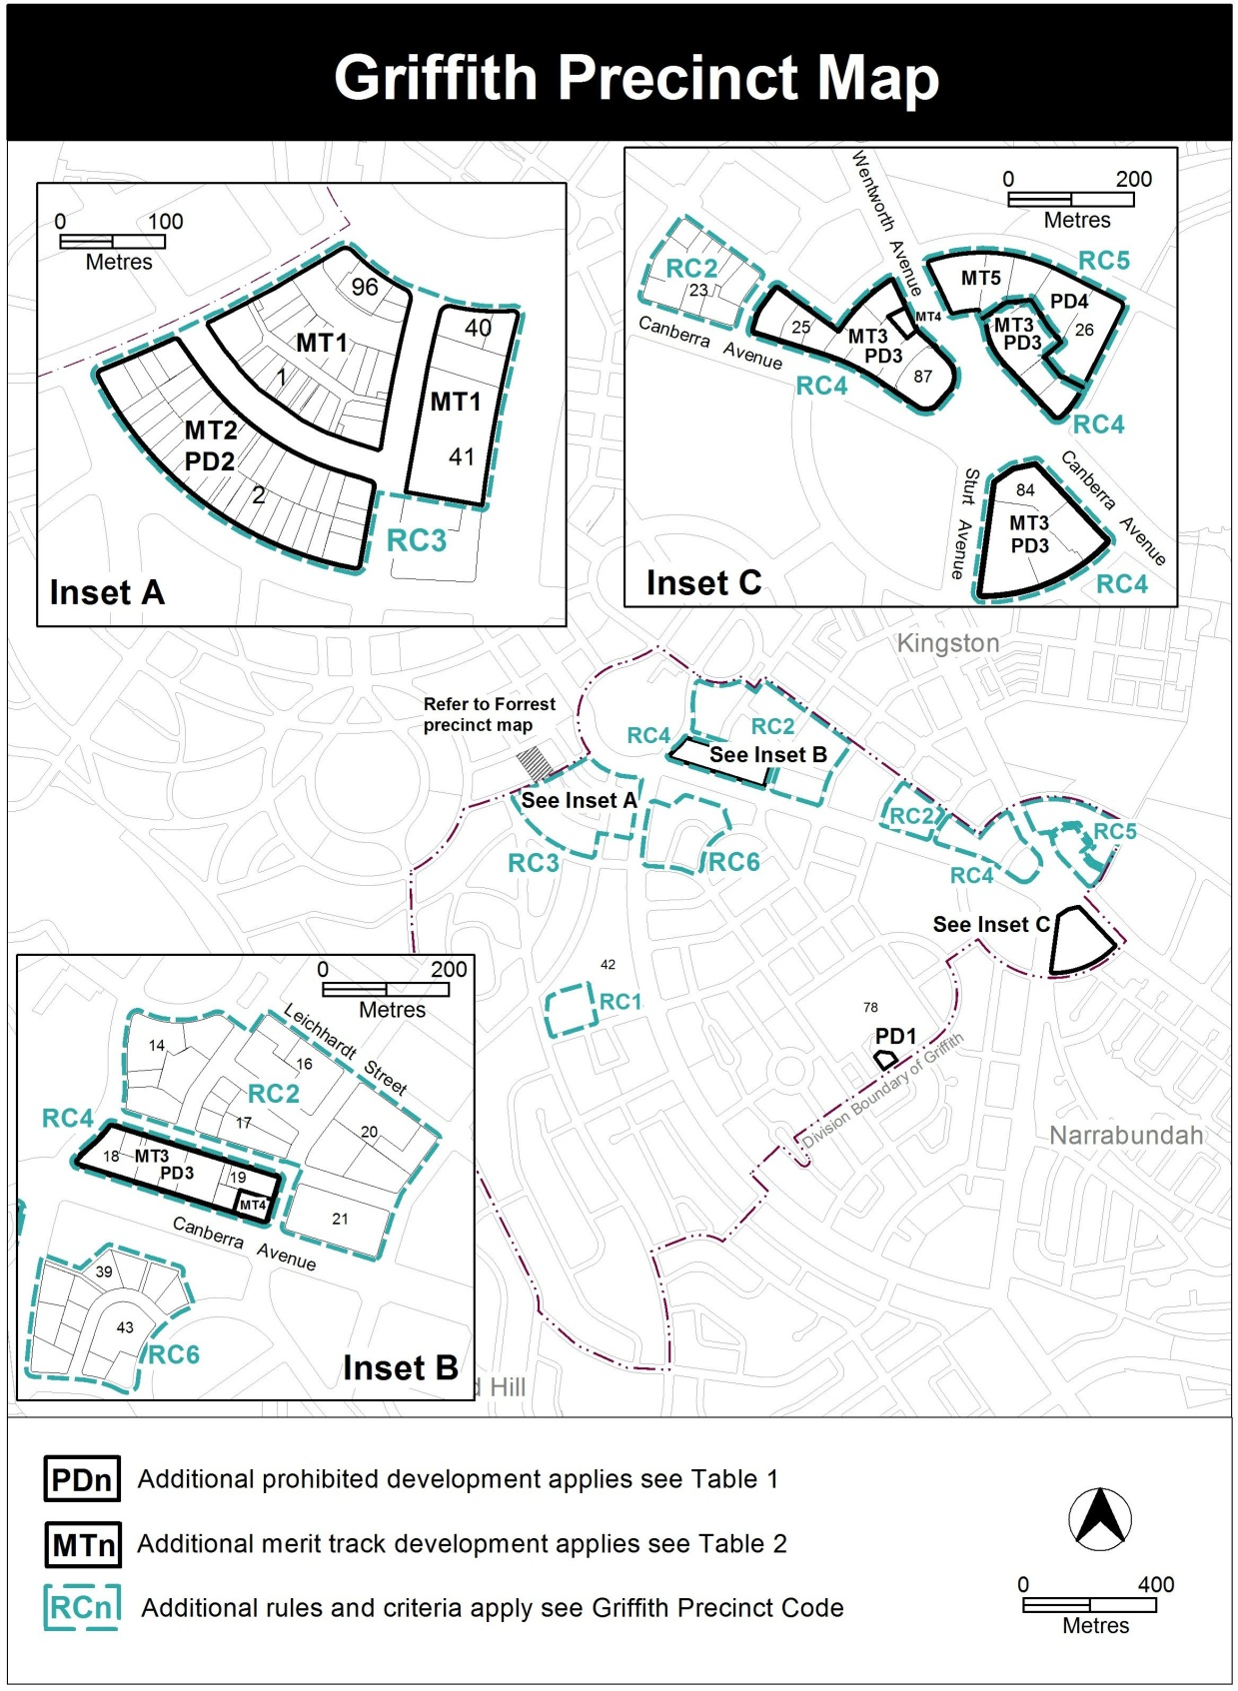
- Griffith Precinct Code – RC6 – Light Street Precinct

Insert the following at the end of the Griffith Precinct Code

  - RC6 – Light Street Precinct
This part applies to blocks and parcels within area RC6 shown on the Griffith Precinct Map.

Desired Character

The desired character for the Light Street precinct is:
- Buildings should be sympathetic to the existing garden neighbourhood character of Griffith in terms of setback, bulk and scale
- Building facades should be visually articulated to avoid a ‘continuous wall’ of development and excessive bulk and scale
- Development should maintain and/or enhance the relationship with the Light Street Park (Section 43, Griffith) by addressing the park through visually interesting facades.

Element 9: Buildings
Rules | Criteria
  - Building height
This rule applies to the areas identified in Figure 4.  The maximum number of storeys permitted are as follows:  - In areas ‘a’ – 3 storeys. Area ‘a’ is measured as a minimum of 20 metres from the boundary frontage with Stuart Street and Evans Crescent.  - In areas ‘b’ – 4 storeys. Area ‘b’ is measured as:  - A minimum of 25 metres wide and 52 metres deep from the boundary frontage with Captain Cook Crescent  - A minimum of 25 metres deep from the common boundary of section 39 blocks 1 and 19 and a minimum of 30 metres from the boundary of section 39 block 20.  - In areas ‘c’ – 6 storeys  For this rule a storey does not include any of the following:  - roof top plant  - lift overruns  - antennas  - photovoltaic panels  - air conditioning units  - chimneys, flues and vents  Note: This rule replaces any rule/criteria where they relate to height in storeys and/or metres. | The maximum number of storeys may be increased by 1 storey where the storey is:  - Being used predominately for vehicular parking;  - Is a continuation of a basement which is also being predominately used for vehicular parking; and  - Is at ground floor level
  - Setback
This rule applies to building elements of 3 or more storeys.  Minimum front boundary setback to Stuart Street and Evans Crescent is 8 metres. | Front boundary setbacks achieve all of the following:  - Consistency with the desired character  - Reasonable amenity for residents  - Sufficient space for street trees to grow to maturity.
This rule applies to areas ‘c’ shown in Figure 4  Building elements above 4 storeys are setback a minimum of 2 metres from the building facade of the floor immediately below. | Building elements above 4 storeys achieve all of the following:  - Consistency with the desired character  - Reasonable amenity for residents  - Do not dominate the street frontage  - Sufficient space for street trees to grow to maturity.

- Access
Rules | Criteria
  - Pedestrian Access
There is no applicable rule | This criterion applies to the existing pedestrian access shown in Figure 4.  Pedestrian access between Captain Cook Crescent and the open space at section 43 Griffith achieves all of the following:  - Should be retained or improved in relation to width, grade and/or landscape quality  - In a location generally in accordance with Figure 4  - Remain permanently open to the public

- Landscape area
Rules | Criteria
  - Landscape area
This rule applies to landscape areas identified in Figure 4.  A landscape area is provided in a location generally in accordance with Figure 4 and has a minimum area of:  - ‘LA1’ - 1500 metres²  - ‘LA2’ – 400 metres²  - ‘‘LA3’ – 500 metres² | Landscape areas are provided and achieve all of the following:  - Present a cohesive sequence of landscape spaces  - Are of a useable size and dimensions for a range of activities by residents  - Are of a size and dimensions to offset the bulk and scale of surrounding development.  - Are landscaped  - Provide reasonable safety and functionality.  Note: this criterion does not override other provisions for site open space, landscape design and principal private open space.
There is no applicable rule | The criterion applies to the landscape areas as shown in Figure 4.  Landscape areas achieve all of the following  - Allow for car parking in limited circumstances that does not dominate the landscape areas  - Have no buildings or structures located within the area (except basements, driveways, surface and/or undercover car parks, play/fitness equipment, shade structures, street furniture and barbeques or similar)  - Provide sufficient areas for deep root planting  - Receive reasonable solar access  - Provide a soft landscaped interface with the buildings and street  Note: this criterion does not override other provisions for site open space, landscape design and principal private open space.

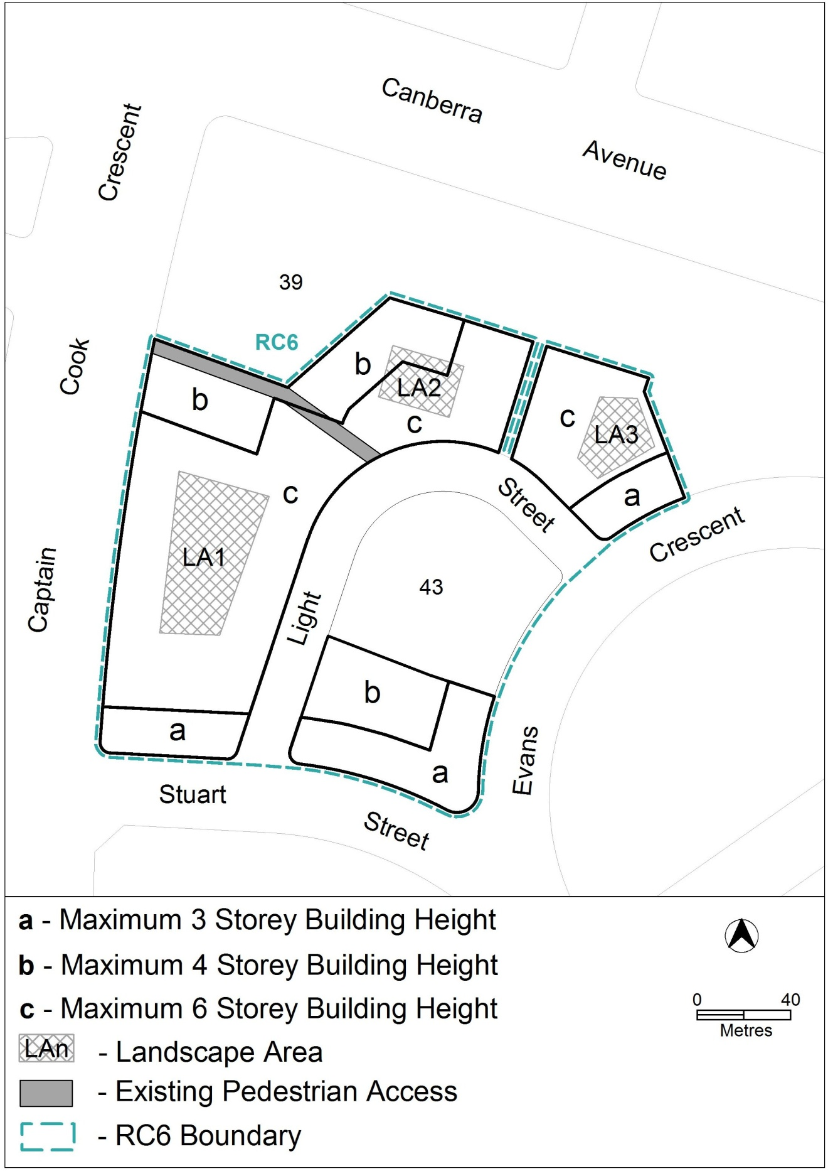
Figure 4: Height of buildings
Interpretation service
