Australian Capital Territory

# Nature Conservation (Uriarra Crossing Recreation Area) Activities Declaration 2016

## Notifiable Instrument NI2016–702

made under the

Nature Conservation Act 2014, s256 (Conservator may make activities declarations)

### 1 Name of instrument

This instrument is the *Nature Conservation (Uriarra Crossing Recreation Area) Activities Declaration 2016*.

### 2 Commencement

This instrument commences on the day after its notification day.

### 3 Application

This instrument applies to the area outlined in bold and shown as “Special Purpose Reserve” in the map in schedule 1 as the Uriarra Crossing Recreation Area.

*Note:* Under section 169 of the *Nature Conservation Act 2014* (the**Act**) the area of Uriarra Crossing Recreation Area is a ‘reserve’ because the area is public land reserved in the Territory Plan as a Special Purpose Reserve under section 315(d) of the *Planning and Development Act 2007* and prescribed by section 5 of the *Nature Conservation Regulation 2015* as a reserve.

### 4 Declaration

I declare that in Uriarra Crossing Recreation Area:

* 1. an activity listed in column 1 of schedule 2 is prohibited;
  2. an activity listed in column 2 of schedule 2 is restricted and may only be carried out if the requirements applying to the activity are complied with.

*Note 1:* If an activity is a ‘prohibited activity’ it means the activity cannot be carried out in any circumstance in the reserve. For example ‘camping’ is declared to be a prohibited activity. This means that camping cannot be carried out in the Uriarra Crossing Recreation Area under any circumstances.

*Note 2:* If an activity is a ‘restricted activity’ it means that it may only be carried out if the requirements applying to the activity are complied with. For example, ‘use of non-motorised vehicles including bicycles’ is declared to be a restricted activity. This means that riding a bicycle cannot be carried out in the reserve unless the requirements are complied with. In this case, the requirements are that riding of a bicycle must be on sealed roads and marked management trails only.

*Note 3:* The Act includes general offences which apply to all reserves (including Uriarra Crossing Recreation Area). The Act may be found at <http://www.legislation.act.gov.au/a/2014-59/default.asp>*.*

Dr Annie Lane  
Conservator of Flora and Fauna

16 December 2016

**SCHEDULE 1** (see section 3)  
**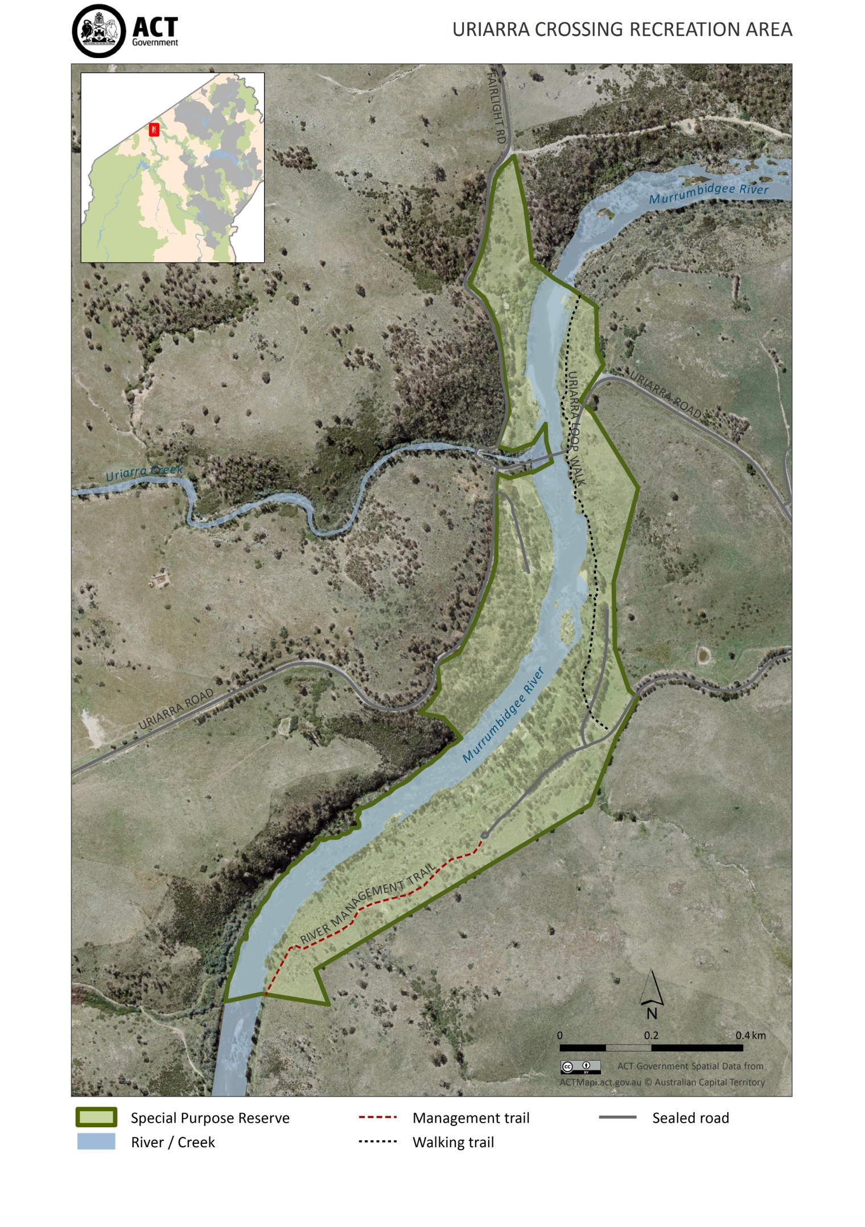**

**SCHEDULE 2** (see section 4)

|  |  |  |  |  |
| --- | --- | --- | --- | --- |
| **Column 1** | |  | **Column 2** | |
| **PROHIBITED ACTIVITIES** | |  | **RESTRICTED ACTIVITIES** | |
| **CAMPING** | **NO_Camping** |  | **DOGS OFF LEASH**  Allowed in Uriarra Crossing Recreation Area (see map at schedule 1) unless signposted otherwise. | dogsoleadv1 |
| **COLLECTING WOOD OR TIMBER** | **No firewood collecting.eps** |  | **USE OF NON-MOTORISED VEHICLES INCLUDING BICYCLES**  It is a requirement that a non-motorised vehicle, including a bicycle is only used on sealed roads and marked management trails only (see map at schedule 1) | **mountainbike_riding (2).tif** |
|  |  |  | **USE OF MOTORISED VEHICLES**  It is a requirement that a motorised vehicle is only used on sealed roads (see map at schedule 1). | VEHICLES.jpg |
|  |  |  | **TAKING PART IN VOLUNTEER ENVIRONMENTAL ACTIVITIES**  It is a requirement that:  (a) volunteer environmental activities are carried out in accordance with an approved volunteer environmental activities program; and  (b) the program is authorised by the Parks and Conservation Service. |  |
|  |  |  | **LIGHTING, MAINTAINING OR USING A FIRE**  It is a requirement that:  (a) the fire is within a fireplace provided or maintained by the Territory, or is a fire produced by a gas heating appliance being used to cook food or heat liquids; and  (b) a total fire ban is not in force; and  (c) the area around the fireplace or appliance is cleared of flammable material for at least three metres in every direction; and  (d) the person who lights, maintains or uses the fire does not leave the fire without first extinguishing it, unless the person leaves the fire under the control of a responsible person. |  |