Australian Capital Territory
Planning and Development (Technical Amendment—Watson) Plan Variation 2017 (No 1)

Notifiable Instrument NI2017—167
Technical Amendment No 2017-07
made under the
Planning and Development Act 2007, section 89 (Making technical amendments) and section 96 (Effect of approval of estate development plan)

- Name of instrument
This instrument is the Planning and Development (Technical Amendment—Watson) Plan Variation 2017 (No 1).
2 Technical amendment
I am satisfied under section 89 (1) (a) of the Planning and Development Act 2007 (the Act) that the Watson plan variation is a technical amendment to the Territory Plan.
3 Commencement
This instrument commences on the day after its notification day.
4 Meaning of Watson plan variation
For this instrument:
Watson plan variation means the technical amendment to the Territory Plan, variation 2017-07, in the schedule.
Note: No consultation was required in relation to the Watson plan variation under section 87 of the Act.
Brett Phillips
Delegate of the planning and land authority
31 March 2017

Planning & Development Act 2007

Technical Amendment
to the Territory Plan
Variation 2017-07

Future urban area variation and amendments to the Watson Precinct Map and Code

March 2017

This page is left intentionally blank

Table of Contents

1. INTRODUCTION 3
1.1 Purpose 3
1.2 Public consultation 3
1.3 National Capital Authority 3
1.4 Process 3
1.5 Types of technical amendments under the Act 4
2. EXPLANATION 5
2.1 Territory Plan Map 5
2.2 Watson Precinct Map and Code 7
3. TECHNICAL AMENDMENT 12
3.1 Territory Plan Map 12
3.2 Watson Precinct Map and Code 13

This page is left intentionally blank

- INTRODUCTION
  - Purpose
This technical amendment makes the following changes to the Territory Plan:
Territory Plan Map
- The Territory Plan map is varied to remove the Future Urban Overlay from Negus Crescent and blocks 12 to 35 section 64 in the Division of Watson
Watson Precinct Map and Code
- The Watson Precinct Map is varied to include blocks 12 to 35 in section 64.
- Include new rules, criteria, ongoing provisions and figures relating to blocks 12 to 35 in section 64.

  - Public consultation
Under section 87 of the Planning and Development Act 2007 (the Act) this type of technical amendment is not subject to public consultation.

  - National Capital Authority
The National Capital Authority does not need to be advised of this technical amendment as per 1.2.
  - Process
This technical amendment has been prepared in accordance with section 87 and made in accordance with section 89 of the Planning and Development Act 2007 (the Act).

  - Types of technical amendments under the Act
The following categories of technical amendments are provided under section 87 of the Act:
- Each of the following territory plan variations is a technical amendment for which no consultation is needed before it is made under section 89:
(a) a variation (an error variation) that –
- would not adversely affect anyone’s rights if approved; and
- has as its only object the correction of a formal error in the plan;
(b) a variation to change the boundary of a zone or overlay under section 90A (Rezoning – boundary changes);
(c) a variation, other than one to which subsection (2) (d) applies, in relation to an estate development plan under section 96 (Effect of approval of estate development plan);
(d) a variation required to bring the territory plan into line with the national capital plan;
(e) a variation to omit something that is obsolete or redundant in the territory plan.
- Each of the following territory plan variations is a technical amendment for which only limited public consultation is needed under section 90:
- a variation (a code variation) that –
- would only change a code; and
- is consistent with the policy purpose and policy framework of the code; and
- is not an error variation;
- a variation to change the boundary of a zone under section 90B (Rezoning – development encroaching on adjoining territory land);
- a variation in relation to a future urban area under section 90C (Technical amendments – future urban areas);
- a variation in relation to an estate development plan under section 96 (Effect of approval of estate development plan) if it incorporates an ongoing provision that was not included in the plan under section 94 (3) (g);
- a variation to clarify the language in the territory plan if it does not change the substance of the plan;
- a variation to relocate a provision within the territory plan if the substance of the provision is not changed.
TA2017-07 has been prepared in accordance with section 87 (1) (c).

- EXPLANATION
This part of the technical amendment document explains the changes to be made to the Territory Plan.

  - Territory Plan Map
Variation to the Territory Plan

The Territory Plan map is varied to identify the zones that apply to land ceasing to be in a future urban area.

Existing Territory Plan Map

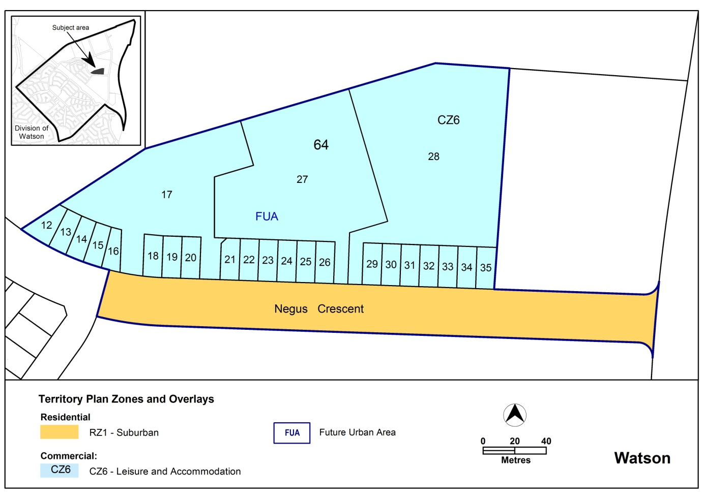

Proposed Territory Plan Map
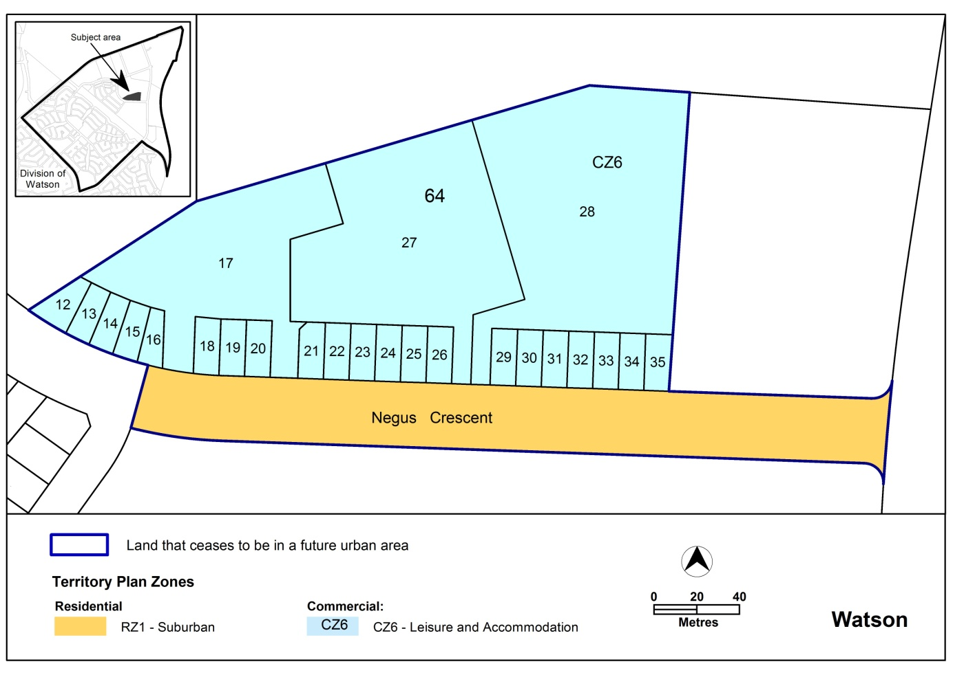

Note: The proposed zones are the same as the existing zones.

  - Watson Precinct Map and Code
Variation to the Watson Precinct Map and Code

The Watson precinct map and code is varied to incorporate rules and criteria, and ongoing block specific provisions.
2.2.1 Watson Precinct Map
Existing Watson precinct map
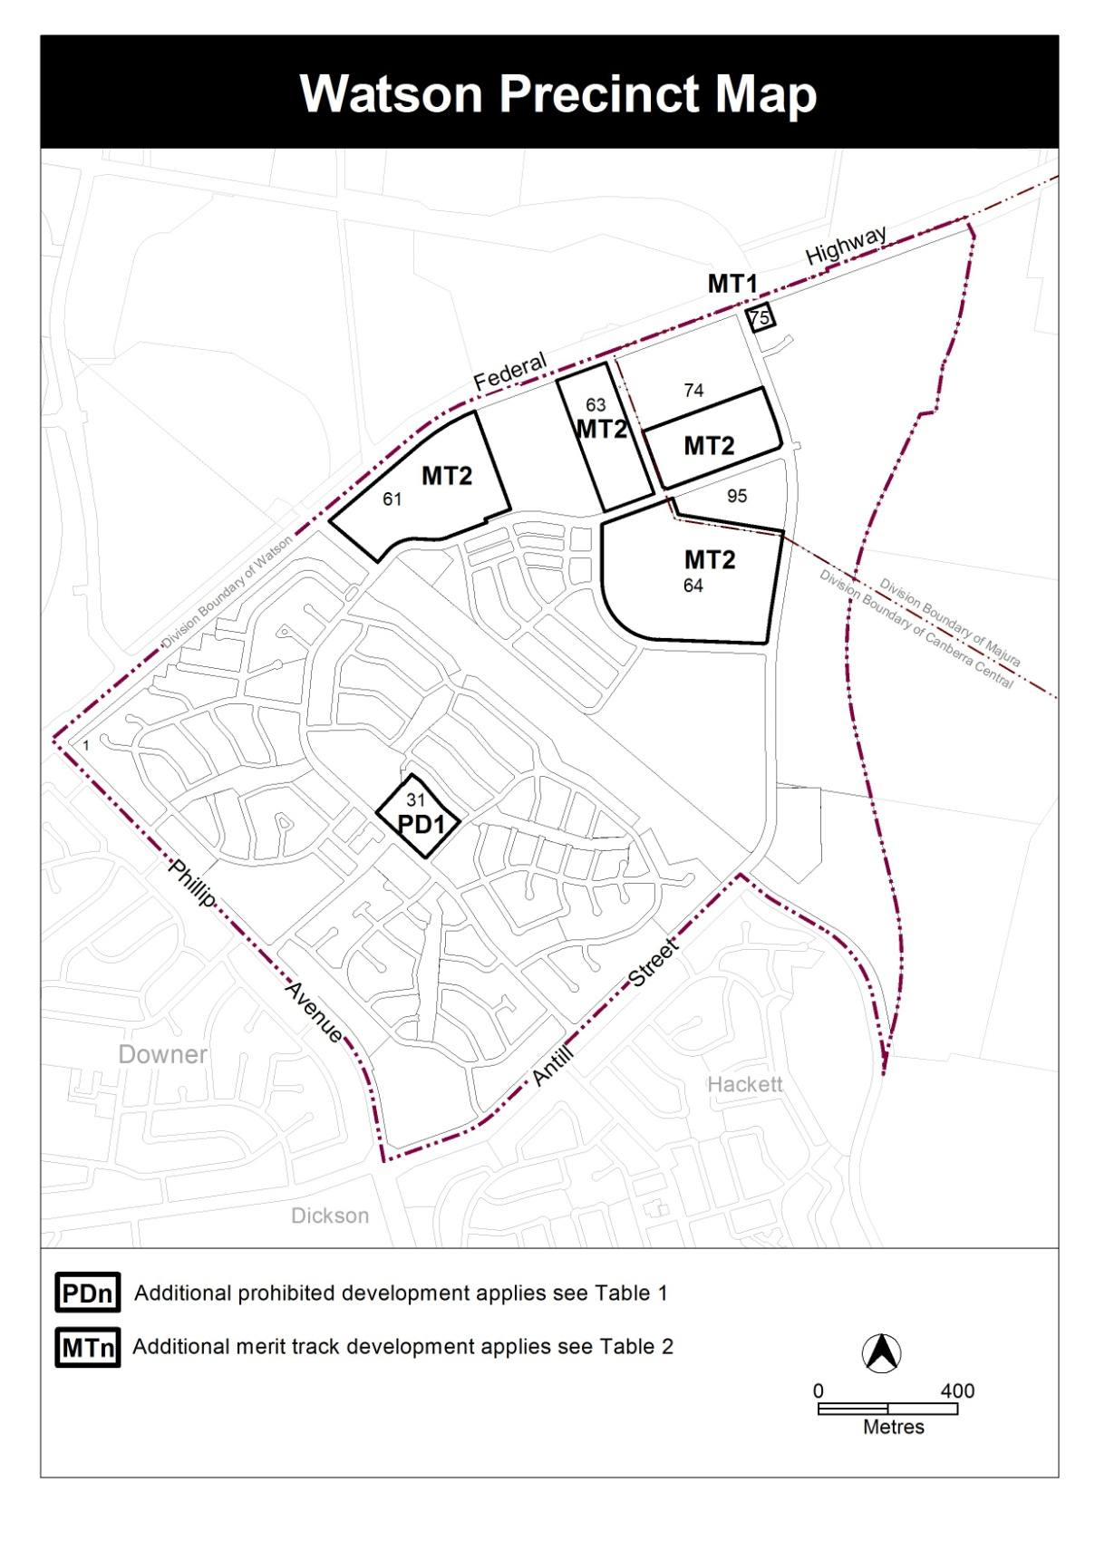

Proposed Watson precinct map

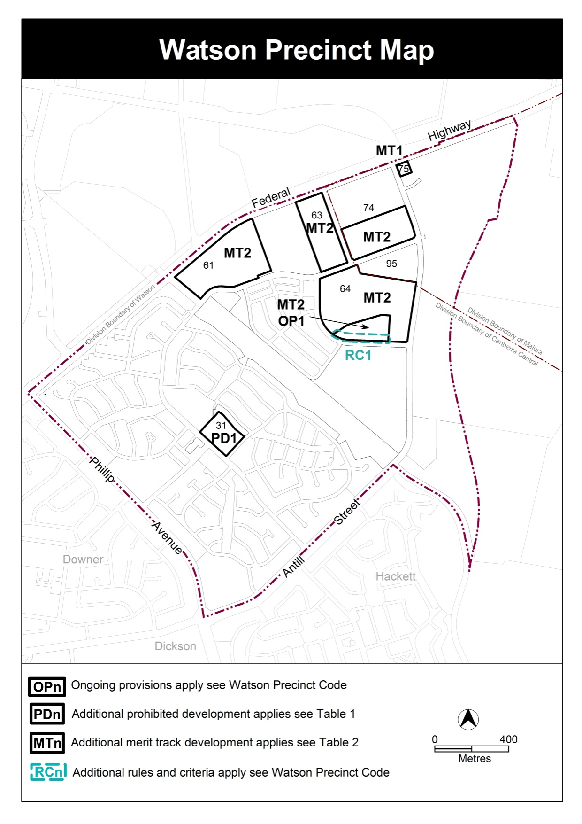

2.2.2 Watson Precinct Code – rules and criteria
Insert Rules and Criteria RC1.

RC1 – Residential
This part applies to blocks and parcels identified in area RC1 shown on the Watson Precinct Map.
- Element 1: Element 1: Building and site controls
Rules | Criteria
1.1 Setbacks
R1  This rule applies to blocks or parcels in locations identified in Figure 1.  Minimum setback to the rear boundary of zero metres permitted for the lower floor level. | This is a mandatory requirement. There is no applicable criterion.
1.2 Height restrictions
R2  Maximum height of building or structure is 8 metres within the shaded area identified in Figure 1. | This is a mandatory requirement. There is no applicable criterion.
1.3 Noise abatement
R3  This rule applies to blocks or parcels in locations identified in Figure 1.  All blocks must achieve a minimum glazing performance in accordance with Table 1. | This is a mandatory requirement. There is no applicable criterion.

Figure 1 Watson residential area 1

Note: STC = sound transmission class

Table 1. Glazing requirements
2.2.3 Watson Precinct Code – ongoing provisions

Insert

OP1 – Watson residential area
This part applies to blocks and parcels identified in area OP1 shown on the Watson Precinct Map.
- ing and site controls
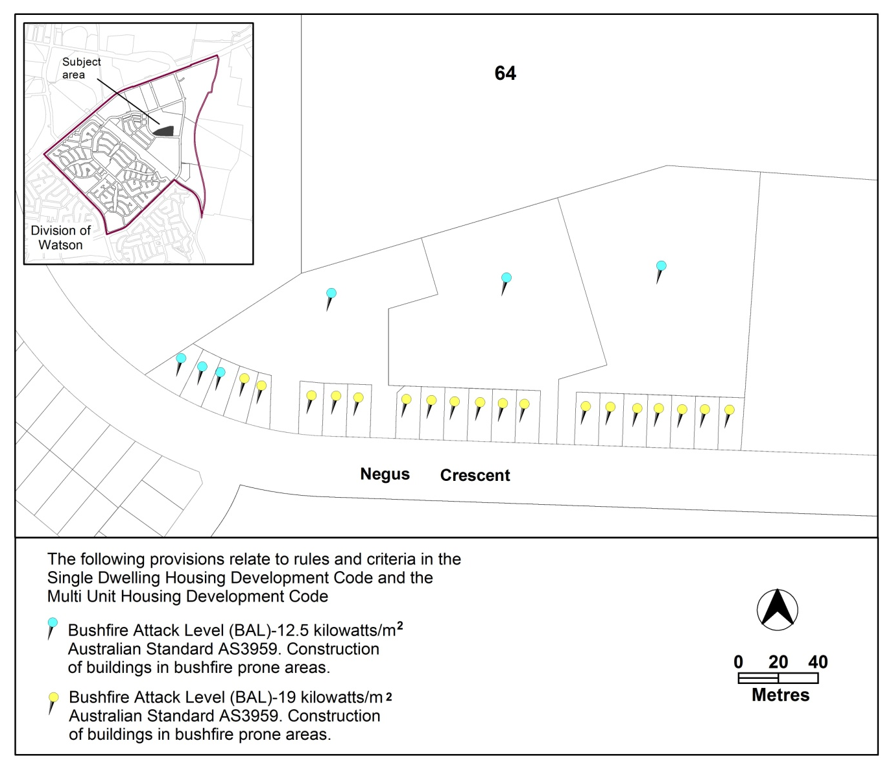

Figure 2 Watson residential area ongoing provisions

- TECHNICAL AMENDMENT
This section of the technical amendment document provides the actual instructions for implementing the changes to the Territory Plan.

  - Territory Plan Map
- Territory Plan Map

The Territory Plan map is varied as indicated below to identify the zones that apply to the land ceasing to be in a future urban area.

  - Watson Precinct Map and Code
- Watson Precinct Map and Code

Substitute with Appendix A.

Interpretation service
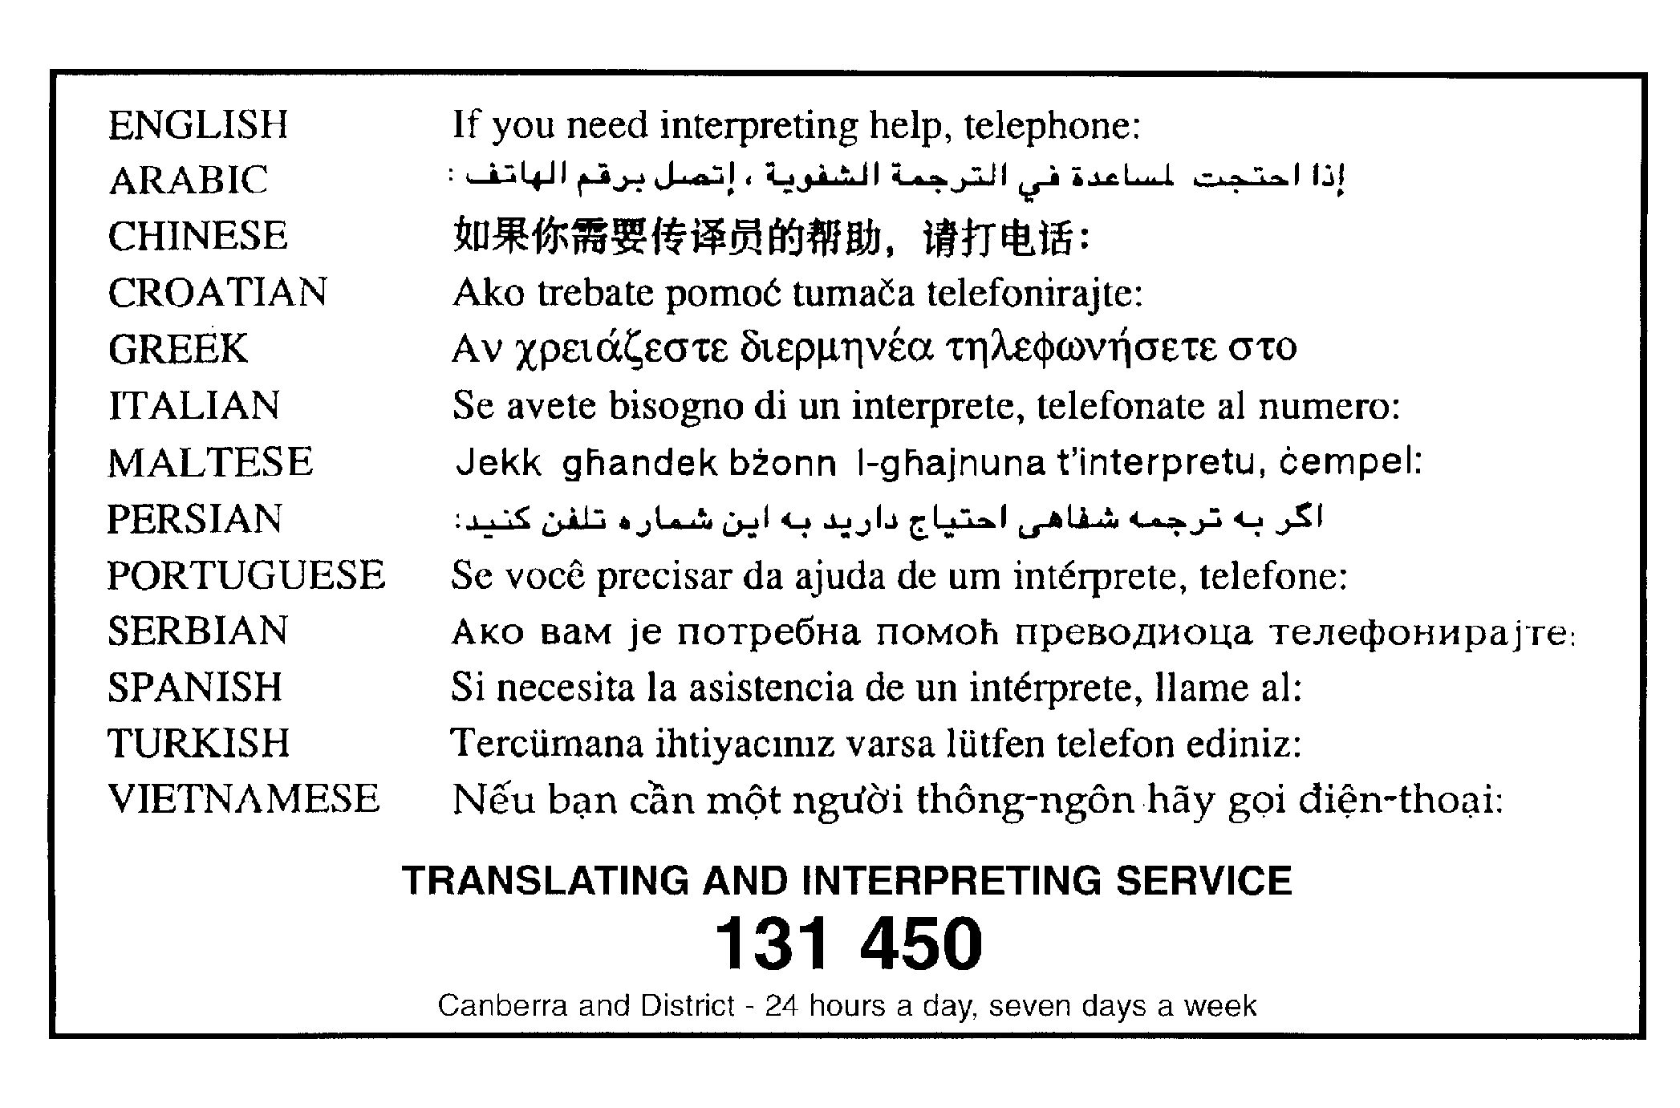

Appendix A

Watson Precinct Map and Code

This page is intentionally blank.

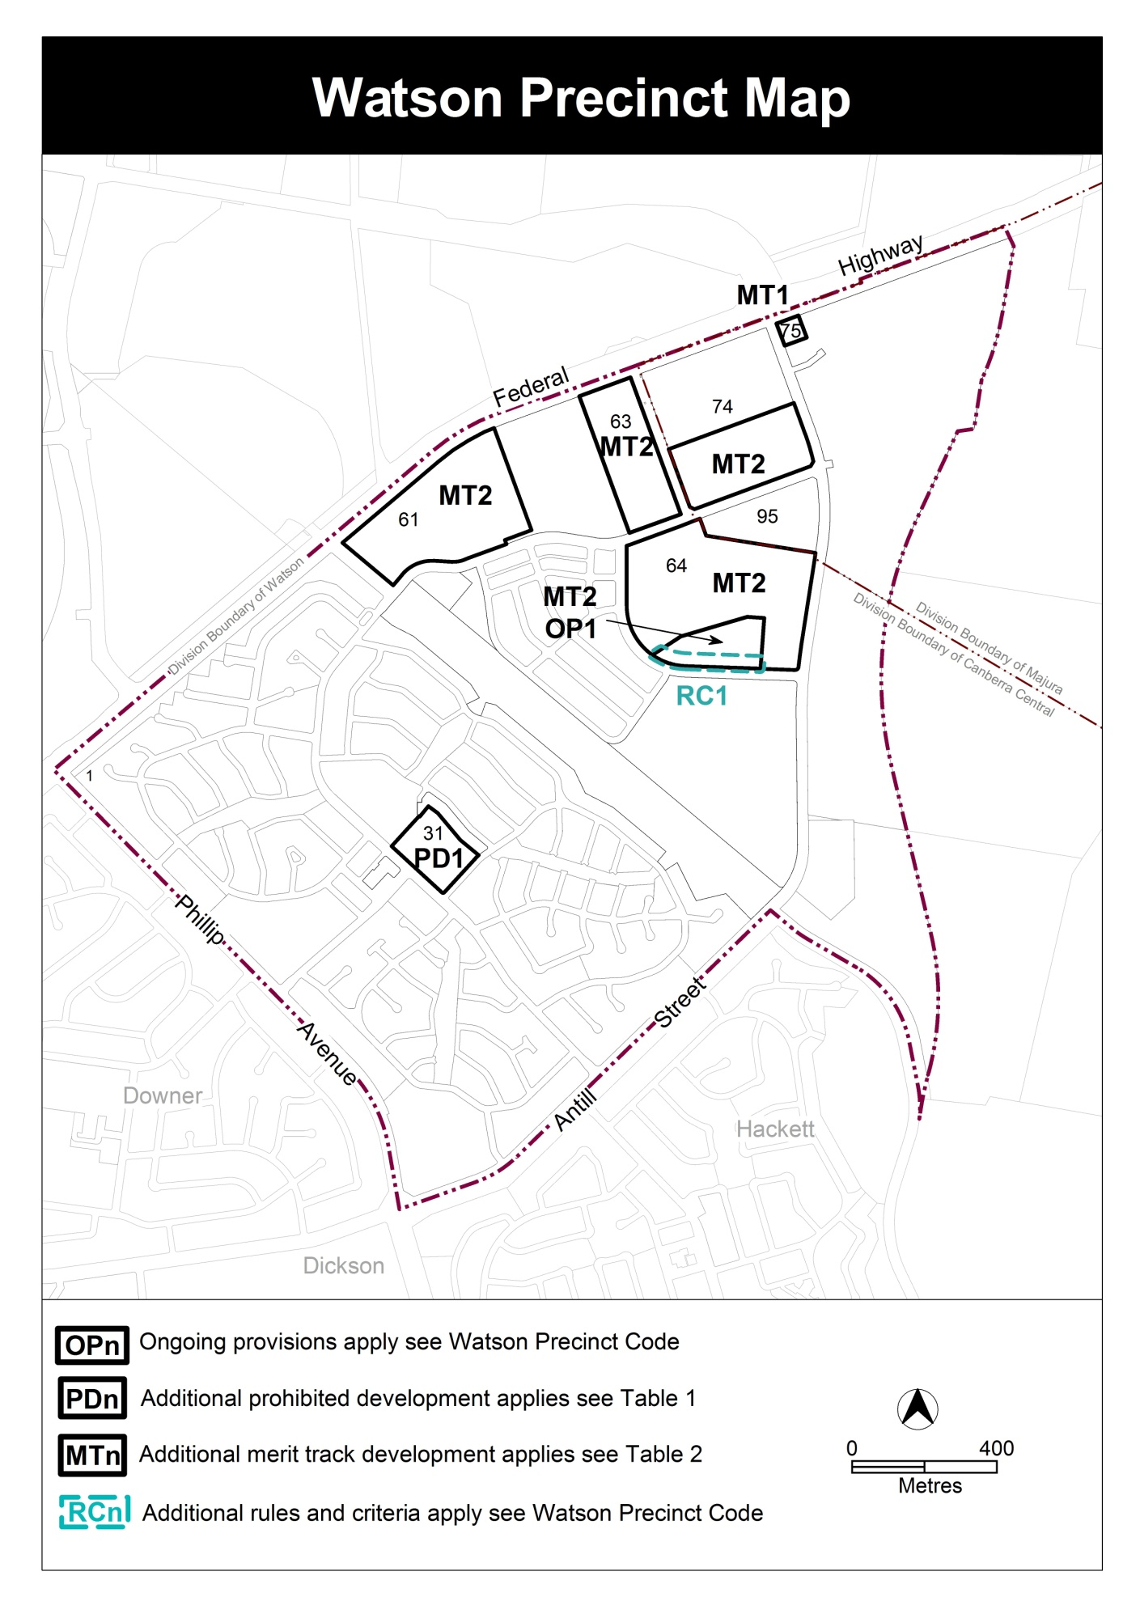

Assessment Tracks

The following tables identify the additional prohibited development and additional merit track development for blocks and parcels shown in the Watson Precinct Map (identified as PDn or MTn). Development that is exempt from requiring development approval, other prohibited development and the minimum assessment track applicable to each development proposal is set out in the relevant zone development table.

The following tables constitute part of the relevant zone development table.

Table 1 – Additional prohibited development
Additional prohibited development
Suburb precinct map label | Zone | Development
PD1 | CFZ | retirement village supportive housing

Table 2 – Additional merit track development
Additional merit track development that may be approved subject to assessment
Suburb precinct map label | Zone | Development
MT1 | CZ6 | service station
MT2 | CZ6 | RESIDENTIAL USE

Watson Precinct Code

Contents
Introduction 4
Additional rules and criteria 6
RC1 – Residential 6
Element 1: Building and site controls 6
Other ongoing provisions 8
OP1 – Watson residential area 8

Figures
Figure 1 Watson residential area 1 7
Table 1 Glazing requirements 7
Figure 2 Watson residential area ongoing provisions 8

Introduction
Name
The name of this code is the Watson Precinct Code.
Application
The code applies to the Division of Watson.
Purpose
This code provides additional planning, design and environmental controls for specific areas or blocks and may also contain references to provisions in other codes.
In conjunction with other relevant codes it will be used by the Authority to assess development applications and offer guidance to intending applicants in designing development proposals and preparing development applications.
Structure
This code contains additional rules and/or criteria for particular blocks or parcels identified as areas RCn on the precinct map, to be read in conjunction with the relevant development code. It may also contain sub-parts.
Each element has one or more rules and, unless the respective rule is mandatory, each rule has an associated criterion. Rules provide quantitative, or definitive, controls. By contrast, criteria are chiefly qualitative in nature.
In some instances rules are mandatory. Such rules are accompanied by the words “This is a mandatory requirement. There is no applicable criterion.” Non-compliance with a mandatory rule will result in the refusal of the development application. Conversely, the words “There is no applicable rule” are found where a criterion only is applicable.
Code hierarchy
Under the Planning and Development Act 2007, where more than one type of code applies to a development, the order of precedence if there is inconsistency of provisions between codes is: precinct code, development code and general code.
If more than one precinct code applies to the site, the most recent precinct code takes precedence to the extent of any inconsistency.
Definitions
Defined terms, references to legislation and other documents are italicised.
Definitions of terms used in this code are listed in part 13 of the Territory Plan or, for terms applicable only to this code, associated with the respective rule.

Acronyms
EPA ACT Environment Protection Authority
ESA ACT Emergency Services Agency
EPSDD ACT Environment, Planning and Sustainable Development Directorate
NCA National Capital Authority
P&D Act Planning and Development Act 2007
TCCS ACT Transport Canberra and City Services

Additional rules and criteria
This part applies to blocks and parcels identified in the Watson Precinct Map (RCn). It should be read in conjunction with the relevant zone development code and related codes.
RC1 – Residential
This part applies to blocks and parcels identified in area RC1 shown on the Watson Precinct Map.
- Building and site controls
Rules | Criteria
1.1 Setbacks
R1  This rule applies to blocks or parcels in locations identified in Figure 1.  Minimum setback to the rear boundary of zero metres permitted for the lower floor level. | This is a mandatory requirement. There is no applicable criterion.
1.2 Height restrictions
R2  Maximum height of building or structure is 8 metres within the shaded area identified in Figure 1. | This is a mandatory requirement. There is no applicable criterion.
1.3 Noise abatement
R3  This rule applies to blocks or parcels in locations identified in Figure 1.  All blocks must achieve a minimum glazing performance in accordance with Table 1. | This is a mandatory requirement. There is no applicable criterion.

Figure 1 Watson residential area 1
Note: STC = sound transmission class

Table 1 Glazing requirements

Other ongoing provisions
This part applies to blocks and parcels identified as ongoing provisions (OPn) in the Watson Precinct Map. It should be read in conjunction with the relevant zone development code and related codes.
OP1 – Watson residential area
This part applies to blocks and parcels identified in area OP1 shown on the Watson Precinct Map.
Figure 2 Watson residential area ongoing provisions

Interpretation service

