Australian Capital Territory
Planning and Development (Technical Amendment—Kingston) Plan Variation 2017 (No 1)

Notifiable instrument NI2017—479
Technical Amendment No 2017-20
made under the
Planning and Development Act 2007, s 89 (Making technical amendments) and s 96 (Effect of approval of estate development plan)

- Name of instrument
This instrument is the Planning and Development (Technical Amendment—Kingston) Plan Variation 2017 (No 1).
2 Technical amendment
I am satisfied under section 89 (1) (a) of the Planning and Development Act 2007 (the Act) that the Kingston plan variation is a technical amendment to the Territory Plan.
3 Commencement
This instrument commences on the day after its notification day.
4 Meaning of Kingston plan variation
For this instrument:
Kingston plan variation means the Technical Amendment to the Territory Plan, Variation 2017-20, in the schedule.
Note: No consultation was required in relation to the Kingston plan variation under section 87 of the Act.
Fleur Flanery
Delegate of the planning and land authority
08 September 2017

Schedule
(see section 4)

This page is left intentionally blank

This page is left intentionally blank

Insert new rules and criteria under the new element heading 8.4 Setbacks – Honeysett View and Insert new rules and criteria under the new element heading 8.5 Building Design – Honeysett View (new R45 to R52/C52)

Rules | Criteria
8.4 Setbacks – Honeysett View
R45  This rule applies to area A shown in figure 8.  The ground floor of the building (except colonnade supports) adjoining the harbour open space is setback minimum 3m; and  3m wide pedestrian access easement to be provided for the length of area A adjoining the harbour open space in accordance with figure 8. | This is a mandatory requirement. There is no applicable criterion.
R46  This rule applies to area A shown in figure 8.  Levels above ground floor have a minimum zero metre setback to the harbour open space | This is a mandatory requirement. There is no applicable criterion.
8.5 Building Design – Honeysett View
R47  This rule applies to area A shown in figure 8.  Finished Floor Level (FFL) of the ground floor is RL558.5 Australian Height Datum | C47  This criterion applies to area A in figure 8.  The finished floor level of the ground floor provides regular spaced and convenient access (including access for use by people with a disability) between the pedestrian access easement within the block and the public open space adjoining Kingston Harbour and is endorsed by TCCS and EPSDD.

Rules | Criteria
R48  This rule applies to area A shown in figure 8.  For buildings fronting both Honeysett View and the main pedestrian area/route, frontages and building design comply with all of the following:  - buildings incorporate clear display windows and/or shop fronts at the ground floor level  - buildings incorporate direct pedestrian access at grade for access and egress for persons with disabilities to each commercial tenancy  - any small areas of walls without windows contain displays, showcases and/or public art, with a maximum of 30% blank frontage per tenancy.  - courtyard walls are not permitted adjoining the main pedestrian route  - open structured car parks, loading docks, substations and service infrastructure are not located along the frontage  Note: C36 in the Kingston Precinct Map and Code still applies. | This is a mandatory requirement. There is no applicable criterion.
R49  This rule applies to area B shown in figure 8.  Courtyard walls adjoining the public open space achieve all of the following:  - Solid boundary elements are to be limited to a maximum 1m high from the finish floor level of the ground floor;  - Elements above 1m high are to be transparent;  - Maximum wall height is 1.6m from the finished floor level of the ground floor;  - Location of the courtyard wall entrances to align with the dwelling/commercial entrance;  - Entrances to the courtyard walls are to be paired to allow one public open space ramp/stairs to service two courtyards; and  - Materials of the courtyard wall match the building  Note: this Rule replaces R42 in the Residential Zones – Multi Housing Development Code | C49  This criterion applies to area B in figure 8.  - Courtyard walls are to be designed to preserve residential privacy while maintaining a relationship with the public domain.  - The courtyard walls are designed to enhance the ability of the ground floor to be adapted to commercial use.  - Each dwelling is to have pedestrian access to the public open space  - Location of entrances to the open space minimise the number of connecting ramps/stairs required and maximise the area of soft landscaping between the shared path in the open space and the block boundary.  - Courtyard walls are constructed from high quality materials consistent with the character of the building  Note: this Criterion replaces C42 in the Residential Zones – Multi Housing Development Code

Rules | Criteria
R50  This rule applies to area B shown in figure 8  Each dwelling provided on the ground floor adjoining the public open space will have direct pedestrian access to the public open space  Where commercial uses are provided on the ground floor, pedestrian access is provided between the building and the public open space every 15m. | C50  This criterion applies to area B in figure 8  Frequent and convenient access is provided between the commercial and residential uses to the adjoining public open space.
R51  This rule applies to figure 8.  Buildings on the ground floor level are not permitted within the “Ground level view line and pedestrian access” area as shown in figure 8, to enable pedestrian access and a visual connection from the site through to the urban open space along Jerrabomberra Creek and Kingston Harbour. | C51  This criterion applies to figure 8  Buildings on the ground floor level enable all of the following:  - Safe and convenient public pedestrian access to buildings on the site and the urban open space  - Generous path width to support pedestrian comfort, safety and amenity and views of the urban open space and Jerrabomberra Creek  - Integration with the pedestrian routes and design of the urban open space
R52  This rule applies to figure 8.  Buildings are not permitted within the “Plaza Common Open Space” area as shown in figure 8, to enable a shared plaza for entry to the site and connection to the “Ground level view line and pedestrian access” through to the urban open space along Jerrabomberra Creek and Kingston Harbour.  Smaller built elements relating to site servicing infrastructure are permitted within the area marked “services” as long as the services themselves are adequately screened from public view. | C52  This criterion applies to figure 8  The “Plaza Common Open Space” achieves all of the following:  - A shared plaza with safe and convenient public pedestrian access to buildings on the site and Honeysett View  - Reasonable vehicular access to the site in a shared space environment  - Adequate siting and screening of smaller built elements relating to site servicing infrastructure to minimise visual impact  - Integration with the adjacent pedestrian routes and design of Honeysett View

Insert a new Item 9.5 and corresponding new rule R62

Rules | Criteria
9.5 Honeysett View – pedestrian areas
R62  Main pedestrian areas and routes are defined in figure 8 | This is a mandatory requirement. There is no applicable criterion.

Substitute renumbered R63 (formerly R54) with

R63  This rule applies to figure 5 and figure 8.  No vehicle access is permitted in areas shown in figure 5 and figure 8. | This is a mandatory requirement. There is no applicable criterion.

- TECHNICAL AMENDMENT
This section of the technical amendment document provides the actual instructions for implementing the changes to the Territory Plan.

  - Territory Plan Map
The Territory Plan map is varied as indicated below to identify the zones that apply to the land ceasing to be in a future urban area.

  - Kingston Precinct Map and Code
Substitute the existing RC4 – Kingston Foreshore and existing RC5 – Canberra Avenue Corridor Site with Appendix A

Appendix A

RC4 – Kingston Foreshore
This part applies to the Kingston Foreshore shown as RC4 on the Kingston precinct map.

Element 7: Use
Rules | Criteria
7.1 Shop
There is no applicable rule. | C33  SHOP development achieves one or more of the following:  - a convenience service limited to the local workforce and residents  - related to the sale of entertainment and leisure goods such as specialty items or arts, crafts and souvenirs
R34  The maximum gross floor area of SHOP selling food is 250m2. | This is a mandatory requirement. There is no applicable criterion.
7.2 Major utility installation
R35  Only a MAJOR UTILITY INSTALLATION that is  essential to the operation of the electricity supply network, the augmentation of the local water and sewerage system or the management of the stormwater system may be approved.  An application for a MAJOR UTILITY INSTALLATION is accompanied by written endorsement of a relevant service provider. | This is a mandatory requirement. There is no applicable criterion.

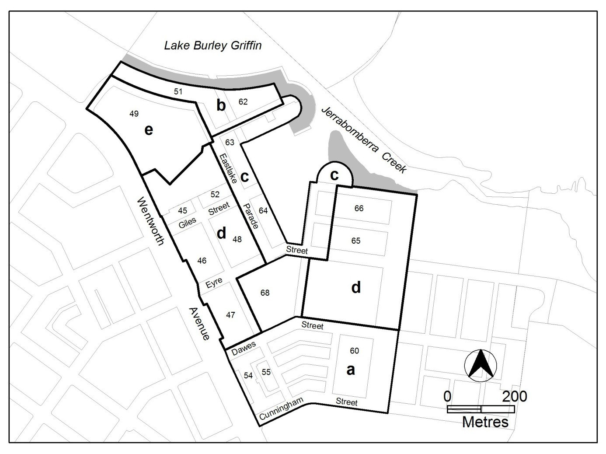

Figure 4 Kingston Foreshore

Rules | Criteria
7.3 Residential use and office
There is no applicable rule. | C36  This rule applies to the area c shown in figure 4.  Buildings at the ground floor level achieve all of the following:  - avoid office and RESIDENTIAL USE in areas fronting main pedestrian areas and routes  - adaptable for commercial use
7.4 Office
R37  This rule applies to the areas b, c and e shown in figure 4.  The maximum gross floor area of office  complies with all of the following  - 500m² per tenancy  - 2000m² per lease | This is a mandatory requirement. There is no applicable criterion.

Rules | Criteria
R38  This rule applies to the area d shown in figure 4.  The maximum gross floor area of office per lease is 2000m² | This is a mandatory requirement. There is no applicable criterion.
7.5 Parberry Street/ The Causeway
There is no applicable rule. | C39  This criterion applies to figure 5:  The ground floor level of all buildings fronting The Causeway are designed to be adaptable for commercial use.

Element 8: Buildings
Rules | Criteria
8.1 Number of storeys
R40  Unless otherwise stated in this precinct code, the maximum number of storeys is 4 with a parapet level at the third storey level. | C40  The number of storeys achieve all of the following:  a) a limited number of buildings may exceed  4 storeys provided they comply with all of the following:  - they achieve urban design objectives such as adding visual interest to the built form, appropriately framing major public spaces, marking important corners or transition points, or screening unsightly elements from the public domain  - they do not significantly impact on the landscape of the area  - their ground floor level is not greater than RL 560m  - they do not detract or compromise views and vistas to the Power House  - the footprint of the higher building elements is no greater than a 15m x 20m rectangle  - to retain significant visual links between the Power House building and East Basin, the roofline of development in area b is punctuated to frame and emphasise the views of the Power House building  - the overall maximum height of building does not exceed the lesser of RL578m or 20m
R41  This rule applies to area A shown in figure 5.  A maximum of 2 storeys is permitted to Parberry Street.  The two storey height limit applies for the first 3m of all built form along the frontage with Parberry Street. | This is a mandatory requirement. There is no applicable criterion.

Rules | Criteria
R42  This rule applies to area B shown in figure 5. The maximum number of storeys is 4. | C42  The number of storeys achieve all of the following:  - a limited number of buildings may exceed 4 storeys provided they comply with all of the following:  - they achieve urban design objectives such as adding visual interest to the built form, appropriately framing major public spaces, marking important corners or transition points, or screening unsightly elements from the public domain  - they do not significantly impact on the landscape of the area  - they do not detract or compromise views and vistas to the Power House  - the footprint of the higher building elements is no greater than a 15m x 20m rectangle  - to retain significant visual links between the Power House building and East Basin, the roofline of development in area b is punctuated to frame and emphasise the views of the Power House building  - the overall maximum height of building does not exceed the lesser of RL578m or 20m
8.2 Built Form
R43  This rule applies to figure 5.  Built form fronting The Causeway is broken into a minimum of 3 buildings.  The separation between buildings is a minimum of 10m.  Separation may need to be increased to allow for solar access to all north facing dwellings at all levels in order to meet the requirements of the Multi Unit Housing Development Code. | This is a mandatory requirement. There is no applicable criterion.

Rules | Criteria
8.3 Roof forms, materials and finishes
There is no applicable rule. | C44  Building roof forms, materials and finishes achieve all of the following  - colour scheme is light in tone although some highlighting with darker colours may be acceptable where these do not present the dominant colour scheme when viewed from or across Lake Burley Griffin  - high quality, durable and low maintenance materials are used on buildings and structures near the edge of Lake Burley Griffin  - avoid the use of highly reflective materials on buildings fronting the edge of Lake Burley Griffin

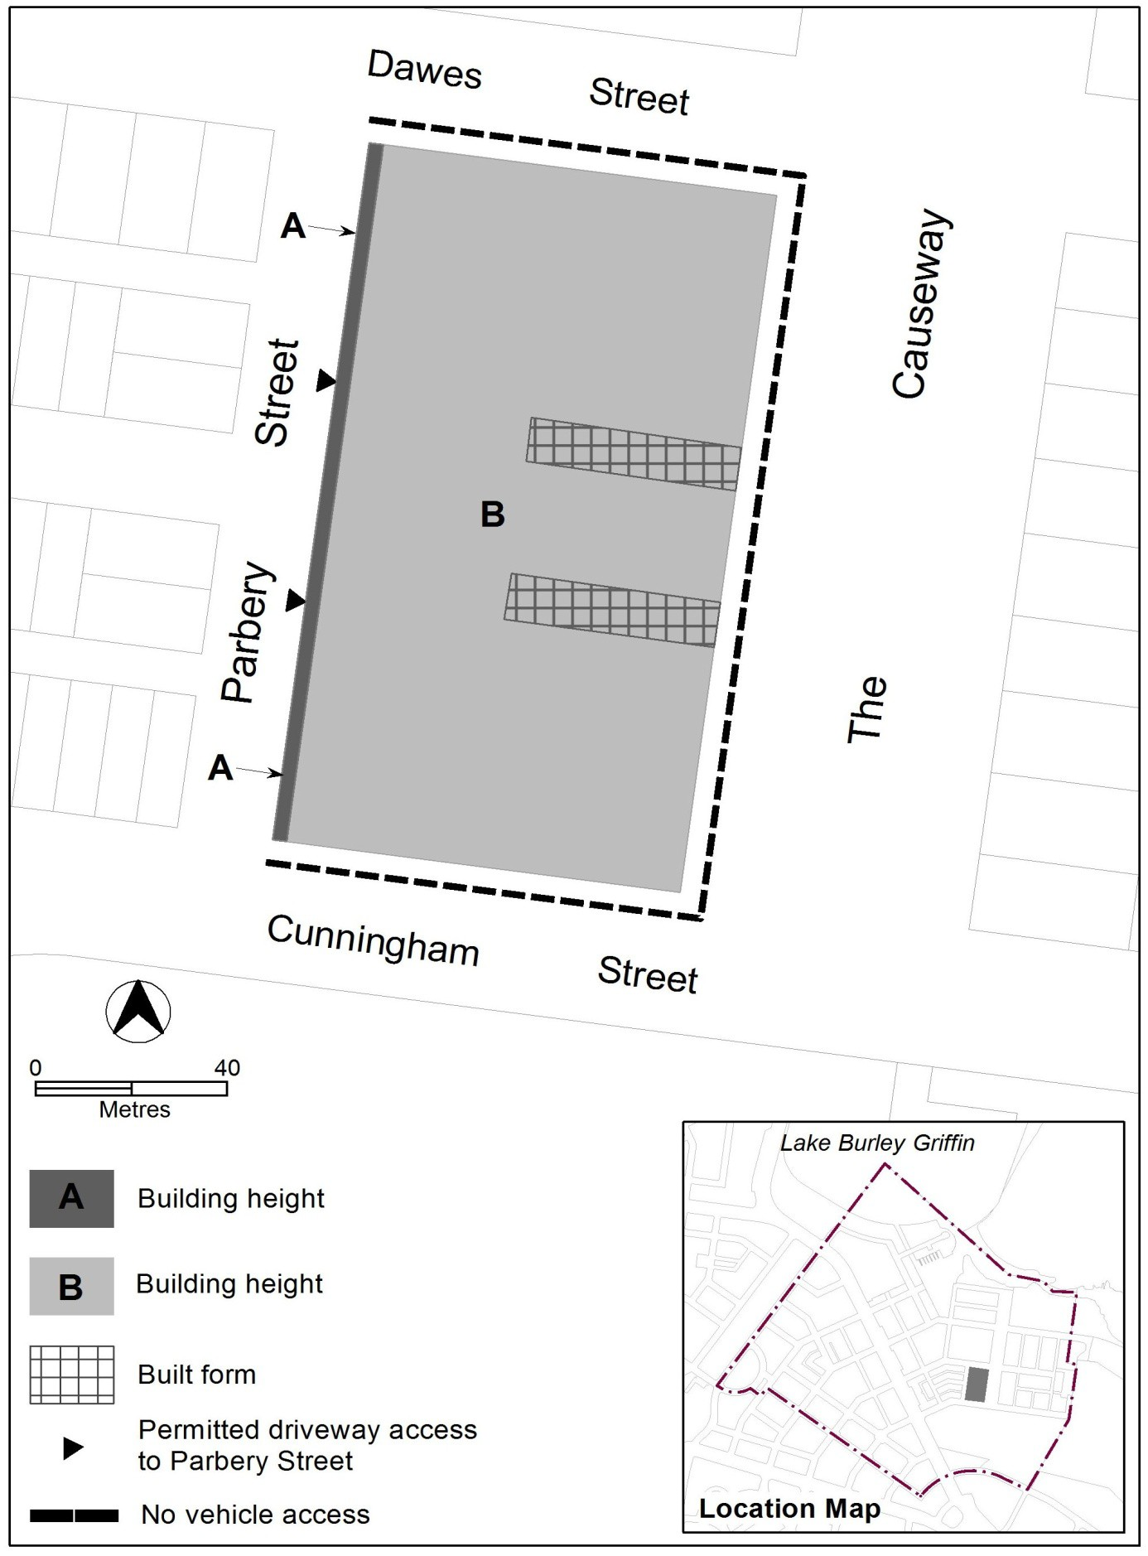

Figure 5 Parberry Street/ The Causeway

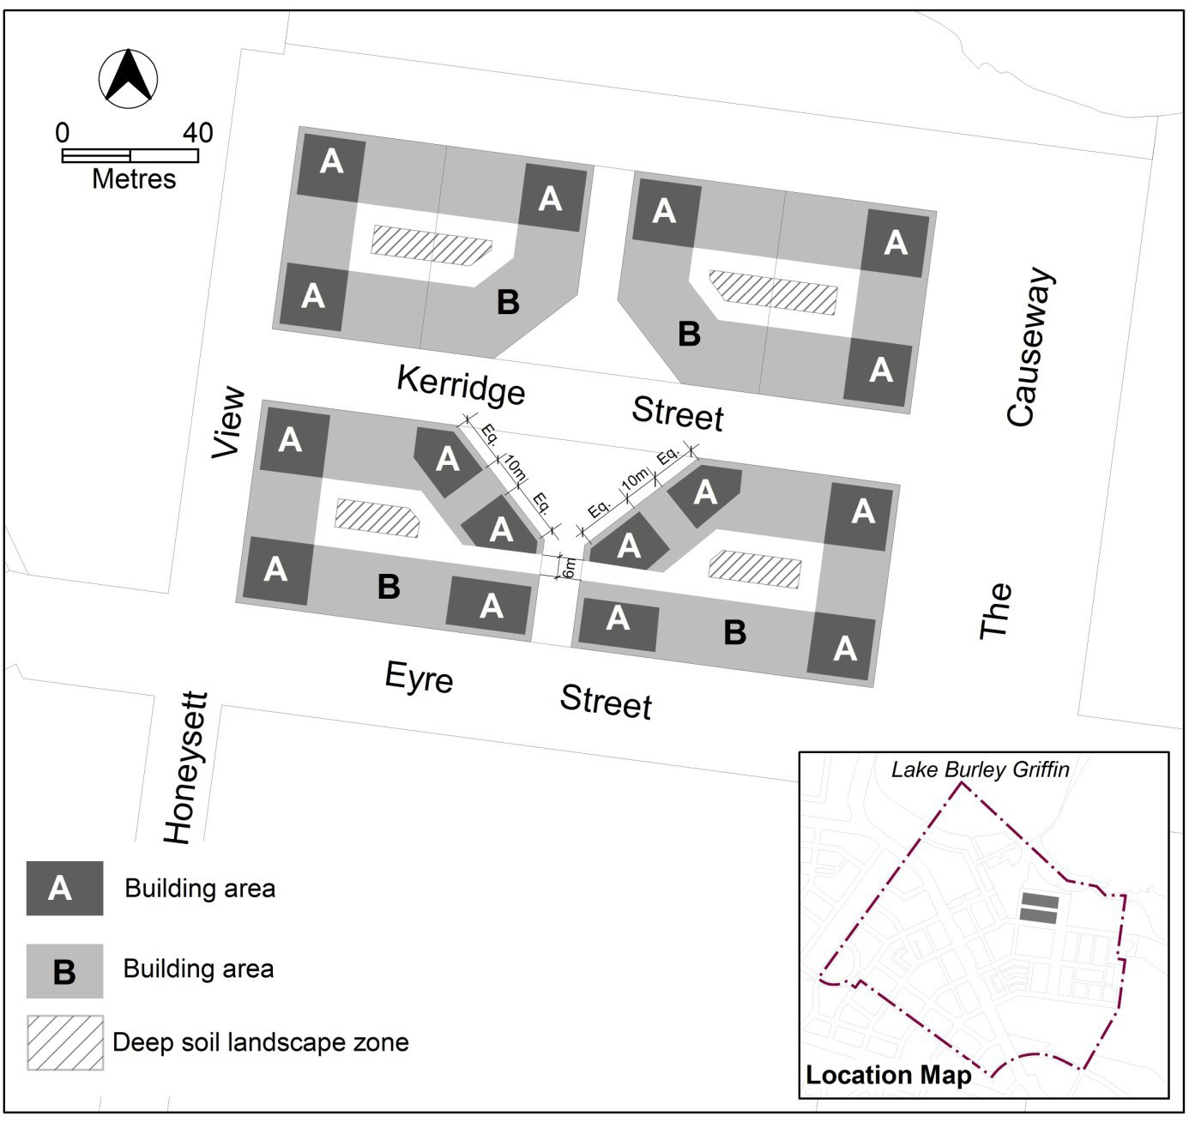

Figure 6 Kerridge Street

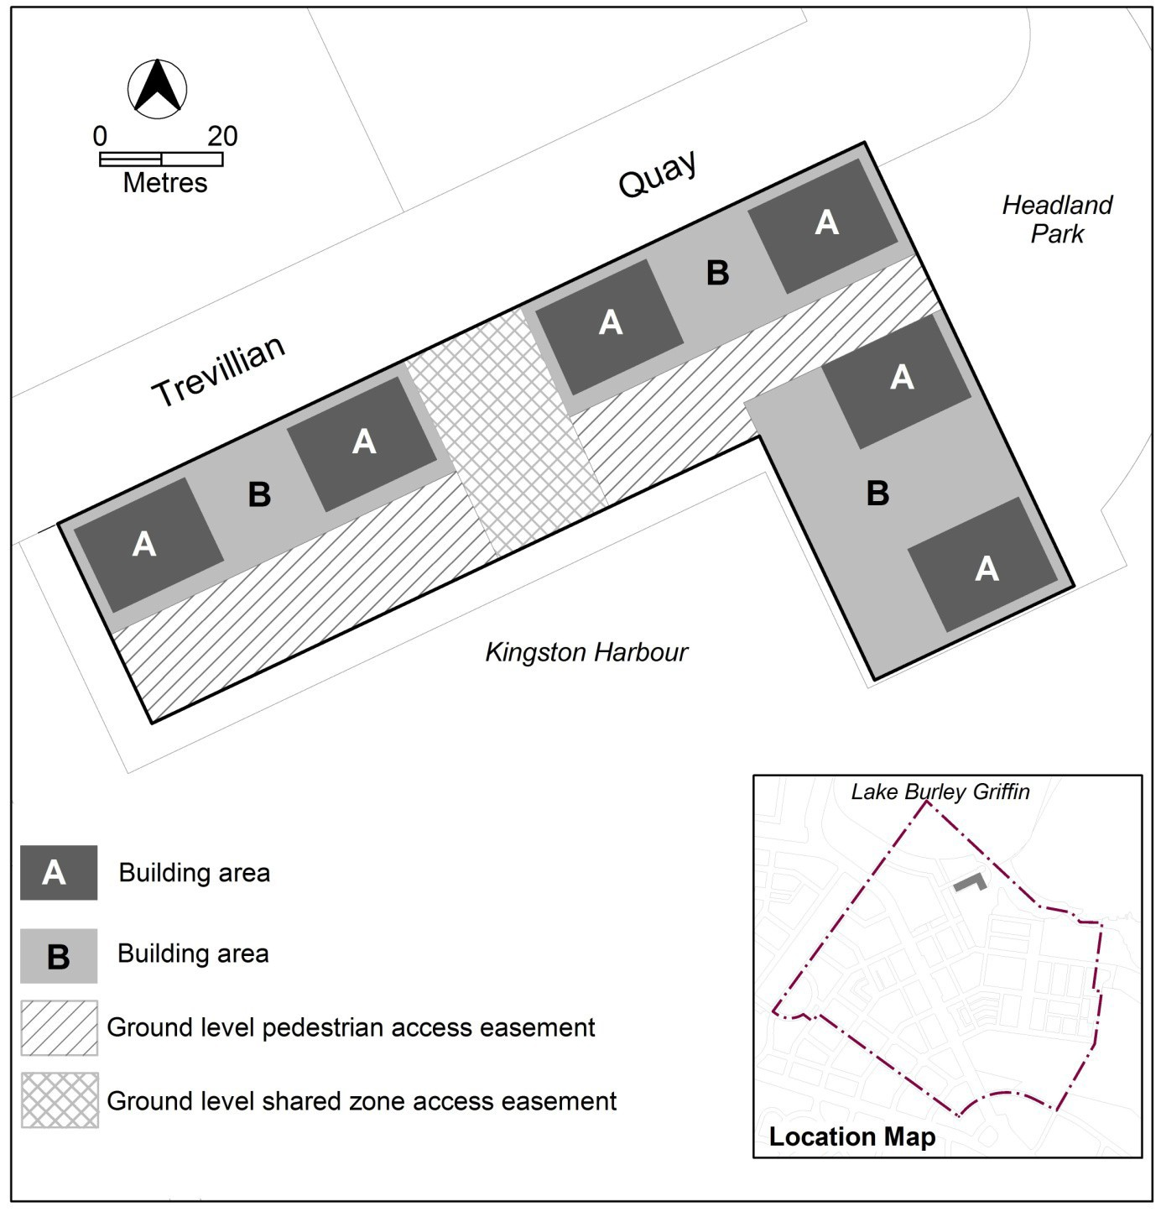

Figure 7 Trevillian Quay - South

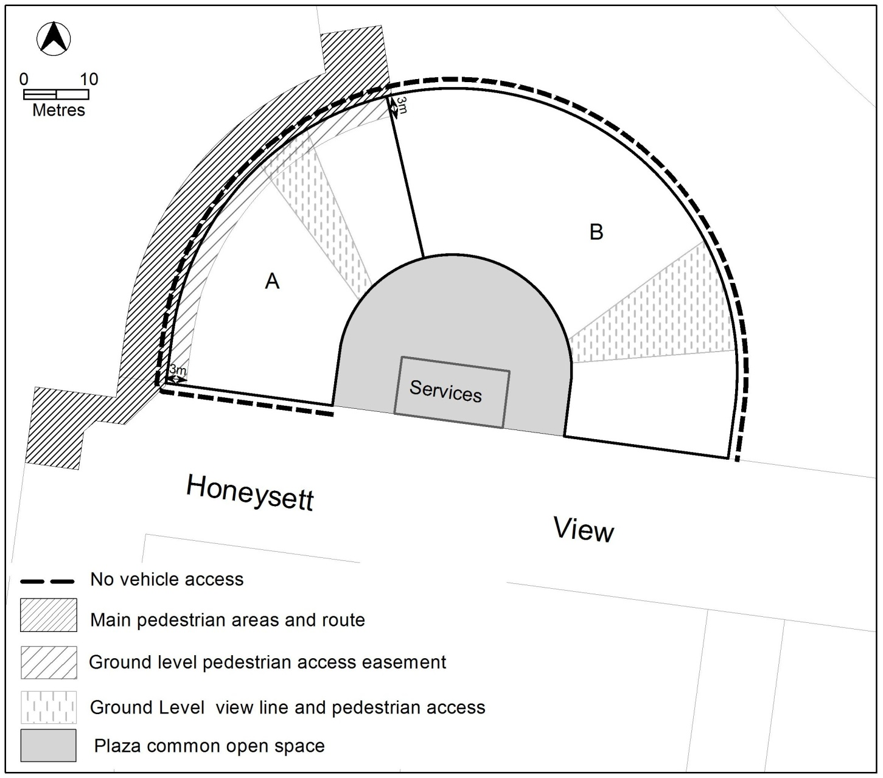

Figure 8 Honeysett View

Rules | Criteria
8.4 Setbacks – Honeysett View
R45  This rule applies to area A shown in figure 8.  The ground floor of the building (except colonnade supports) adjoining the harbour open space is setback minimum 3m; and  3m wide pedestrian access easement to be provided for the length of area A adjoining the harbour open space in accordance with figure 8. | This is a mandatory requirement. There is no applicable criterion.
R46  This rule applies to area A shown in figure 8.  Levels above ground floor have a minimum zero metre setback to the harbour open space | This is a mandatory requirement. There is no applicable criterion.
8.5 Building Design – Honeysett View
R47  This rule applies to area A shown in figure 8.  Finished Floor Level (FFL) of the ground floor is RL558.5 Australian Height Datum | C47  This criterion applies to area A in figure 8.  The finished floor level of the ground floor provides regular spaced and convenient access (including access for use by people with a disability) between the pedestrian access easement within the block and the public open space adjoining Kingston Harbour and is endorsed by TCCS and LDA.

Rules | Criteria
R48  This rule applies to area A shown in figure 8.  For buildings fronting both Honeysett View and the main pedestrian area/route, frontages and building design comply with all of the following:  - buildings incorporate clear display windows and/or shop fronts at the ground floor level  - buildings incorporate direct pedestrian access at grade for access and egress for persons with disabilities to each commercial tenancy  - any small areas of walls without windows contain displays, showcases and/or public art, with a maximum of 30% blank frontage per tenancy.  - courtyard walls are not permitted adjoining the main pedestrian route  - open structured car parks, loading docks, substations and service infrastructure are not located along the frontage  Note: C36 in the Kingston Precinct Map and Code still applies. | This is a mandatory requirement. There is no applicable criterion.

Rules | Criteria
R49  This rule applies to area B shown in figure 8.  Courtyard walls adjoining the public open space achieve all of the following:  - Solid boundary elements are to be limited to a maximum 1m high from the finish floor level of the ground floor;  - Elements above 1m high are to be transparent;  - Maximum wall height is 1.6m from the finished floor level of the ground floor;  - Location of the courtyard wall entrances to align with the dwelling/commercial entrance;  - Entrances to the courtyard walls are to be paired to allow one public open space ramp/stairs to service two courtyards; and  - Materials of the courtyard wall match the building  Note: this Rule replaces R42 in the Residential Zones – Multi Housing Development Code | C49  This criterion applies to area B in figure 8.  - Courtyard walls are to be designed to preserve residential privacy while maintaining a relationship with the public domain.  - The courtyard walls are designed to enhance the ability of the ground floor to be adapted to commercial use.  - Each dwelling is to have pedestrian access to the public open space  - Location of entrances to the open space minimise the number of connecting ramps/stairs required and maximise the area of soft landscaping between the shared path in the open space and the block boundary.  - Courtyard walls are constructed from high quality materials consistent with the character of the building  Note: this Criterion replaces C42 in the Residential Zones – Multi Housing Development Code
R50  This rule applies to area B shown in figure 8  Each dwelling provided on the ground floor adjoining the public open space will have direct pedestrian access to the public open space  Where commercial uses are provided on the ground floor pedestrian access is provided between the building and the public open space every 15m. | C50  This criterion applies to area B in figure 8  Frequent and convenient access is provided between the commercial and residential uses to the adjoining public open space.

Rules | Criteria
R51  This rule applies to figure 8.  Buildings on the ground floor level are not permitted within the “Ground level view line and pedestrian access” area as shown in figure 8, to enable pedestrian access and a visual connection from the site through to the urban open space along Jerrabomberra Creek and Kingston Harbour. | C51  This criterion applies to figure 8  Buildings on the ground floor level enable all of the following:  - Safe and convenient public pedestrian access to buildings on the site and the urban open space  - Generous path width to support pedestrian comfort, safety and amenity and views of the urban open space and Jerrabomberra Creek  - Integration with the pedestrian routes and design of the urban open space
R52  This rule applies to figure 8.  Buildings are not permitted within the “Plaza Common Open Space” area as shown in figure 8, to enable a shared plaza for entry to the site and connection to the “Ground level view line and pedestrian access” through to the urban open space along Jerrabomberra Creek and Kingston Harbour.  Smaller built elements relating to site servicing infrastructure are permitted within the area marked “services” as long as the services themselves are adequately screened from public view. | C52  This criterion applies to figure 8  The “Plaza Common Open Space” achieves all of the following:  - A shared plaza with safe and convenient public pedestrian access to buildings on the site and Honeysett View  - Reasonable vehicular access to the site in a shared space environment  - Adequate siting and screening of smaller built elements relating to site servicing infrastructure to minimise visual impact  - Integration with the adjacent pedestrian routes and design of Honeysett View

Rules | Criteria
8.6 Kerridge Street
R53  This rule applies to each area A shown in figure 6.  The maximum number of storeys is 6.  The maximum height of building is the lesser of RL578 and 20m.  The maximum floor area for storey 5 is 300m². The maximum floor area for storey 6 is 300m².  The maximum external horizontal dimension for any part of the building over 4 storeys is 20m.  The minimum front boundary setback for that part of the building with more than 4 storeys is 2m.  Rule 18 does not apply. | This is a mandatory requirement. There is no criterion.
R54  This rule applies to each area B shown in figure 6.  The maximum number of storeys is 4.  The maximum external horizontal depth is 18m (including enclosed building area and articulation elements but excluding awnings over footpaths and basements). | C54  4 storey building elements achieve all of the following:  - alignment to the block perimeter  - high levels of natural daylight, ventilation and solar access to dwellings  - central courtyards sized to meet the reasonable needs of residents.
8.7 Trevillian Quay
R55  This rule applies to each area A shown in figure 7.  The maximum dimensions for each area A are 20m x 15m.  The maximum number of storeys is 6.  The maximum height of building is the lesser of RL578 and 20m  The minimum setback from Trevillian Quay and Headland Park for that part of the building with more than 4 storeys is 2m.  Rule 18 does not apply. | This is a mandatory requirement. There is no criterion.
R56  This ruleapplies to each area B shown in figure 7.  The maximum number of storeys is 4. | This is a mandatory requirement. There is no criterion.

Element 9: Site
Rules | Criteria
9.1 Outdoor lighting
There is no applicable rule. | C57  Outdoor lighting in the area should generally use full-cut off light fittings and up-lighting of buildings and structures should be carefully designed to keep night time overspill lighting to a minimum.
There is no applicable rule. | C58  The overall lighting impact should not compete in prominence with the lighting of the National Triangle. The area should be lit predominantly with high pressure sodium light sources for streets and mercury vapour for pedestrian routes. Lake frontages external lighting should use metal halide sources. There should be no flashing or laser beam lighting on or around buildings fronting Lake Burley Griffin.
9.2 Kerridge Street - deep soil landscape zones
R59  This rule applies to the hatched areas identified as deep soil landscape zones in figure 6.  The location of deep soil landscape zones are indicatively shown in figure 6.  Deep soil landscape zones represent a minimum of 10% of the total site area. | C59  Provision is made for sufficient soil to allow planting and growth of healthy canopy trees in the central courtyards.
9.3 Trevillian Quay - shared zone
R60  Ground level shared zone access easements are provided in accordance with figure 7. | C60  Shared zones achieve all of the following:  - safe and convenient public pedestrian access to buildings on the site and the foreshore  - reasonable vehicular access to the foreshore.

Rules | Criteria
9.4 Trevillian Quay - pedestrian areas
R61  Ground level pedestrian access easements are provided in accordance with figure 7. | C61  Pedestrian access easements achieve all of the following:  - safe and convenient public pedestrian access to buildings on the site and the foreshore  - provision for small scale ancillary buildings and structures associated with harbour operations.
9.5 Honeysett View – pedestrian areas
R62  Main pedestrian areas and routes are defined in figure 8. | This is a mandatory requirement. There is no applicable criterion.
9.6 Vehicular access
R63  This rule applies to figure 5 and figure 8.  No vehicle access is permitted in areas shown in figure 5 and figure 8. | This is a mandatory requirement. There is no applicable criterion.
R64  This rule applies to figure 5.  Driveways are permitted to Parberry Street in locations shown in figure 5. | This is a mandatory requirement. There is no applicable criterion.
9.7 Site contamination – Section 49
R65  Applications for any permitted uses (including hotel and child care centre) proposed on a site are to be accompanied by a report from an Environment Protection Authority (EPA) approved auditor, with written endorsement from the EPA, advising that the site has been assessed for suitability from a contamination perspective. | C65  Applications without written auditor and EPA endorsement will be referred to the EPA.

RC5 – Canberra Avenue Corridor Site
This part applies to blocks and parcels within area RC5 shown on the Kingston precinct map. RC5 includes the Canberra Avenue corridor site.

Element 10: Use
Rules | Criteria
10.1 Restaurant and shop
R66  One or more of the following uses are permitted where it is ancillary to other uses:  - restaurant  - SHOP | This is a mandatory requirement. There is no applicable criterion.

Element 11: Buildings
Rules | Criteria
11.1 Number of storeys
R67  The maximum number of storey is 4. | C67  The number of storeys comply with all of the following:  - are compatible with existing, or future desired character of, adjacent development  - are appropriate to the scale and function of the use  - minimise detrimental impacts, including overshadowing and excessive scale  - are no higher than the established tree canopy along main avenues with primarily landscaped frontage
11.2 Materials and finishes
R68  Building colours are off-white to light buff/grey. | C68  Building colours achieve all of the following:  - Relate to clearly defined elements of the building  - are predominantly earthy toned  - minor elements in the building facade may be accented  - subsidiary to the main off-white to light buff/grey materials

