Australian Capital Territory
Planning and Development (Technical Amendment—Watson) Plan Variation 2018 (No 1)

Notifiable Instrument NI2018—118
Technical Amendment No 2018-04
made under the
Planning and Development Act 2007, section 89 (Making technical amendments) and section 96 (Effect of approval of estate development plan)

- Name of instrument
This instrument is the Planning and Development (Technical Amendment—Watson) Plan Variation 2018 (No 1).
2 Commencement
This instrument commences on the day after its notification day.
3 Technical amendment
I am satisfied under section 89 (1) (a) of the Planning and Development Act 2007 (the Act) that the Watson plan variation is a technical amendment to the Territory Plan.
4 Meaning of Watson plan variation
For this instrument:
Watson plan variation means the technical amendment to the Territory Plan, variation 2018-04, in the schedule.
Note: No consultation was required in relation to the Watson plan variation under section 87 of the Act.
Fleur Flanery
Delegate of the planning and land authority
02 March 2018

Planning & Development Act 2007

Technical Amendment
to the Territory Plan
Variation 2018-04

Future urban area variation

March 2018

This page is left intentionally blank

Table of Contents

1. INTRODUCTION 3
1.1 Purpose 3
1.2 Public consultation 3
1.3 National Capital Authority 3
1.4 Process 3
1.5 Types of technical amendments under the Act 4
2. EXPLANATION 5
2.1 Territory Plan 5
2.2 Watson Precinct Map and Code 7
3. TECHNICAL AMENDMENT 9
3.1 Territory Plan Map 9
3.2 Watson Precinct Map and Code 10

This page is left intentionally blank

- INTRODUCTION
  - Purpose
This technical amendment makes the following changes to the Territory Plan:
Territory Plan Map
- The Territory Plan map is varied to remove the Future Urban Overlay from
Sections 115, 116 and 119 in the Division of Watson.

Watson Precinct Map and Code
- The Watson Precinct Map and Code is varied to include ongoing provisions for sections 114 – 121.

  - Public consultation
Under section 87 of the Planning and Development Act 2007 (the Act) this type of technical amendment is not subject to public consultation.

  - National Capital Authority
The National Capital Authority does not need to be advised of this technical amendment as per 1.2.
  - Process
This technical amendment has been prepared in accordance with section 87 and made in accordance with section 89 of the Planning and Development Act 2007 (the Act).

  - Types of technical amendments under the Act
The following categories of technical amendments are provided under section 87 of the Act:
- Each of the following territory plan variations is a technical amendment for which no consultation is needed before it is made under section 89:
(a) a variation (an error variation) that –
- would not adversely affect anyone’s rights if approved; and
- has as its only object the correction of a formal error in the plan;
(b) a variation to change the boundary of a zone or overlay under section 90A (Rezoning – boundary changes);
(c) a variation, other than one to which subsection (2) (d) applies, in relation to an estate development plan under section 96 (Effect of approval of estate development plan);
(d) a variation required to bring the territory plan into line with the national capital plan;
(e) a variation to omit something that is obsolete or redundant in the territory plan.
- Each of the following territory plan variations is a technical amendment for which only limited public consultation is needed under section 90:
- a variation (a code variation) that –
- would only change a code; and
- is consistent with the policy purpose and policy framework of the code; and
- is not an error variation;
- a variation to change the boundary of a zone under section 90B (Rezoning – development encroaching on adjoining territory land);
- a variation in relation to a future urban area under section 90C (Technical amendments – future urban areas);
- a variation in relation to an estate development plan under section 96 (Effect of approval of estate development plan) if it incorporates an ongoing provision that was not included in the plan under section 94 (3) (g);
- a variation to clarify the language in the territory plan if it does not change the substance of the plan;
- a variation to relocate a provision within the territory plan if the substance of the provision is not changed.
TA2018-04 has been prepared in accordance with section 87 (1) (c).

- EXPLANATION
This part of the technical amendment document explains the changes to be made to the Territory Plan.

  - Territory Plan
Variation to the Precinct Map

The Territory Plan map is varied to identify the zone that applies to land ceasing to be in a future urban area.

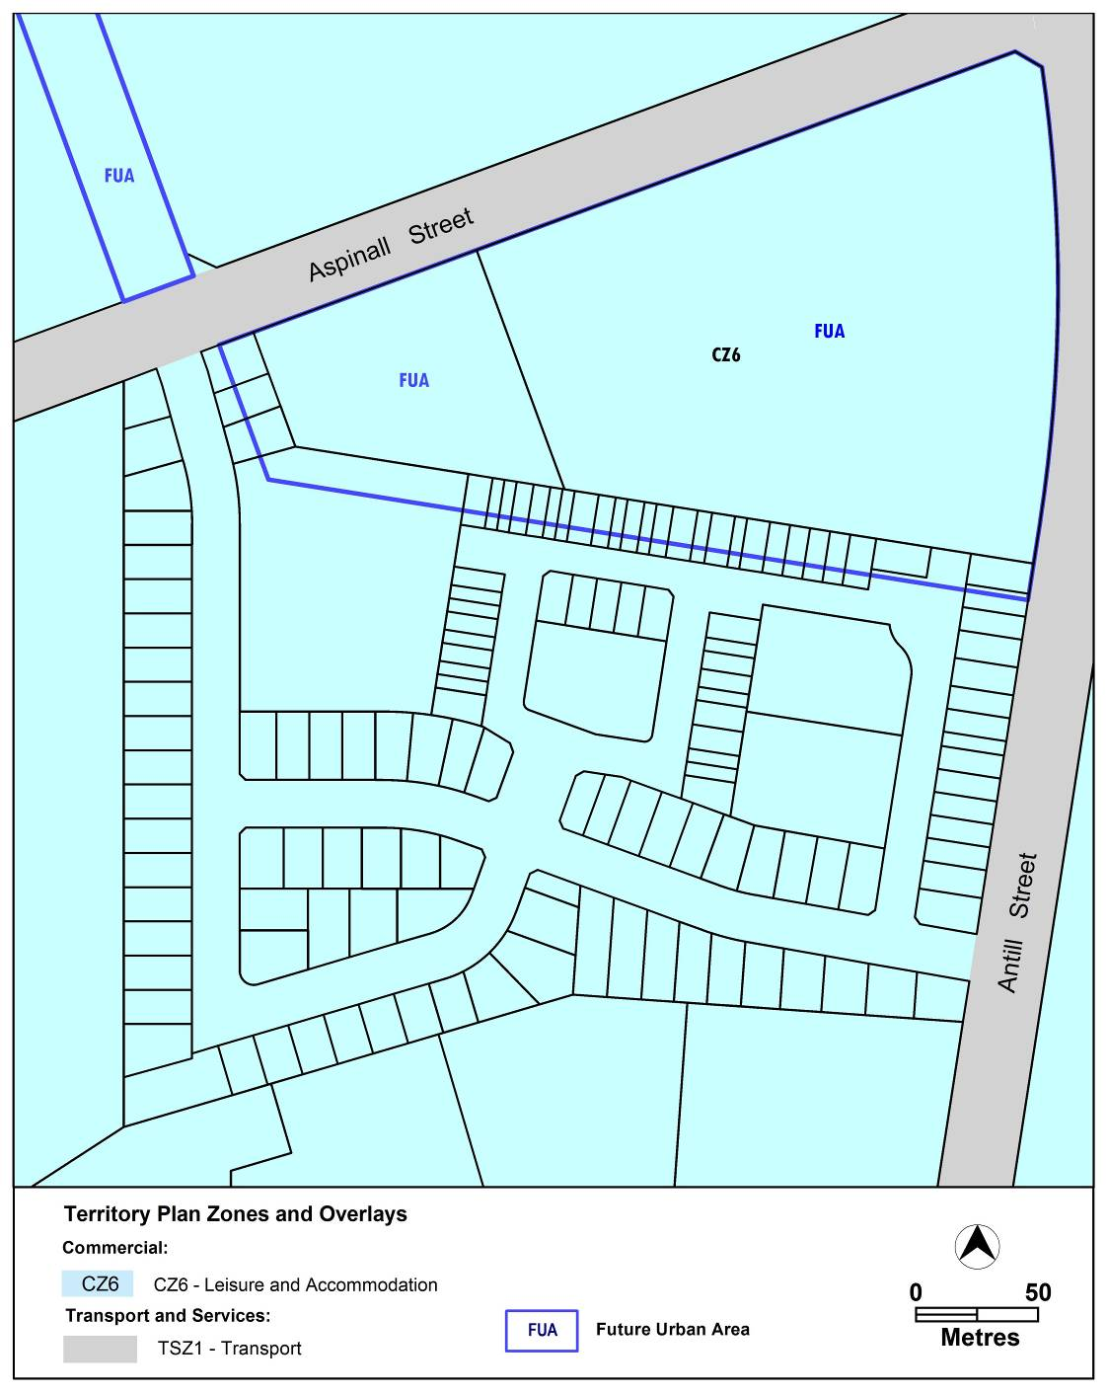Existing
Proposed
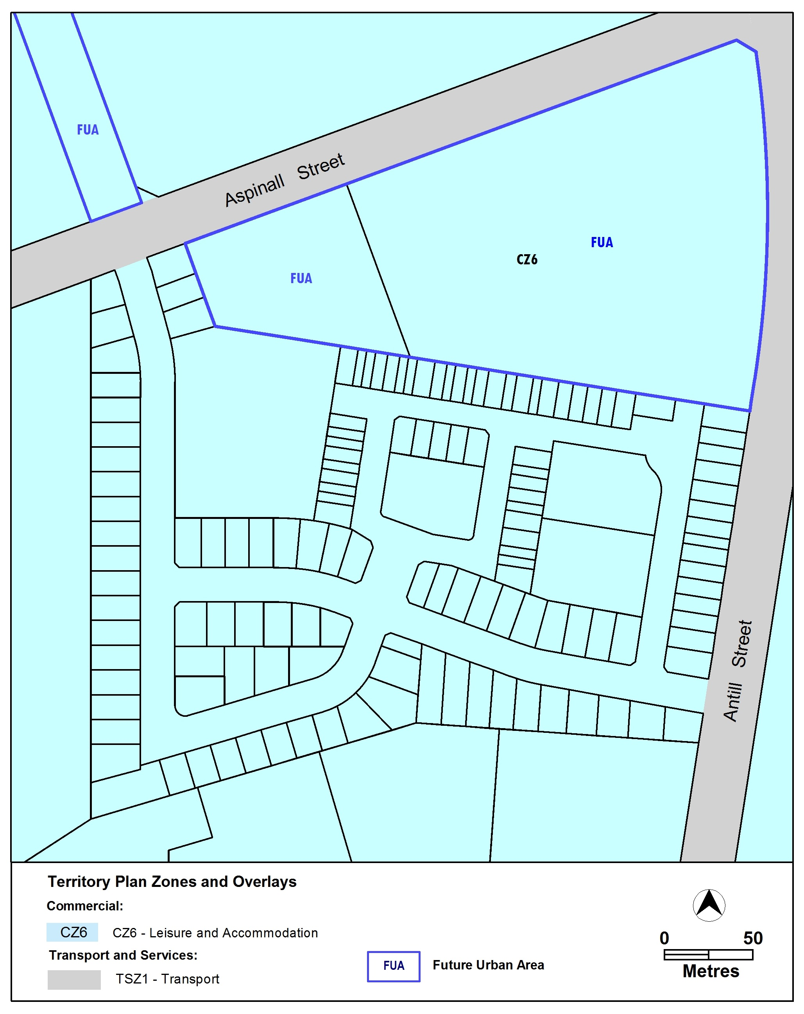

  - Watson Precinct Map and Code
Variation to the Precinct Map

The Watson Precinct Map is varied to incorporate rules and criteria and ongoing block specific provisions that are consistent with the approved estate development plan.

Existing Watson Precinct Map

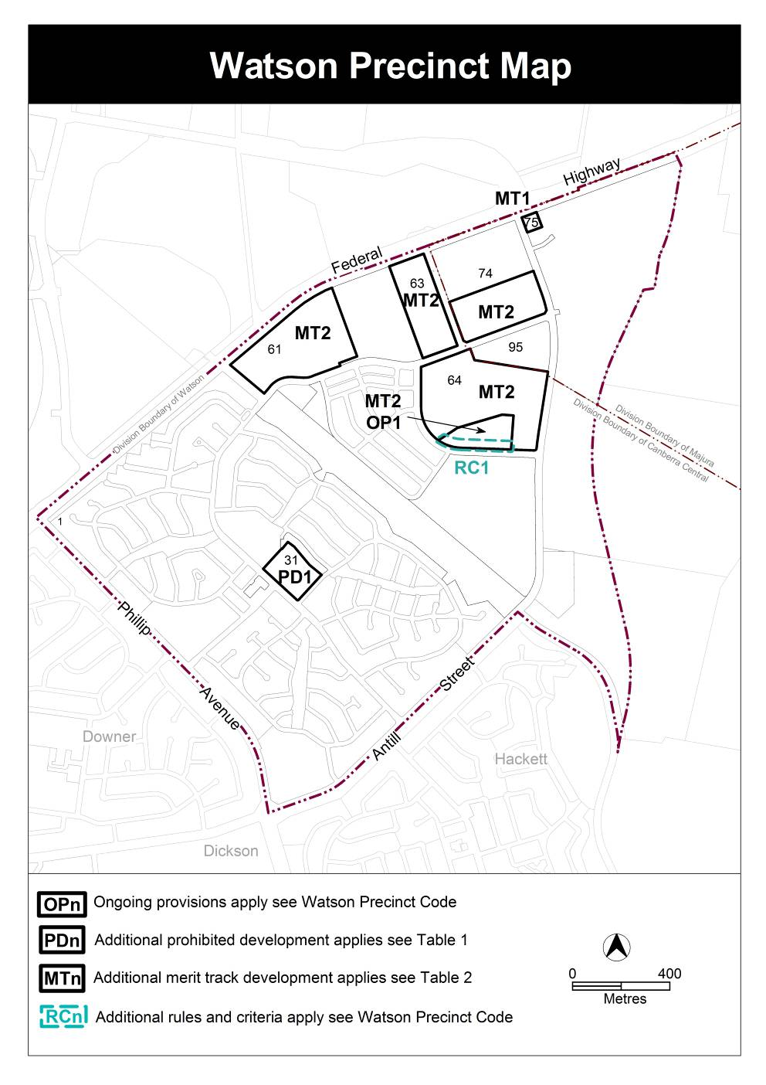

Proposed Watson Precinct Map

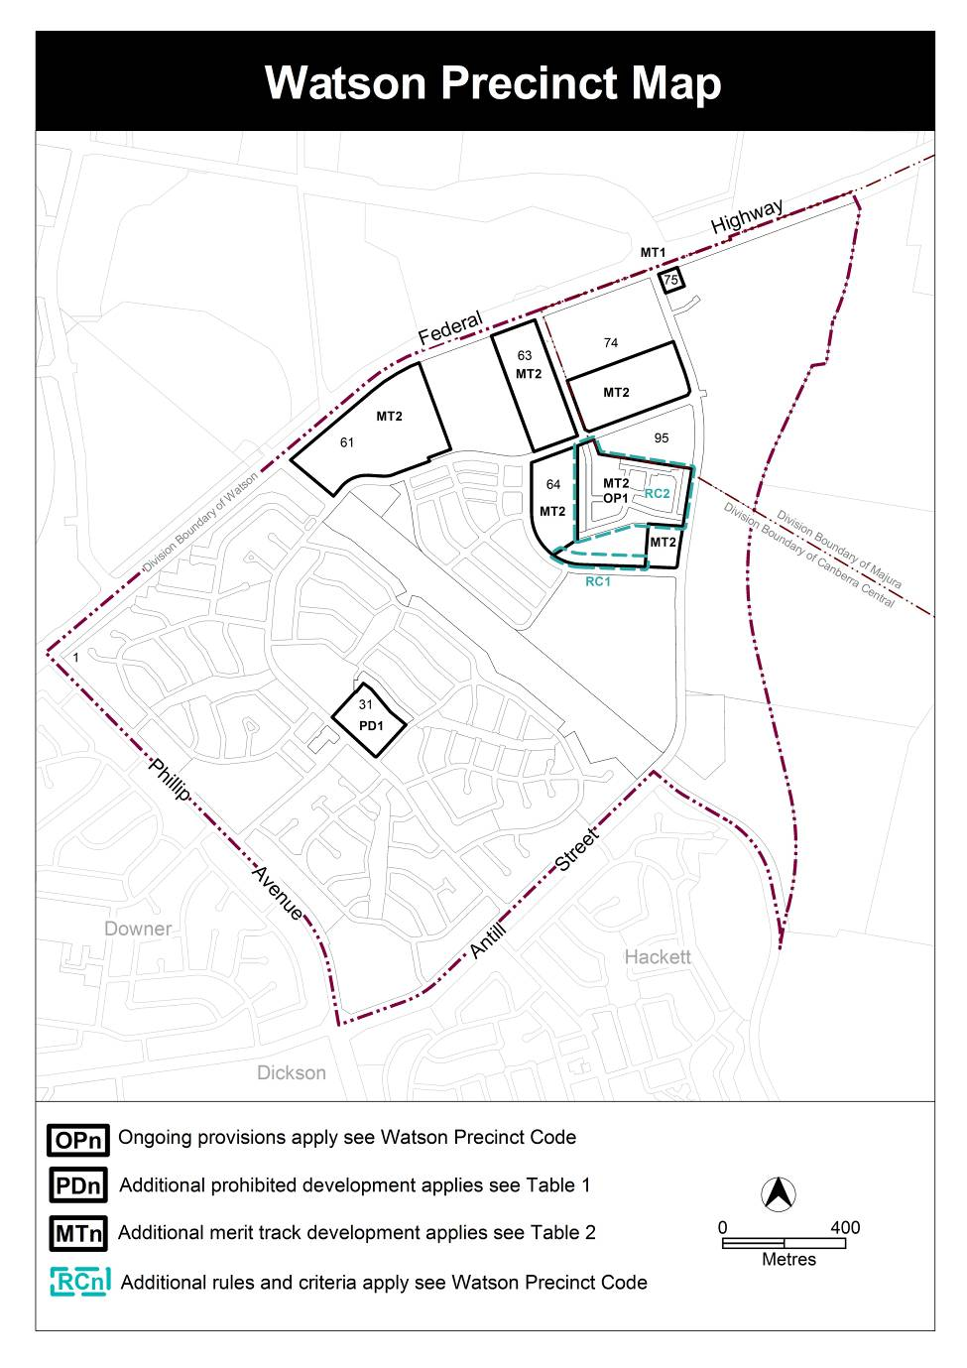

- TECHNICAL AMENDMENT
This section of the technical amendment document provides the actual instructions for implementing the changes to the Territory Plan.

  - Territory Plan Map
- Territory Plan Map

The Territory Plan map is varied as indicated below to identify the zone that applies to the land ceasing to be in a future urban area.

  - Watson Precinct Map and Code
- Watson Precinct Map

Substitute
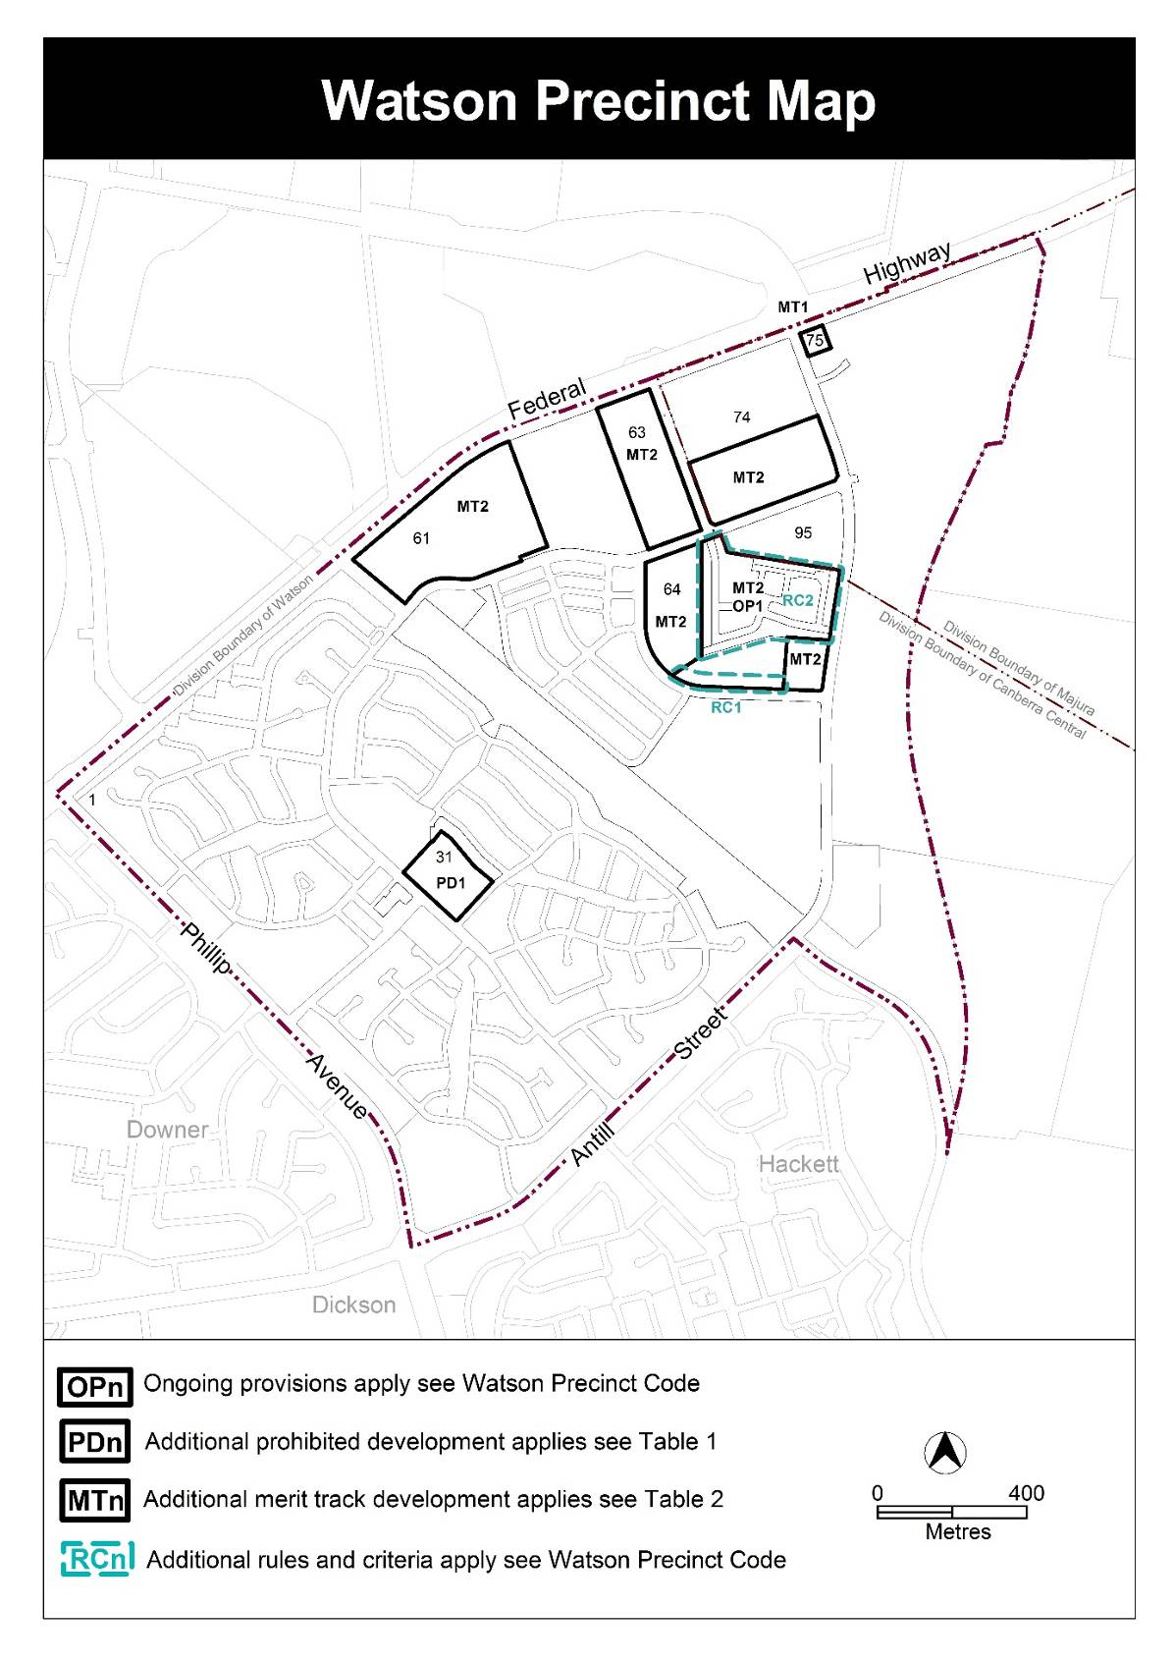

- Watson Precinct Code, Additional rules and criteria, RC1 - Residential

Insert after Table 1 Glazing requirements

RC2 – Residential
This part applies to blocks and parcels identified in area RC2 shown on the Watson Precinct Map.
- Element 1: Element 2: Building and Site Controls
Rules | Criteria
2.1 Applicable Development
R4  All single dwelling blocks are subject to the Single Dwelling Housing Development Code unless otherwise specified in this Code. | This is a mandatory requirement. There is no applicable criterion.
R5  All multi unit blocks are subject to the Multi Unit Housing Development Code unless otherwise specified in this Code. | This is a mandatory requirement. There is no applicable criterion.
R6  Principal private open space on all blocks to achieve a minimum dimension of 4 x 4 metres unless otherwise specified in this Code. | This is a mandatory requirement. There is no applicable criterion.
2.2 Setbacks
R7  This rule applies to blocks or parcels in locations identified in Figures 2 and 3.  Minimum boundary setback to all floors is nominated. | This is a mandatory requirement. There is no applicable criterion.
R8  This rule applies to blocks or parcels in locations identified in Figures 2 and 3.  Minimum boundary setback is only applicable to upper floor level as nominated. | This is a mandatory requirement. There is no applicable criterion.
R9  This rule applies to blocks or parcels in locations identified in Figures 2 and 3.  Upper floor can be built to the side boundary for a maximum length of 3 metres forward of the ground floor. | This is a mandatory requirement. There is no applicable criterion.
Rules | Criteria
R10  This rule applies to blocks or parcels in locations identified in Figures 2 and 3.  Minimum setback to garage/ carport is nominated. | This is a mandatory requirement. There is no applicable criterion.
2.3 Heights
R11  This rule applies to blocks or parcels in locations identified in Figure 4.  The maximum number of storeys is two. | This is a mandatory requirement. There is no applicable criterion.
2.4 Balcony
R12  This rule applies to blocks or parcels in locations identified in Figures 2 and 3.  Balcony must have screening to adjoining block that is 1.8 metres high. | This is a mandatory requirement. There is no applicable criterion.
2.5 Walls
R13  This rule applies to blocks or parcels in locations identified in Figures 2 and 3.  Maximum length of wall at nominated setback cannot exceed nominated length. | This is a mandatory requirement. There is no applicable criterion.
R14  This rule applies to blocks or parcels in locations identified in Figures 2 and 3.  Minimum length of wall at nominated setback is nominated. | This is a mandatory requirement. There is no applicable criterion.
2.6 Principal Private Open Space
R15  This rule applies to blocks or parcels in locations identified in Figure 4.  The minimum dimensions of principal private open space is 3 x 5.5 metres either at ground or upper floor level. | This is a mandatory requirement. There is no applicable criterion.
Rules | Criteria
2.7 Solar Building Envelope
R16  This rule applies to blocks or parcels in locations identified in Figure 4.  Nominated blocks are exempt from solar building envelope provisions in the Single Dwelling Housing Development Code. | This is a mandatory requirement. There is no applicable criterion.
2.8 Garage
R17  This rule applies to blocks or parcels in locations identified in Figure 4.  Garage opening can exceed 50% of building façade width on the block. | This is a mandatory requirement. There is no applicable criterion.
2.9 Parking
R18  This rule applies to blocks or parcels in locations identified in Figure 4.  One parking space only is required. | This is a mandatory requirement. There is no applicable criterion.
3.0 Fencing
R19  This rule applies to blocks or parcels in locations identified by ‘Antill Street fencing’ in Figure 5.  The minimum front setback for the entire length of the fence is 0m. The maximum height is 1.8m*.The maximum height for principal private open space screen is 1.8m*. The materials are to be a combination of masonry/ stonework with infill panels (see Table 2). The level of transparency is to be 25-50%. An access gate to street or open space is required.  * Where located above a retaining wall, fencing to be setback a minimum of 600mm from the boundary. The maximum combined height of wall and fence is 2.2.m from footpath level. Sufficient space between retaining wall and fence to provide planting. | This is a mandatory requirement. There is no applicable criterion.
Rules | Criteria
R20  This rule applies to blocks or parcels in locations identified by ‘front fencing’ in Figure 5.  The minimum front setback for the entire length of the fence is 600mm. The maximum height is 1.2m. The maximum height for principal private open space screen is 1.5m. The maximum height of side fencing to front of front building line is 1.5m. The materials are to be a combination of masonry/ stonework with infill panels (see Table 2). The level of transparency is to be 25- 50%. An access gate to street or open space is required. Planting is to be provided forward of the courtyard wall. | This is a mandatory requirement. There is no applicable criterion.
R21  This rule applies to blocks or parcels in locations identified by ‘corner block fencing’ in Figure 5.  The minimum front setback for 50% of the length of the fence is 0m and 50% is 600mm. The maximum height is 1.5m*. The maximum height for principal private open space screen is 1.5m*. The materials are to be a combination of masonry/ stonework with infill panels (see Table 2). The level of transparency is to be 25-50%. No fencing permitted within 6m of the corner of block as shown in Figure 6.  * Where located above a retaining wall, fencing to be setback a minimum of 600mm from the boundary. The maximum combined height of wall and fence is 2.2.m from footpath level. Sufficient space between retaining wall and fence to provide planting. | This is a mandatory requirement. There is no applicable criterion.
R22  This rule applies to blocks or parcels in locations identified by ‘open space fencing’ in Figure 5.  The minimum front setback for the entire length of the fence is 0m. The maximum height is 1.8m*. The maximum height for principal private open space screen is 1.8m*. The materials are to be a combination of masonry/ stonework with infill panels consistent with materials in Table 2. The level of transparency is to be 25-50%.  * Where located above a retaining wall, fencing to be setback a minimum of 600mm from the boundary. The maximum combined height of wall and fence is 2.2.m from footpath level. Sufficient space between retaining wall and fence to provide planting. | This is a mandatory requirement. There is no applicable criterion.
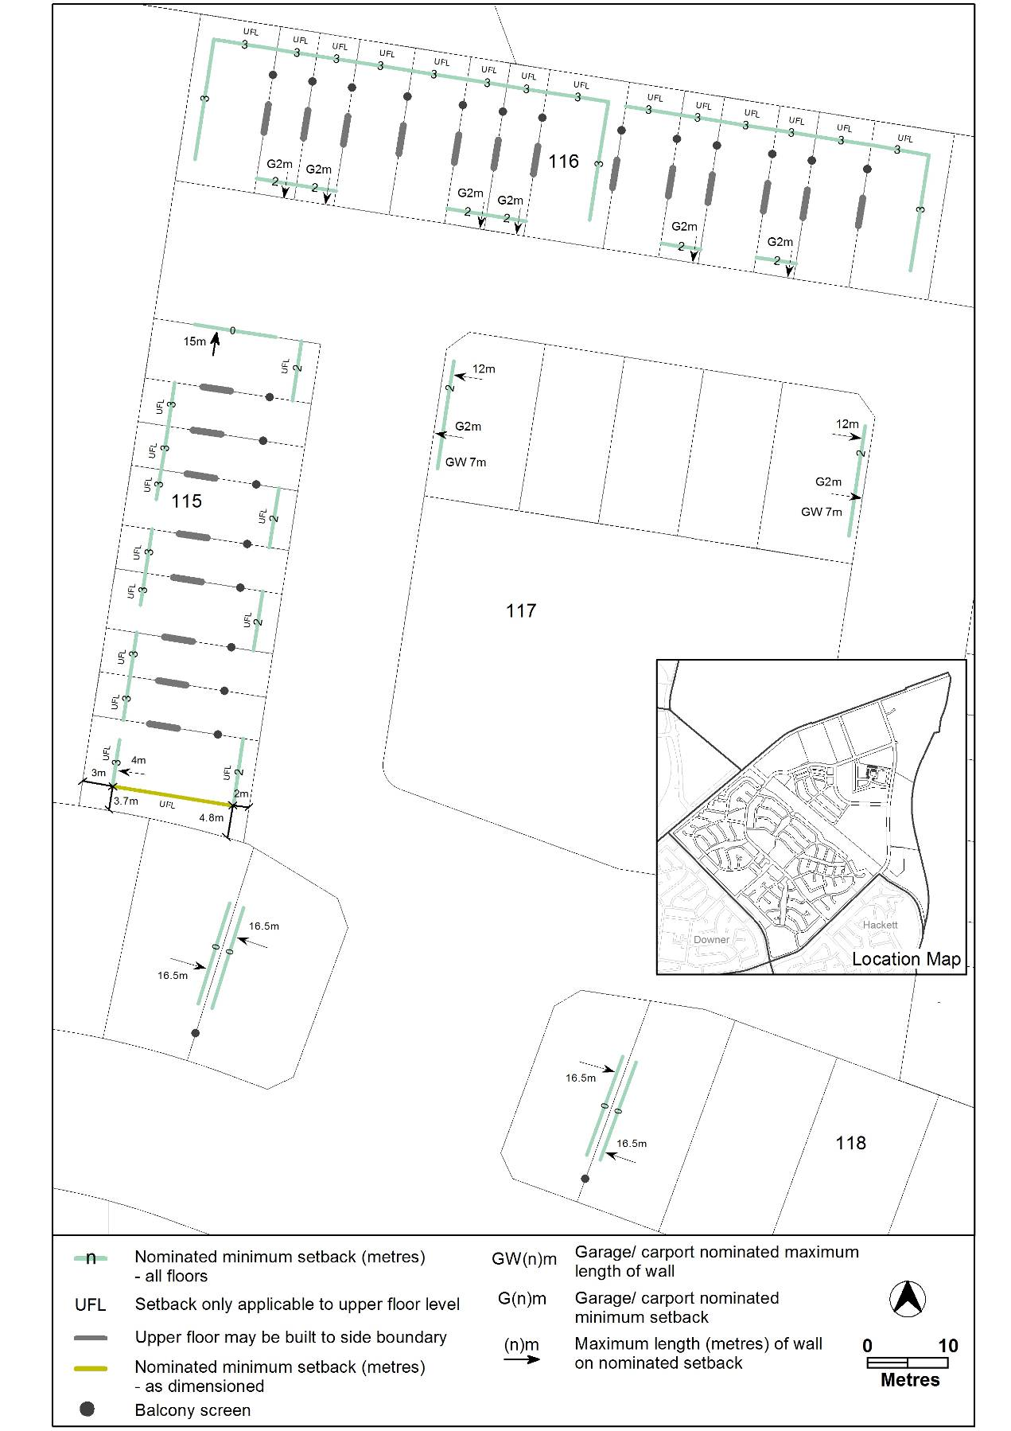

Figure 2 Watson residential area 1
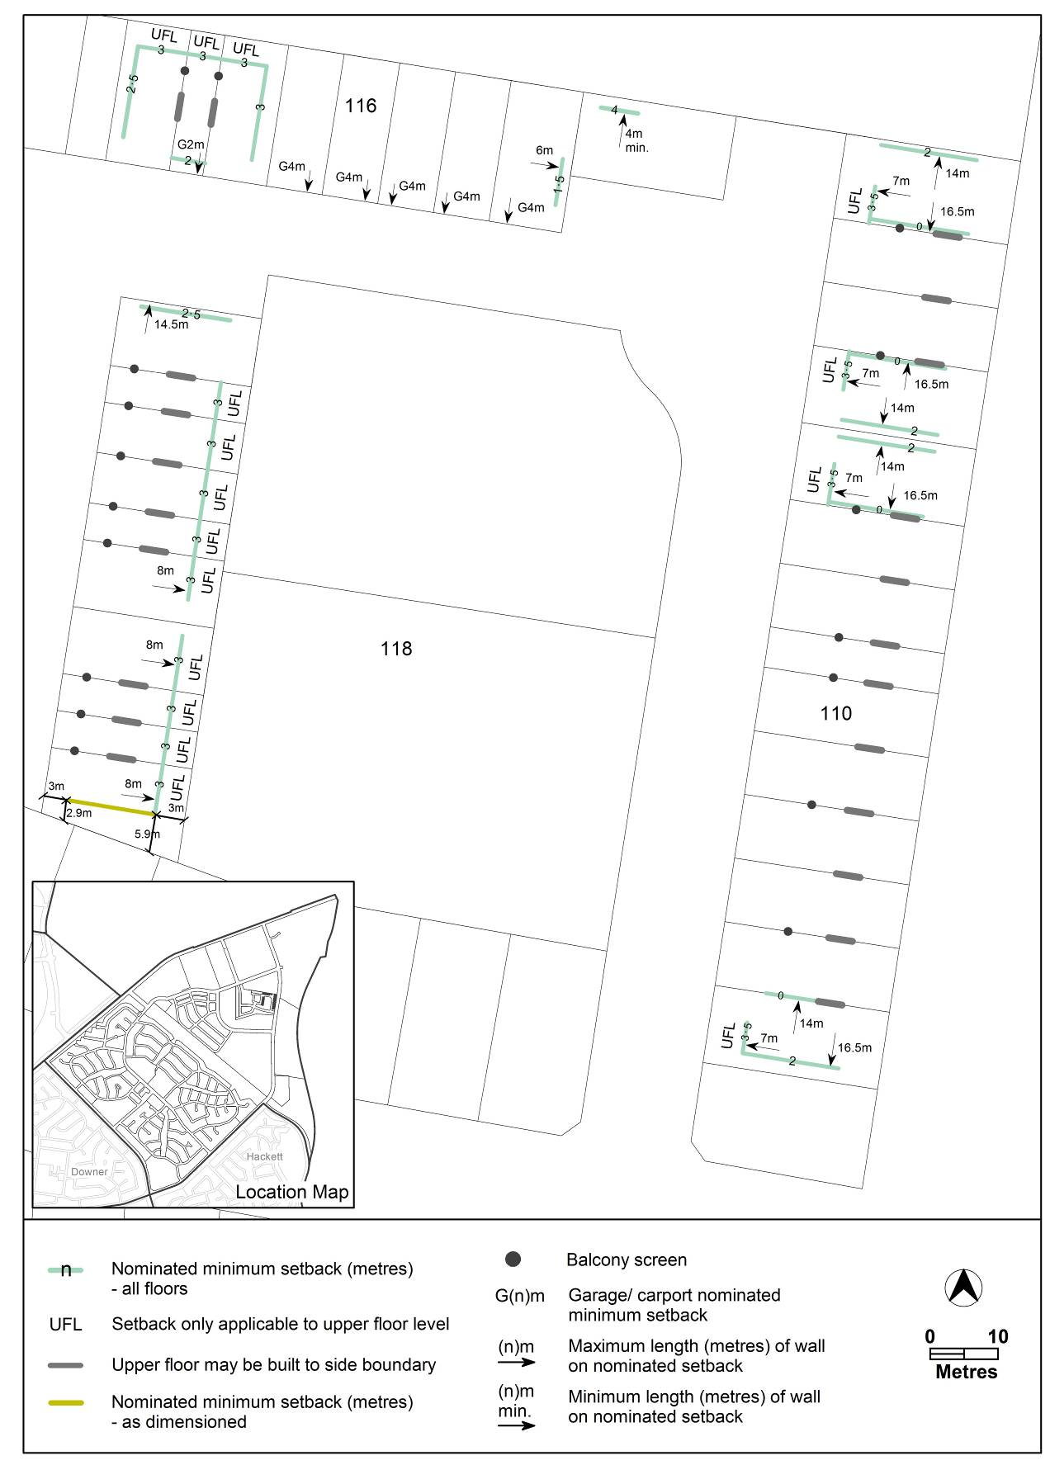
Figure 3 Watson residential area 2

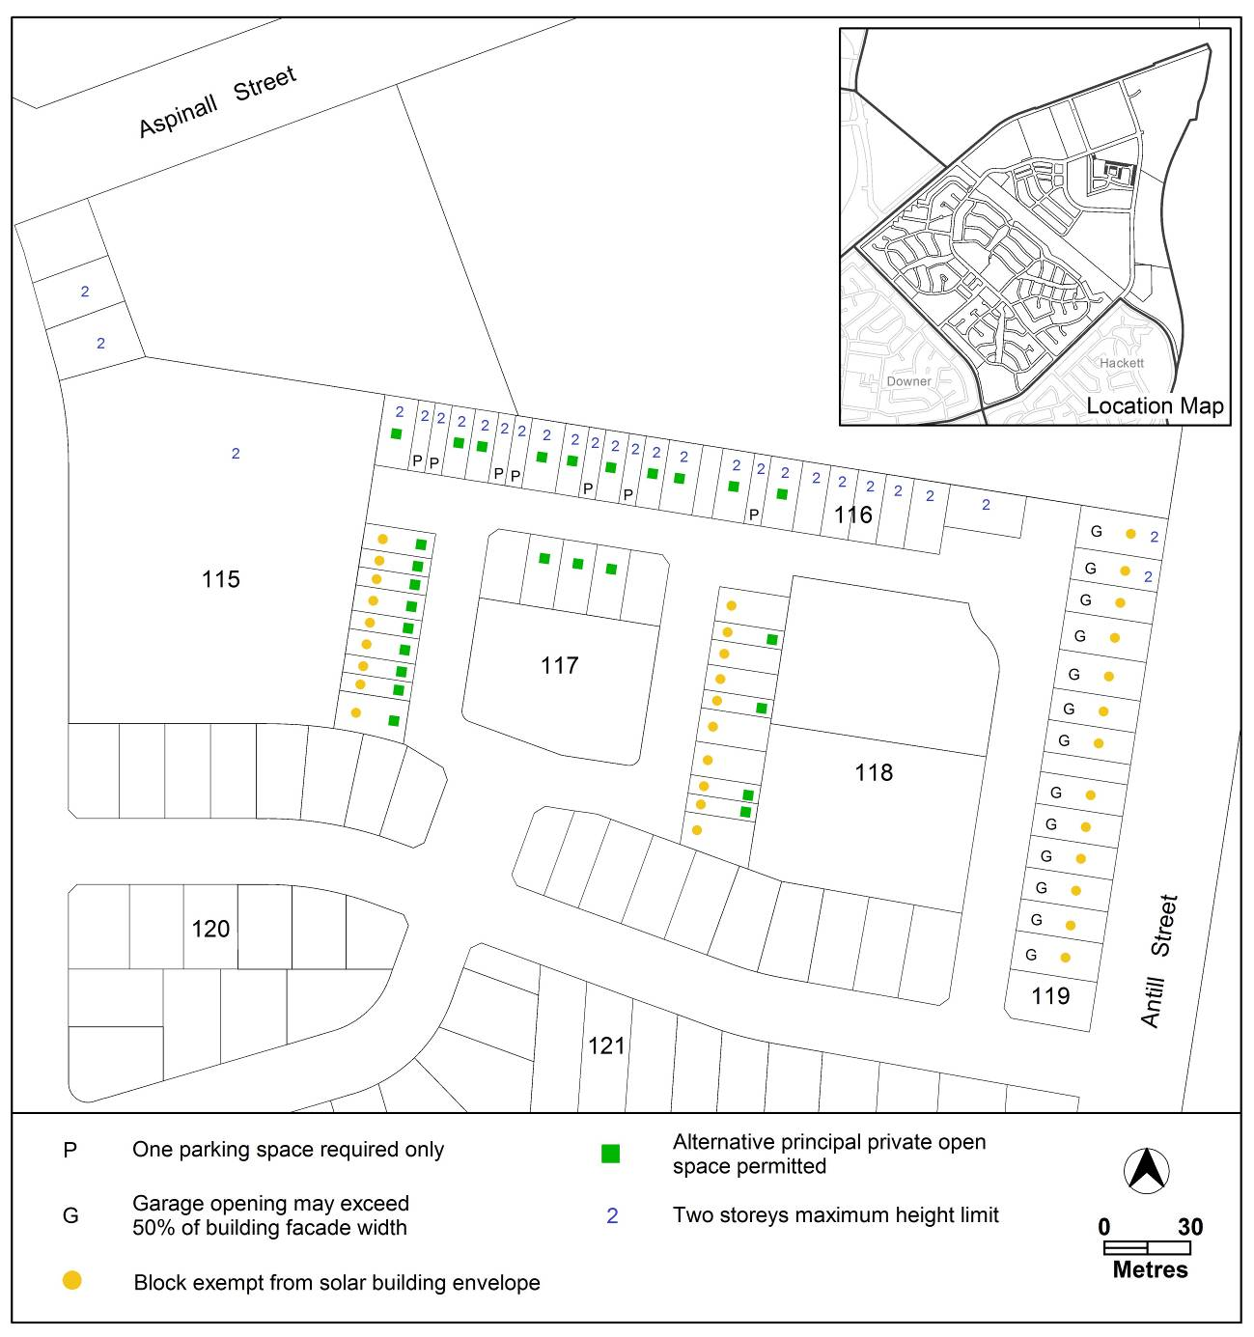

Figure 4 Watson residential area 3

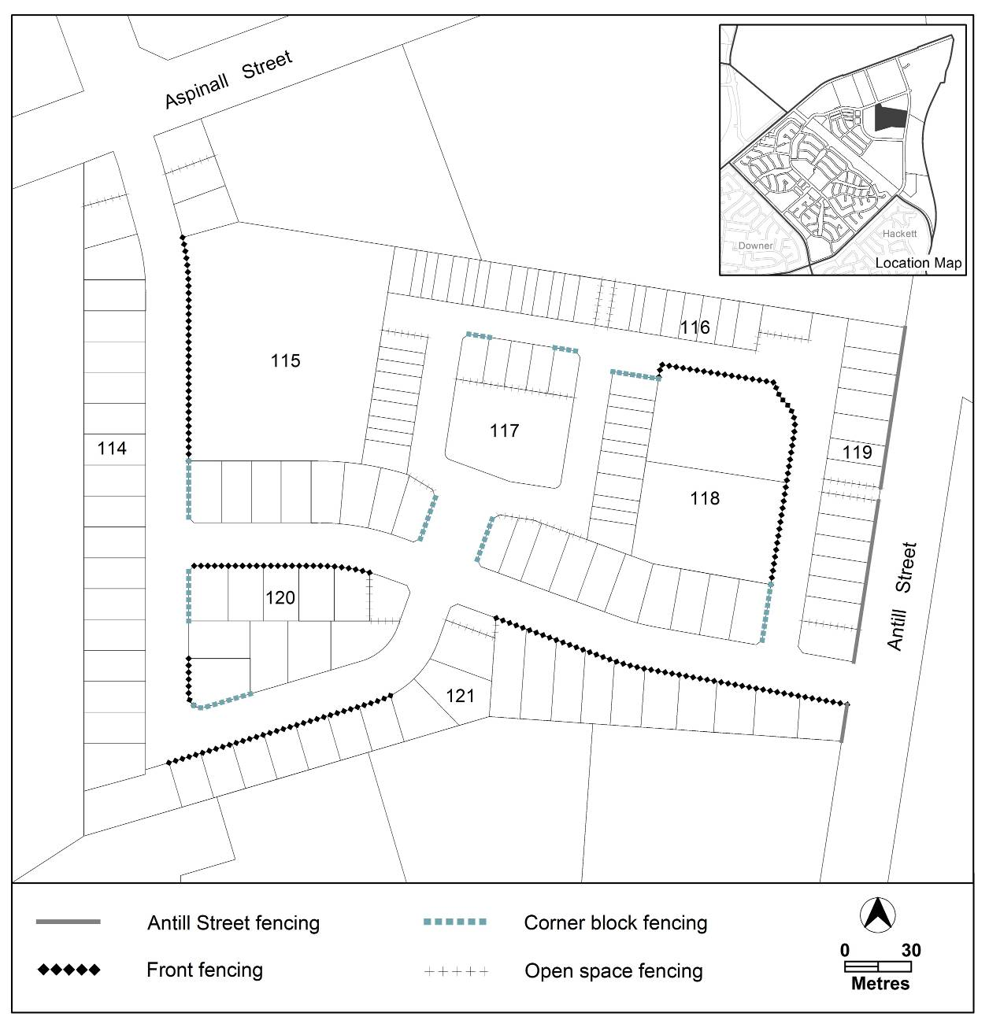

Figure 5 Watson residential area 4

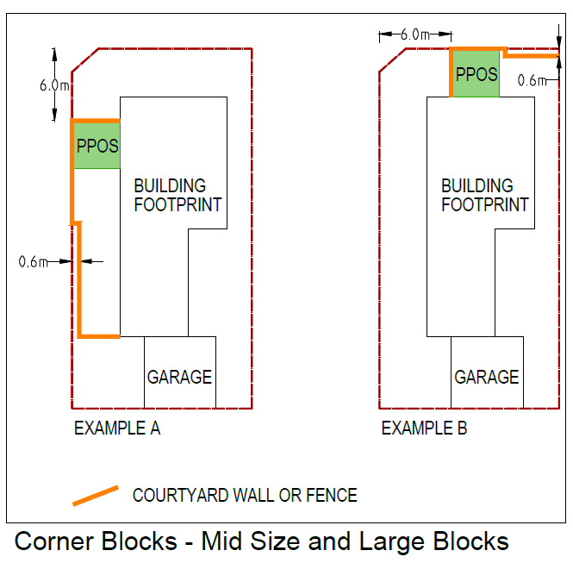

Figure 6 Corner blocks

COURTYARD WALLS AND FENCES  FORWARD OF THE BUILDING LINE TO  BE CONSTRUCTED OF: | MATERIALS NOT PERMITTED  FORWARD OF THE BUILDING  LINE
- masonry or stonework  - dressed hardwood timber  - powder coated aluminium slats  - cast iron railings | - paling fence  - chain mesh fencing  - colorbond fencing  - untreated timber slat fencing  - timber sleepers

Table 2 Fencing materials

- Other ongoing provisions, OP1 – Watson residential area

Substitute

OP1 – Watson residential area
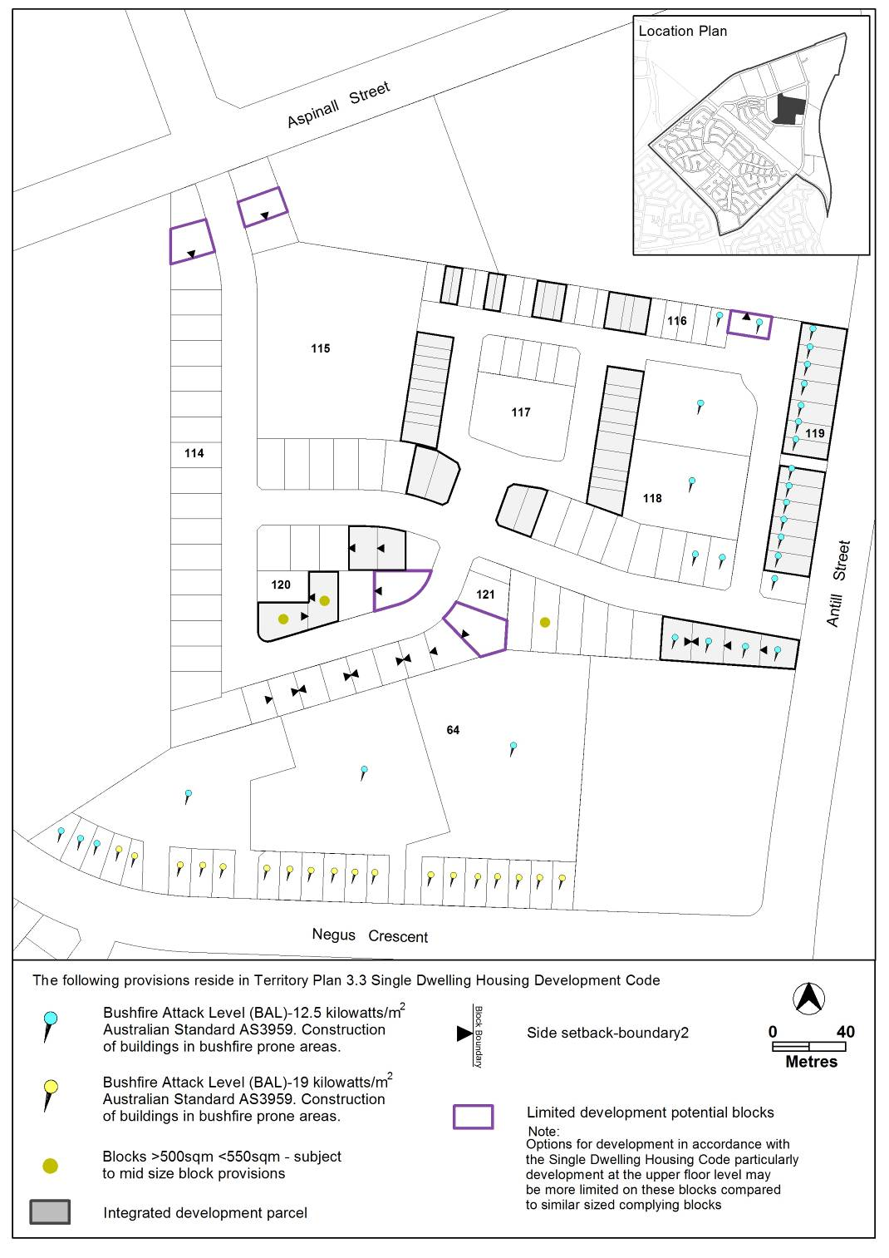This part applies to blocks and parcels identified in area OP1 shown on the Watson Precinct Map.
- site control
Figure 7 Watson residential area ongoing provisions

Interpretation service
