Australian Capital Territory
Planning and Development (Plan Variation No 356) Approval 2018

Notifiable Instrument NI2018-524
made under the
Planning and Development Act 2007, section 76 (Minister’s powers in relation to draft plan variations)

1 Name of instrument
This instrument is the Planning and Development (Plan Variation No 356) Approval 2018.
2 Approval of draft plan variation
(1) I approve under section 76(2)(a) of the Planning and Development Act 2007 the draft plan variation No 356 to the Territory Plan.
(2) In this section:
Draft plan variation No 356 to the Territory Plan means the draft plan variation in the schedule.

Mick Gentleman MLA
Minister for Planning and Land Management
18 September 2018

Planning and Development Act 2007

Variation to the
Territory Plan
No 356

Amendments to the West Belconnen Concept Plan for
Ginninderry Stage 1 Development

Final variation prepared under s76 of the
Planning and Development Act 2007

Contents

1. EXPLANATORY STATEMENT 1
1.1 Background 1
1.2 Summary of the Proposal 1
1.3 The National Capital Plan 2
1.4 Site Description 2
1.5 Current Territory Plan Provisions 4
1.6 Changes to the Territory Plan 5
1.7 Consultation on the Draft Variation 6
2. VARIATION 6
2.1 Variation to the Territory Plan 6

This page is intentionally blank.

- EXPLANATORY STATEMENT
  - Background
The variation amends the West Belconnen Concept Plan by making the provision of gas utility services to blocks in Stage 1 of Ginninderry Estate, West Belconnen, an optional rather than a mandatory requirement. V356 does not prohibit the installation of gas utility services in Stage 1 of Ginninderry Estate, West Belconnen.
Currently, the Estate Development Code contains a mandatory requirement for gas to be provided to each block in new estates and subdivisions. V356 overrides this mandatory requirement for Stage 1 of Ginninderry Estate.
Given the increasing supply and affordability of renewable energy sources, mandating the provision of gas is not considered to be consistent with the principles and policies of the West Belconnen Structure Plan.
The Structure Plan states that ‘subdivision design will facilitate energy efficient housing consistent with current best practice.’ Additionally, the Structure Plan allows for the concept plan to depart from the relevant development code in response to contemporary best practice for energy efficiency.
This variation supports a pilot project, where approximately 350 houses in Stage 1 are proposed to be developed on the basis that there will be no gas utility services provided for residential use. This pilot project will assess whether houses are able to work efficiently and cost effectively without gas and will be evaluated in terms of both customer experience and energy use. The ACT is the only jurisdiction in Australia that has a mandatory requirement for gas infrastructure to be provided in new estates and subdivisions.
The mandatory utility service provisions of water, sewer, stormwater, electricity, and telecommunications to each block will be retained.

  - Summary of the Proposal
Variation 356 varies the West Belconnen Concept Plan by making the provision of gas utility services to blocks in Stage 1 of Ginninderry Estate, West Belconnen, an optional rather than a mandatory requirement.
V356 introduces a new rule into the West Belconnen Concept Plan to override the mandatory requirement in the Estate Development Code to provide a gas connection service to blocks in Stage 1 of Ginninderry Estate, West Belconnen.
V356 does not prohibit gas utility services in Stage 1 Ginninderry Estate, West Belconnen.
  - The National Capital Plan
The Australian Capital Territory (Planning and Land Management) Act 1988 established the National Capital Authority (NCA) with two of its functions being to prepare and administer a National Capital Plan (NCP) and to keep the NCP under constant review and to propose amendments to it when necessary.
The NCP, which was published in the Commonwealth Gazette on 21 January 1990 is required to ensure that Canberra and the Territory are planned and developed in accordance with their national significance. The Planning and Land Management Act 1988 also required that the Territory Plan is not inconsistent with the NCP.
In accordance with section 10 of the Australian Capital Territory (Planning and Land Management) Act 1988, the National Capital Plan defines the planning principles and policies for Canberra and the Territory, for giving effect to the object of the NCP and sets out the general policies to be implemented throughout the Territory, including the range and nature of permitted land uses.
It also sets out the detailed conditions of planning, design and development for areas that have special significance to the National Capital known as designated areas and identifies special requirements for the development of some other areas.

  - Site Description
The subject site is Stage 1 of Ginninderry Estate in West Belconnen. It is located immediately west of the existing suburbs of Holt and Macgregor, east of the Murrumbidgee River and south of the NSW state border.

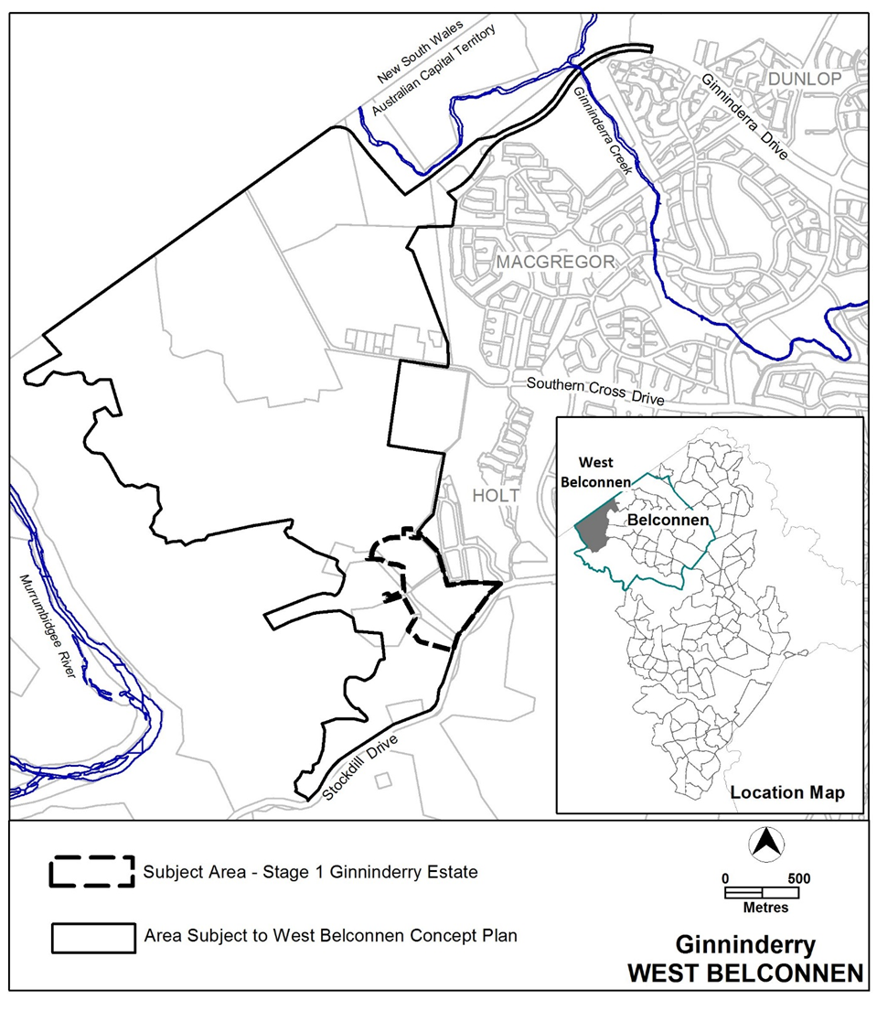
Figure 1 Location of Stage 1 Ginninderry Estate, West Belconnen
  - Current Territory Plan Provisions
Under the Territory Plan, all estate planning and subdivision of land in the ACT must comply with any relevant development code, concept plan or precinct code.
The requirement for the supply of utility services in Ginninderry Estate is currently subject to the provisions in the Estate Development Code. Under Rule 43 of the Estate Development Code, it is mandatory for gas to be provided to each block in new suburbs.
V356 varies the *West Belconnen Concept Plan to override the mandatory requirement in the Estate Development Code for gas to be supplied to each block, for Stage 1 of Ginninderry Estate.
Under the Planning and Development Act 2007, where more than one type of code applies to a development and there is inconsistency between provisions, the provisions in the concept plan take precedence over those in the Estate Development Code.
*Note: A concept plan is deemed to be precinct code under the Planning and Development Act 2007

  - Changes to the Territory Plan
Detailed changes to the Territory Plan are noted in section 2 of this document.

  - Consultation on the Draft Variation
Draft Variation No 356 (DV356) was released for public comment between Friday 4 May 2018 and Friday 22 June 2018. A consultation notice under section 63 of the Planning and Development Act 2007 (P&D Act) was published on the ACT Legislation Register on Friday 4 May 2018.
One written submission was received, from an individual member of the public. Main issues raised by the submitter included:
• Support of DV356
• suggested further amendments should be considered to remove the default provision which mandates gas in the Territory
The above issue was considered and is detailed in a report on consultation. No changes were made as a result of consultation. The outcomes of consultation were considered by the Minister responsible for planning prior to approval of this variation.

  - Revisions to the Draft Variation Recommended to the Minister
No changes were made to the draft variation recommended to the Minister.

- VARIATION
  - Variation to the Territory Plan
The Territory Plan is varied in all of the following ways:

Variation to the West Belconnen Concept Plan
- Part B Subdivision

Insert

16A. Utility Services

R33A  Utility services, including water, sewer,  stormwater, electricity, gas and  telecommunications are provided to each block.  For Stage 1 Ginninderry Estate, the provision of gas to each block is not a mandatory requirement.  Note: A condition of development approval may be imposed to ensure compliance with this rule. | C33A  This is a mandatory requirement. There are no applicable criterion

Interpretation service
