Australian Capital Territory
Heritage (Decision about Provisional Registration of the Natural Temperate Grassland (Endangered Ecological Community) Barton Grassland) Notice 2018
Notifiable Instrument NI2018–528
made under the
Heritage Act 2004, s32 (Decision about provisional registration) and s34 (Notice of decision about provisional registration)

1 Name of instrument
This instrument is the Heritage (Decision about Provisional Registration of the Natural Temperate Grassland (Endangered Ecological Community) Barton Grassland) Notice 2018.
2 Decision about provisional registration
On 20 September 2018, the ACT Heritage Council (the Heritage Council) decided not to provisionally register the Natural Temperate Grassland (Endangered Ecological Community) Barton Grassland (the Place).
3 Description of the Place
The description of the Place is in the schedule.
4 Reason for the decision
The Heritage Council decided not to provisionally register the Place because registration of the place is prohibited under s 42A of the Heritage Act 2004, as the Place only has natural heritage significance of a kind that is protected under the Nature Conservation Act 2014. A detailed statement of reasons is provided in the schedule.
5 Date decision takes effect
The decision not to provisionally register the Place takes effect on 21 September 2018 (being the day after the Heritage Council made its decision in writing as set out in the schedule).

Jennifer O’Connell (as delegate for)
ACT Heritage Council
20 September 2018
Schedule
(See sections 3 and 4)
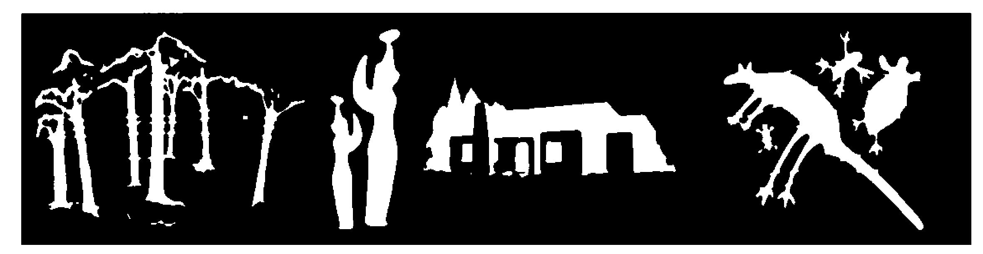
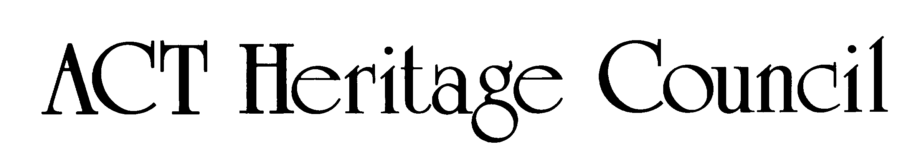

STATEMENT OF REASONS
DECISION NOT TO PROVISIONALLY REGISTER
Natural Temperate Grassland (Endangered Ecological Community) Barton Grassland
IN THE ACT HERITAGE REGISTER
Blocks 3 and 15 Section 22, Blocks 11 and 32 Section 5 Barton
Description
The Natural Temperate Grassland (Endangered Ecological Community) Barton Grassland nomination contains remnant natural temperate grasslands which are an endangered ecological community in the ACT and nationally and is also a habitat for the threatened Golden Sun Moth (Synemon plana).
Reasons for Decision
The Council considered the nomination at its meeting of 20 September 2018 and decided that the Natural Temperate Grassland (Endangered Ecological Community) Barton Grassland is not able to be registered under the Heritage Act 2004 because registration of places or objects under this Act is prohibited if they have only natural heritage significance of a kind that is protected by the Nature Conservation Act 2014. The details of this are:
- the place includes the habitat of a threatened ecological community and a threatened native species, i.e. it is habitat for natural temperate grasslands and Golden Sun Moth (Synemon plana), which means that the place has protection under the Nature Conservation Act 2014 and section 42A of the Heritage Act 2004 applies and therefore limits the ability of the place to be added to the Heritage Register; and
- with section 42A applying to the place, the Council may only register it if it also has cultural heritage significance (as defined under section 10B of the Heritage Act 2004), or, if it is a part of the habitat of a threatened native species or ecological community but not threatened itself, is of a kind of natural heritage significance that is not protected under the Nature Conservation Act 2014 and:
  - the Council considers that any cultural heritage significance is already captured by existing registrations or nominations and that the nomination under assessment does not include any other cultural heritage significance; and
  - the nomination is for a kind of natural heritage significance that will be protected under the Nature Conservation Act 2014 as a part of the protected habitat of a threatened native species or ecological community.
This decision respects the protection and management of the natural heritage of the place under the Nature Conservation Act 2014, which is integrated into the land planning and development system, and as such is consistent with the functions of the Council under section 18(c) of the Heritage Act 2004 to work within the land planning and development system to achieve appropriate conservation of the ACT’s natural and cultural heritage places and objects. This includes protection for Aboriginal places and objects, as well as addressing the function in section 18(e) of the Heritage Act 2004 to encourage and assist in appropriate management of heritage places and objects. As detailed in section 42A, many places of natural heritage significance are appropriately protected by the Nature Conservation Act 2014 and further protection measures under the Heritage Act 2004 are not appropriate.
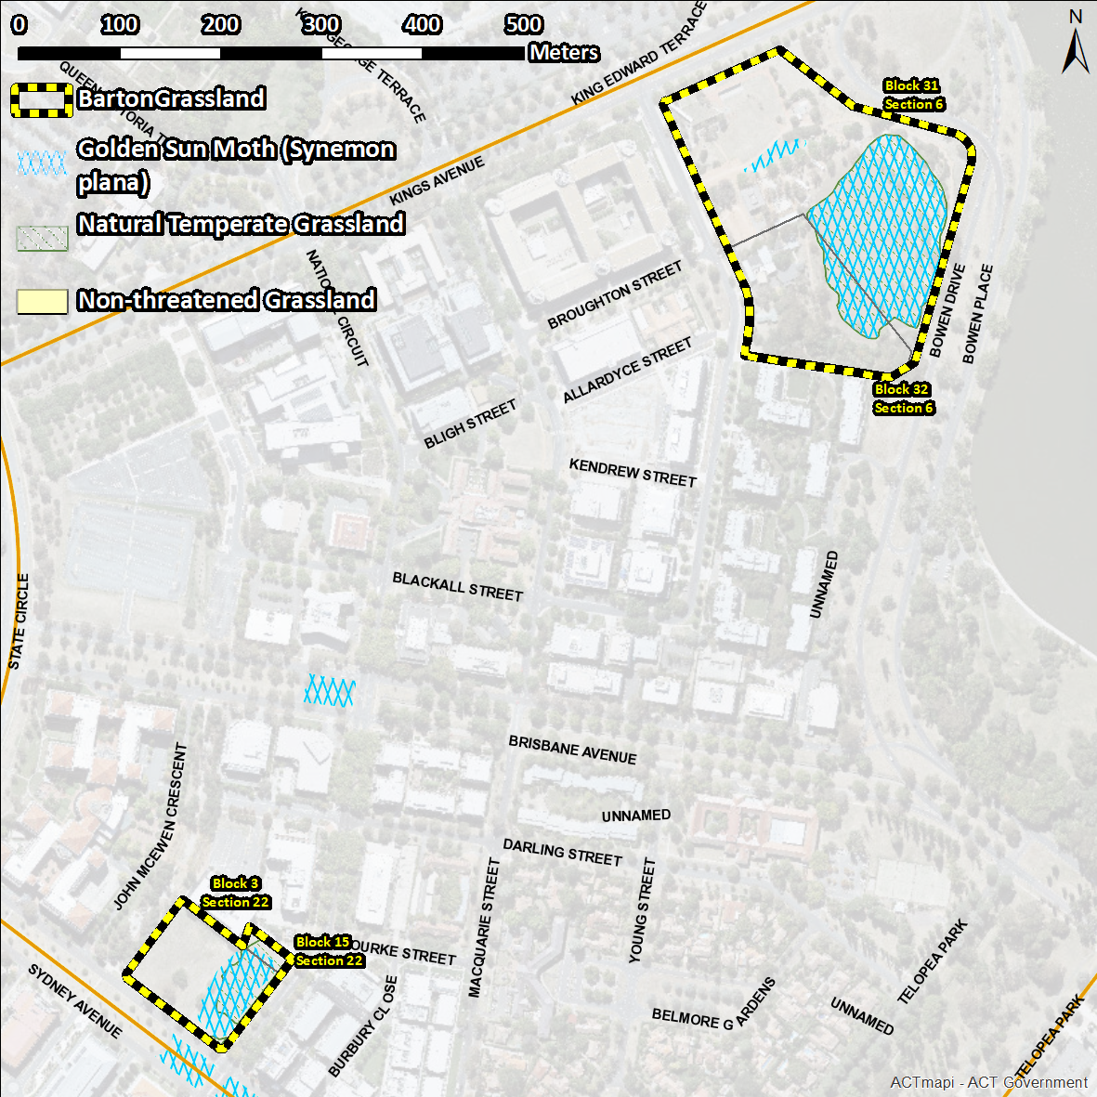
Figure 1 Natural Nomination location (boundary encompasses entire blocks that contain the habitat)

