Australian Capital Territory
Heritage (Decision about Registration of 11 Northcote Crescent, Deakin) Notice 2018
Notifiable instrument NI2018—636
made under the
Heritage Act 2004, s40 (Decision about registration)

1 Name of instrument
This instrument is the Heritage (Decision about Registration of 11 Northcote Crescent, Deakin) Notice 2018.
2 Decision about registration
On 15 November 2018, the ACT Heritage Council (the Heritage Council) decided to register 11 Northcote Crescent, Deakin (the Place).
3 Registration details of the Place
The registration details of the Place are in the schedule.
4 Reasons for the decision
The Heritage Council is satisfied on reasonable grounds that the Place has heritage significance as it meets one or more of the heritage significance criteria in section 10 of the Heritage Act 2004. A detailed statement of reasons including an assessment against the heritage significance criteria is provided in the schedule.
5 Date registration takes effect
The registration of the Place takes effect on the day after this notice is notified.
6 Revocation
The Heritage (Decision about Provisional Registration of 11 Northcote Crescent, Deakin) Notice 2018 (NI2018—177) is revoked.
Fiona Moore
Secretary (as delegate for)
ACT Heritage Council
15 November 2018

Schedule
See sections 3 and 4

AUSTRALIAN CAPITAL TERRITORY
HERITAGE REGISTER
(Registration)

For the purposes of s. 40 of the Heritage Act 2004, an entry to the heritage register has been prepared by the
ACT Heritage Council for the following place:

11 Northcote Crescent, Deakin

Block 8 Section 9, Deakin
DATE OF REGISTRATION
15 November 2018 Notifiable Instrument: 2018–

Copies of the Register Entry are available for inspection at ACT Heritage. For further information please contact:

The Secretary

ACT Heritage Council

GPO Box 158

CANBERRA ACT 2601

Telephone 13 22 81

This statement refers to the location of the place as required in s. 12 (b) of the Heritage Act 2004.
LOCATION OF THE PLACE

11 Northcote Crescent, Deakin Block 8 Section 9, Deakin

This statement refers to the description of 11 Northcote Crescent, Deakin as required in s.12(c) of the Heritage Act 2004. The attributes described in this section form part of the heritage significance of the place. For the purposes of s. 12(c) of the Heritage Act 2004, the boundary of the place is at Image 1.
DESCRIPTION OF THE PLACE

11 Northcote Crescent, Deakin, is a detached house which consists of the following attributes:
- The major architectural elements that are particular to the Post-War International Style (1940-1960) and that are displayed by this building relate to the external forms. They are:
  - Cubiform overall shape (including the roof form and the balconies, terraces and the roofed entrance staircase within the form) and;
  - Large sheets of glass.
- Other architectural elements of this style displayed by the building that relate to the external forms are:
  - Overhanging for shade (i.e. wide, overhanging eaves);
  - Plain smooth wall surfaces;
  - Corbusian window motif and;
  - Contrasting textures (notably the use of natural stone).

This statement refers to the heritage significance of place as required in s.12(d) of the Heritage Act 2004.
STATEMENT OF HERITAGE SIGNIFICANCE

11 Northcote Crescent Deakin was designed by one of Australia’s leading architects of the modern movement, Harry Seidler, in 1951-2. It demonstrates his adoption of Bauhaus design principles and is one of the most significant examples of the early Post-War International Style (1940-60) in a detached residential building in the ACT. Seidler cites this house as an outstanding example of Bauhaus that typifies his early work in the ACT.
CONSERVATION OBJECTIVE

The guiding conservation objective is that 11 Northcote Crescent, Deakin shall be conserved and appropriately managed in a manner respecting its heritage significance.

The ACT Heritage Council may adopt heritage guidelines applicable to the place under s25 of the Heritage Act 2004.

For further information on guidelines applicable to the place, or for advice on proposed works or development, please contact ACT Heritage on 13 22 81.

REASON FOR REGISTRATION

The Council has assessed 11 Northcote Crescent, Deakin, against the heritage significance criteria and is satisfied that the place has heritage significance when assessed against criterion (d) under s.10 of the Heritage Act 2004.
ASSESSMENT AGAINST THE HERITAGE SIGNIFICANCE CRITERIA

The Council’s assessment against the criteria specified in s.10 of the Heritage Act 2004 is as follows.

In assessing the heritage significance of 11 Northcote Crescent, Deakin, the Council considered:
- the original nomination and documentary evidence supplied by the nominator;
- the Council’s Heritage Assessment Policy (March 2018);
- information provided by a site inspection on 2 February 2018 by ACT Heritage;
- the report by ACT Heritage titled, Background Information 11 Northcote Crescent, Deakin, November 2018, containing photographs and information on history, description, condition and integrity; and
- Comments received during the public consultation period under s.37 of the Act:
  - One submission was received during the public consultation period that supported registration; and
  - Under s.37(4)(b) of the Act, the Council considered one submission that was received after the public consultation period that did not support registration based on an extensive summary of alterations to the property undertaken since original construction. In order for the Council to thoroughly assess these claims, the Minister issued a direction for the Council to further consider these issues and extended the provisional registration period for three months. In assessing the list of alterations, the Council determined that they did not diminish the heritage significance of the place as the original fabric related to the description of the place under s.12(c) is still clearly expressed and that most of the alterations refer to internal changes that do not form part of the significance of the place as noted in the description of the place under s.12(c) or in the Council’s assessment against the heritage significance criteria under s.10.

Pursuant to s.10 of the Heritage Act 2004, a place or object has heritage significance if it satisfies one or more of the following criteria. Future research may alter the findings of this assessment.
importance to the course or pattern of the ACT’s cultural or natural history;
The Council has assessed 11 Northcote Crescent, Deakin against criterion (a) and is satisfied that the place does not meet this criterion.
The Post-War International Style (1940-1960), of which 11 Northcote is a good example, did have some influence on the course of the cultural history of the ACT. Buildings of this style occupied considerable public and commercial space in mid-century Canberra, including notable public housing complexes (Northbourne Housing Precinct, Bega and Allawah flats), and prominent commercial buildings in the central business district, such as the MLC Building and ANZ Bank Building.

11 Northcote Crescent, Deakin belongs to one of a small group of detached residential properties in the ACT in the early 1950s where private owners commissioned an architect designed house, reflecting the beginning of a shift away from mainly government designed and built housing.

However, nearly every building in the ACT could be said to fit into a story of a particular design or planning context, or historical trend, but this does not mean that every place meets the threshold required by the criteria. An entry on the Heritage Register is valid to the extent that it establishes a level of significance that is strong and special that is therefore above the ordinary, and
11 Northcote Crescent, whilst representative of a style that was important in the ACT, does not show a clear connection to this building’s importance to the progression of the ACT’s cultural history.
has uncommon, rare or endangered aspects of the ACT’s cultural or natural history;
The Council has assessed 11 Northcote Crescent, Deakin against criterion (b) and is satisfied that the place does not meet this criterion.
11 Northcote Crescent, Deakin is as an excellent example of Seidler’s early work in the ACT. It is the first and one of the most significant examples of the early Post-War International Style in a detached residential building in the ACT (see criterion (d)). It is the only remaining example of Seidler’s detached residential housing in the ACT. The fact that this building survives, however, is not in itself enough to meet the high standard of this criterion with regard to this building’s connection to the ACT’s cultural history.
As a notable example of a highly intact Modernist home, 11 Northcote Crescent, Deakin effectively demonstrates the main characteristics of its kind. In the broader context of Post-War International Style (1940-60), however, 11 Northcote Crescent, Deakin is not considered to be uncommon or rare. Examples of Post-War International Style buildings on the ACT Heritage register include:
- 10 Gawler Crescent ‘Benjamin House’ (Deakin, 1956)
- MLC Building (City, 1957-61)
- Northbourne Housing Precinct Representative Sample (Dickson, 1959)
- ANZ Bank Building (City, 1961-63)
- Campbell Group Housing (Campbell, 1964)
- Birch House (Yarralumla, 1967)
- 4 Cobby Street (Campbell, 1969-70)
The places listed above have been nominated or identified by the Council as good or excellent examples of the styles, are still occupied, and/or in good condition. As such, the Council does not consider buildings of Post-War International Style (1940-60) to be endangered aspects of the ACT’s cultural history.
potential to yield important information that will contribute to an understanding of the ACT’s cultural or natural history;
The Council has assessed 11 Northcote Crescent, Deakin against criterion (c) and is satisfied that the place does not meet this criterion.
There is insufficient evidence before the Council to demonstrate that 11 Northcote Crescent, Deakin has the potential to yield important information that will contribute to a wider understanding of the ACT’s cultural history. The Council does not anticipate a reasonable likelihood that the place contains substantial physical evidence pertaining to a defined, significant research interest, and it is unlikely to provide key information that will fill an important gap in existing knowledge about the history of the ACT.
As an educational resource the house is able to demonstrate the Bauhaus principles adopted by Seidler and their creative application in his early work. It demonstrates the acceptance of trends towards modern architecture in post war Canberra and the suitability of this change in design ethos for the new modern life style developing in the National Capital. However, this is adequately recorded in pictures, plans and other archival recordings, so the physical building itself is not considered to have the ability to yield important information beyond what is already known.
importance in demonstrating the principal characteristics of a class of cultural or natural places or objects;
The Council has assessed 11 Northcote Crescent, Deakin against criterion (d) and is satisfied that the place meets this criterion.
As a Modernist building the house has special interest in being a strong example in the ACT of this modern ideal by one of Australia’s notable architects. The original house demonstrates the creative design principles of the influential German Bauhaus school of design which provided a formative influence in early Post-War International Style (1940-60). Seidler’s influences as an architect were of authentic engagement with Bauhaus principles in Europe and America. He was one of the earliest and strongest proponents introducing the Bauhaus approach to architecture to Australia and this house is a very good example of his application of that approach in a domestic setting. The house is the ACT’s first true example of the rationale of the Bauhaus movement.
The major architectural elements that are particular to the Post-War International Style (1940-1960) and that are overtly displayed by this building relate to the external forms. They are:
- cubiform overall shape (including the roof form and the balconies, terraces and the roofed entrance staircase within the form), and
- the use of large sheets of glass.
Other architectural elements of this style displayed by the building that relate to the external forms are:
- overhanging for shade (i.e. wide, overhanging eaves),
- plain smooth wall surfaces;
- Corbusian window motif;
- contrasting textures (notably the use of natural stone, which is a feature of Seidler’s work).
The original cantilevered balcony off the main bedroom, which has now been enclosed but is structurally intact, is an element of the style. This has the potential to be reinstated in the future.
The design has been compromised by Seidler’s additions in 1960 and the additions of a local architect in 1978. The contained cubist form of the house no longer remains due to the addition of bedroom three and the bathroom (designed by Seidler 1960) and the original ‘butterfly’ roof form now extends in a gable over the addition. In 1978 the cantilevered balcony was enclosed and the garage below extended beneath it.
Although the additions have an adverse effect in terms of form, which is an important Bauhaus design aesthetic, the original house and fabric remain in evidence. It is considered that the house is still able to demonstrate the principal characteristics of Post-War International Style as influenced by the Bauhaus design.
importance in exhibiting particular aesthetic characteristics valued by the ACT community or a cultural group in the ACT;
The Council has assessed 11 Northcote Crescent, Deakin against criterion (e) and is satisfied that the place does not meet this criterion.
The house is valued by the Australian Institute of Architects (AIA) and is included in the RAIA (ACT Chapter) Register of Significant Twentieth Century Architecture as a very good example of the architecture of Harry Seidler. The house may also be of interest to those with an affection for Bauhaus design principles and can be considered an educational tool for such study. Seidler used this house in lectures as an example of his early work. While these groups may value the aesthetic attributes of the place, there is no evidence that it is valued by the wider ACT community or a cultural group. Furthermore, there is insufficient evidence before the Council to demonstrate that 11 Northcote Crescent, Deakin exhibits other aesthetic characteristics which are valued by the ACT community or a cultural group in the ACT.
The Council notes that the ‘ACT community’ encompasses the broad community of the ACT, across the full geographical context, and a broad spectrum of society; while ‘a cultural group’ has a narrower focus, taken to be a ‘group of people within a society with a shared ethnic or cultural background’ or ‘a group of people connected through the same way of living, which has been transmitted from one generation to another’. The definition specifically precludes professional organisations or special interest groups.
importance in demonstrating a high degree of creative or technical achievement for a particular period;
The Council has assessed 11 Northcote Crescent, Deakin against criterion (f) and is satisfied that the place does not meet this criterion.
11 Northcote Crescent, Deakin exhibits some degree of creative achievement for its time through its design. It was completed in 1955, an early date to have demonstrated the defining features of Modernist design in a detached residential building in the ACT.
The residence displays similar forms, materials and design principles seen in Seidler’s larger more well-known houses. In particular, the broken or ‘butterfly’ roof form of the Dr S Fink House was employed at 11 Northcote Crescent, Deakin. As well, the original cantilevered balcony off the main bedroom, which has now been enclosed but is structurally intact, is a notable element of the style. This has the potential to be reinstated in the future. These elements, whilst notable components of Modernist style, do not exhibit a high degree of achievement beyond the ordinary within the context of the ACT.

The terrace sliding doors were constructed using sheet glass of the largest size available at the time. Sun control and functional requirements are significant propellants of the Bauhaus design. In plan the bedrooms and quiet areas are distributed in a long rectangular form with south-east aspect for early morning sun penetration. The living areas have a north-west aspect with the roofed terrace designed to protect the interior from hot summer sun and to permit the entry of winter sun. These attempts at solar passivity were very much of their era, as 1950s sheet glass was thermally inefficient. It is not considered that these measures for sun control demonstrate a breakthrough in terms of design, fabrication or construction techniques and thus are not considered to be a high degree, sufficient to meet threshold for listing under this criterion.
has a strong or special association with the ACT community, or a cultural group in the ACT for social, cultural or spiritual reasons;
The Council has assessed 11 Northcote Crescent, Deakin against criterion (g) and is satisfied that the place does not meet this criterion.
There is insufficient evidence to demonstrate that 11 Northcote Crescent, Deakin has strong or special associations with the ACT community, or a cultural group in the ACT for social, cultural or spiritual reasons.
The Council notes that the ‘ACT community’ encompasses the broad community of the ACT, across the full geographical context, and a broad spectrum of society; while ‘a cultural group’ has a narrower focus, taken to be a ‘group of people within a society with a shared ethnic or cultural background’ or ‘a group of people connected through the same way of living, which has been transmitted from one generation to another’. The definition specifically precludes professional organisations or special interest groups.
has a special association with the life or work of a person, or people, important to the history of the ACT.
The Council has assessed 11 Northcote Crescent, Deakin against criterion (h) and is satisfied that the place does not meet this criterion.
Harry Seidler is recognised as one of Australia’s leading architects of the modern movement. Seidler’s recognition of this house as a key example of his early work highlights the significance of this house for its association with him, along with it featuring in publications including 100 Canberra Houses and the Australian Institute of Architecture’s Register of Significant Twentieth Century Architecture (Item no.R111).
Seidler himself refers to this building as an excellent example of the reductive elegance of the Bauhaus design philosophy. Seidler claimed it as one of his favourite and most important designs, dedicating a lengthy seven page spread to the residence in the 1954 portfolio of his work titled Houses, Interiors and Projects (1954). During an interview on ABC radio in 2006 Seidler expressed his disappointment about the proposed demolition of the Yapunyah St residence, but stated that of his two free standing houses in the ACT, he considered 11 Northcote Crescent, Deakin to be the better example of modernist domestic architecture. Seidler used this house in lectures as an exemplar of his early work.
However, while the Council acknowledges Seidler as one of Australia’s most important architects, and his association with the place is considered special, the Council does not consider Seidler to have shaped the history of the ACT in order to be considered ‘important’ to the high threshold level necessary to meet this criterion.

SITE PLAN

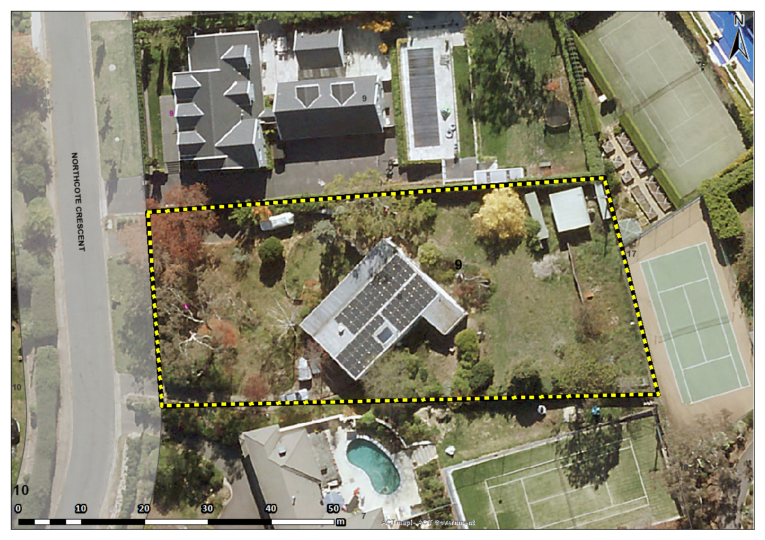
Image 1 11 Northcote Crescent, Deakin site boundary

