Australian Capital Territory
Electoral (Expenditure cap for 2019) Declaration 2018

Notifiable instrument NI2018 — 658
made under the
Electoral Act 1992, s205E (Working out indexation for expenditure cap)

1 Name of instrument
This instrument is the Electoral (Expenditure cap for 2019) Declaration 2018.
2 Commencement
This instrument commences on 1 January 2019.
3 Calculation
The yearly amount for the period 1 January 2019 to 31 December 2019 is worked out as follows:
EC + (EC x CPI* percentage increase)
where:
CPI means the all groups consumer price index number, being the weighted average of the 8 capital cities, published by the Australian Statistician.
CPI percentage increase for the year, means the annual percentage increase in the CPI from the September quarter of the previous year to the September quarter of the year the calculation is made.
EC means the expenditure cap for the year the calculation is made, and for 2018 is $41,265 according to section 205D(b).
The CPI number for the September 2018 quarter is 113.5.
The CPI number for the September 2017 quarter is 111.4.
The annual percentage increase is calculated by dividing the increase in the September quarter CPI index by the earlier index and multiplying by 100%. For the period September 2017 to September 2018, the percentage increase is calculated as follows:
(113.5 – 111.4) x 100% = 1.8851 %.
111.4
The expenditure cap amount for 2019 is calculated as:
41,265 + (41,265 x 1.8851 %) = $42,042.89
In accordance with section 205E(4), if the calculation of the expenditure cap results in an expenditure cap that is not a multiple of $5, the amount declared must be rounded up to the next whole dollar amount that is a multiple of 5.
Therefore, the expenditure cap for 2019 is $42,045.
4 Declaration
I declare the amount for 2019 to be $42,045.
5 Expiry
This instrument expires on 31 December 2019.

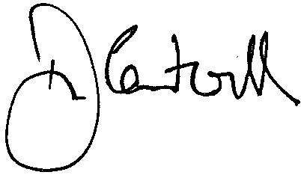

Damian Cantwell AM
Electoral Commissioner

20 November 2018

