Australian Capital Territory
Planning and Development (Technical Amendment—Denman Prospect) Plan Variation 2018 (No 1)

Notifiable Instrument NI2018—93
Technical Amendment No 2018-01
made under the
Planning and Development Act 2007, section 89 (Making technical amendments) and section 96 (Effect of approval of estate development plan)

- Name of instrument
This instrument is the Planning and Development (Technical Amendment—Denman Prospect) Plan Variation 2018 (No 1).
2 Commencement
This instrument commences on the day after its notification day.
3 Technical amendment
I am satisfied under section 89 (1) (a) of the Planning and Development Act 2007 (the Act) that the Denman Prospect plan variation is a technical amendment to the Territory Plan.
4 Meaning of Denman Prospect plan variation
For this instrument:
Denman Prospect plan variation means the technical amendment to the Territory Plan, variation 2018-01, in the schedule.
Note: No consultation was required in relation to the Denman Prospect plan variation under section 87 of the Act.
Fleur Flanery
Delegate of the planning and land authority
22 February 2018

Planning & Development Act 2007

Technical Amendment
to the Territory Plan
Variation 2018-01

Future urban area variation and amendments to the Denman Prospect Precinct Map and Code

February 2018

This page is left intentionally blank

Table of Contents

1. INTRODUCTION 3
1.1 Purpose 3
1.2 Public consultation 3
1.3 National Capital Authority 3
1.4 Process 3
1.5 Types of technical amendments under the Act 4
2. EXPLANATION 5
2.1 Territory Plan Map 5
2.2 Denman Prospect Precinct Map and Code 7
3. TECHNICAL AMENDMENT 9
3.1 Territory Plan Map 9
3.2 Denman Prospect Precinct Map and Code 10

This page is left intentionally blank

- INTRODUCTION
  - Purpose
This technical amendment makes the following changes to the Territory Plan:
Territory Plan Map
- The Territory Plan map is varied to remove the Future Urban Overlay from land in the Division of Denman Prospect, as identified in Part 2 of this document.
Denman Prospect Precinct Map and Code
- The Denman Prospect Precinct Map and Code is amended to include ongoing provisions, as described in Part 2 of this document.

  - Public consultation
Under section 87 of the Planning and Development Act 2007 (the Act) this type of technical amendment is not subject to public consultation.

  - National Capital Authority
The National Capital Authority does not need to be advised of this technical amendment as per 1.2.
  - Process
This technical amendment has been prepared in accordance with section 87 and made in accordance with section 89 of the Planning and Development Act 2007 (the Act).

  - Types of technical amendments under the Act
The following categories of technical amendments are provided under section 87 of the Act:
- Each of the following territory plan variations is a technical amendment for which no consultation is needed before it is made under section 89:
(a) a variation (an error variation) that –
- would not adversely affect anyone’s rights if approved; and
- has as its only object the correction of a formal error in the plan;
(b) a variation to change the boundary of a zone or overlay under section 90A (Rezoning – boundary changes);
(c) a variation, other than one to which subsection (2) (d) applies, in relation to an estate development plan under section 96 (Effect of approval of estate development plan);
(d) a variation required to bring the territory plan into line with the national capital plan;
(e) a variation to omit something that is obsolete or redundant in the territory plan.
- Each of the following territory plan variations is a technical amendment for which only limited public consultation is needed under section 90:
- a variation (a code variation) that –
- would only change a code; and
- is consistent with the policy purpose and policy framework of the code; and
- is not an error variation;
- a variation to change the boundary of a zone under section 90B (Rezoning – development encroaching on adjoining territory land);
- a variation in relation to a future urban area under section 90C (Technical amendments – future urban areas);
- a variation in relation to an estate development plan under section 96 (Effect of approval of estate development plan) if it incorporates an ongoing provision that was not included in the plan under section 94 (3) (g);
- a variation to clarify the language in the territory plan if it does not change the substance of the plan;
- a variation to relocate a provision within the territory plan if the substance of the provision is not changed.
TA2018-01 has been prepared in accordance with section 87 (1) (c).

- EXPLANATION
This part of the technical amendment document explains the changes to be made to the Territory Plan.

  - Territory Plan Map
Variation to the Territory Plan

The Territory Plan map is varied to identify the zones and overlays that apply to land ceasing to be in a future urban area.

Existing Territory Plan Map
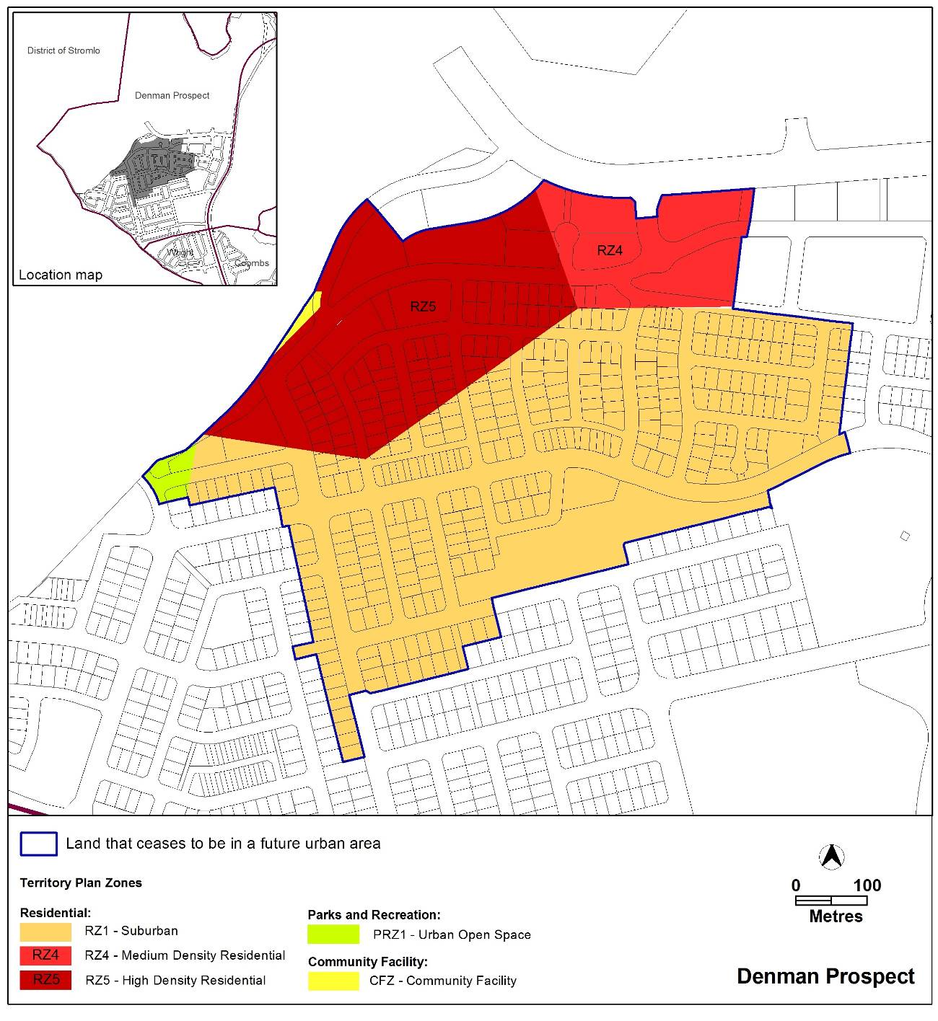

Proposed Territory Plan Map

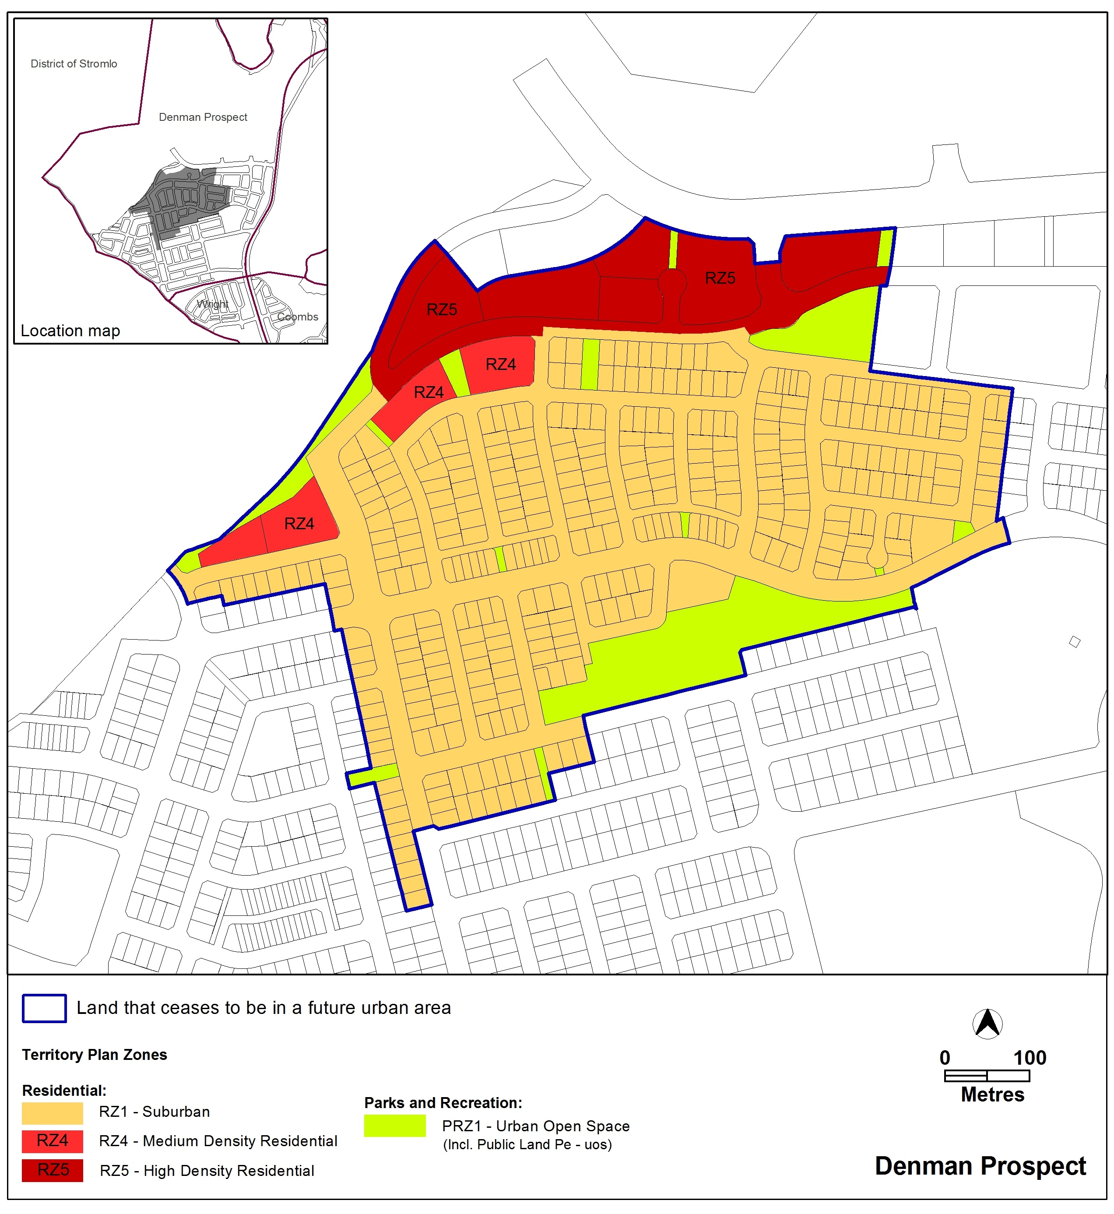

  - 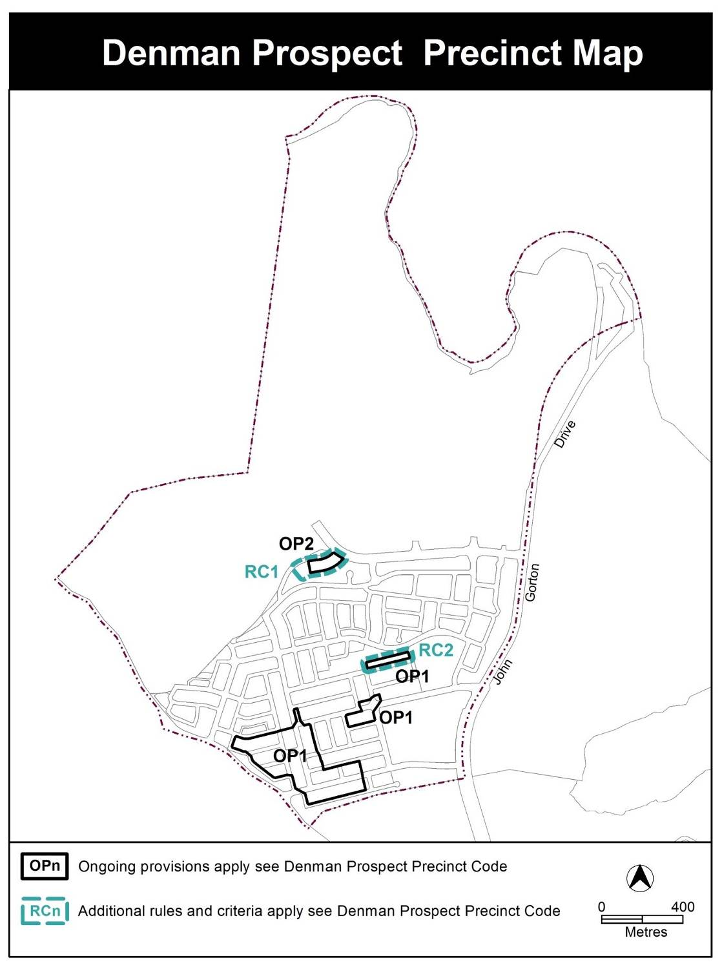Denman Prospect Precinct Map and Code
Variation to the Denman Prospect Precinct Map and Code

The Denman Prospect Precinct Map and Code is varied to incorporate rules and criteria and ongoing block specific provisions that are consistent with the approved estate development plan.

    - Denman Prospect Precinct Map
Existing Denman Prospect Precinct Map
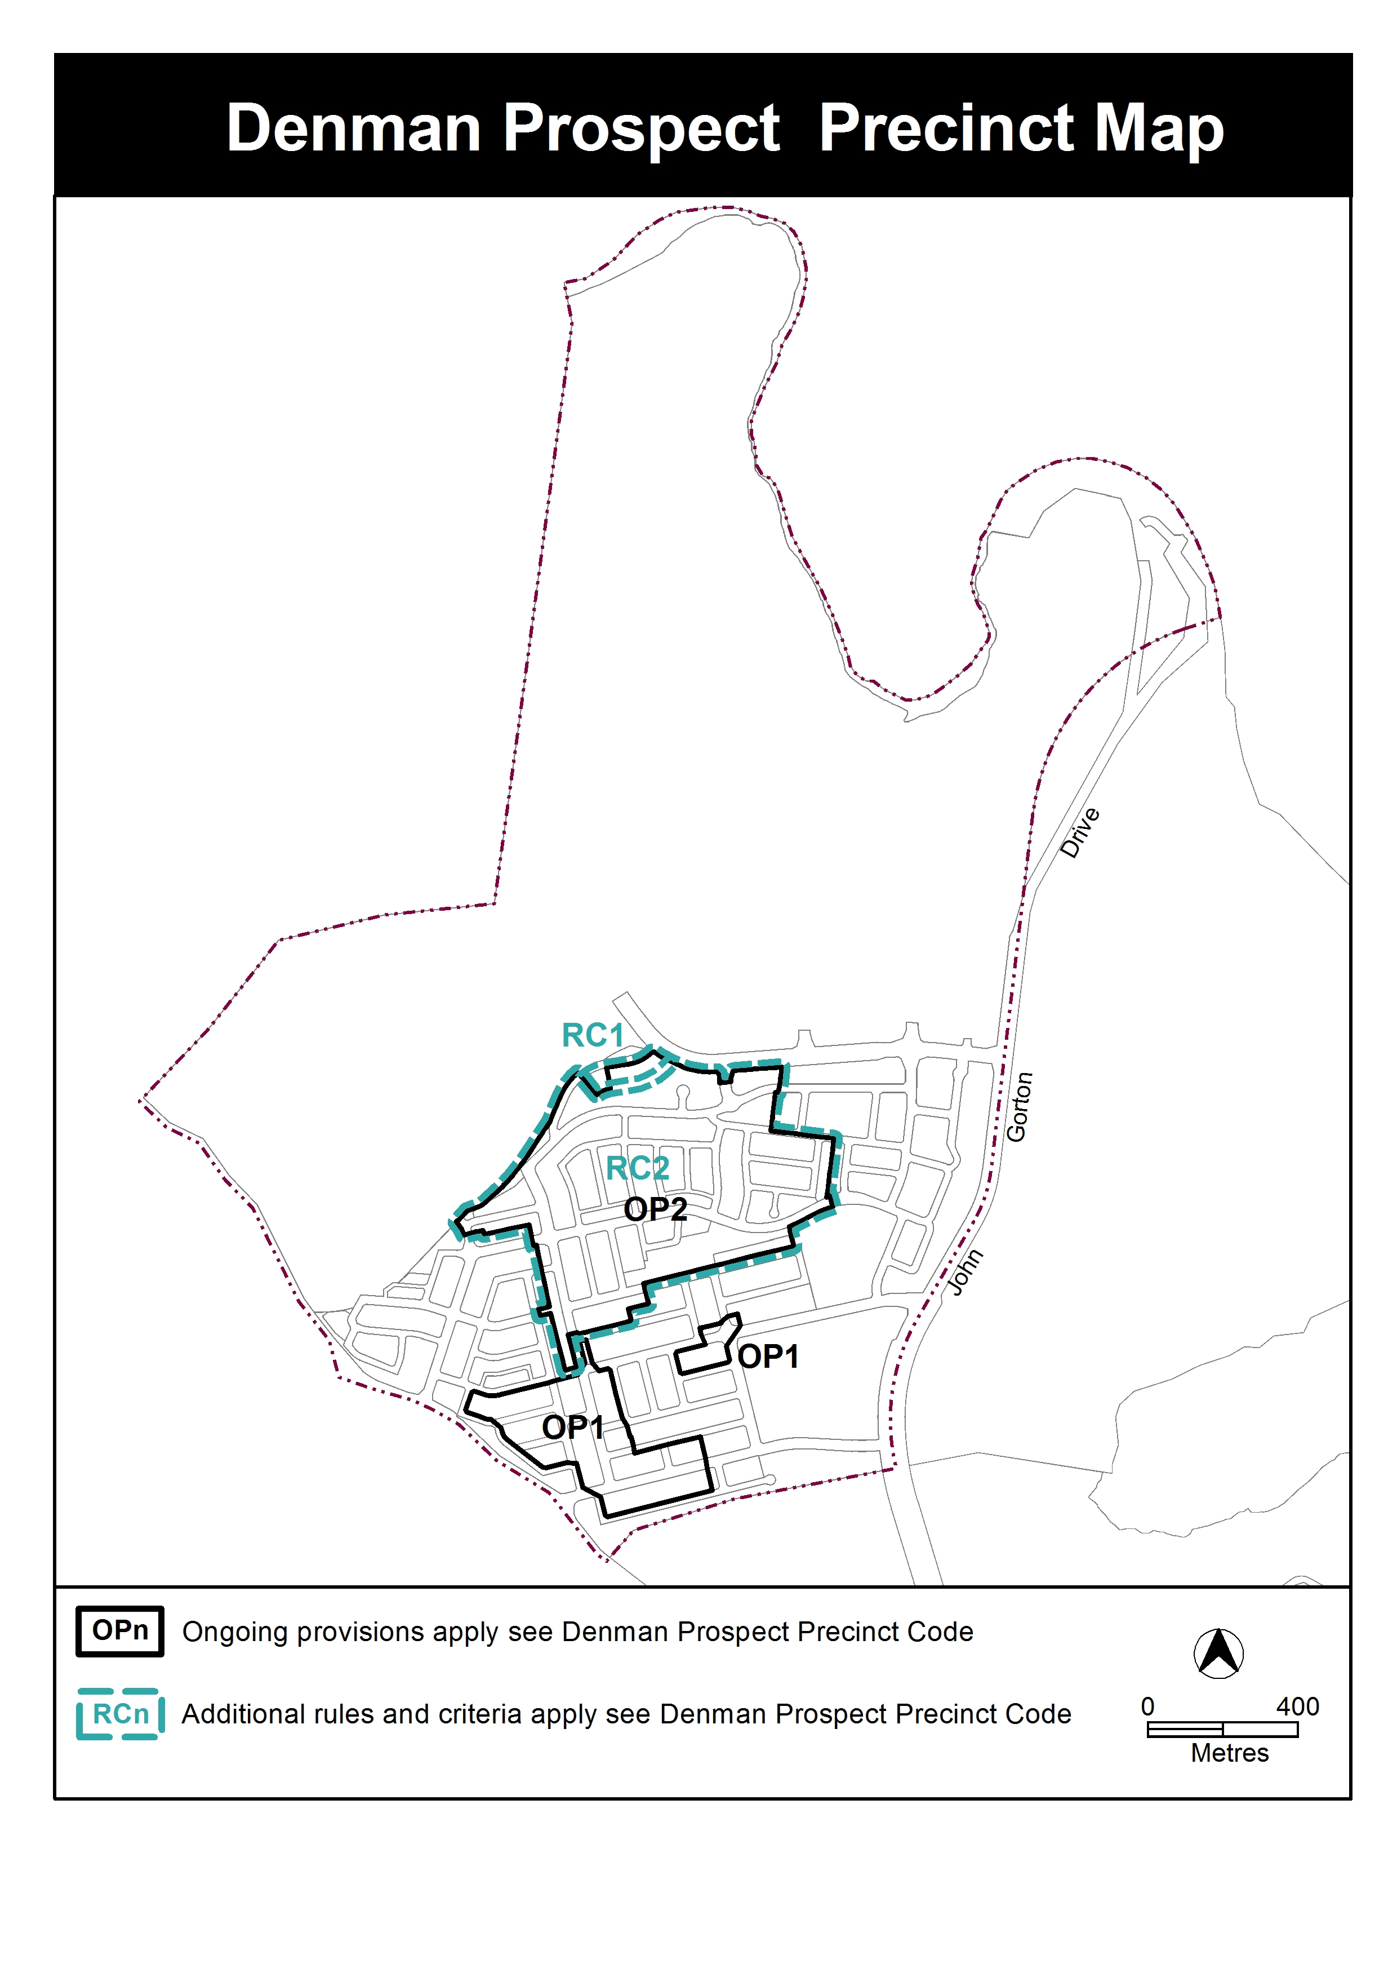Proposed Denman Prospect Precinct Map

    - Denman Prospect Precinct Code
The provisions to be included are detailed in Part 3 of this document.

- TECHNICAL AMENDMENT
This section of the technical amendment document provides the actual instructions for implementing the changes to the Territory Plan.

  - Territory Plan Map
- Territory Plan Map

The Territory Plan map is varied as indicated below to identify the zones that apply to the land ceasing to be in a future urban area.

  - Denman Prospect Precinct Map and Code
- Denman Prospect Precinct Map

Substitute

- Denman Prospect Precinct Code, RC2 – Residential Area, Element 2: Building and Site Controls

Substitute

RC2 – Residential Area
This part applies to blocks and parcels identified in area RC2 shown on the Denman Prospect Precinct Map.
- Element 1: Element 2: Building and Site Controls
Rules | Criteria
2.1 Private open space
R4  This rule applies to blocks or parcels in locations identified in Figure 3.  The mandatory level of private open space cannot be lower than 1m below the front boundary level for a depth of 3m from the front boundary to the open space. | This is a mandatory requirement. There is no applicable criterion.
2.2 Setbacks - garages
R5  This rule applies to blocks or parcels in locations identified in Figures 2 and 3.  Minimum side boundary setback to garage is nominated. | This is a mandatory requirement. There is no applicable criterion.
2.3 Setbacks – upper and lower floors
R6  This rule applies to blocks or parcels in locations identified in Figure 3.  Maximum length of wall at zero setback is limited to length of the adjoining dwelling party wall. | This is a mandatory requirement. There is no applicable criterion.
2.4 Gates
R7  This rule applies to blocks or parcels in locations identified in Figures 2 and 3.  Front boundaries to open space must provide one gate access. | This is a mandatory requirement. There is no applicable criterion.
Rules | Criteria
2.5 Parking
R8  This rule applies to blocks or parcels in locations identified in Figures 2 and 3.  All visitor parking requirements as determined by the Parking and Vehicle Access General Code are to be provided within the block. | This is a mandatory requirement. There is no applicable criterion.
2.6 Vehicular access
R9  This rule applies to blocks or parcels identified in Figure 3.  No vehicle access is permitted. | This is a mandatory requirement. There is no applicable criterion.
2.7 Fencing
R10  This rule applies to blocks or parcels fronting open space.  Transparent type fencing with a maximum height of 1.2m to be provided. | This is a mandatory requirement. There is no applicable criterion.

- Denman Prospect Precinct Code, RC2 – Residential Area, Element 2: Building and Site Controls, Figure 2 Denman Prospect residential area 1

Omit existing Figure 2

Insert the following:
- Figure 2 Denman Prospect residential area 1
- Figure 3 Denman Prospect residential area 2

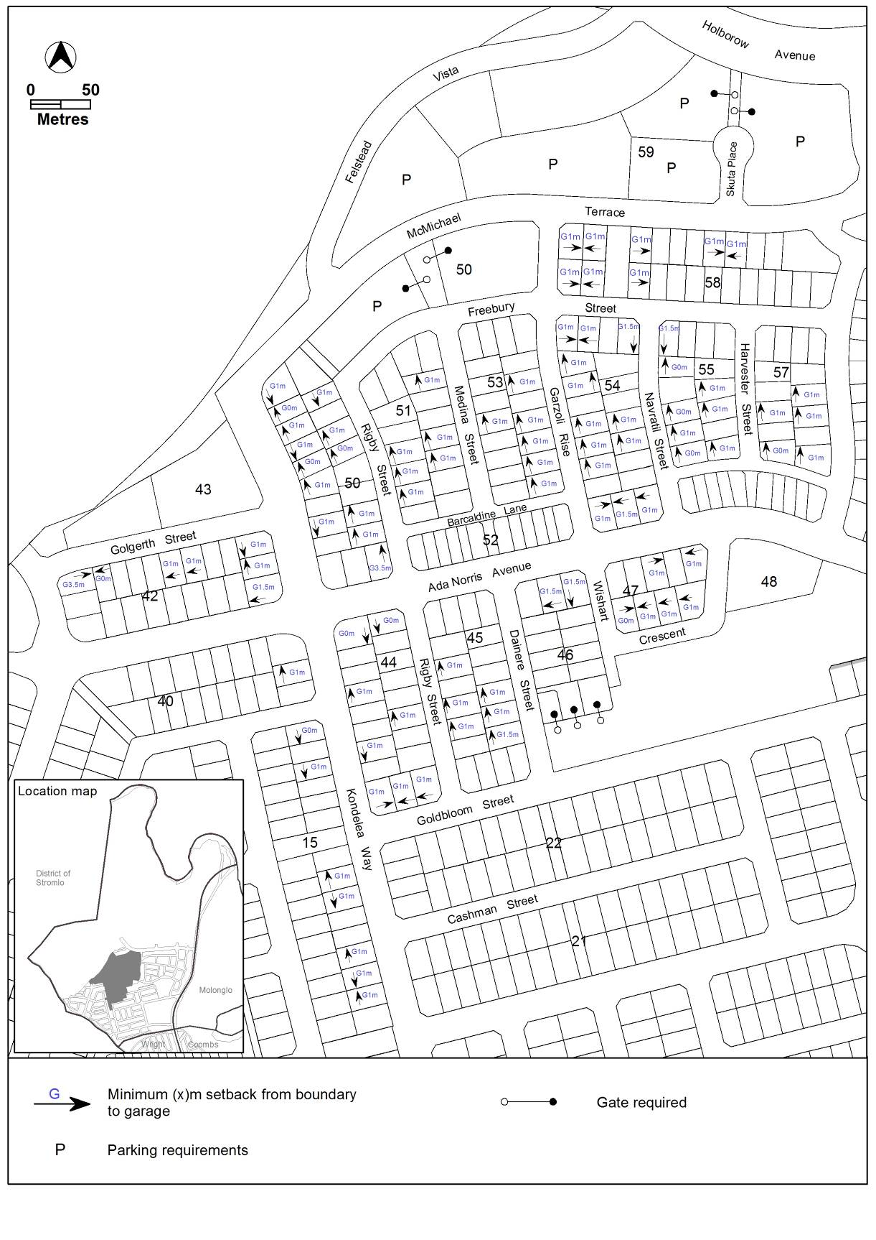
Figure 2 Denman Prospect residential area 1

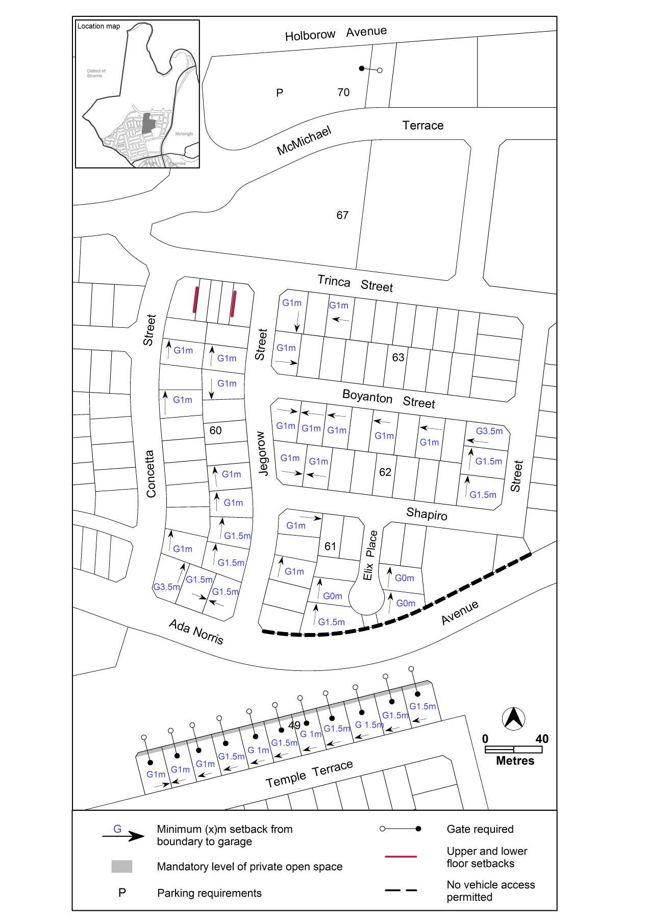
Figure 3 Denman Prospect residential area 2

- Denman Prospect Precinct Code, OP1 – Denman Prospect residential area, Figure 3 Denman Prospect residential area ongoing provisions

Substitute existing Figure 3 with:

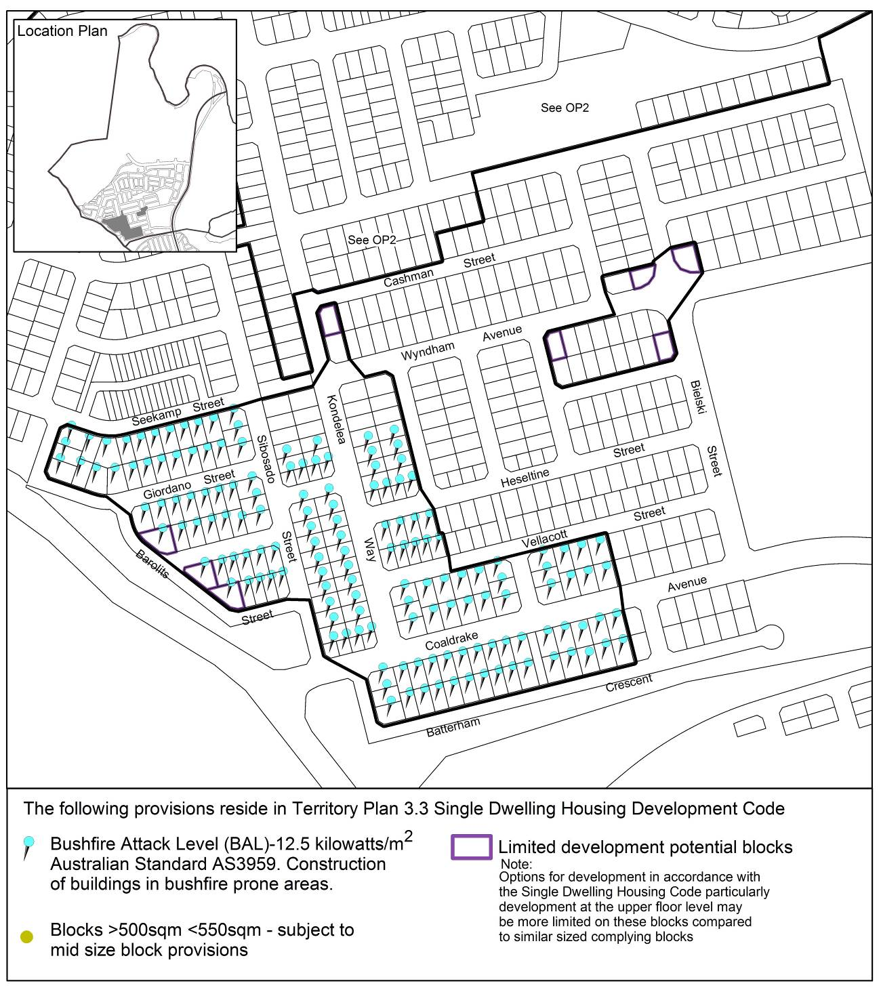
Figure 4 Denman Prospect residential area ongoing provisions

- Denman Prospect Precinct Code, OP2 – Denman Prospect residential area

Substitute

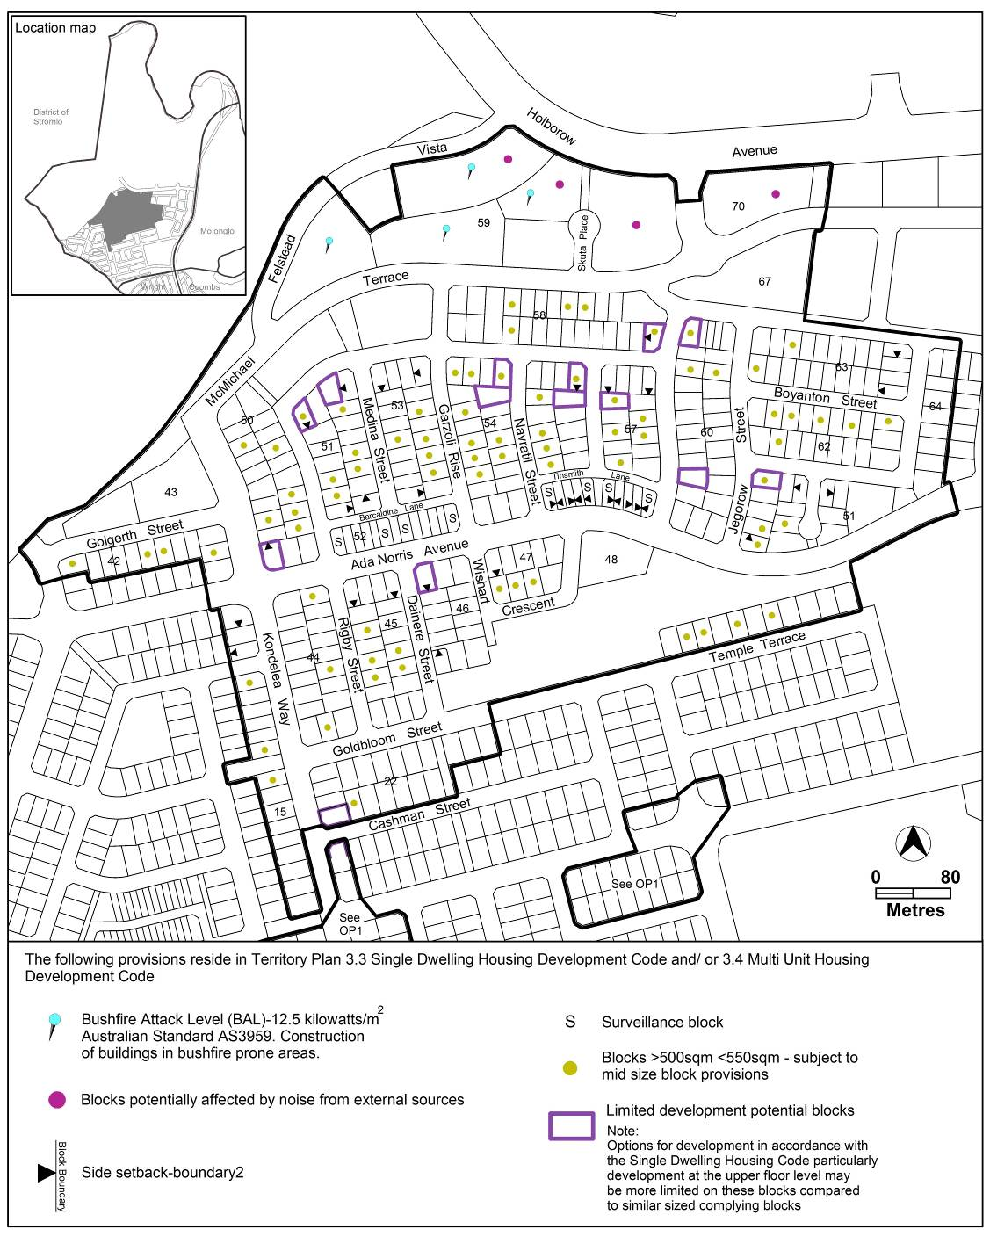This part applies to blocks and parcels identified in area OP2 shown on the Denman Prospect Precinct Map.

Figure 5 Denman Prospect residential area ongoing provisions

Interpretation service
