Australian Capital Territory
Planning and Development (Plan Variation No 345) Approval 2019

Notifiable instrument NI2019-164
made under the
Planning and Development Act 2007, s 76 (Minister’s powers in relation to draft plan variations)

1 Name of instrument
This instrument is the Planning and Development (Plan Variation No 345) Approval 2019.
2 Approval of draft plan variation
- I approve under section 76 (2) (a) of the Planning and Development Act 2007 the draft plan variation No 345 to the Territory Plan.
- In this section:
draft plan variation No 345 to the Territory Plan means the draft plan variation in the schedule.
Mick Gentleman MLA
Minister for Planning and Land Management
28 March 2019

This page is intentionally blank.

Planning and Development Act 2007

Variation to the
Territory Plan
No 345

Mawson Group Centre:
Zone changes and amendments to the Mawson precinct map and code

March 2019

Final variation prepared under s76 of the
Planning and Development Act 2007

This page is intentionally blank.

Contents

1. EXPLANATORY STATEMENT 1
1.1 Background 1
1.2 Summary of the Proposal 1
1.3 The National Capital Plan 1
1.4 Site Description 2
1.5 Current Territory Plan Provisions 4
1.6 Changes to the Territory Plan 6
1.7 Consultation on the Draft Variation 6
1.8 Revisions to the Draft Variation Recommended to the Minister 7
2. VARIATION 8
2.1 Variation to the Territory Plan map 8
2.2 Variation to the Territory Plan written document 9

This page is intentionally blank.

- EXPLANATORY STATEMENT
  - Background
Variation 345 incorporates the recommendations of the Mawson group centre master plan, which has been undertaken as part of the ACT Government initiative for encouraging the rejuvenation of selected commercial centres, and to direct development within the centre over the next 10 to 20 years.
  - Summary of the Proposal
The variation incorporates the recommendations of the approved Mawson group centre master plan into the Territory Plan to provide guidance on the desired built form and character of the centre as it develops into the future.
V345 retains the two storey height limit within the central area to retain solar access to the public squares and proposes higher development of four and six storeys to the east of Heard Street and six storeys to the west of Mawson Place. V345 also allows for development up to eight storeys near the south eastern corner of the Athllon Drive/Mawson Drive intersection as a marker development for the centre, as recommended by the approved master plan.
V345 rezones several areas in accordance with the approved master plan, including land along Athllon Drive proposed to be rezoned from suburban core residential and road reserve to high density residential and urban open space. The rezoning will increase the area of urban open space and ensure the existing shared path connecting Mawson to Woden town centre is retained.
V345 rezones the CZ3 services zone between Mawson Place and Athllon Drive to CZ2 business zone, and rezones the public carpark south of Mawson Place from PRZ1 urban open space to CZ3 services zone in accordance with the master plan recommendations to permit additional commercial development within the centre.
V345 also identifies main pedestrian areas within the centre and areas where active frontages are required, which provide interest and activity at the ground floor level. Locations where awnings are required for all weather protection for pedestrians are also nominated.
  - The National Capital Plan
The Australian Capital Territory (Planning and Land Management) Act 1988 established the National Capital Authority (NCA) with two of its functions being to prepare and administer a National Capital Plan (NCP) and to keep the NCP under constant review and to propose amendments to it when necessary.
The NCP, which was published in the Commonwealth Gazette on 21 January 1990 is required to ensure that Canberra and the Territory are planned and developed in accordance with their national significance. The Planning and Land Management Act 1988 also required that the Territory Plan is not inconsistent with the NCP.
In accordance with section 10 of the Australian Capital Territory (Planning and Land Management) Act 1988, the National Capital Plan defines the planning principles and policies for Canberra and the Territory, for giving effect to the object of the NCP and sets out the general policies to be implemented throughout the Territory, including the range and nature of permitted land uses.
It also sets out the detailed conditions of planning, design and development for areas that have special significance to the National Capital known as designated areas and identifies special requirements for the development of some other areas.

  - Site Description
The subject area is the Mawson group centre and surrounding land, including the land located along Athllon Drive. The group centre is located almost 2 km south of Woden Town Centre, and adjacent to the intersection of Athllon Drive and Mawson Drive. The centre is bounded by Athllon Drive to the west, Mawson Drive to the north, Mountevans Street to the east and recreational spaces to the south.
Several community clubs are located between Heard Street and Mountevans Street, and large areas of surface parking are provided along Heard Street and the southern part of Mawson Place. A line of buildings containing cafes and take away food shops along the ground floor are located along the western side of Mawson Place, bookended by petrol stations at either end, with the eastern side of Mawson Place a mix of food retailing, shops and back of business loading areas.
Development in the centre is a mix of one and two storeys, with retail uses, restaurants, cafes and personal services at the ground floor and offices and indoor recreation uses above. The surrounding land to the south contains tennis courts and playing fields, with multi unit residential housing to the east and suburban core residential to the north that is predominately detached single dwellings. To the west are Athllon Drive and a large strip of unleased Territory land that has Yarralumla Creek running through it.
The land along Athllon Drive included in this draft variation is grassed land separated from existing single dwelling blocks to the east by trees and a shared path and separated from Athllon Drive to the west by Yarralumla Creek.

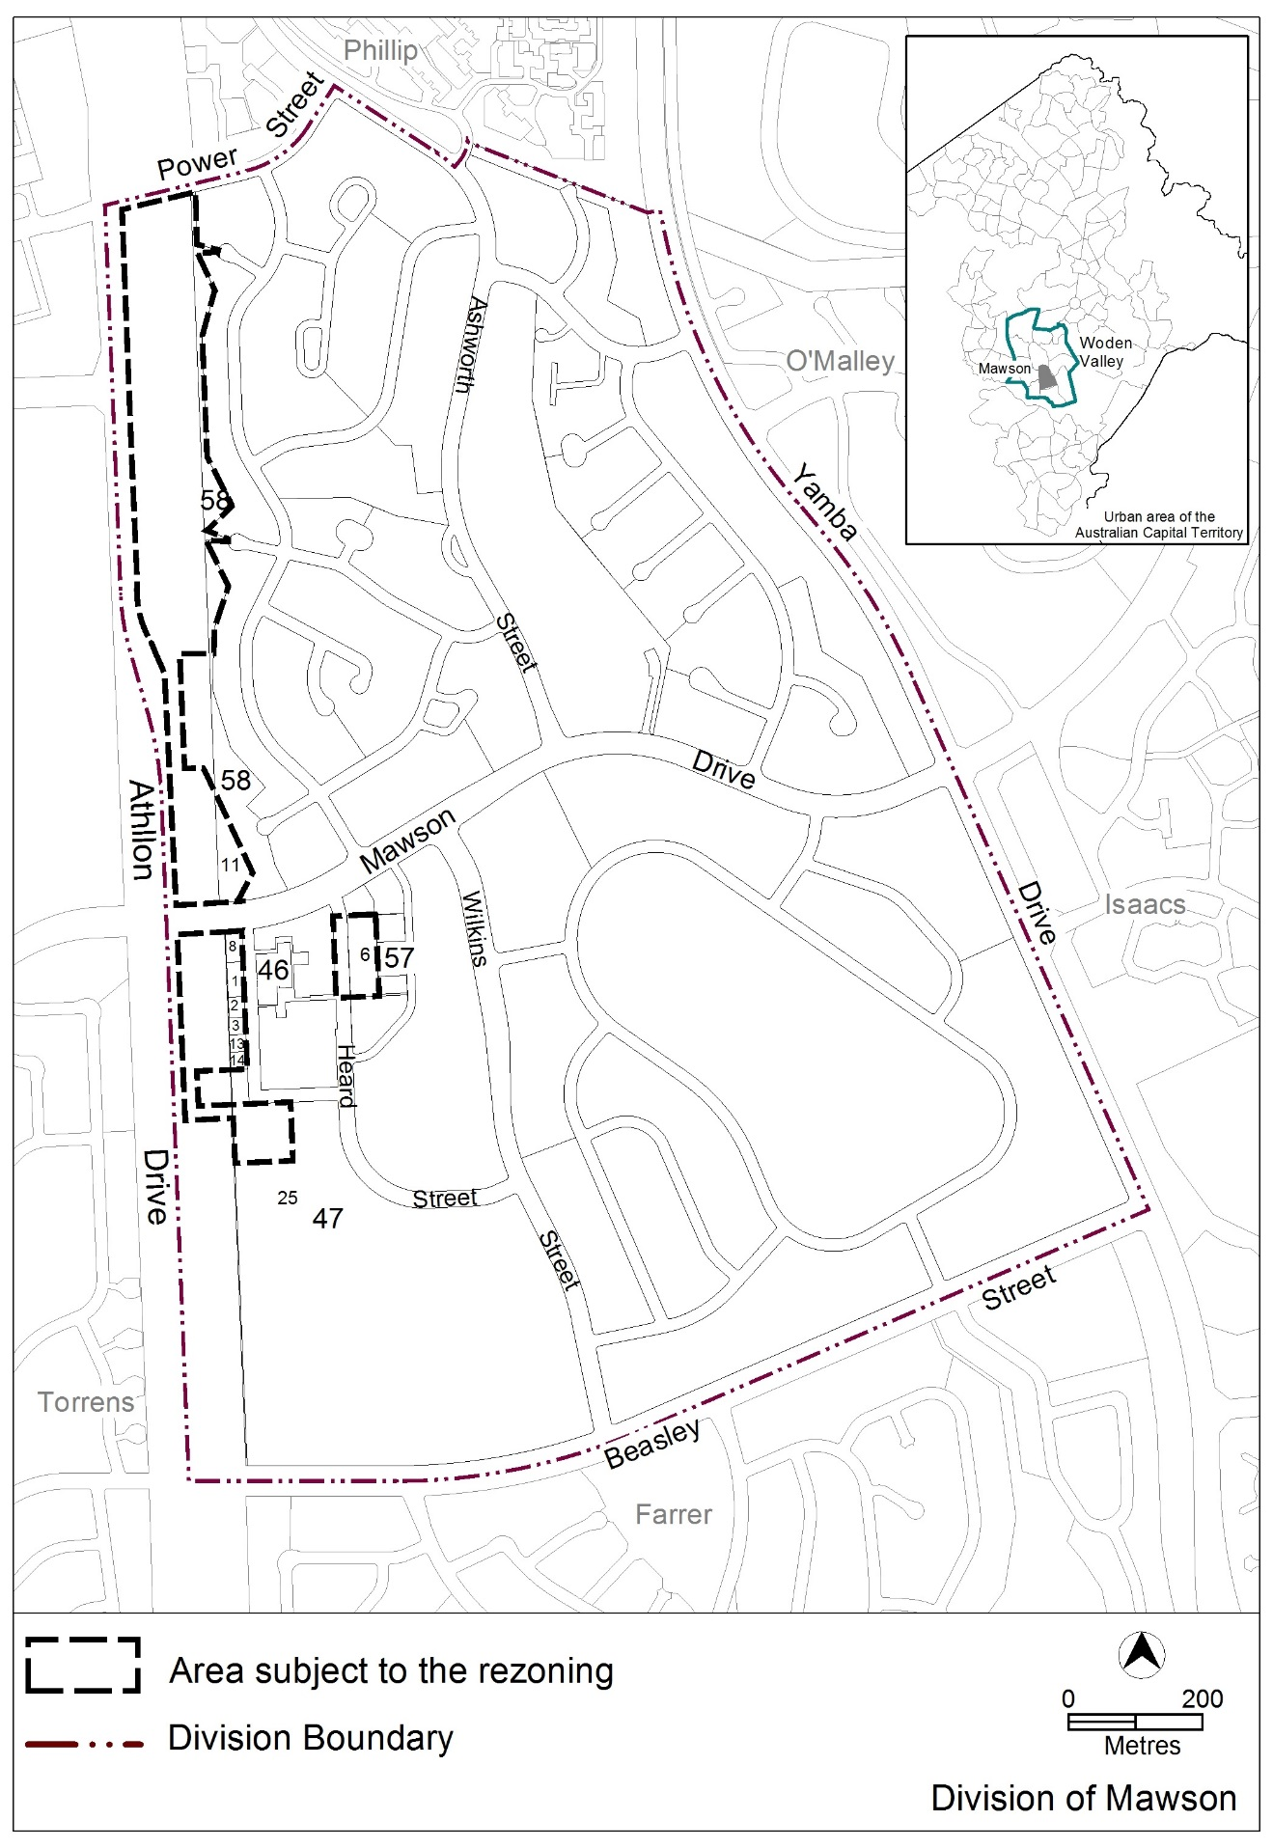
Figure 1: Location map and areas subject to rezoning
  - Current Territory Plan Provisions
The Territory Plan map for the area subject to this variation is shown in Figure 2.
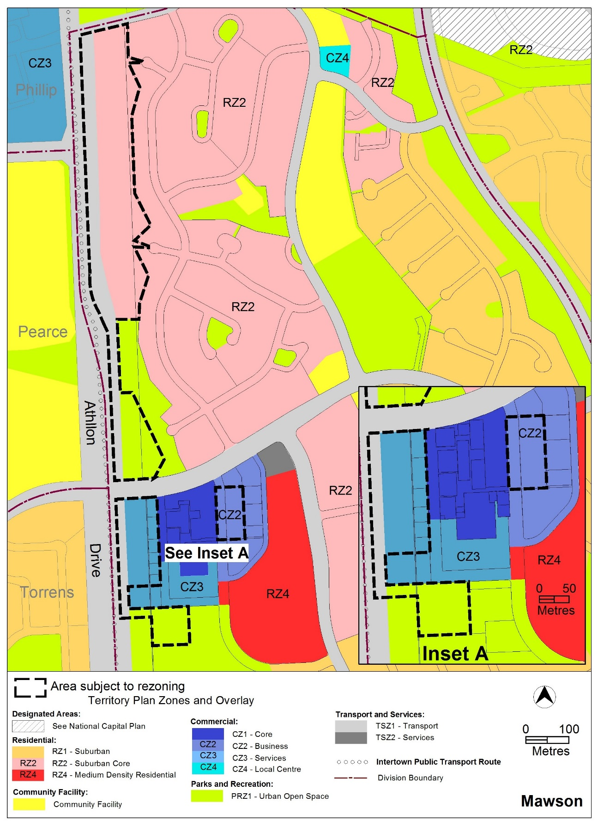
Figure 2: Territory Plan Zones Map
The central area is zoned CZ1 commercial core zone, with the CZ2 commercial business zone located to the east of Heard Street, and CZ3 commercial service trades zone to the west and south of the core zone. The Athllon Drive land is predominately zoned RZ2 suburban core residential towards Phillip, and PRZ1 urban open space adjacent to the group centre, while the transport corridor is zoned TSZ1 transport zone. The existing car park south of the centre is zoned PRZ1 urban open space.
The group centre is subject to the Commercial Zone development code and the Mawson precinct map and code, while the residential areas are subject to the Residential Zones Development code, Single Dwelling Housing development code and the Multi Unit Housing development code. The adjoining open space areas are subject to the Parks and Recreation Zone development code.
The general codes may also apply.
  - Changes to the Territory Plan
Detailed changes to the Territory Plan are noted in section 2 of this document.
  - Consultation on the Draft Variation
Draft Variation No 345 (DV345) was released for public comment between 3 March 2017 and 21 April 2017, with an extension to 2 June 2017. A consultation notice under section 63 of the Planning and Development Act 2007 (P&D Act) was published on the ACT Legislation Register on 3 March 2017.
A total of 21 written submissions were received, which included 12 submissions from local residents, 4 submissions from local businesses, 3 submissions from community groups, 1 submission from a company with an interest in the centre, and 1 submission from a Member of the Legislative Assembly.
Main issues raised by submitters included:
- building heights, with views mixed between support for increased heights generally or in selected areas, and opposing views requesting lower building heights generally or in selected areas
- retention of the surface car parking areas and concern additional development will impact on parking
- retaining solar access to the central courtyard area and residential development
- mixed views of development along Athllon Drive with both support for increased density and opposition to increased density, particularly until the light rail route has been determined, and not at the intersection of Athllon drive and Mawson Drive
- mixed views on zoning with requests for additional rezonings to support additional commercial development, as well as requests for lower density zoning in selected areas
- comments on the condition of existing footpaths and requests to include active travel paths in the variation; and
- concerns with the impact of the light rail route on the outcomes of the variation
The above issues were considered and are detailed in a report on consultation, which is available at www.act.gov.au/recommendedvariations. No changes were made as a result of consultation.
  - Revisions to the Draft Variation Recommended to the Minister
The following changes were made after consideration of the Legislative Assembly Standing Committee on Planning and Urban Renewal’s report 6 of 2018:
- A new rule R5 and associated criterion C5 to ensure that people using the replacement public car parking, required where surface car parks are redeveloped, will be able to walk into and out of the car park directly to and from public space, rather than being directed into the development.
- A new rule R12 and associated criterion C12 (replacing the previously proposed criterion C23), requires new development to not overshadow the two main courtyards any more than an 8m high wall, to limit the extent of two storey development around the main public spaces.
- A new rule R21 and associated criterion C21 requires any redevelopment of the surface car park on block 17 section 46 to provide a new courtyard area along the southern end of the block that integrates with the existing pedestrian path. In addition, any building on the car park site will need to provide an active frontage facing the new courtyard area, and not excessively overshadow the courtyard.

- VARIATION
  - Variation to the Territory Plan map
The Territory Plan map is varied as indicated in figure 3:
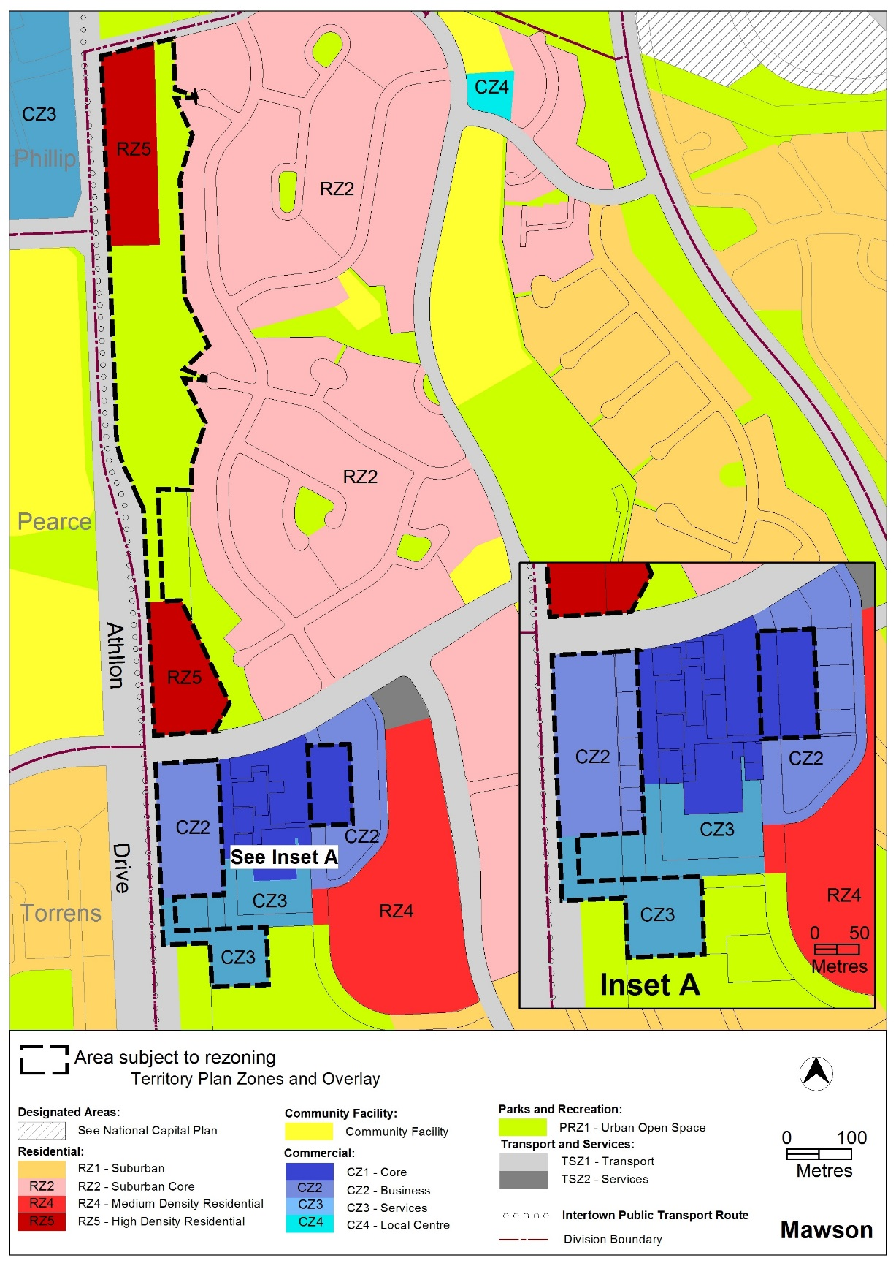
Figure 3: Areas subject to rezoning
  - Variation to the Territory Plan written document

The Territory Plan written document is varied as follows:

Variation to the Mawson precinct map and code
10. Precinct maps and codes, Mawson precinct map and code

Substitute all of the following with the nominated attachments
Mawson precinct map – Attachment A
Mawson precinct code, RC1 – Mawson Group Centre (Southlands) – Attachment B

insert after RC1
Mawson precinct code, RC2 – Athllon Drive Corridor – Attachment C
Interpretation service

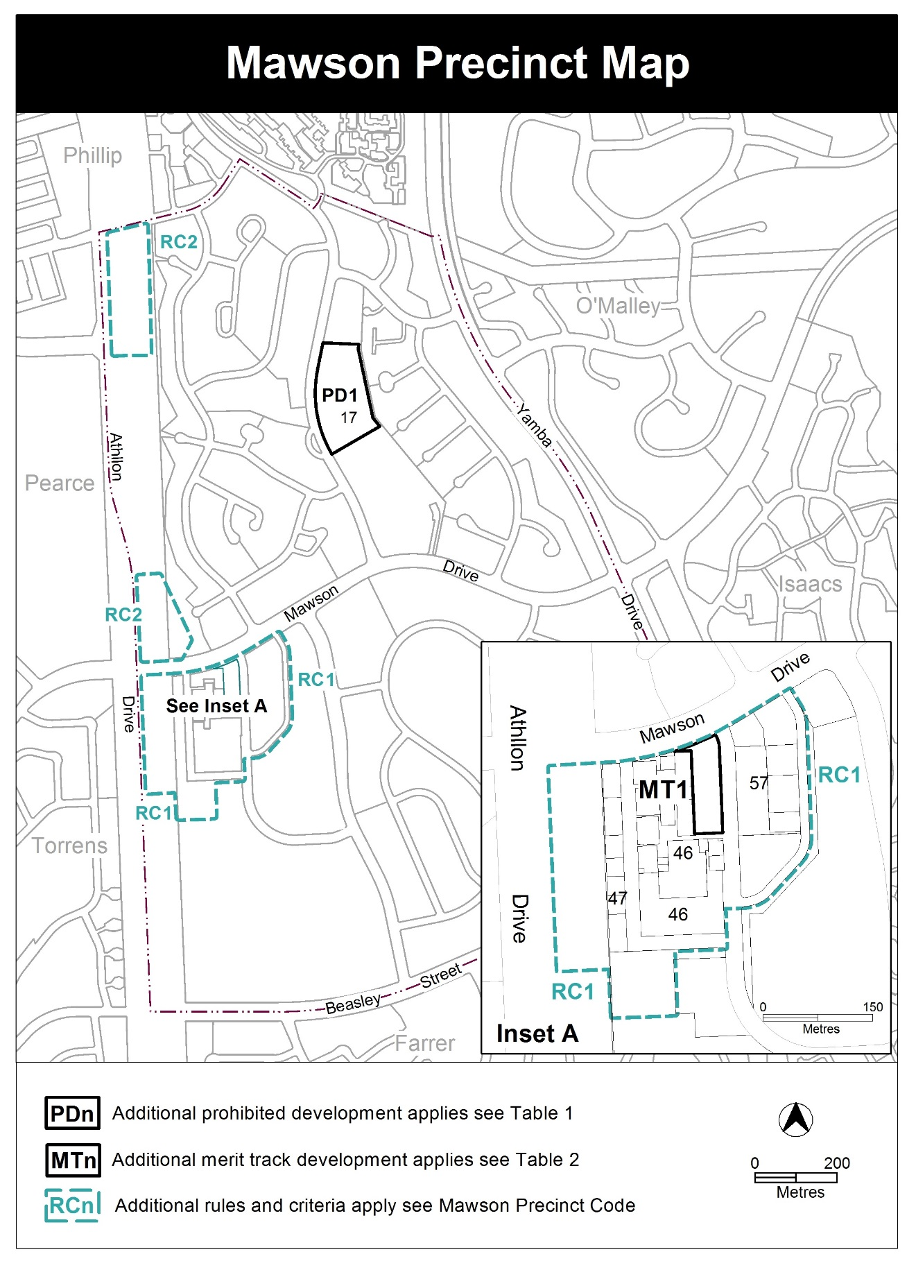

Assessment Tracks

The following tables identify the additional prohibited development and additional merit track development for blocks and parcels shown in the Mawson Precinct Map (identified as PDn or MTn). Development that is exempt from requiring development approval, other prohibited development and the minimum assessment track applicable to each development proposal is set out in the relevant zone development table.

The following tables constitute part of the relevant zone development table.

Table 1 – Additional prohibited development
Additional prohibited development
Suburb precinct map label | Zone | Development
PD1 | CFZ | retirement village  supportive housing

Table 2 – Additional merit track development
Additional merit track development that may be approved subject to assessment
Suburb precinct map label | Zone | Development
MT1 | CZ1 | industrial trades  municipal depot  store

Additional rules and criteria
This part applies to blocks and parcels identified in the Mawson Precinct Map (RCn). It should be read in conjunction with the relevant zone development code and related codes.
RC1 – Mawson Group Centre (Southlands)
This part applies to blocks and parcels identified in area RC1 shown on the Mawson Precinct Map. RC1 includes the Mawson Group Centre.
- Use
Rules | Criteria
  - Ground floor use
This rule applies to sites in CZ1 with boundaries to primary active frontages shown in figure 1.  Only the following uses are permitted along the primary active frontage at the ground floor level:  - business agency  - club  - community activity centre  - drink establishment  - financial establishment  - hotel  - indoor entertainment facility  - indoor recreation facility  - public agency  - restaurant  - SHOP | This is a mandatory requirement. There is no applicable criterion.
There is no applicable rule. | This criterion applies to sites in CZ2 and CZ3 with boundaries to primary active frontage shown in figure 1.  Buildings incorporate uses on the ground floor that generate activity in the adjoining public space.
  - Industrial trades, municipal depot and store
This rule applies to the area shaded grey in figure 1.  One or more of the following uses are permitted only in association with a structured car park:  - industrial trades  - municipal depot  - store. | This is a mandatory requirement. There is no applicable criterion.
  - Development on nominated car parking areas
This rule applies to the areas shaded grey shown in figure 2.  Development complies with all of the following:  - the existing number of car parking spaces is retained on the site and made available for public use at all times  - provides car parking that is generated by the development on site in accordance with the Parking and Vehicular Access General Code in addition to the spaces required by item a). | Development achieves all of the following:  - any additional parking provision requirements (under the Parking and Vehicular Access General Code) for the development  - makes a substantial contribution to the long term publicly accessible parking supply at the group centre.
This rule applies to the areas shaded grey shown in figure 2.  Development provides an unimpeded, permanently open pedestrian path of travel from at least one boundary adjoining a key pedestrian route, shown in figure 1, to the public car parking spaces within the development. | Development ensures users of the public car parking have suitable direct and unimpeded pedestrian access to and from the public realm at all times.
This rule applies to development on the park and ride facility located at the south eastern corner of the Athllon Drive and Mawson Drive intersection.  Development ensures the existing number of car parking spaces is retained on the site and made available for public use at all times as a park and ride facility. | Any proposal to relocate the park and ride facility and/or amend the number of publicly available car parking spaces must include written endorsement from Transport Canberra and City Services.

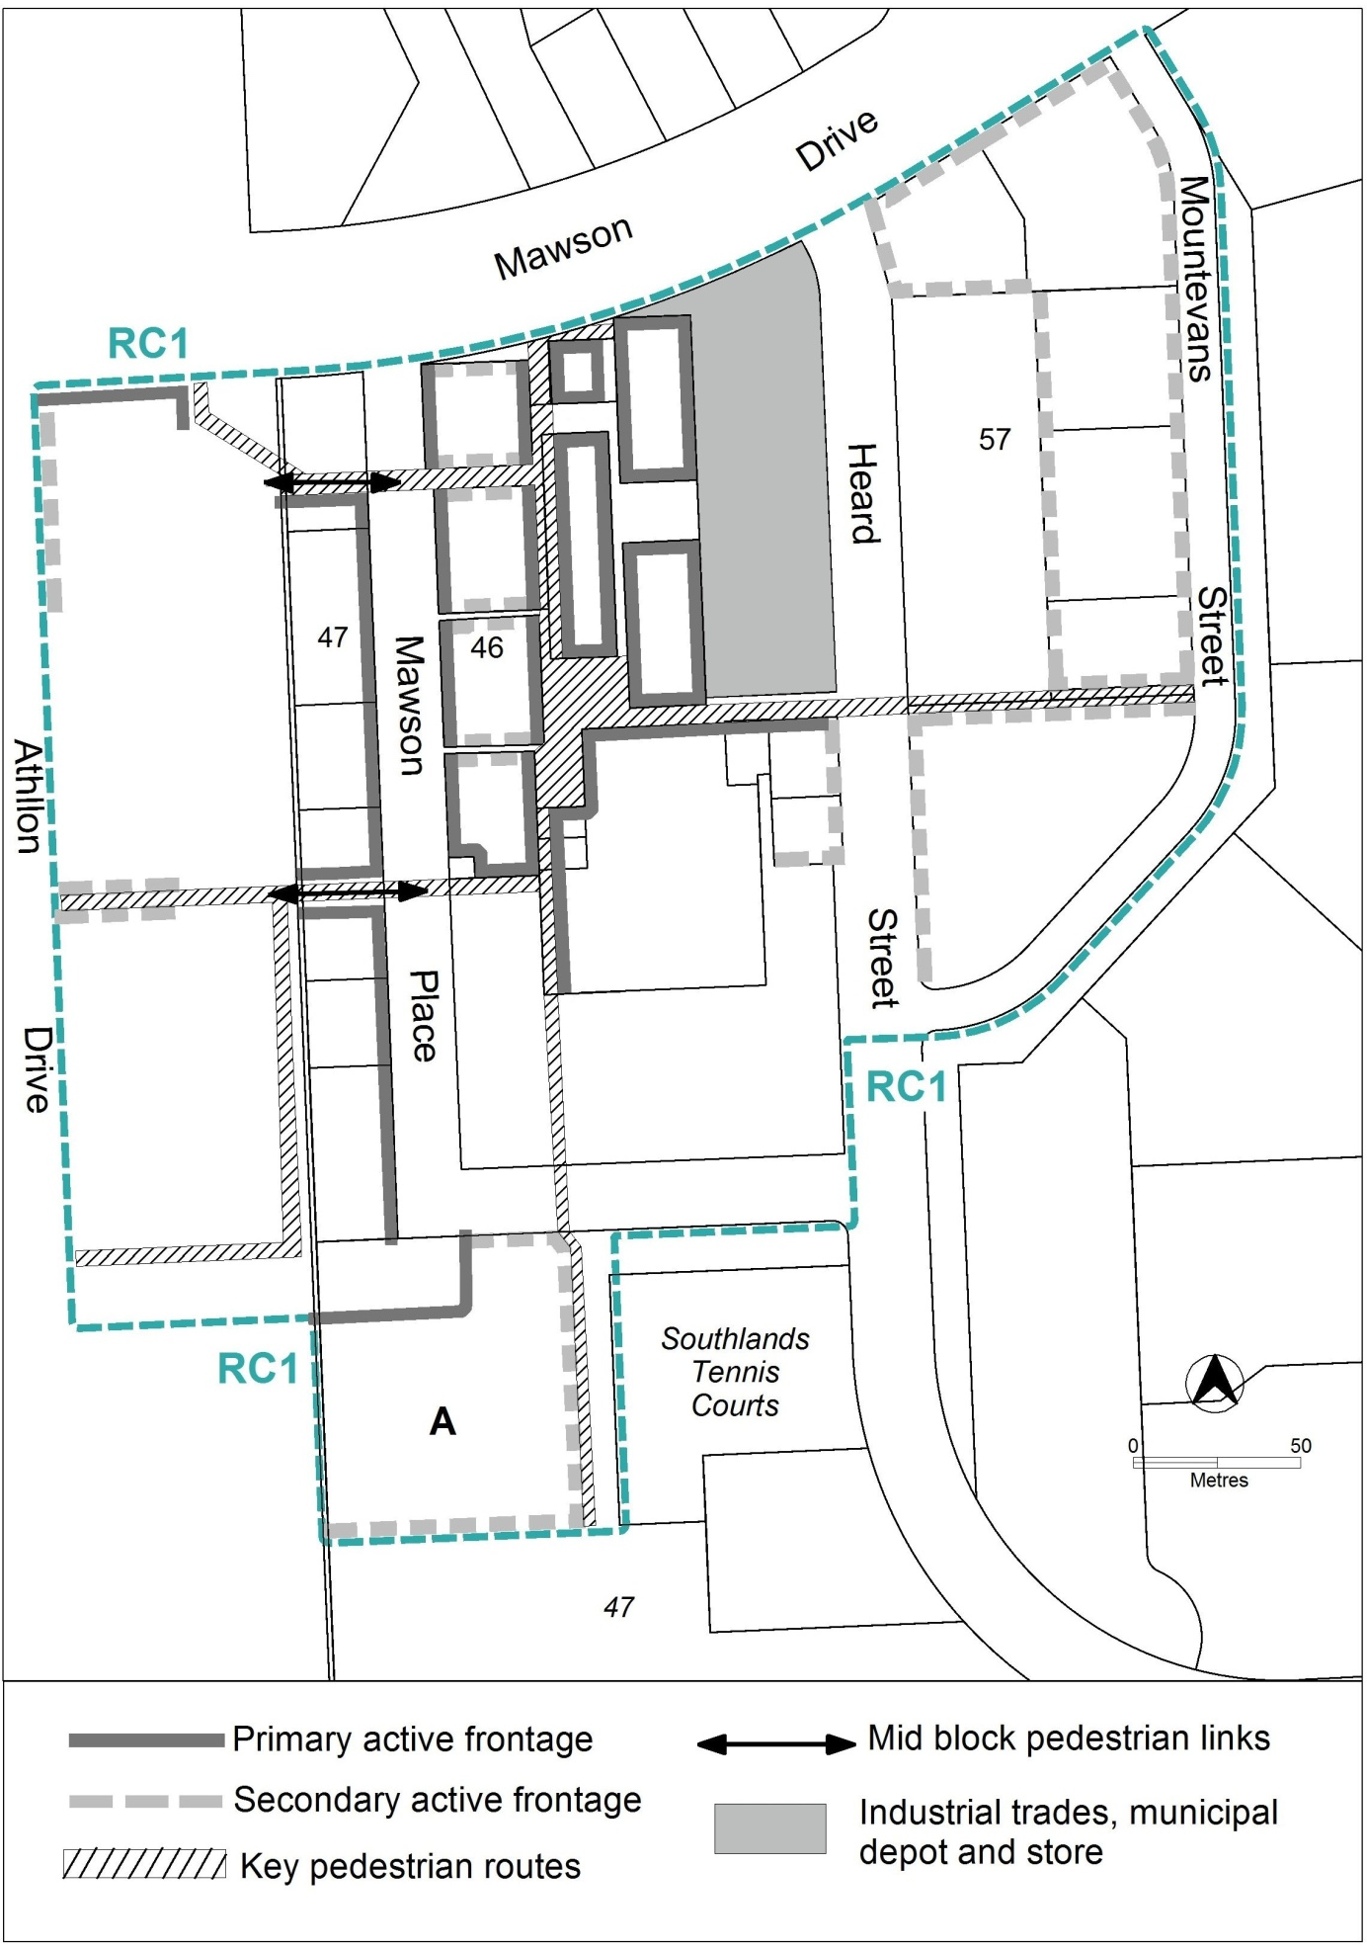
Figure 1

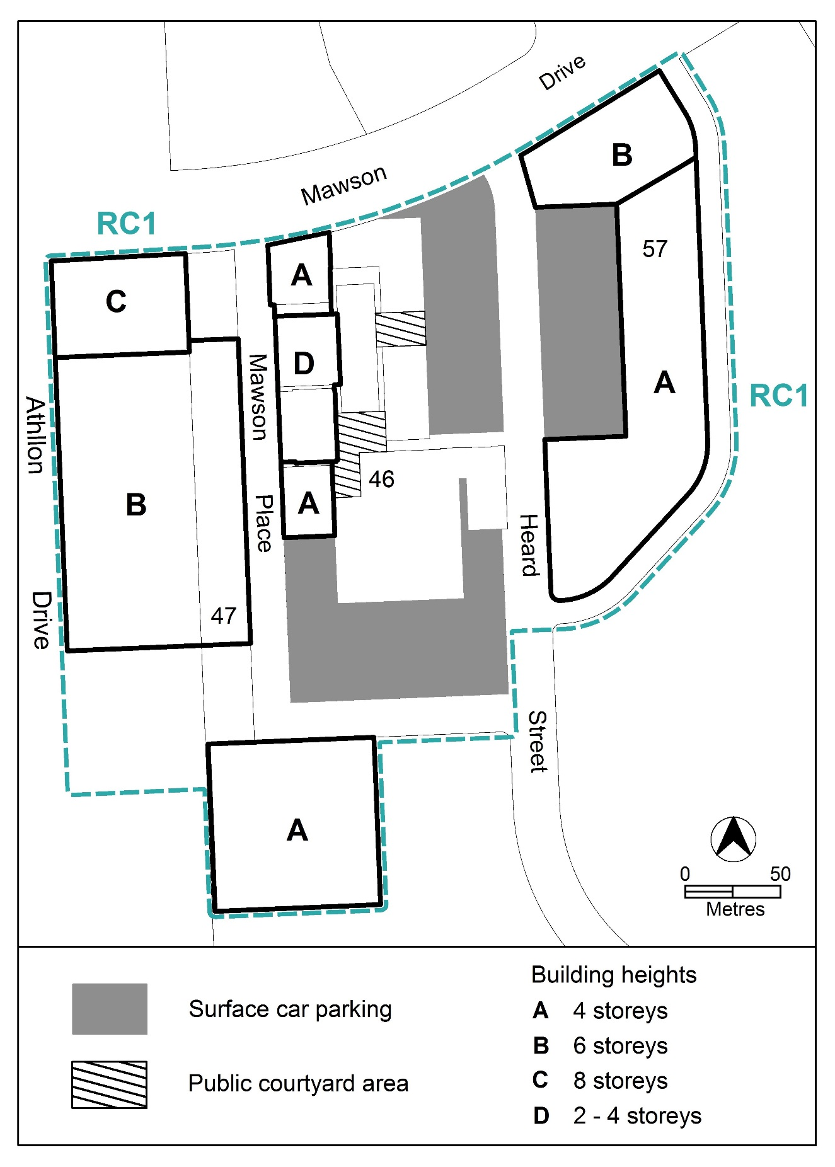
Figure 2

Rules | Criteria
  - Residential use
This rule applies to development with primary active frontage as identified in figure 1.  Dwellings are not permitted at the ground floor level. | This is a mandatory requirement. There is no applicable criterion.

- Buildings
Rules | Criteria
  - Building heights
The maximum height of building is two storeys, except for the following areas shown in figure 2:  - area A: maximum height of building is four storeys  - area B: maximum height of building is six storeys  - area C: maximum height of building is eight storeys.  Plant room set back a minimum of 3m from the building facade of the floor immediately below is not included in the number of storeys. | This is a mandatory requirement. There is no applicable criterion.
The maximum height of building for area D shown in figure 2 is two storeys. | The maximum height of building may be increased to up to four storeys where development retains reasonable solar access to the adjoining public square to the east between the hours of 12pm to 2pm during 21 June (winter solstice).
  - Built form
Buildings are built to the front boundary at ground level. Above ground floor level, the minimum front setbacks are:  - 0m up to three storeys above datum ground level  - 3m for the portion of development above three storeys up to eight storeys. | Building setbacks:  - contribute to the pedestrian orientated environment  - do not prejudice the future development of adjoining sites  - provide a reduction of the visual bulk and potential overshadowing impacts of taller buildings  - allow for light penetration, air circulation and privacy.
Block 8 and block 3 section 47, or the blocks resulting from the consolidation of either block with at least one other adjoining block, provides the mid block pedestrian link shown in figure 1 as part of any redevelopment, consolidation or subdivision of the block. | This is a mandatory requirement. There is no applicable criterion.
This rule applies to development in section 46.  Buildings, excluding awnings, do not overshadow the hatched courtyard areas identified in figure 2 beyond the shadow cast by a notional 8m high wall measured from the datum ground level at the boundary adjoining the public realm. | Development provides reasonable solar access to public and private areas of open space during winter months.
This rule applies to development in section 47 and section 57 directly adjoining the mid block pedestrian links shown in figure 1.  The minimum side setbacks to development along the mid block pedestrian link is:  - 3 m for the first three storeys above datum ground level  - 5m for the portion of development above three storeys up to six storeys. | Building setbacks:  - provide a reduction of the visual bulk and potential overshadowing impacts of taller buildings to the mid block pedestrian links  - allow for light penetration, air circulation and privacy.
This rule applies to residential development along primary active frontages shown in figure 1.  Development includes balconies and/or windows to main living areas addressing the street and public spaces. | Residential development provides opportunities for passive surveillance of public spaces.
This rule applies to CZ1 and CZ2.  The minimum floor to ceiling height at ground level is 3.6m. | Floor to ceiling heights:  - contribute to natural ventilation  - promote penetration of daylight  - are adaptable for commercial use.
This rule applies to development in area A in figure 1.  Buildings, excluding basement and/or awnings are set back a minimum of 15m from the western boundary of block 17 section 47. | Development ensures a strong physical and visual connection from Mawson Place to the Mawson District Playing Fields.
There is no applicable rule. | Structured car parks and podium car parks comply with the following:  - provide high quality architectural finishes to facades addressing public spaces  - where publicly accessible parking is provided, ensures pedestrian access and egress directly to public land.
  - Pedestrian routes
This rule applies to the blocks containing the mid block pedestrian links shown in figure 1.  Redevelopment and/or subdivision:  - provides proposed mid block pedestrian links as uncovered open laneways in the locations indicated  - retains the existing pedestrian routes. | Redevelopment and/or subdivision are consistent with the pattern of existing and proposed pedestrian links at the locations shown in figure 1.
This rule applies to the blocks containing the mid block pedestrian links shown in figure 1.  The mid block pedestrian links comply with all of the following:  - minimum unobstructed width is 6m  - remain publicly accessible at all times  - for new mid block pedestrian links, signage at each end identifying the connection provided. | Pedestrian connections achieve all of the following:  - sufficient width for pedestrian movement  - continuous public access  - identification of the available connection.
Key pedestrian routes shown in figure 1 are publicly accessible at all times, and comply with the requirements of the Crime Prevention Through Environmental Design general code. | This is a mandatory requirement. There is no applicable criterion.
This rule applies to the area shaded grey shown in figure 1.  Redevelopment and/or subdivision provides an open public courtyard space that complies with all of the following:  - is publicly accessible at all times  - is located at the southern end of the site and integrates with the adjoining key pedestrian route  - has a minimum north-south dimension of 14m measured from the southern boundary of the shaded area, and  - extends the width of the shaded area measuring east-west.  In addition, any building adjoining the open public courtyard:  - treats the façade facing the courtyard as a primary active frontage as described elsewhere in this code; and  - does not overshadow the courtyard area beyond the shadow cast by a notional 8m high wall measured from the datum ground level at the boundary adjoining the courtyard, excluding awnings. | Redevelopment and/or subdivision provide a publicly accessible courtyard to the south of the site that integrates with the existing public spaces and is fronted by windows, active uses and publicly accessible entrances.
  - Active frontages
For buildings located along primary active frontage areas identified in figure 1, ground floor frontages and building design comply with all of the following:  - buildings incorporate clear display windows and shop fronts at the ground level  - buildings incorporate direct pedestrian access at grade with the verge level for access and egress for persons with disabilities  - any small areas of walls without windows contain displays, showcases and/or public art, with a maximum of 30% blank frontage per tenancy. | Buildings achieve all of the following:  - direct pedestrian access from main pedestrian areas  - avoid extensive lengths of blank walls unrelieved by doors, display windows or the like.
For buildings located along secondary active frontage areas identified in figure 1:  - ground floor commercial building frontages incorporate:  - clear display windows and shop fronts at the ground floor level; and  - direct pedestrian access at grade for access and egress for persons with disabilities.  - ground floor residential building frontages incorporate:  - a separate access point for each ground floor dwelling; and  - commercial adaptable front facades. | Development at ground level achieves all of the following:  - is adaptable for commercial uses  - where building access is provided, direct pedestrian access at street level  - provide opportunities for views into and out of the building.
  - Awnings
This rule applies to buildings fronting primary active frontage areas shown in figure 1.  Buildings incorporate colonnades or awnings along the entire length of the building façade adjoining the front boundary, with a minimum height clearance of 3.2m, and a maximum height clearance of 4.3m.  NOTE:- Only cantilevered awnings (without posts) may be located outside of leased block boundaries. Colonnades (with support posts or columns) must be located within leased block boundaries. | Continuous all weather pedestrian shelter is provided in a form compatible with existing awnings or colonnades.
  - Screening
There is no applicable rule. | Waste collection areas are screened from public view.
  - Separation to playing fields
This rule applies to development in area ‘A’ shown in figure 1.  Development provides a minimum 30m separation from the district playing fields. | Development within 30m of the district playing fields will be referred to the agency responsible for sportsground management, and its advice considered before the determination of the application.

RC2 – Athllon Drive Corridor
This part applies to blocks and parcels identified in area RC2 shown on the Mawson Precinct Map.
- Built form
Rules | Criteria
  - Number of storeys
This rule applies to development in area ‘a’ and area ‘b’ shown in figure 3.  The maximum number of storeys is:  - for area ‘a’- 3, except where within 25m of the front boundary addressing Athllon Drive road reserve, where the maximum number of storeys is 6  - for area ‘b’- 4, except where within 35m of the front boundary adjoining Athllon Drive or Mawson Drive road reserve, where the maximum number of storeys is 6. | This is a mandatory requirement. There is no applicable criterion.
  - Setback
This rule applies to development in area ‘b’ shown in figure 3.  The minimum front setback to Athllon Drive boundary is 10m. | Building frontages to Athllon Drive provide a landscaped setting.
  - Open space interface
This rule applies to area ‘a’ in figure 3.  Development along the open space shared path provides all of the following:  - addresses the open space with windows to habitable rooms, balconies and areas of open space adjoining the shared boundary  - openings for pedestrian access to the open space shared path. | Development provides passive surveillance and pedestrian access to the shared path open space area.
  - Vehicle access
This rule applies to area ‘a’ in figure 3.  Development incorporates the indicative road layout. | This is a mandatory requirement. There is no applicable criterion.

- Heritage
  - Potential archaeological deposits
There is no applicable rule. | Development applications will be referred to the ACT Heritage Council, and its advice considered before the determination of the application.

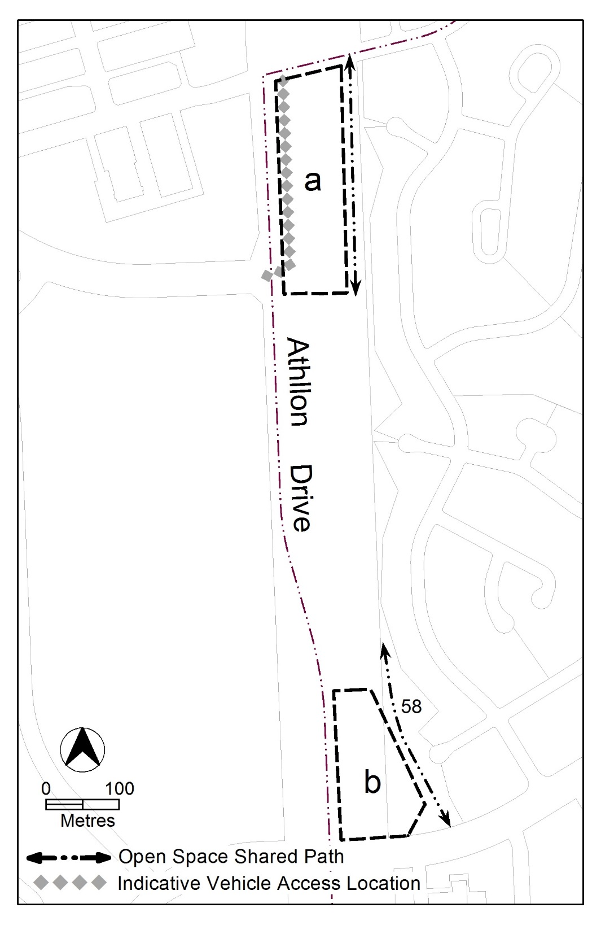
Figure 3

