Australian Capital Territory
Heritage (Decision about Provisional Registration of 40 Donaldson Street, Braddon) Notice 2019
Notifiable Instrument NI2019–186
made under the
Heritage Act 2004, s32 (Decision about provisional registration) and s34 (Notice of decision about provisional registration)

1 Name of instrument
This instrument is the Heritage (Decision about Provisional Registration of
40 Donaldson Street, Braddon) Notice 2019.
2 Decision about provisional registration
On 4 April 2019, the ACT Heritage Council (the Heritage Council) decided not to provisionally register 40 Donaldson Street, Block 4, Section 41, Braddon (the Place).
3 Description of the Place
The description of the Place is in the schedule.
4 Reasons for the decision
The Heritage Council is not satisfied on reasonable grounds that the Place is likely to have heritage significance as defined by section 10 of the Heritage Act 2004. The Place was demolished in 2018 and there is no remaining built fabric, as outlined in the schedule.
5 Date decision takes effect
The decision not to provisionally register the Place takes effect on 5 April 2019 (being the day after the Heritage Council made its decision in writing as set out in the schedule).

Fiona Moore
Secretary (as delegate for)
ACT Heritage Council
4 April 2019

Schedule
(See sections 3 and 4)
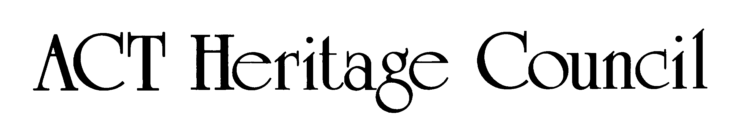

STATEMENT OF REASONS
DECISION NOT TO PROVISIONALLY REGISTER
40 DONALDSON STREET BRADDON
Braddon Block 4 Section 41
IN THE ACT HERITAGE REGISTER

Decision
The Heritage Council (the Council) has decided not to provisionally register 40 Donaldson Street Braddon. This is because the place was demolished in 2018, and there is therefore no place to which the potential heritage value could attach. Additionally, registration would have no effect as the place cannot be protected or conserved retrospectively.
The nomination claimed that the place was significant as the previous house and residence of former ACT magistrate F.C.P Keane. As all claims and evidence towards the heritage significance of the place relate intrinsically to the physical material of the building, the Council has decided not to conduct an assessment against the heritage significance criteria under s 10 of the Heritage Act 2004.
In order to provisionally register a place the Council must be satisfied on reasonable grounds that the place is likely to have heritage significance. The Council is not satisfied that the place is likely to have heritage significance because the place does not exist.

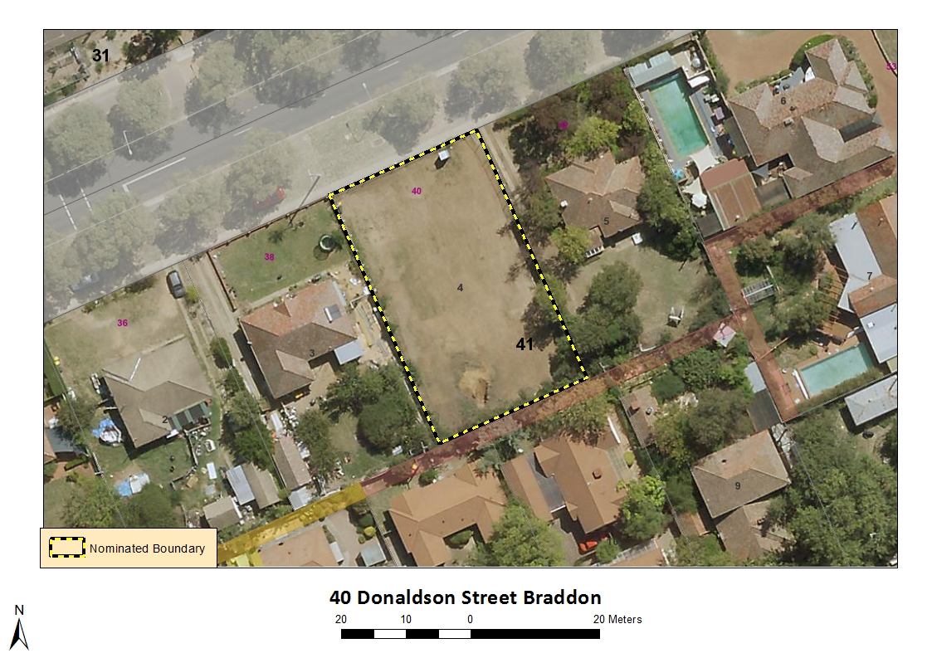
Image 1

