Australian Capital Territory

**Nature Conservation (Grey-headed Flying-fox) Conservation Advice 2019**

**Notifiable instrument NI2019–229**

made under the

**Nature Conservation Act 2014, s 90C (Conservation advice)**

**1 Name of instrument**

This instrument is the *Nature Conservation (Grey-headed Flying-fox) Conservation Advice 2019*.

**2 Commencement**

This instrument commences on the day after its notification day.

**3 Conservation advice for the Grey-headed Flying-fox**

Schedule 1 sets out the conservation advice for the Grey-headed Flying-fox (*Pteropus poliocephalus*).

Arthur Georges

Chair, Scientific Committee

1 May 2019

**Schedule 1**

(see s 3)

Conservation Advice  
Grey-headed Flying-fox  
*Pteropus poliocephalus*

Conservation Status

The Grey-headed Flying-fox *Pteropus poliocephalus* Temminck, 1825 is recognised as threatened in the following jurisdictions:

International **Vulnerable**, International Union of Conservation of Nature (IUCN) Red List

**Appendix II**, Convention on International Trade in Endangered Species of Wild Fauna and Flora (CITES)

National **Vulnerable**, *Environment Protection and Biodiversity Conservation Act 1999*

**Vulnerable**, *The Action Plan for Australian Mammals* 2012

ACT **Vulnerable**, *Nature Conservation Act 2014*

NSW **Vulnerable**, *Biodiversity Conservation Act 2016*

VIC **Threatened**, *Flora and Fauna Guarantee Ac*t 1988

**Vulnerable**, Advisory List of Threatened Fauna in Victoria 2013

SA **Rare**, *National Parks and Wildlife Act 1972*

[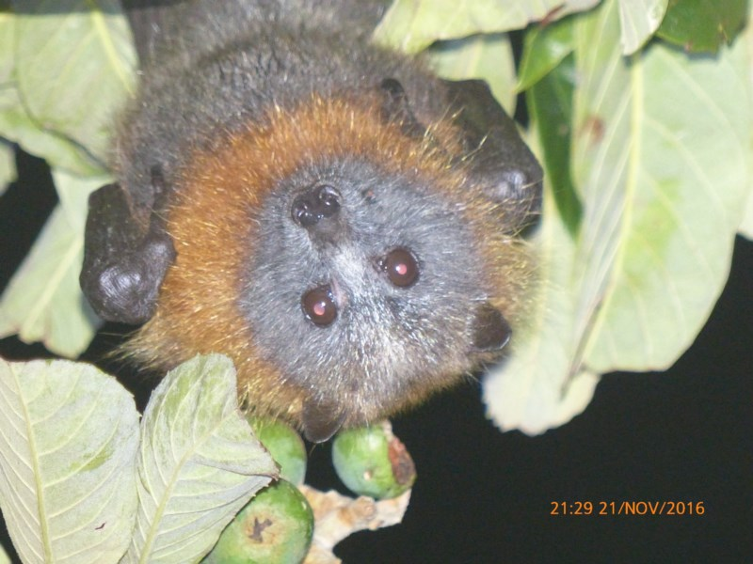](https://canberra.naturemapr.org/Community/Sightings/Details/3367729)ELIGIBILITY

The Grey-headed Flying-fox is listed as Vulnerable in the ACT Threatened Native Species List under IUCN Criterion A—A2(a)(b)(c). The factors that make it eligible include: a continuing population decline (>30%), over the last three generations (18–21 years) with continuation into the future due to shrinkage in distribution and loss of overwintering foraging habitat, and probable competition and hybridisation with *P. alecto* (Lunney et al. 2008).

DESCRIPTION AND ECOLOGY

The Grey-headed Flying-fox is one of the largest bats in the world. Adult males generally weigh between 750 and 1000 g, and weights as high as 1133 g have been recorded (Ratcliffe 1932; Tidemann 1995; J. Nelson, Monash University unpublished data in Department of Environment, Climate Change and Water (DECCW) 2009). Adult females generally weigh between 650 and 800 g. Although males and females differ in weight, their forearms are of similar length at 155 to 175 mm. Body fur is typically medium to dark grey, with many light-tipped hairs (Hall and Richards 2000). Fur on the head is also grey but varies in shade from near black to silver. An orange or russet-coloured mantle or collar encircles the neck and leg fur extends to the ankle which distinguishes the species from the similarly sized Black Flying-fox *P. alecto*, the legs of which are bare below the knee. Wing membranes are black (DECCW 2009).

[Grey-headed Flying Fox](https://canberra.naturemapr.org/Community/Sightings/Details/3367729) ([Chris Davey – Canberra Nature Map](https://canberra.naturemapr.org/Community/Sighting/3367729))

The species fill a very important pollination and seed dispersal role in our native forests. The primary food source are the flowers of Eucalyptus, Banksia, Melaleuca species, plus rainforest fruits. It roosts in colonies in patches of trees and dense vegetation (Lunney et al. 2008). The species requires multiple, dispersed populations of food trees (Duncan et al. 1999).

Females generally give birth to a single young (Duncan et al. 1999; Lunney et al. 2008). Generation length is likely to be around six or seven years (A. Divljan pers. comm. in Lunney et al. 2008).

Distribution and Habitat

The Grey-headed Flying-fox is endemic to eastern Australia, with a distribution ranging from Bundaberg in Queensland to Melbourne in Victoria. The range extends from the coast to the western slopes of New South Wales (NSW) with reports in South Australia. (TSSC 2001). The range has contracted from the north in recent years (and by 500 km in past 100 years) with an increase in the numbers and permanent colonies in the south (L. Lumsden pers. comm. in Lunney et al. 2008).

While sightings in inland areas of southern NSW were once uncommon (DECCW 2009), the Grey-headed Flying fox has become a regular visitor to the Australian Capital Territory (ACT) in recent years during the summer/autumn months and more recently has over-wintered. Records indicate a large colony visited the ACT and established a camp of up to 100 on Commonwealth land at Commonwealth Park in 2004 (Canberra.naturemapr.org (CNM) 2018). The National Capital Authority (NCA), in partnership with the Australasian Bat Society, undertakes survey counts of the camp throughout the year (NCA 2014). The colony’s numbers increased to several thousand by 2010 and 500 overwintered that year (Pennay in Cohen 2010). Wildlife ACT counted over 6000 by 2011. A maternity colony flew into Canberra to give birth in October 2013, prior to this the scouting colonies were predominantly males (Kirstie Hawkins in Westcott 2014). Over the last couple of years, a second camp established itself in an area near Lake Ginninderra and a new roosting location was potentially identified at Kowen forest in 2018 (M. Mulvaney in CNM 2018).

**Figure 1: Grey-headed Flying-fox surveys at Commonwealth Park, Canberra**

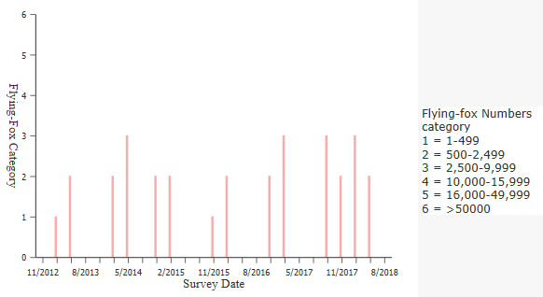

Source: Department of the Environment (2019).

The Grey-headed Flying-fox is found in tropical moist forest, open forest, closed and open woodlands, Melaleuca swamps, Banksia woodlands, mangroves, and commercial fruit plantations. It also occurs in urban areas where suitable foraging and roosting habitat are available (Lunney et al. 2008).

Threats

The primary threat to the Grey-headed Flying-fox is the loss of foraging and roosting habitat, largely through clearance of native vegetation for agriculture, forestry operations and urban development (Duncan et al. 1999). In the Australian Capital Territory, the main threat to Grey-headed Flying-foxes is entrapment in fine gauge netting loosely draped over backyard fruit trees. If nets are not tight they can easily become entangled.

Climate change is likely to increase the incidence of extreme hot days and affect the species (Welbergen et al. 2008). Impacts of climate change may also include changes to the phenology and productivity of key food species (Woinarski 2014).

Major Conservation Objectives

The overall objectives of recovery from the Draft Recovery Plan (DECCW 2009) are:

* to reduce the impact of threatening processes on Grey-headed Flying-foxes and arrest decline
* to conserve the functional roles of Grey-headed Flying-foxes in seed dispersal and pollination
* to improve the standard of information available to guide recovery of the Grey-headed Flying-fox, in order to increase community knowledge of the species and reduce the impact of negative public attitudes on the species.

Conservation Issues and Proposed Management Actions

Recommended management actions are provided and prioritised in the Draft Recovery Plan (DECCW 2009). Those applicable to the ACT include:

* identify and protect roosting and foraging habitat critical to the survival of Grey-headedFlying-foxes (special offset requirements in the ACT include no clearing of roosting trees, unless expert advice has been obtained and tree removal is justified on safety grounds (Department of Environment and Planning 2015))
* develop non-destructive methods for management of camps in problem areas
* improve public attitudes toward Grey-headed Flying-foxes, promote the recovery program to the wider community and encourage participation in recovery actions.

Other Relevant Advice, plans or Prescriptions

* [Commonwealth Listing Advice](http://www.environment.gov.au/biodiversity/threatened/species/p-poliocephalus.html) — Grey-headed Flying-fox (TSSC 2001)
* [Draft National Recovery Plan](https://www.environment.nsw.gov.au/resources/threatenedspecies/08214dnrpflyingfox.pdf) — Grey-headed Flying-fox (NSW DECCW 2009)
* The Action Plan for Australian Bats (Duncan et al. 1999)
* The Action Plan for Australian Mammals 2012 (Woinarski et al. 2014)

Listing Background

The Grey-headed Flying-foxwas listed as Vulnerable under the *Environment Protection and Biodiversity Conservation Act 1999* (EPBC Act) on 6 December 2001. In 2019, under the *Nature Conservation Act 2014*, the ACT Scientific Committee recommended the Grey-headed Flying-fox be listed in the Vulnerable category in the ACT Threatened Native Species List to align with the EPBC Act listing.

References

Canberra.naturemapr.org (CNM) 2018. Canberra Nature Map. <https://canberra.naturemapr.org/Community/Species/15502>.

Convention of International Trade in Endangered Species of Wild Fauna and Flora 2017. Appendices I, II and III, valid from 4 October 2017. <https://www.cites.org/eng/app/appendices.php>

Cohen S 2010. Bats in Canberra are here to stay, *Bush Capital Horse Forum*. <http://bushcapital.org.au/forum/index.php?topic=6188.0>

Department of the Environment 2019. National Flying-fox Monitoring Interactive Viewer. Commonwealth of Australia. Accessed 26 February 2019 from: <http://www.environment.gov.au/webgis-framework/apps/ffc-wide/ffc-wide.jsf>

Department of Environment, Climate Change and Water (DECCW) 2009. *Draft National Recovery Plan for the Grey-headed Flying-fox Pteropus poliocephalus.* Prepared by Dr Peggy Eby. NSW Department of Environment, Climate Change and Water, Sydney. <https://www.environment.nsw.gov.au/resources/threatenedspecies/08214dnrpflyingfox.pdf>

Department of Environment and Planning 2015. ACT Environmental Offsets Calculator Assessment Methodology. ACT Government Canberra. <http://www.environment.act.gov.au/__data/assets/pdf_file/0005/728600/Schedule-1-Environmental-offsets-Assessment-Methodology-FINAL-2.pdf>

Duncan A, Baker GB and Montgomery N (1999). *The Action Plan for Australian Bats*. Environment Australia, Canberra. <http://www.environment.gov.au/biodiversity/threatened/publications/action/bats/index.html>

Lunney D, Richards G and Dickman C 2008. *Pteropus poliocephalus*. *The IUCN Red List of Threatened Species 2008.* <http://dx.doi.org/10.2305/IUCN.UK.2008.RLTS.T18751A8554062.en>

National Capital Authority (NCA) 2014. *Grey Headed Flying Fox Information Sheet*. National Capital Authority. <https://www.nca.gov.au/national-land/asset-management/grey-headed-flying-fox-information-sheet>

Office of Environment and Heritage (OEH) 2016. National Flying-fox Monitoring Program. NSW Office of Environment and Heritage. <http://www.environment.nsw.gov.au/animals/NFFMP.htm>

Threatened Species Scientific Committee (2001). Commonwealth Listing Advice on *Pteropus poliocephalus* (Grey-headed Flying-fox). <http://www.environment.gov.au/biodiversity/threatened/species/p-poliocephalus.html>

Welbergen JA, Klose SM, Markus N and Eby P 2008. Climate change and the effects of temperature extremes on Australian flying-foxes. Proceedings of the Royal Society B-Biological Sciences 275: 419-425. <https://doi.org/10.1098/rspb.2007.1385>

Westcott B 2014. Canberra's bat numbers soar but they are doing more good than harm, so far. *Canberra Times,* 28 January 2014.  
<http://www.canberratimes.com.au/act-news/canberras-bat-numbers-soar-but-they-are-doing-more-good-than-harm-so-far-20140127-31j5b.html>

Woinarski JCZ, Burbidge AA and Harrison PL 2014. *The Action Plan for Australian Mammals 2012*. CSIRO Publishing, Collingwood.

Further Information

Further information on this species or other threatened species and ecological communities can be obtained from the Environment, Planning and Sustainable Development Directorate (EPSDD).

Phone: (02) 132281, EPSDD Website: <http://www.environment.act.gov.au/cpr>