Australian Capital Territory

Nature Conservation (Kiandra Greenhood) Conservation Advice 2019

Notifiable instrument NI2019–236
made under the
Nature Conservation Act 2014, s 90C (Conservation advice)

- Name of instrument
This instrument is the Nature Conservation (Kiandra Greenhood) Conservation Advice 2019.
- Commencement
This instrument commences on the day after its notification day.
- Conservation advice for the Kiandra Greenhood
Schedule 1 sets out the conservation advice for the Kiandra Greenhood (Pterostylis oreophila).

Arthur Georges
Chair, Scientific Committee
1 May 2019
Schedule 1
(see s 3)

Conservation Advice
Kiandra Greenhood
Pterostylis oreophila

Conservation Status
The Kiandra Greenhood Pterostylis oreophila Clemesha (1974) is recognised as threatened in the following jurisdictions:
National Critically Endangered, Environment Protection and Biodiversity Conservation Act 1999
ACT Critically Endangered, Nature Conservation Act 2014
NSW Critically Endangered, Biodiversity Conservation Act 2016
Victoria Endangered, Advisory List of Rare or Threatened Plants in Victoria, 2014

ELIGIBILITY
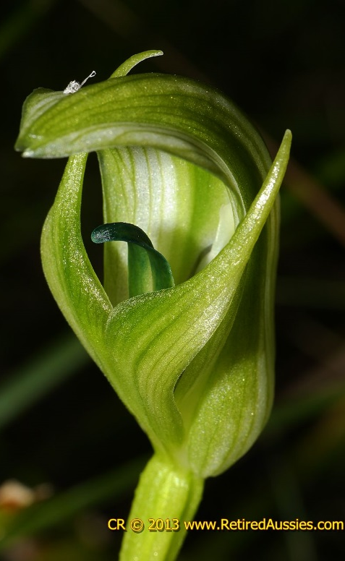
The Kiandra Greenhood is listed as Critically Endangered in the ACT Threatened Native Species List under IUCN Criterion B and Criterion C. The factors that make it eligible include the very low number of mature individuals and the species’ distribution is very restricted and precarious for its survival due to fragmentation and ongoing threats (Threatened Species Scientific Committee (TSSC) 2012).

DESCRIPTION AND ECOLOGY
The Kiandra Greenhood, also known as the Blue-tongued Greenhood, is a terrestrial orchid growing to 200 mm tall, with dark green, fleshy, flat leaves. Basal leaves are stalked, whilst the other leaves are stalkless and are scattered up the stem. The flower stem is smooth. The solitary flowers are erect, light green and white, and 25–30 mm long x 12–16 mm wide. The recurved labellum is a distinctive bluish or blue-green (aqua) colour. The sharply pointed dorsal sepal is of a similar length to the petals (Jones 2006; NSW SC 2008).
Flowering occurs from November to January and small gnats and/or mosquitoes pollinate the flowers (Jones 2006). Pods develop to ripening during December to March. It is possible that germination from seed is the only reproductive pathway (P. Branwhite pers. comm. 2010 in TSSC 2012).
Kiandra Greenhood (Colin and Mischa Rowan)

Distribution and Habitat
The Kiandra Greenhood occurs in 20 sites in four distinct geographic locations: the Brindabella Ranges in the ACT; the Kiandra and Bago areas of NSW; and north-east Victoria (NSW SC, 2008). Across this range the population is extremely fragmented and occurs in restricted alpine habitats. There are 240 confirmed sexually-mature individuals. The extent of occurrence and area of occupancy of this species are unknown, however the low number of sexually-mature individuals and severe fragmentation, strongly suggests the species has a very restricted geographic distribution. Given the current threats to the species, it is likely that the number of known plants will decline (Department of Environment (DoE) 2012).

The species is restricted to growing beside small montane and subalpine streams under tall dense thickets of Mountain Tea Tree (Leptospermum grandiflorum), in black oozing mud or less commonly in peaty soils and sphagnum mounds (Jones 2006). This type of habitat occurs throughout much of the upper areas of Kosciuszko National Park and the Alpine National Park areas in Victoria (M. Clements pers. comm. 2011 in TSSC 2012). The distribution of this species overlaps with the ‘Alpine Sphagnum Bogs and Associated Fens’ EPBC Act—listed threatened ecological community (DoE 2012).
Records of the Kiandra Greenhood in the ACT are from three sub-populations with a total of approximately 60 mature plants in Namadgi National Park in the Brindabella Ranges (TSSC 2012).

Threats
The main threats to the Kiandra Greenhood identified in the Commonwealth Conservation Advice (DoE 2012) that may be relevant to the sub-populations in the ACT include:
- grazing and trampling
- altered hydrology due to the impacts of grazing
- soil disturbance by rooting by feral pigs and trampling
- weed invasion
- inappropriate land management including inappropriate fire regimes (NSW SC, 2008)
- plant collection.
In the ACT, two particular threats to the vegetation of the Namadgi National Park are pest animals and weeds. Pest animals, such as hoofed grazers (pigs, goats, horses) and rabbits have the potential to damage the integrity of vegetation communities by selective grazing, over-grazing, and disturbing soil, leading to erosion and weed invasion. Many parts of Namadgi are relatively weed-free, weeds mainly being restricted to roadsides and along management tracks and land previously used for grazing. A comprehensive weed management program is essential to control existing weeds and keep new invasive species from establishing in the park (ACT Government 2010).

Major Conservation Objectives
The Commonwealth TSSC recommends there should be a national recovery plan prepared for the Kiandra Greenhood as a high level of planning may be required because of its wide distribution in fragmented sub-populations over three jurisdictions and numerous stakeholders. In addition, there do not appear to be any programs in place to recover the species and a high level of priority recovery actions may be required (TSSC 2012).
Conservation of habitat involves, in particular, management actions to deal with or avoid the potential threats outlined above, ensuring that the sites are not deleteriously affected by grazing and trampling, weeds are controlled, and the sites are protected from potentially damaging fires.

Conservation Issues and Proposed Management Actions
Several of the following actions specific to the Kiandra Greenhood from the Commonwealth Conservation Advice (DoE 2012) may be relevant in the ACT and are generally supported in the Namadgi National Park Plan of Management (ACT Government 2010). Management of populations of the Kiandra Greenhood will be undertaken in the context of Chapter 5, Objective 5.9 of this reserve management plan, in particular:
- identify populations of high conservation priority
- monitor known populations to identify key threats
- ensure there is no unnecessary disturbance in areas where the Kiandra Greenhood occurs
- manage any changes to hydrology
- appropriately manage sites to prevent introduction of threatening weeds, especially invasive weeds
- maintain the eradication of feral horses and control pigs in the region
- include considerations and maps in fire management strategies or plans for Kiandra Greenhood habitat
- monitor the progress of recovery, including the effectiveness of management actions and the need to adapt them if necessary
- raise awareness of the Kiandra Greenhood within the local community
- implement ACT Conservator translocation guidelines (ACT Government 2017) if establishing additional populations is considered necessary and feasible.

Other Relevant Advice, plans or Prescriptions

Commonwealth Listing Advice — Kiandra Greenhood (TSSC 2012)
- Commonwealth Conservation Advice — Kiandra Greenhood (DoE 2012)
- The Namadgi National Park Plan of Management 2010 (ACT Government 2010)
- Ginini Flats Wetland Complex Ramsar Site Management Plan (ACT Government 2017)
- ACT Conservation Advice — High Country Bogs and Fens (Scientific Committee 2019)

LISTING BACKGROUND
The Kiandra Greenhood was listed as Critically Endangered under the Environment Protection and Biodiversity Conservation Act 1999 (EPBC Act) on 3 May 2012 (meeting EPBC Criterion 2 and Criterion 3). In 2019, under the Nature Conservation Act 2014, the ACT Scientific Committee recommended the Kiandra Greenhood be listed in the Critically Endangered category in the ACT Threatened Native Species List to align with the EPBC Act listing.

References
ACT Government 2010. Namadgi National Park Plan of Management 2010. Department of Territory and Municipal Services, Canberra. https://www.legislation.act.gov.au/View/di/2010-192/current/PDF/2010-192.PDF.
ACT Government 2017. Ginini Flats Wetland Complex Ramsar Site Management Plan. Environment, Planning and Sustainable Development Directorate, ACT Government, Canberra.
ACT Government 2017. Nature Conservation (Translocation of Native Flora and Fauna) Conservator Guidelines. Environment, Planning and Sustainable Development Directorate, ACT Government, Canberra. https://www.legislation.act.gov.au/View/ni/2017-650/current/PDF/2017-650.PDF.
Atlas of Living Australia (ALA) 2018. Atlas of Living Australia. http://www.ala.org.au/
Clemesha SC 1974. A new Pterostylis from southern New South Wales. The Orchadian 4(11): 100.

Department of Environment (DoE) 2012. Approved Conservation Advice for Pterostylis oreophila (Kiandra Greenhood). Department of Sustainability, Environment, Water, Population and Communities. Australian Government, Canberra.

Jones DL 2006. A Complete Guide to Native Orchids of Australia: Including the Island Territories. Reed New Holland, Frenchs Forest.

New South Wales Scientific Committee (NSW SC) 2008. Pterostylis oreophila (an orchid) – critically endangered species listing. Final determination.
Scientific Committee 2019. Conservation Advice – High Country Bogs and Associated Fens Ecological Community. Environment Planning and Sustainable Development, ACT Government Canberra. https://www.legislation.act.gov.au/ni/2019-66/
Threatened Species Scientific Committee (TSSC) 2012. Commonwealth Listing Advice on Pterostylis oreophila (Kiandra Greenhood). Department of Sustainability, Environment, Water, Population and Communities. Australian Government Canberra.

Further Information
Further information on this or other threatened species and ecological communities can be obtained from the Environment, Planning and Sustainable Development Directorate (EPSDD).
Phone: (02) 132281, EPSDD Website: http://www.environment.act.gov.au/cpr

