Australian Capital Territory

Nature Conservation (Pale Pomaderris) Conservation Advice 2019

Notifiable instrument NI2019–237
made under the
Nature Conservation Act 2014, s 90C (Conservation advice)

- Name of instrument
This instrument is the Nature Conservation (Pale Pomaderris) Conservation Advice 2019.
- Commencement
This instrument commences on the day after its notification day.
- Conservation advice for the Pale Pomaderris
Schedule 1 sets out the conservation advice for the Pale Pomaderris (Pomaderris pallida).

Arthur Georges
Chair, Scientific Committee
1 May 2019
Schedule 1
(see s 3)

Conservation Advice
PALE POMADERRIS
Pomaderris pallida

Conservation Status
Pale Pomaderris Pomaderris pallida N.A.Wakef (Wakefield 1951) is recognised as threatened in these jurisdictions:
National Vulnerable, Environment Protection and Biodiversity Conservation Act 1999
ACT Vulnerable, Nature Conservation Act 2014
NSW Vulnerable, Biodiversity Conservation Act 2016

ELIGIBILITY
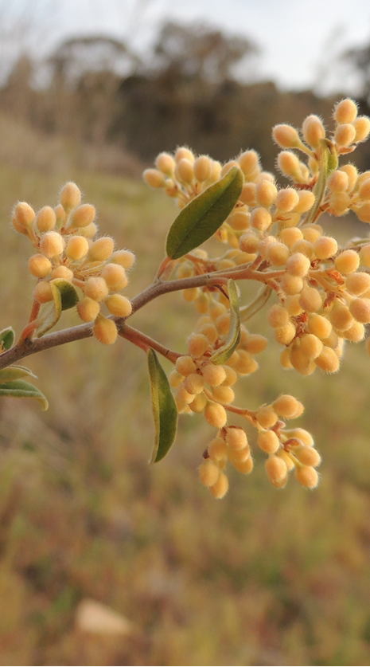
Pale Pomaderris is listed as Vulnerable in the ACT Threatened Native Species List as it is listed as Vulnerable under the Environment Protection and Biodiversity Conservation Act 1999 (Cwlth) (EPBC Act) due to its small area of distribution and ongoing threats (Department of Environment (DoE) 2008).

DESCRIPTION AND ECOLOGY
Pale Pomaderris, family Rhamnaceae, is a small round shrub up to 1.5 m high. Leaves are small, narrow or elliptical and up to 18 mm long and 7 mm wide. Both leaf surfaces are covered in a dense mat of soft, star-shaped hairs. The upper surface is pale green and the lower surface is greyish-white. The flowers are pale yellow, small, and have five sepals which are petal-like structures. The flowers are on short stalks and arranged in clusters in axils of leaves towards the ends of the outer branchlets. The fruits are small, dry, three-chambered capsules (Office of Environment and Heritage (OEH) 2018).
Flowering occurs from mid-September to December. There is a lack of ecological information and a need to increase the understanding of the ecological requirements for this species (OEH 2018).
Pale Pomaderris (Michael Bedingfield – Canberra Nature Map)

Distribution and Habitat
Pale Pomaderris is known to occur in the ACT, southern NSW, and eastern Victoria with the majority of the populations located along the Murrumbidgee, Cotter, and Paddys Rivers in the ACT (as of 2008). This species is conserved in Namadgi National Park (NP), Bullen Range Nature Reserve and Stony Creek Nature Reserve, each with fewer than 1000 individuals (Briggs & Leigh, 1995). It is also protected in Melrose Nature Reserve, Tuggeranong Nature Reserve, Rob Roy Nature Reserve and McQuoids Hill Nature Reserve.
In NSW, five key sites for priority management have been identified, including Queanbeyan River (near Queanbeyan with 250 plants), Tinderry Nature Reserve (730 plants), Murrumbidgee River (500 plants), Dangelong Nature Reserve (300 plants) and Byadbo Wilderness (in Kosciuszko National Park with 3000 plants) (OEH 2018).
Other populations are known from the Molonglo River, Kydra Trig and Shoalhaven River (DoE 2008).
Pale Pomaderris has been recorded in the ACT at Belconnen, Booth, Bullen Range, Calwell, Conder, Coree, Gigerline, Greenway, Kambah Pool, Kambah, Kowen Forest, Lower Molonglo, Mcquoids Hill, Namadgi National Park, Paddys River, Murrumbidgee River (Pine Island to Point Hut), Rendezvous Creek, Rob Roy Range, Stony Creek, Stromlo, Tennent, Theodore, Tuggeranong Hill, Tuggeranong, Uriarra Recreation (Canberra.naturemapr.org 2018).
Pale Pomaderris is found in dry open forests and shrub communities. The mid-stratum often has Grevillea juniperina, Bursaria spinosa, Acacia rubida, and Kunzea ericoides (Briggs and Leigh 1985) surrounded by Brittle Gum (Eucalyptus mannifera) and Red Stringybark (E. macrorhyncha) or Callitris spp. woodland (OEH 2018). The ACT sites are only on the eastern banks of the rivers, with an aspect ranging from north-westerly through westerly to southerly. The soils are shallow, pale brown sandy loams over granite rock and large, exposed granite boulders may be present (DoE 2008).

Threats
The main identified threats in the Commonwealth Conservation Advice (DoE 2008) include:
- rural residential development
- weed competition, particularly Blackberry (Rubus sp.)
- browsing by Feral Goats (Capra hircus)
- inappropriate fire regimes too frequent fires will potentially eliminate populations
- increasing fragmentation
- loss of remnants.
Other threats identified in NSW (OEH 2018) include:
- browsing by other feral animals including deer, goats and potentially horses and grazing by livestock and kangaroos
- sediment runoff from fire trails
- flood damage in smaller riparian populations where frequent flooding may disrupt the lifecycle to the extent that the soil seedbank may be affected
- low genetic diversity in isolated small populations that are likely to be at higher risk of loss from stochastic events
- lack of knowledge regarding dormancy thresholds, seed vigour and seedling and plant performance for this species, which is known to be triploid (three sets of chromosomes).

Major Conservation Objectives
The primary objective in the ACT is to maintain known populations of Pale Pomaderris.

Conservation Issues and Proposed Management Actions
Conservation actions identified in NSW (OEH 2018) relevant to management of ACT populations of Pale Pomaderris may include:
- minimise impacts of development
- remove woody weeds, particularly Blackberry (Rubus sp.), using appropriate methods that ensure habitat and species protection
- control of livestock and feral animals
- ensure planning for hazard reduction burns identifies the habitat of the species to avoid impacts
- following burning, protect populations (where possible) from further fires until plants have reached reproductive maturity. The NSW Rural Fire Service (RFS) recommends no fire more than once every 20 years; no slashing more frequently than every 10 years; and no trittering or tree removal for Pale Pomaderris (NSW RFS, 2018).

Other Relevant Advice, plans or Prescriptions
- ACT Aquatic and Riparian Conservation Strategy (ACT Government 2018a)
- Lower Cotter Catchment Reserve Management Plan (ACT Government 2018b)
- Lower Molonglo River Corridor Management Plan (ACT Government 2001)
- Commonwealth Conservation Advice — Pale Pomaderris (DoE 2008)

Listing Background
Pale Pomaderris is eligible for listing as Vulnerable under the Environment Protection and Biodiversity Conservation Act 1999 (EPBC Act) as, prior to the commencement of the EPBC Act, it was listed as vulnerable under Schedule 1 of the Endangered Species Protection Act 1992 (Cwlth). In 2019, under the Nature Conservation Act 2014, the ACT Scientific Committee recommended that Pale Pomaderris be listed in the Vulnerable category in the ACT Threatened Native Species List to align with the EPBC Act listing.

References
ACT Government 2001. Lower Molonglo River Corridor Management Plan. ACT Government, Canberra. https://www.legislation.act.gov.au/View/di/2001-298/20010927-704/PDF/2001-298.PDF
ACT Government 2018a. ACT Aquatic and Riparian Conservation Strategy and Action Plans. ACT Government, Canberra. http://www.environment.act.gov.au/__data/assets/pdf_file/0011/1244729/ACT-Aquatic-and-Riparian-Conservation-Strategy.pdf
ACT Government 2018b. Lower Cotter Catchment Reserve Management Plan. ACT Government, Canberra. https://www.environment.act.gov.au/__data/assets/pdf_file/0003/1166565/Lower-Cotter-Catchment-Reserve-Management-Plan-ACCESS.pdf
Atlas of Living Australia (ALA) 2018. Atlas of Living Australia. Accessed 10 October 2018 from: http://www.ala.org.au/
Briggs JD and Leigh JH 1985. Delineation of Important Habitats of Rare and Threatened Plant Species in the Australian Capital Territory. Final Report. National Estate Grants Program, Canberra.
Canberra.naturemapr.org (CNM) 2018. Canberra Nature Map. Accessed 10 October 2018 from: https://canberra.naturemapr.org/Community/Species/3421
Department of the Environment, Water Heritage and the Arts (DoE) 2008. Approved Conservation Advice for Pomaderris pallida. Commonwealth Government. Canberra.
Moore IF 2005. The Recovery and Ecology of Pomaderris pallida. Unpublished Masters’ Thesis, University of New England, Armidale.
NSW Rural Fire Service (RFS) 2018. Threatened Species Hazard Reduction List: Part 1 – Plants. NSW Rural Fire Service. Accessed 15 October 2018 from: https://www.rfs.nsw.gov.au/__data/assets/pdf_file/0017/24335/Web-Version-ThreatenedSpeciesHazardReductionList-Part1-Plants-06-04-2017.pdf
Office of Environment and Heritage (OEH) 2018. Pale Pomaderris – profile. OEH NSW, Sydney. Accessed 10 October 2018 from: http://www.environment.nsw.gov.au/threatenedspecies/
Wakefield NA 1951. New species of Pomaderris. The Victorian Naturalist 68(8): 141–143.

Further Information
Further information on the species or other threatened species and ecological communities can be obtained from the Environment, Planning and Sustainable Development Directorate (EPSDD).
Phone: (02) 132281, EPSDD Website: http://www.environment.act.gov.au/cpr

