Australian Capital Territory

Nature Conservation (Austral Toadflax) Conservation Advice 2019

Notifiable instrument NI2019–238
made under the
Nature Conservation Act 2014, s 90C (Conservation advice)

1 Name of instrument
This instrument is the Nature Conservation (Austral Toadflax) Conservation Advice 2019.

2 Commencement
This instrument commences on the day after its notification day.

3 Conservation advice for the Austral Toadflax
Schedule 1 sets out the conservation advice for the Austral Toadflax (Thesium australe).

Arthur Georges
Chair, Scientific Committee
1 May 2019
Schedule 1
(see s 3)

Conservation Advice
AUSTRAL TOADFLAX
Thesium australe

Conservation Status
Austral Toadflax Thesium australe R.Br. (Brown, 1810) is recognised as threatened in the following jurisdictions:
National Vulnerable, Environment Protection and Biodiversity Conservation Act 1999
ACT Vulnerable, Nature Conservation Act 2014
NSW Vulnerable, Biodiversity Conservation Act 2016
VIC Threatened, Flora and Fauna Guarantee Act 1988
Vulnerable, Advisory List of Threatened Vertebrate Fauna 2013
QLD Vulnerable, Nature Conservation Act 1992
TAS Extinct, Threatened Species Protection Act 1995

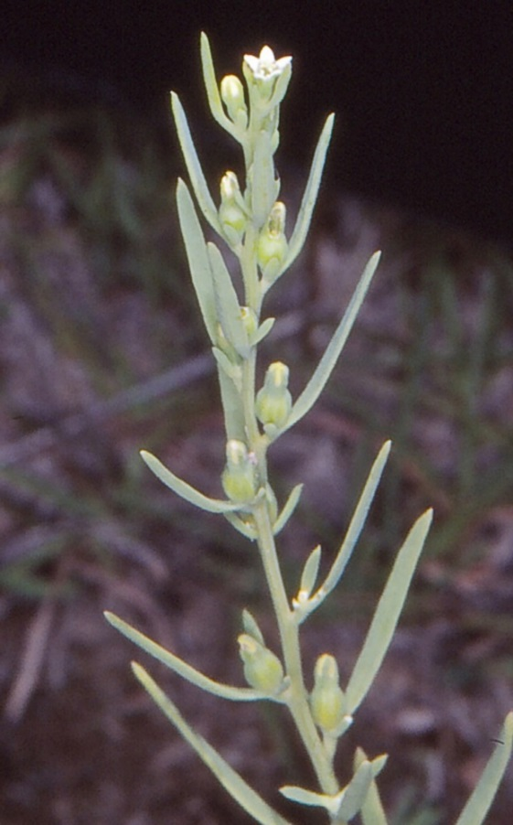
ELIGIBILITY
Austral Toadflax is listed as Vulnerable in the ACT Threatened Native Species List as it is listed as vulnerable under the Environment Protection and Biodiversity Conservation Act 1999 (Cwlth) (EPBC Act) (Department of the Environment (DoE) 2013).

DESCRIPTION AND ECOLOGY
The Austral Toadflax in the family Santalaceae, is a hairless, yellow-green perennial herb with slender wiry stems to 40 cm high and tiny white flowers (George 1984; Harden 1992; Eddy et al. 1998).
Austral Toadflax mostly flowers in spring and summer (Jeanes, 1999). It is semi-parasitic, deriving water and mineral salts from the roots of other grassland species (Leigh et al. 1984), notably Kangaroo Grass (Themeda australis) (Scarlett et al. 2003). Attempts to germinate seed from the ACT populations were unsuccessful (Briggs and Leigh 1985).
Austral Toadflax (Don and Betty Wood – Canberra Nature Map)

Distribution and Habitat
Austral Toadflax occurs in coastal and neighbouring tableland areas of south-eastern Australia (Scarlett et al. 2003; OEH, 2018). Its distribution is sporadic but widespread (ALA 2018). The species was recorded once in Tasmania, from the Derwent River valley in 1804 and is considered extinct in that state (DPIWE, 2003).
All known populations of Austral Toadflax in the ACT occur in nature reserves, including, Mulligans Flat Nature Reserve, Kambah Pool Reserve, Tidbinbilla Nature Reserve (two populations) and Namadgi National Park (ACT Government 2004). Austral Toadflax has also been recorded at Stromlo, Bonython, Tuggeranong (near Gigerline Nature Reserve in 2015), Bullen Range, Paddys River, Murrumbidgee River (Pine Island/Point Hut in 2007) and Tennent (Canberra.naturemapr.org 2018).
The species is found on a variety of soil types over a wide range of altitudes in grassland, grassy woodland and grassy heath (ACT Government 2004).

Threats
The small localised nature of occurrences and small population numbers make the local populations susceptible to impacts. Threats are heavy grazing (stock, rabbits, kangaroos and grasshoppers) and the development of dense shrub or tree cover (ACT Government 2004). Loss and degradation of habitat and/or populations due to: residential, infrastructure and agricultural developments; intensification of grazing regimes; and invasion of weeds were also identified as threats (OEH 2018).

Major Conservation Objectives
The primary objective in the ACT is to maintain known populations of Austral Toadflax.

Conservation Issues and Proposed Management Actions
Potential conservation actions (ACT Government 2004) include:
- manage sites to retain an open vegetation structure
- minimise impacts of grazing by kangaroos and rabbits
- monitor the species as appropriate in suitable habitat (e.g. Kangaroo Grass in grassy woodlands)
- encourage research that will assist in maintaining the species.

Other Relevant Advice, plans or Prescriptions
- ACT Woodland Conservation Strategy (ACT Government 2004)
- Commonwealth Conservation Advice — Austral Toadflax (DoE 2013)

Listing Background
The Austral Toadflax is eligible for listing as Vulnerable under the Environment Protection and Biodiversity Conservation Act 1999 (EPBC Act) as, prior to the commencement of the EPBC Act, it was listed as Vulnerable under Schedule 1 of the Endangered Species Protection Act 1992 (Cwlth). In 2019, under the Nature Conservation Act 2014, the ACT Scientific Committee recommended that Austral Toadflax be listed in the Vulnerable category in the ACT Threatened Native Species List to align with the EPBC Act listing.

References
ACT Government 2004. Woodlands for Wildlife: ACT Lowland Woodland Conservation Strategy. Action Plan No. 27. Environment ACT, Canberra.
Atlas of Living Australia (ALA) 2018. Atlas of Living Australia. Accessed 10 October 2018 from: http://www.ala.org.au/
Briggs JD and Leigh JH 1985. Delineation of Important Habitats of Rare and Threatened Plant Species in the Australian Capital Territory. Final Report, National Estate Grants Program, Canberra.
Brown R 1810. Prodromus florae Novae Hollandiae et insulae Van-Diemen, exhibens characteres plantarum quas annis 1802–1805.
Canberra.naturemapr.org (CNM) 2018. Canberra Nature Map. Accessed 10 October 2018 from: https://canberra.naturemapr.org/Community/Species/3439
Department of Primary Industries, Water and Environment (DPIWE) 2003. Threatened Species Notesheet — Thesium australe. Tasmania DPIWE, Hobart. Accessed 10 October 2018 from: https://dpipwe.tas.gov.au/Documents/Thesium-australe.pdf
Department of the Environment (DoE) 2013. Approved Conservation Advice for Thesium australe (Austral Toadflax). Department of the Environment. Canberra. Accessed 10 October 2018 from: http://www.environment.gov.au/biodiversity/threatened/species/pubs/15202-conservation-advice.pdf
Eddy D, Mallinson D, Rehwinkel R, and Sharp S 1998. Grassland Flora: a field guide for the Southern Tablelands (NSW and ACT.) WWF Australia, Australian National Botanic Gardens, NSW National Parks and Wildlife Service, and Environment ACT, Canberra.
George AS (1984). Thesium. In: Flora of Australia 22:67. Australian Government Printing Service, Canberra.
Harden GJ (ed.) 1992. Flora of New South Wales Volume 3. University of NSW Press, Kensington.
Jeanes JA 1999. Thesium. In: Walsh NG and Entwisle TJ (eds). Flora of Victoria 4:37. Inkata Press, Melbourne,
Leigh J, Boden R and Briggs J 1984. Extinct and Endangered Plants of Australia. Macmillan, Melbourne.
Office of Environment and Heritage (OEH) 2018. Austral Toadflax – profile. OEH NSW, Sydney. Accessed 13 February 2019 from: http://www.environment.nsw.gov.au/threatenedspecies/
Scarlett NH, Branwell M and Earl G 2003. Action Statement No. 56 Austral Toad-flax Thesium australe. Department of Sustainability and Environment, Melbourne. Accessed 13 February 2019 from: https://www.environment.vic.gov.au/__data/assets/pdf_file/0023/32567/Austral_Toad-flax_Thesium_australe.pdf

Further Information
Further information on the species or other threatened species and ecological communities can be obtained from the Environment, Planning and Sustainable Development Directorate (EPSDD).
Phone: (02) 132281, EPSDD Website: http://www.environment.act.gov.au/cpr

