Australian Capital Territory

Nature Conservation (Australasian Bittern) Conservation Advice 2019

Notifiable instrument NI2019–246
made under the
Nature Conservation Act 2014, s 90C (Conservation advice)

1 Name of instrument
This instrument is the Nature Conservation (Australasian Bittern) Conservation Advice 2019.

2 Commencement
This instrument commences on the day after its notification day.

3 Conservation advice for the Australasian Bittern
Schedule 1 sets out the conservation advice for the Australasian Bittern (Botaurus poiciloptilus).

Arthur Georges
Chair, Scientific Committee
1 May 2019
Schedule 1
(see s 3)

Conservation Advice
Australasian Bittern
Botaurus poiciloptilus

Conservation Status
The Australasian Bittern Botaurus poiciloptilus (Wagler, 1827) is recognised as threatened in the following jurisdictions:
International Endangered, International Union of Conservation of Nature (IUCN) Red List
National Endangered, Environment Protection and Biodiversity Conservation Act 1999
Endangered, Action Plan for Australian Birds 2010
ACT Endangered, Nature Conservation Act 2014
NSW Endangered, Biodiversity Conservation Act 1995
VIC Threatened, Flora and Fauna Guarantee Act 1988
Endangered, Advisory List of Threatened Vertebrate Fauna 2013
QLD Endangered, Nature Conservation Act 1992
SA Vulnerable, National Parks and Wildlife Act 1972
WA Endangered, Biodiversity Conservation Act 2016

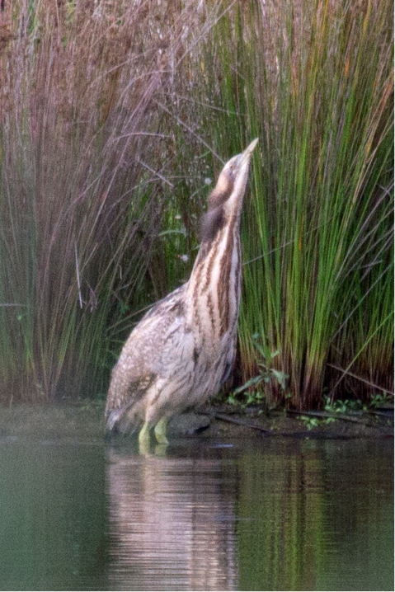
ELIGIBILITY
The Australasian Bittern is listed as Endangered in the ACT Threatened Native Species List under IUCN Criterion A — A2(c) and Criterion C — C1. The factors that make it eligible include: low estimated total numbers (250–800) across the entire range with severe population decline (>50%) over the past three generations (16.5 years); the threats and causes of decline have not ceased and are likely to continue to reduce the area of occupancy (> 20% over two generations); with the loss of habitat and breeding grounds of the species leading to a further decline in population (Threatened Species Scientific Committee (TSSC) 2011).

DESCRIPTION AND ECOLOGY
The Australasian Bittern is a large, secretive, stocky, thick-necked heron-like wetland bird with mottled brown and dark brown to black plumage. It grows to a length of 66–76 cm and has a wingspan of 1050–1180 cm. Its legs and feet are pale green to olive (Marchant and Higgins 1990; Pizzey and Knight 1997). Adults tend to be darker than juveniles.
Australasian Bittern (Julian Teh – Canberra Birds)
The Australasian Bittern feeds on fish, tadpoles, frogs, eels, freshwater crayfish, aquatic insects and small mammals. It is nomadic, dispersing widely to and from coastal and inland wetlands as they fill or dry out. The Australasian Bittern breeds from October to February in single solitary pairs. Sometimes, however, several nests may be in proximity to each other and clutch size is usually four or five eggs, but ranges from three to six eggs (Marchant and Higgins 1990). Generation length is estimated at 5.5 years (Garnett et al. 2011).

Distribution and Habitat
The Australasian Bittern occurs in Australia, New Zealand and New Caledonia. In Australia, the species occurs from south–east Queensland to south–east South Australia, Tasmania and in the south–west of Western Australia (TSSC 2019). Riverina (NSW) rice crops support the largest known Australasian Bittern breeding population in summer (Herring 2016). It is crucial to have a sufficient network of wetlands from autumn to spring that are large, shallow, vegetated but treeless, freshwater swamps that can support them for long periods between rice seasons. Individuals have been tracked moving seasonally between the Riverina in NSW and the Victorian coastal areas (Herring 2016). The total population of the Australasian Bittern in Australia was estimated to be less than 1000 (Garnett et al. 2011).
The Australasian Bittern is a rare, non-breeding vagrant to the ACT (Wilson 1999). The first published records were by Mathews (1943 in Wilson 1999) and Daley (1946 in Wilson 1999) and these were the only two records in the ACT up to 2014. Most sightings in the region are outside the ACT (Figure 1).
The Australasian Bittern was not reported during the ACT Atlas survey (Taylor and Canberra Ornithologists Group (COG) 1992) however it occurs occasionally in the ACT at Jerrabomberra Wetlands and Lake Ginninderra. Opportunistic sightings at McKellar Wetland in 2014 and 2015 were recorded (COG 2016; Canberra.naturemapr.org 2019). There has not been a targeted survey for this species in the ACT.
For the 2016–17 period there were three sightings from Red Hill, AFP Majura Complex and Acacia Inlet (COG 2018).
The preferred habitat of the Australasian Bittern is comprised of fresh-water wetlands with tall dense vegetation, where it forages in still, shallow water up to 0.3 m deep, often at the edges of pools or waterways, or from platforms or mats of vegetation over deep water. It favours permanent and seasonal freshwater habitats, particularly those dominated by sedges, rushes and reeds or cutting grass growing over a muddy or peaty substrate (Marchant and Higgins 1990). Urban wetlands can provide critical habitat during droughts if water levels are stable (TSSC 2019).

Threats

Of the main threats to the Australasian Bittern identified in the Commonwealth Conservation Advice (TSSC 2019) those most relevant to the ACT are likely to be:
- the loss or alteration of wetland habitats due to clearing for urban and agricultural development
- predation by introduced vertebrate pests such as foxes (Vulpes vulpes) and cats (Felis catus)
- the primary purpose of urban wetlands (stormwater control) resulting in fluctuating water levels
- reduced water quality as a result of increasing salinity, siltation and pollution.

Figure 1: Distribution of Australasian Bittern records in the ACT region – 1982–2017
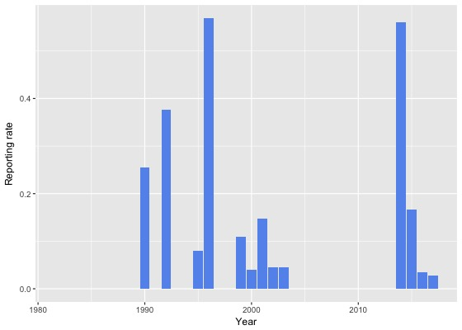
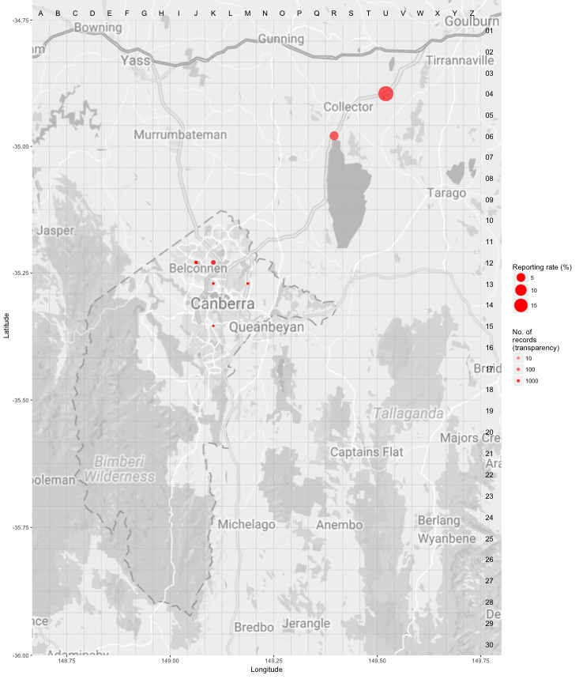Source: Canberrabirds.org.au. (2019). Note: Reporting rate (%) is the proportion of all surveys in which the species was present. These data were collected by volunteer birdwatchers using various survey methods and, on some occasions, more than one person may have recorded bird sightings on the same day, which may skew the data.

Major Conservation Objectives
The ACT is not regarded as a key site or breeding site as individuals of the species are only infrequent visitors.

Conservation Issues and Proposed Management Actions
Some of the sites where the Australasian Bittern has been recorded in the ACT are protected for other species of birds facing similar threats (ACT Government 2018). Key actions recommended for such sites include:
- maintain feral animal control around wetland sites
- improve the ability to manage water levels to maintain habitat.

Other Relevant Advice, plans or Prescriptions
- Commonwealth Listing Advice — Australasian Bittern (TSSC 2011)
- Commonwealth Conservation Advice — Australasian Bittern (TSSC 2019)

Listing Background
The Australasian Bittern was listed as an Endangered species under the Environment Protection and Biodiversity Conservation Act 1999 (EPBC Act) on 3 March 2011. It was assessed as Endangered under Criterion 1 (A2c) and 3 (C1) of the EPBC Act. In 2019, under the Nature Conservation Act 2014, the ACT Scientific Committee recommended the Australasian Bittern be listed in the Endangered category in the ACT Threatened Native Species List to align with the EPBC Act listing.

References
ACT Government 2018. Action Plan for Listed Migratory Species. Environment, Planning and Sustainable Development Directorate, ACT Government, Canberra.
BirdLife International. 2016. Botaurus poiciloptilus. The IUCN Red List of Threatened Species 2016. Accessed 11 February 2019 from: http://dx.doi.org/10.2305/IUCN.UK.2016-3.RLTS.T22697353A93610014.en
BirdLife International 2018. Species factsheet: Botaurus poiciloptilus. Accessed 11 February 2019 from: http://datazone.birdlife.org/species/factsheet/australasian-bittern-botaurus-poiciloptilus/text
Canberrabirds.org.au 2019. Australasian Bittern Botaurus poiciloptilus data sheet. Accessed 11 February 2019 from: http://canberrabirds.org.au/wp-content/bird_data/197_Australasian%20Bittern.html
Canberra.naturemapr.org (CNM) 2019. Canberra Nature Map. Accessed 11 February 2019 from: https://canberra.naturemapr.org/Community/Species/15002
COG 2016. Annual Bird Report: 1 July 2014 to 30 June 2015. Canberra Bird Notes 41(1): 1–110.
COG 2018. Annual Bird Report: 1 July 2016 to 30 June 2017. Canberra Bird Notes 43(1): 1–110.
Garnett ST, Szabo JK and Dutson G 2011. The Action Plan for Australian Birds 2010. CSIRO Publishing, Collingwood.
Herring M 2016. The Story So Far 2012-2016. Bitterns in Rice Project. Accessed 11 February 2019 from: http://www.bitternsinrice.com.au/wp-content/uploads/2016/08/Bitterns-in-Rice-Project-2012-2016-summary-booklet.pdf
Marchant S and Higgins PJ (eds) 1990. Handbook of Australian, New Zealand and Antarctic Birds. Volume One - Ratites to Ducks. Oxford University Press, Melbourne.
Pizzey G and Knight F 1997. The Graham Pizzey and Frank Knight Field Guide to the Birds of Australia. Angus and Robertson, Sydney.
Threatened Species Scientific Committee (TSSC) 2011. Commonwealth Listing Advice on Botaurus poiciloptilus (Australasian Bittern). Department of Sustainability, Environment, Water, Population and Communities, Commonwealth of Australia, Canberra.
Threatened Species Scientific Committee (TSSC) 2019. Conservation Advice Botaurus poiciloptilus Australasian Bittern. Department of the Environment and Energy, Commonwealth of Australia, Canberra.
Taylor M and Canberra Ornithologists Group (COG) 1992. Birds of the Australian Capital Territory – An Atlas. Canberra Ornithologist Group and National Capital Planning Authority, Canberra.
Wagler J 1827. Systema Avium. Pars prima. JG Cottae, Stuttgart and Tubingen.
Wilson S 1999. Birds of the ACT: Two Centuries of Change. Canberra Ornithologists Group, Canberra.

Further Information
Further information on this or other threatened species and ecological communities can be obtained from the Environment, Planning and Sustainable Development Directorate (EPSDD).
Phone: (02) 132281, EPSDD Website: http://www.environment.act.gov.au/cpr

