Australian Capital Territory

Nature Conservation (Brown Treecreeper) Conservation Advice 2019

Notifiable instrument NI2019–247
made under the
Nature Conservation Act 2014, s 90C (Conservation advice)

1 Name of instrument
This instrument is the Nature Conservation (Brown Treecreeper) Conservation Advice 2019.

2 Commencement
This instrument commences on the day after its notification day.

3 Conservation advice for the Brown Treecreeper
Schedule 1 sets out the conservation advice for the Brown Treecreeper (Climacteris picumnus victoriae).

Arthur Georges
Chair, Scientific Committee
1 May 2019
Schedule 1
(see s 3)

Conservation Advice
Brown Treecreeper
Climacteris picumnus victoriae

Conservation Status
The Brown Treecreeper Climacteris picumnus victoriae Matthews, 1912 is recognised as threatened in the following jurisdictions:
National Near Threatened, Action Plan for Australian Birds 2010
ACT Vulnerable, Nature Conservation Act 2014
NSW Vulnerable, Biodiversity Conservation Act 2016
Victoria Near Threatened, Advisory List of Threatened Vertebrate Fauna 2013

ELIGIBILITY
The factors that make the Brown Treecreeper eligible for listing as Vulnerable in the ACT Threatened Native Species List are included in the Listing Background section below.

DESCRIPTION AND ECOLOGY
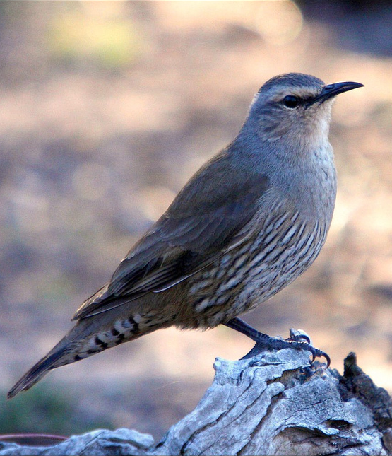
The Brown Treecreeper is the largest species of Australia's treecreepers, measuring about 16–18 cm and weighing (on average) 31.5 g. It is mostly pale brown in plumage. The head, throat and upper breast are pale greyish-brown, while the lower breast and belly are strongly streaked with black and buff. In flight, a buff stripe can be seen in the wing.
The sexes are similar, except females have rufous edges to the feathers of the upper breast, while in the male these edges are black. Juveniles resemble the adults, but are duller, have less obvious stripes on the underparts and the lower belly is a pale rufous colour. (Birdlife Australia 2018).
The Brown Treecreeper (south-eastern) Climacteris picumnus victoriae is the sub-species resident in the ACT. This sub-species C. p. victoriae and C. p. picumnus are distinguished by colour differences on the face, body and tail markings. The two sub-species grade into each other through central NSW. Individuals are active, noisy and conspicuous, and give a loud ‘pink’ call. This call is often repeated in contact, and sometimes given in a series of five to ten descending notes.
Adult Brown Treecreeper (Tobias Hayashi – Canberra Birds)
Breeding occurs from July to February across its range (OEH 2017). The nest is a collection of grasses, feathers and other soft material, placed in a suitable tree hollow or similar site. Both sexes build the nest but the female alone incubates the eggs. Pairs often have two broods during each breeding season. Occasionally, other individuals assist the breeding pair with building the nest and feeding young (Birdlife Australia 2018).
The Brown Treecreeper climbs up the trunks and branches of trees in search of food, usually in pairs or small groups. It probes into cavities and under loose bark with its long downward curving bill. In this way it searches for insects and their larvae with the most favoured insects being ants. Feeding can also take place on the ground on fallen logs or by diving on ground-dwelling prey from a perch (Birdlife Australia 2018).

Distribution and Habitat
Three sub-species of Climacteris picumnus are recognised: C. p. melanotus (Cape York Peninsula, Queensland), C. p. picumnus (inland eastern Australia, eastern Queensland) and C. p. victoriae (south-eastern Australia) (Schodde and Mason 1999; Garnett and Crowley 2000).
The south-eastern sub-species C. p. victoriae is the breeding resident of the ACT. Nationally, this sub-species has an estimated extent of occurrence of 600,000 km² and area of occupancy of 12,000 km². However, a substantial decline in the distribution is likely to be occurring given the loss and fragmentation of habitat (Garnett et al. 2011). The species is found in sub-coastal environments and the inland slopes of the Great Dividing Range from the Grampians in western Victoria, through central New South Wales (Wagga Wagga, Temora, Forbes, Dubbo, and Inverell) to the Queensland border and north to the Bunya Mountains (Schodde and Mason 1999).
Within its range, the species is described as a common resident, provided habitat is suitable. Blakers et al. (1984) recorded densities of 0.04–0.50 birds/ha, however, large reductions in density have been reported over most parts of its range (Walters et al. 1999, Traill and Duncan 2000). The Brown Treecreeper has declined or disappeared from most remaining habitat fragments under 300 ha, at least partly, because females disperse from these areas or die preferentially and are not replaced (Walters et al. 1999). A decline of 70% was recorded in central New South Wales between 1990 and 2000 (Traill and Duncan 2000).
The Brown Treecreeper is likely to exist in isolated family groups in the ACT region in dry eucalypt woodlands and open forest below 1,000 m. It was once described as ‘fairly common from the lowlands to the alpine woodland’ in the ACT in the early 1950s (Cabby 2000). Taylor and COG (1992) reported it as relatively common in the Clear Range and along the Lower Naas River with other populations occurring at Campbell Park, Burbong, former quarries south of the airport, and Castle Hill, north of Tharwa. Surveys by the NSW NPWS in the late 1990s recorded the species at several remnant woodland and dry forest sites between Boorowa, Gunning and the ACT and at one site between Crookwell, Taralga, Collector and Tarago (ACT Government 1999).
There have been few sightings at Mulligans Flat Nature Reserve since 1999, where it was once common. Local extinction (Caswell Drive area on the western slopes of Black Mountain) (Marchant 1973) and decline in the Murrumbidgee River Corridor (Taylor 1987) have been documented. In 2003, the species was found in small numbers at Gooroo, Majura Field Firing Range and Newline quarry woodland (Cunningham 2003).
On Canberra Nature Map (CNM 2018) the Brown Treecreeper was recorded at Percival Hill, Mulligans Flat and Goorooyarroo in the north; Majura, Mount Ainslie, Gossan Hill, Kama, Jerrabomberra Grassland and Jerrabomberra (ACT) in central ACT areas; Namadgi National Park, Gigerline, Old Naas Travelling Stock Route, Booth and Tennent in the south; and in nearby NSW at Gundaroo, Googong Foreshore, Burra and Michelago. These were recorded between 2005 and 2018.
Brown Treecreepers were recorded nine times in the 2008 Bird Blitz (Allan 2009). Sightings were of single birds or groups of up to four birds, comprised two breeding records and were from Namadgi National Park, Castle Hill, Tharwa, Newline and Kama. Sightings of Brown Treecreepers then appeared to stabilise in the ACT region until 2008–2009, after which there was a steady and steep decline. An attempt was made to introduce 43 birds into woodlands inhabited formerly by the Brown Treecreeper. While the attempt failed it contributed to the scanty knowledge of reintroduction biology (Bennett et al. 2012). Therefore, there is a need to protect as much extant habitat as possible as reintroductions have not proved effective.
Between 2015 and 2017, the reporting rate levelled off, not far above zero per cent (COG 2018) (Figure 1). Most records of sightings in the ACT region (259 total birds (207 in 2015–2016)) were outside the ACT in 2016–2017 (COG 2018) (Figure 2 and Figure 3).
Critical habitat features required by the Brown Treecreeper include:
- relatively undisturbed grassy woodland with native understorey
- large living and dead trees which are essential for roosting and nesting sites and for foraging
- fallen timber which provides essential foraging habitat.
Figure 1: Brown Treecreeper records in the ACT region – 1982–2017
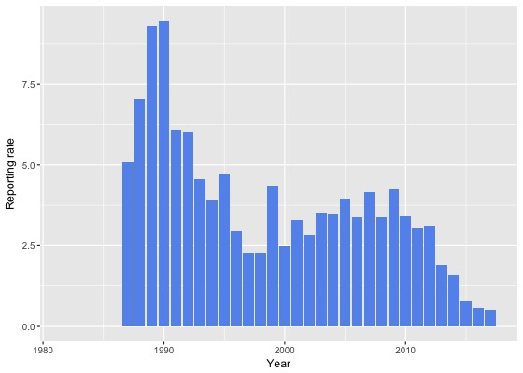
Source: Canberrabirds.org.au. (2018). Note: Reporting rate (%) is the proportion of all surveys in which the species was present. These data were collected by volunteer birdwatchers using various survey methods and on some occasions more than one person may have recorded bird sightings on the same day, which may skew the data.
Figure 2: Brown Treecreeper distribution in the ACT region – 2017
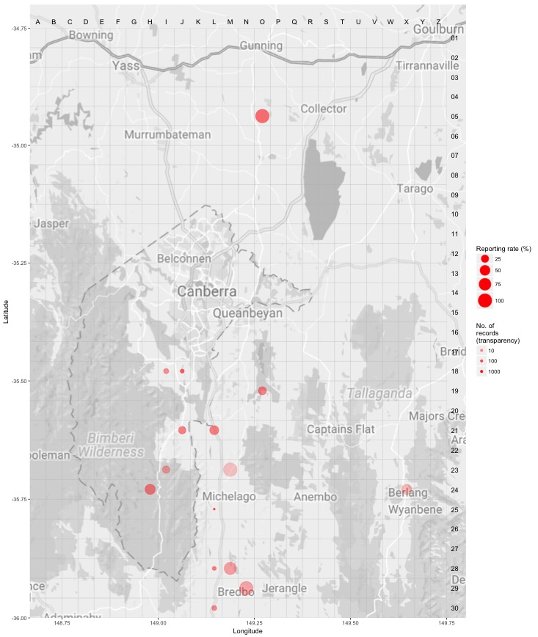
Source: Canberrabirds.org.au. (2018). Note: Reporting rate (%) is the proportion of all surveys in which the species was present. These data were collected by volunteer birdwatchers using various survey methods and on some occasions more than one person may have recorded bird sightings on the same day, which may skew the data.
Figure 3: Brown Treecreeper distribution in the ACT region – 1982–2017
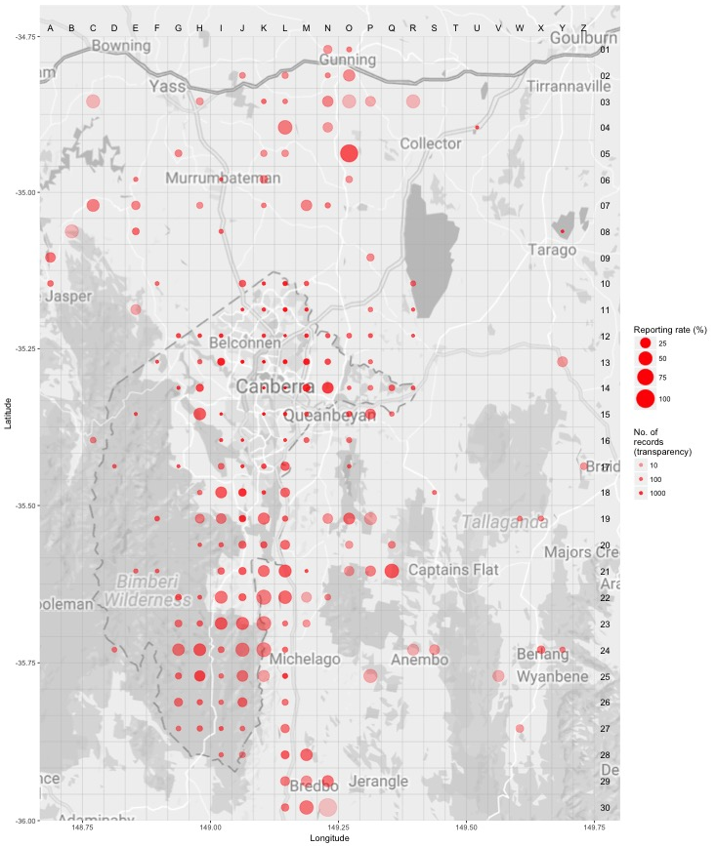Source: Canberrabirds.org.au. (2018). Note: Reporting rate (%) is the proportion of all surveys in which the species was present. These data were collected by volunteer birdwatchers using various survey methods and on some occasions more than one person may have recorded bird sightings on the same day, which may skew the data.

Threats
In common with many other threatened bird species, the principal threat to the Brown Treecreeper is a severe decline in the quality and quantity of its woodland habitat. In particular, the removal of timber for firewood is likely to result in local reduction of Brown Treecreeper numbers (ACT Government 2004). The fragmented nature of woodlands may present barriers to movement and recolonisation unless measures are taken to connect areas of viable habitat with existing populations.
Threats to the Brown Treecreeper (ACT Government 2004) include:
- removal of fallen timber and litter and inappropriate fire regimes
- predation by feral and/or uncontrolled domestic animals (foxes, dogs and cats)
- invasion of key habitats by introduced pasture and weeds
- uncontrolled grazing by livestock
- clearing of both living and dead trees
- rural tree dieback

Major Conservation Objectives
The primary objective in the ACT is to protect Brown Treecreeper habitat through limiting clearance of suitable woodland habitat and prioritising conservation management to woodland patches, particularly those that are large or have complex habitat structure.

Conservation Issues and Proposed Management Actions
The conservation actions relevant to the Brown Treecreeper in the ACT Lowland Woodland Conservation Strategy (ACT Government 2004) include the following:
- protect habitat
- maintain and enhance connectivity
- limit removal of live and dead timber
- reduce intensive grazing
- maintain patches of shrubs or eucalypt regrowth
- regenerate habitat
- minimise adverse effects of fire
- minimise nest hollow competition.

Other Relevant Advice, plans or Prescriptions
- ACT Woodland Conservation Strategy (ACT Government 2004)
- ACT Draft Woodland Conservation Strategy (ACT Government 2019)
- ACT Conservation Advice — Loss of Mature Trees (Scientific Committee 2018)

Listing Background
The Brown Treecreeper was initially listed in the ACT as Climacteris picumnus as a Vulnerable species on 30 May 1997 in accordance with section 38 of the Nature Conservation Act 1980.
The Flora and Fauna Committee (now Scientific Committee) concluded that at that time the assessment satisfied the criteria:
2.2 The species is observed, estimated, inferred or suspected to be at risk of premature extinction in the ACT region in the medium-term future, as demonstrated by:
2.2.1 Current serious decline in population or distribution from evidence based on:
2.2.1.1 Direct observation, including comparison of historical and current records; and
2.2.1.3 Serious decline in quality or quantity of habitat.

Under the Nature Conservation ACT 2014 it is possible to list at the sub-species level where there are differentiated threats across the species range. Climacteris picumnus melanotus (Cape York Peninsula, Queensland) and C. p. picumnus (inland eastern Australia, eastern Queensland) sub-species are not listed as threatened in their range states. Climateris picumnus victoriae is the only sub-species in the ACT and nearby NSW and is listed as Vulnerable in NSW and as Near Threatened in Victoria.

References
ACT Government 1999. Brown Treecreeper (Climacteris picumnus): A vulnerable species. Action Plan No.18. Environment ACT, Canberra.
ACT Government 2004. Woodlands for Wildlife: ACT Lowland Woodland Conservation Strategy. Action Plan No. 27. Environment ACT, Canberra.
ACT Government 2019. Draft ACT Woodland Conservation Strategy and Action Plans. Environment Planning and Sustainable Development Directorate, Canberra.
Allan B 2009. The Canberra Bird Blitz 2008. Canberra Bird Notes 34(2): 111–125.
Bennett VA, Doerr VA, Doerr ED, Manning AD and Lindenmayer DB 2012. The anatomy of a failed reintroduction: a case study with the Brown Treecreeper. Emu 112: 298–312.
BirdLife Australia 2018. Brown Treecreeper Climacteris picumnus Profile. Accessed 21 May 2018 from: http://www.birdlife.org.au/bird-profile/brown-treecreeper
BirdLife International 2016. Climacteris picumnus. The IUCN Red List of Threatened Species 2016. Accessed 21 May 2018 from: http://dx.doi.org/10.2305/IUCN.UK.2016-3.RLTS.T22703577A93928711.en
BirdLife International 2018. Species factsheet: Climacteris picumnus. Accessed 21 May 2018 from: http://datazone.birdlife.org/species/factsheet/brown-treecreeper-climacteris-picumnus
Blakers M, Davies SJJF and Reilly PN 1984. The Atlas of Australian Birds. Melbourne University Press and RAOU, Melbourne.
Cabby J 2000. List of Birds of the ACT – early 1950s, Canberra Bird Notes 25(1): 1–22. Accessed 21 May 2018 from: http://canberrabirds.org.au/wp-content/canberra-bird-notes/cbnvol25no1.pdf
Canberrabirds.org.au (2018). Brown Treecreeper Climacteris picumnus data sheet. Accessed 22 August 2018 from: http://canberrabirds.org.au/wp-content/bird_data/555_Brown%20Treecreeper.html
Canberra.naturemapr.org (CNM) 2018. Canberra Nature Map. Accessed 21 May 2018 from: https://canberra.naturemapr.org/Community/Species/15169
COG 2018. Annual Bird Report: 1 July 2016 to 30 June 2017. Canberra Bird Notes 43(1):1–110.
Cunningham R 2003. A statistical analysis of the status and trends of woodland birds in the ACT. COG database, Canberra Ornithologists Group, Canberra.
Freudenberger D 1999. Guidelines for enhancing grassy woodlands for the vegetation investment project. CSIRO Wildlife and Ecology, Canberra.
Garnett ST and Crowley GM 2000. The Action Plan for Australian Birds 2000. Environment Australia, Canberra.
Garnett ST, Szabo JK and Dutson G 2011. The Action Plan for Australian Birds, CSIRO Publishing, Collingwood.
Matthews GM 1912. A reference-list to the birds of Australia. Novitates Zoologicae 18:171–455, 382.
Office of Environment and Heritage (OEH) 2017. Brown Treecreeper (eastern subspecies) Profile. Accessed 21 May 2018 from: https://www.environment.nsw.gov.au/threatenedSpeciesApp/profile.aspx?id=10171
Reid J 1999. Threatened and declining birds in the New South Wales sheep–wheat belt: 1. Diagnosis, characteristics and management. Consultancy report to NSW National Parks and Wildlife Service, CSIRO Sustainable Ecosystems, Canberra.
Schodde R and Mason IJ 1999. The Directory of Australian Birds – Passerines. CSIRO Publishing, Collingwood.
Schodde R and Tidemann SC 1986. Complete Book of Australian Birds. Readers Digest, Sydney.
Scientific Committee 2018. Conservation Advice – Loss of Mature Trees (including Hollow-bearing Trees) and Lack of Recruitment. ACT Government, Canberra.
Taylor M and Canberra Ornithologists Group (COG) 1992. Birds of the Australian Capital Territory – An Atlas. Canberra Ornithologist Group and National Capital Planning Authority, Canberra.
Traill BJ and Duncan S 2000. Status of birds in the New South Wales temperate woodlands region. Report to NSW National Parks and Wildlife Service, Dubbo.
Walters J, Ford HA and Cooper C 1999. The ecological basis of sensitivity to habitat fragmentation: a preliminary assessment. Biological Conservation 90: 13–20.

Further Information
Further information can be obtained from the Environment, Planning and Sustainable Development Directorate (EPSDD). Phone: (02) 132281, EPSDD Website: http://www.environment.act.gov.au/cpr

