Australian Capital Territory

Nature Conservation (Little Eagle) Conservation Advice 2019

Notifiable instrument NI2019–250
made under the
Nature Conservation Act 2014, s 90C (Conservation advice)

1 Name of instrument
This instrument is the Nature Conservation (Little Eagle) Conservation Advice 2019.

2 Commencement
This instrument commences on the day after its notification day.

3 Conservation advice for the Little Eagle
Schedule 1 sets out the conservation advice for the Little Eagle (Hieraaetus morphnoides).

Arthur Georges
Chair, Scientific Committee
1 May 2019

Schedule 1
(see s 3)

Conservation Advice
Little Eagle – Hieraaetus morphnoides

Conservation Status
The Little Eagle Hieraaetus morphnoides (Gould, 1841) is recognised as threatened in the following jurisdictions:
ACT Vulnerable, Nature Conservation Act 2014
NSW Vulnerable, Biodiversity Conservation Act 2016

ELIGIBILITY
The factors that make the Little Eagle eligible for listing as Vulnerable in the ACT Threatened Native Species List are included in the Listing Background section below.

DESCRIPTION AND ECOLOGY
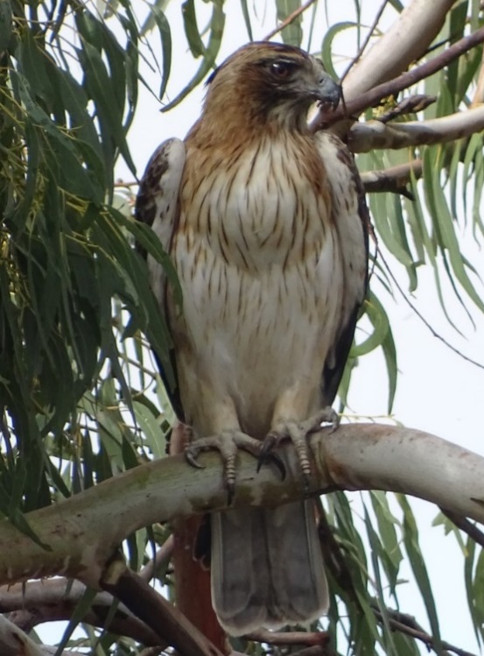
The Little Eagle is a small, stocky, brown eagle measuring 45–55 cm in length, with females being larger than males. It has a square-tipped barred tail, feathered legs, and a black streaked head with a short crest (Birdlife Australia 2018). There are two morphs: pale and dark. A distinguishing underwing ‘M’ pattern is only obvious in the light morph. Juveniles are brighter rufous (pale morph) to reddish brown (dark morph) than their respective adults (Marchant and Higgins 1993; Debus 1998; Ferguson-Lees and Christie 2001).
The Little Eagle is a fast, agile hunter and takes live prey by swooping from either elevated perches or while soaring up to 500 m altitude (Marchant and Higgins 1993; Olsen et al. 2006; Debus et al. 2007; Debus and Ley 2009). Diet is broad and varies based primarily on availability, however rabbits (mostly juveniles), birds (parrots and small passerines <500 g), insects and reptiles are typical dietary inclusions (Baker-Gabb 1984; Marchant and Higgins 1993; Debus 1998; Debus and Rose 1999; Olsen and Osgood 2006; Olsen et al. 2006; Debus et al. 2007; Debus and Ley, 2009; Olsen et al. 2010). Carrion is also occasionally taken. In the ACT region its diet comprises mostly rabbits and to a lesser extent birds (especially rosellas, Magpie-larks and Starlings) (Olsen & Fuentes, 2004; Olsen et al. 2006; Olsen et al. 2010; Rae et al. 2018).
Little Eagle (Roy McDowall – Canberra Nature Map)
Little Eagles nest in open woodland (usually on hillsides) and along tree-lined watercourses, with the nest typically placed in a mature, living tree. The birds build a stick nest lined with leaves and may use different nests in successive years, including those of other birds such as ravens. Typically, two eggs (1–3) are laid in late August to early September (Marchant and Higgins 1993). The incubation period typically lasts about 37 days, after which the female mainly broods the young and feeds them small pieces of food bill to bill. The male hunts for food for both the young and the female (Birdlife Australia 2018). One or two young are fledged after approximately eight weeks (Olsen & Fuentes 2004; Debus et al. 2007; Debus and Ley 2009).
Little Eagle nesting territories are defended against intruders and advertised by soaring, undulating flight display, conspicuous perching and/or calling (Marchant and Higgins 1993; Debus et al. 2007; Bounds 2008). Movement behaviour varies between individuals, and may be partly migratory, dispersive or permanently resident (Marchant and Higgins 1993). Satellite tracking of an adult male during an unsuccessful breeding season (2015–16) indicated a home range of approximately 65 sq. km, with an average daily flight distance of 10 km (Brawata and Gruber 2016).

Distribution and Habitat
The Little Eagle is endemic to Australia and is distributed throughout the mainland. In south-eastern Australia there has been a general and continuing decline in its abundance over the last 30 years based on indices established by national and regional censuses.
Sightings of the Little Eagle have been recorded across much of the ACT, but the breeding range is in the lower elevation areas of the ACT in the north, with the highest concentrations in the Murrumbidgee and the Molonglo River corridors (Figure 1) (Taylor and Canberra Ornithologists Group (COG) 1992).
The reporting rate (1.1%) for 2016–17 was the lowest on record since 2001–02, and the distribution of reports in the ACT region has contracted since reporting began (Figure 2). Although additional breeding pairs and nests were located during 2017–18 (Rae et al. 2018), this is mainly attributed to increased search effort, rather than an increase in the local breeding population. There were at least nine nesting locations in the ACT and two in nearby NSW in 2017–18. Nests were regularly spaced (mean distance of 5 km), and found in woodland, partially cleared woodland or a windbreak. Nesting eagles did not appear to avoid, or prefer to be near, urban features (Rae et al. 2018).
Higher abundance of the species is associated with hillsides where there is a mosaic of wooded and open areas such as riparian woodlands, forest margins and wooded farmland. Little Eagles usually avoid large areas of dense forest, preferring to hunt in open woodland, where the birds use trees for lookouts (Marchant and Higgins 1993; Ferguson-Lees and Christie 2001). Large living eucalypt trees surrounded by other trees, are preferred nesting locations, however, exotic pines were also utilised for nests (Rae et al. 2018).
The research to date confirms that both breeding male and dispersing juvenile female Little Eagles are capable of travelling large distances during the non-breeding season and that a male had a large foraging territory during the breeding season. This indicates that a landscape scale, preferably national approach, is needed for its ongoing conservation (unpublished, ACT Government 2018).
Figure 1. Little Eagle distribution in the ACT region – 2017
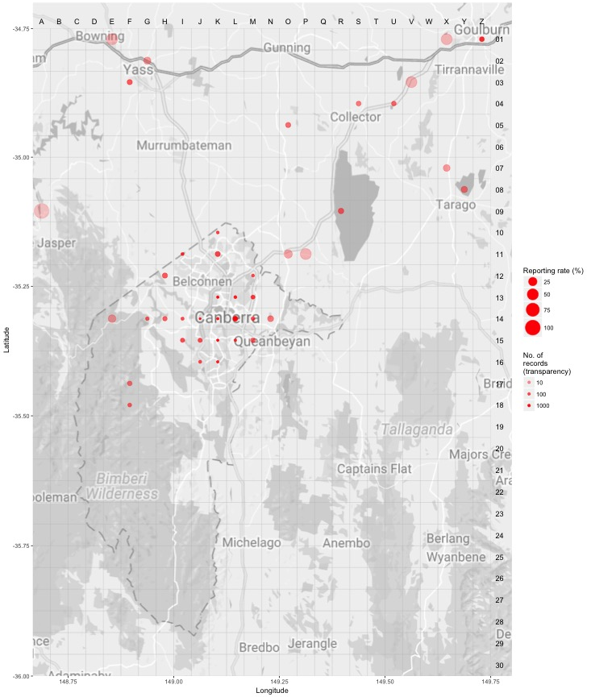
Source: Canberrabirds.org.au. (2018). Note: Reporting rate (%) is the proportion of all surveys in which the species was present. These data were collected by volunteer birdwatchers using various survey methods and on some occasions more than one person may have recorded bird sightings on the same day, which may skew the data.
Figure 2. Distribution of Little Eagle records in the ACT region – 1982–2017
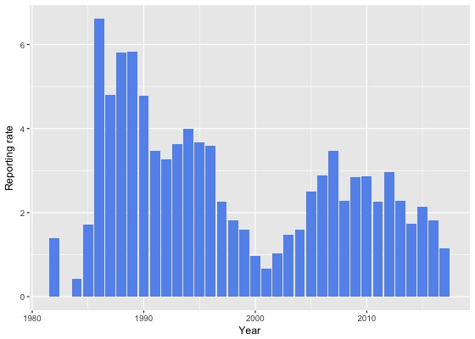
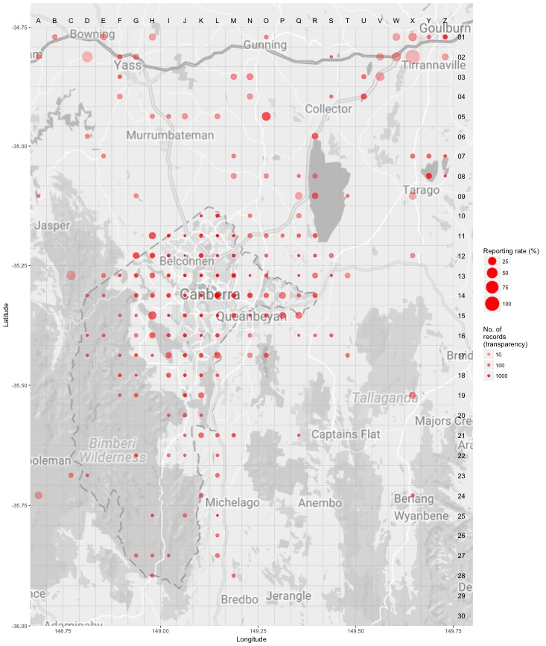 Source: Canberrabirds.org.au. (2018). Note: Reporting rate (%) is the proportion of all surveys in which the species was present. These data were collected by volunteer birdwatchers using various survey methods and on some occasions more than one person may have recorded bird sightings on the same day, which may skew the data.

Threats
In common with many other threatened bird species, the principal threat to the Little Eagle is a severe decline in the quality and quantity of its habitat. In the ACT this is mostly due to the encroachment of urban development on remnant woodland and grassland. Associated human activity may also cause the retreat of Little Eagles from nearby, otherwise suitable habitat (Debus 2005; Olsen and Fuentes 2005; Olsen and Osgood 2006; Debus et al. 2007; Olsen et al. 2008).
Increased competition for food and nest-sites with Wedge-tailed Eagles (Aquila audax) and the use of the pesticide Pindone for rabbit control have also been suggested as potential reasons for Little Eagle decline (ACT Government 2013).
Protection of nest trees and foraging areas, typically located in woodland has been recommended (Olsen and Osgood 2006; Debus and Ley 2009) but made complex by nesting and foraging areas often being separated by large distances and the use of alternative nest trees. Largely as a result of actions relating to the protection and recovery of endangered Yellow Box – Blakely’s Red Gum Woodland, there has been significant additional protection of key foraging habitat in recent time (ACT Government 2018).

Major Conservation Objectives
The primary objective is to maintain a viable, wild population of Little Eagles in the ACT and region (ACT Government 2013).

Conservation Issues and Proposed Management Actions
The conservation actions for the Little Eagle include the following:
- identify and protect nesting sites and associated foraging habitat
- monitor all known nesting areas and other possible locations to determine the status and breeding ecology of Little Eagles in the ACT and surrounding NSW.
- regenerate habitat
- restrict clearing of mature native trees
- limit removal of live and dead timber
- maintain and enhance connectivity
- minimise adverse effects of fire.

Other Relevant Advice, plans or Prescriptions
- ACT Action Plan – Little Eagle (ACT Government 2013)
- ACT Conservation Advice – Loss of Mature Native Trees (Scientific Committee 2018)
- ACT Woodland Conservation Strategy (ACT Government 2004)
- ACT Draft Woodland Conservation Strategy (ACT Government 2019)

Listing Background
The Little Eagle was listed in the ACT as a Vulnerable species on 25 February 2008 in accordance with section 38 of the Nature Conservation Act 1980.
The Flora and Fauna Committee (now Scientific Committee) concluded that at that time the assessment satisfied the criteria:
2.2 The species is observed, estimated, inferred or suspected to be at risk of premature extinction in the ACT region in the medium-term future, as demonstrated by:
2.2.1 Current serious decline in population or distribution from evidence based on:
2.2.1.1 Direct observation, including comparison of historical and current records.

References
ACT Government 2004. Woodlands for Wildlife: ACT Lowland Woodland Conservation Strategy. Action Plan No. 27. Environment ACT, Canberra.
ACT Government 2010. ACT Woodland Restoration Implementation Plan. Unpublished report by Department of Territory and Municipal Services, Canberra.
ACT Government 2013. Little Eagle (Hieraaetus morphnoides) Action Plan No. 35. Environment ACT, Canberra. https://www.legislation.act.gov.au/View/di/2013-276/current/PDF/2013-276.PDF
ACT Government 2018. Unpublished progress report – Little Eagle Hieraaetus morphnoides Action Plan No. 35. Environment Planning and Sustainable development Directorate, Canberra.
ACT Government 2019. Draft ACT Woodland Conservation Strategy and Action Plans. Environment Planning and Sustainable Development Directorate, Canberra.
Baker-Gabb D J 1984. The breeding ecology of twelve species of diurnal raptor in north-western Victoria. Wildlife Research 11: 145–160.
Birdlife Australia 2018. Little Eagle. Accessed 23 October 2018 from: http://birdlife.org.au/bird-profile/Little-Eagle
Bounds J 2008. Nomination of a vulnerable species to the ACT Flora and Fauna Committee: Little Eagle. Canberra Bird Notes 33: 84–95.
Brawata R and Gruber B 2016. Movements of the Little Eagle (Hieraaetus morphnoides) surrounding the proposed Riverview Development Area, Australian Capital Territory. A report for the Riverview Group, Institute for Applied Ecology, University of Canberra.
Canberrabirds.org.au (2018). Little Eagle Hieraaetus morphnoides data sheet. Accessed 23 October 2018 from: http://canberrabirds.org.au/wp-content/bird_data/225_Little%20Eagle.html
Dabb G 2018. An Inconvenient Eagle. Canberra Bird Notes 43(2): 132–137.
Debus S 1998. The Birds of Prey of Australia: A Field Guide. Oxford University Press, Melbourne.
Debus S 2005. Potential impacts of proposed urban development on the raptors in the Molonglo Valley, ACT. Unpublished report to ACT Planning and Land Authority, Canberra.
Debus S 2018. Little Eagles in the ACT: A reply to Olsen and Rae (2017). Canberra Bird Notes 43(2): 138–139.
Debus SJ, Hatfield TS, Ley AJ and Rose AB 2007. Breeding biology and diet of the Little Eagle Hieraaetus morphnoides in the New England Region of New South Wales. Australian Field Ornithology 24: 137–157.
Debus SJ and Ley AJ 2009. Aspects of the breeding cycle of the Little Eagle Hieraaetus morphnoides. Australian Field Ornithology 26: 76–99.
Debus SJ and Rose AB 1999. Notes on the diet of the Wedge-tailed Eagle Aquila audax. Australian Bird Watcher 18: 38–41.
Ferguson-Lees J and Christie DA 2001. Raptors of the World. Helm, London.
Gould J 1841. Aquila morphnoides. Proceedings of the Zoological Society of London Pt VIII 1840: 161-162. https://www.biodiversitylibrary.org/item/96163
Marchant S and Higgins PJ Eds. 1993. Handbook of Australian, New Zealand and Antarctic Birds. Oxford University Press, Melbourne.
Olsen J 2018. Eleven historic breeding territories of the ACT Little Eagles is an underestimate - a reply to Olsen and Rae (2017). Canberra Bird Notes 43(2): 120-131.
Olsen J and Fuentes E 2004. Preliminary report on the effect of the development of the Molonglo Valley on the community of birds of prey.
Olsen J and Fuentes E 2005. Collapse in the number of breeding Little Eagles in the Australian Capital Territory. Canberra Bird Notes 30(4): 141–145.
Olsen J, Fuentes E, Rose AB and Frost S 2006. Food and hunting of eight breeding raptors near Canberra, 1990–1994. Australian Field Ornithology 26: 77–95.
Olsen J, Judge D, Fuentes E, Rose AB and Debus S 2010. Diets of Wedge-tailed Eagles (Aquila audax) and Little Eagles (Hieraaetus morphnoides) breeding near Canberra. Journal of Raptor Research 44: 50–61.
Olsen J and Osgood M 2006. Numbers of breeding Little Eagles in the Australian Capital Territory in 2006. Canberra Bird Notes 31: 178–182.
Olsen J, Osgood M, Maconachie M and Dabb G 2008. Numbers of breeding Little Eagle Hieraaetus morphnoides in the Australian Capital Territory in 2007. Canberra Bird Notes 33: 77–80.
Olsen P and Rae S 2017. Invalid evidence for purported 'collapse' in the number of breeding Little Eagles in the Australian Capital Territory. Canberra Bird Notes 43(3): 245–249.
Rae S, Fletcher D, Mulvaney M, Davies M, Roberts D and Olsen P 2018. Notes on the breeding ecology of Little Eagles in the ACT in 2017/2018. Canberra Bird Notes 43(2): 186-193.
Scientific Committee 2018. Conservation Advice – Loss of Mature Native Trees (Including Hollow-bearing Trees) and a Lack of Recruitment. Environment Planning and Sustainable Development Directorate, ACT Government, Canberra.
Taylor M and Canberra Ornithologists Group (COG) 1992. Birds of the Australian Capital Territory: An Atlas. Canberra Ornithologists Group and the National Capital Planning Authority, Canberra.

Further Information
Further information on the related Action Plan or other threatened species and ecological communities can be obtained from: Environment, Planning and Sustainable Development Directorate (EPSDD)
Phone: (02) 132281, EPSDD Website: http://www.environment.act.gov.au/cpr

