Australian Capital Territory

Nature Conservation (Scarlet Robin) Conservation Advice 2019

Notifiable instrument NI2019–253
made under the
Nature Conservation Act 2014, s 90C (Conservation advice)

1 Name of instrument
This instrument is the Nature Conservation (Scarlet Robin) Conservation Advice 2019.

2 Commencement
This instrument commences on the day after its notification day.

3 Conservation advice for the Scarlet Robin
Schedule 1 sets out the conservation advice for the Scarlet Robin (Petroica boodang).

Arthur Georges
Chair, Scientific Committee
1 May 2019
Schedule 1
(see s 3)

Conservation Advice
SCARLET RObin – Petroica boodang

Conservation Status
The Scarlet Robin Petroica boodang (Lesson, 1838) is recognised as threatened in the following jurisdictions:
ACT Vulnerable, Nature Conservation Act 2014
NSW Vulnerable, Biodiversity Conservation Act 2016
SA Rare, eastern sub-species – P. b. boodang, National Parks and Wildlife Act 1972
Vulnerable, western sub-species – P. b. campbelli, National Parks and Wildlife Act 1972

ELIGIBILITY
The factors that make the Scarlet Robin eligible for listing as Vulnerable in the ACT Threatened Native Species List are included in the Listing Background section below.

DESCRIPTION AND ECOLOGY
The Scarlet Robin is 12–14 cm in length and weighs an average 13 g Adult male birds have bold red, black and white plumage and females are brownish with a red/orange wash on the breast (Pizzey and Knight 2012). Juvenilles resemble the adult female.
The Scarlet Robin is one of three red-breasted robins in Australia, the others being the Flame Robin (P. phoenicea) and the Red-capped Robin (P. goodenovii). The Scarlet Robin is distinguishable from the other red-breasted robins by the obvious white forehead and red wash on the breast in females. Unlike P. phoenicea, the Scarlet Robin’s red breast plumage colour does not continue up the throat to the bill. It is distinguised from P. goodenovii by the lack of a scarlet red cap in the males (Pizzey and Knight 2012).

Scarlet Robins are quiet and unobtrusive foragers. They forage from low perches, fence-posts, shrubs, tree trunks, logs or the ground, pouncing on small insects and other invertebrates, sometimes foraging in the shrub or canopy layer (Frith 1984; Higgins and Peter 2002). Birds usually occur singly or in pairs, occasionally in small family parties.
Male Scarlet Robin (Tobias Hayashi – Canberra Birds)

Breeding pairs form and stay together all year round and defend a breeding territory mainly between July and January, although, in recent years, the earliest breeding dates in the ACT have tended to be later in August or early September (COG 2014, 2015). In autumn and winter, they join mixed flocks of other small insectivorous birds that forage through dry forests and woodlands.

Eggs are pale greenish-, bluish- or brownish-white, with brown spots, and clutch size ranges from one to four with two or three broods a season. The nest is an open cup made of plant fibres and cobwebs, and is often built in the fork of a tree that is usually more than two metres above the ground. Nests are often found on a dead branch on a live tree or in a dead tree or shrub.

Distribution and Habitat
The Scarlet Robin is found in south-eastern Australia (from far south-east Queensland to Tasmania, western Victoria and south-east South Australia) and south-west Western Australia. The sub-species in the Act is Petroica bodang bodang. Dolman and Joseph (2015) advocated the “continued recognition of sub-species P. b. campbelli in Western Australia”. The sub-species in Tasmania is recognised as P. b. leggii (Sharpe 1879).
In NSW, the Scarlet Robin occupies open forests and woodlands from the coast to the inland slopes (Higgins and Peter 2002), with dispersing birds sometimes appearing in autumn or winter on the eastern fringe of the inland plains (NSW Scientific Committee 2010).
The Scarlet Robin is distributed widely across the ACT (Figure 1) in eucalypt woodlands and dry, open forest, particularly where shrubs, logs, coarse woody debris and native grasses are present, but is generally absent from open areas where no trees remain (Taylor and COG 1992). Figure 2 shows the distribution in the ACT region, from 1982 to 2017 (COG 2018).
In the warmer months, Scarlet Robins are mainly found at higher altitude in the foothills of the ranges in open forest and shrubby habitats. The species disperses to lowland woodland, peri-urban woodland, grazed paddocks with scattered trees, gardens and parklands at lower altitude in autumn and winter (Taws et al. 2012; COG 2018).
Analysis of data from COG’s Woodland Bird Survey (Bounds et al. 2010) found strong evidence of decline in abundance in the ACT. More recent research has confirmed the Scarlet Robin as one of five woodland-dependent species showing a long-term decline in abundance over 14 years (Rayner 2015). The Scarlet Robin has also been classified as one of three ‘urban avoider’ native bird species that show a long-term declining population in the ACT. Urban avoider species are more likely to be: observed at sites at an increasing distance from the urban fringe (0–3 km); a migratory or dispersive species; and smaller-bodied woodland-dependent species that rely on mid to upper canopy structures for nesting (Rayner et al. 2015).
The reporting rate (COG 2018) was low in 2016–17 and down 27% on the ten-year average and 45% on the 30-year average. Most records were in autumn and winter, following the typical seasonal pattern. Despite the low reporting rate, there were 1877 sightings and 26 breeding records which was a little lower than in 2015–16 with 2158 sightings (being the highest on record (COG 2018).
The Garden Bird Survey (COG 2018) had 51 records in 2016–17 while there were 112 in 2015–16, mostly of 1–2 birds from 11 sites, a sharp downturn following the previous 5 years of recovery from the very low numbers in 2000–2011. The Scarlet Robin was recorded from 2 rural (Wamboin, Carwoola) and 9 suburban sites that were nearly all abutting woodland. Most records were from autumn and winter with no breeding recorded in gardens (COG 2018).
Critical habitat for the Scarlet Robin is its breeding and foraging habitat in open forest and woodland areas (ACT Government 2016).
Figure 1: Distribution of Scarlet Robin records in the ACT region – 2017
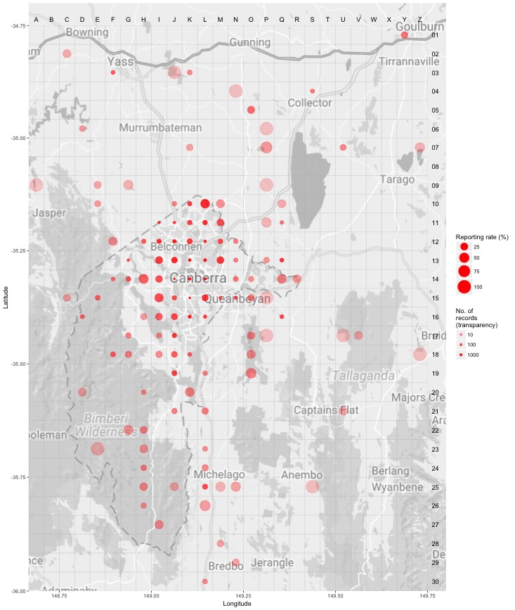
Source: Canberrabirds.org.au. (2018). Note: Reporting rate (%) is the proportion of all surveys in which the species was present. These data were collected by volunteer birdwatchers using various survey methods and, on some occasions, more than one person may have recorded bird sightings on the same day, which may skew the data.

Figure 2: Distribution of Scarlet Robin records in the ACT region – 1982–2017
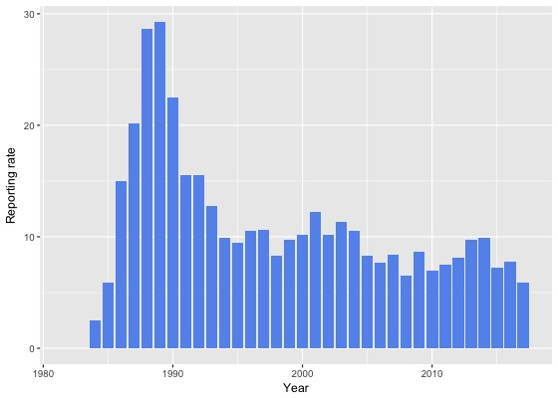
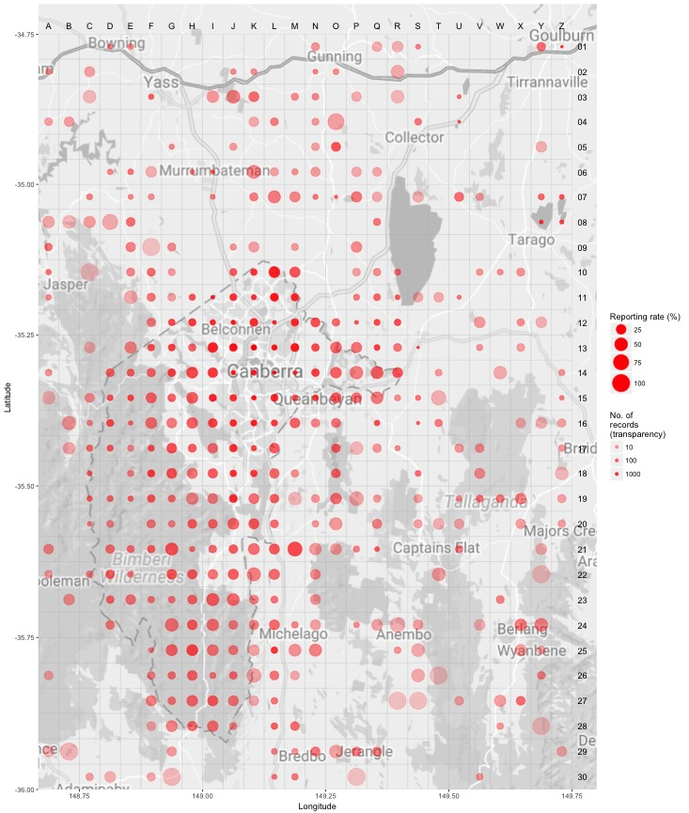
Source: Canberrabirds.org.au. (2018). Note: Reporting rate (%) is the proportion of all surveys in which the species was present. These data were collected by volunteer birdwatchers using various survey methods and, on some occasions, more than one person may have recorded bird sightings on the same day, which may skew the data.

Threats
In common with many other threatened bird species, the principal threat to the Scarlet Robin is loss of its open forest or woodland breeding and foraging habitat and habitat degradation. Threats to the Scarlet Robin (ACT Government 2016) include:
- clearing of open forest and woodland
- reduction in the structural complexity of habitat
- habitat fragmentation of woodland into smaller patches and loss of connectivity
- firewood collection, tidying-up of rough pasture, pasture improvement and overgrazing
- unsuitable dense regeneration of shrub layers after fire
- nest failure due to predation by Pied Currawongs (Strepera graculina), mammals and reptiles
- direct predation by cats
- competition through aggressive exclusion by Noisy Miners (Manorina melanocephala)
- ‘medium’ sensitivity to climate change.

Major Conservation Objective
The primary objective in the ACT is to maintain a viable, wild population of Scarlet Robins by protecting habitat through limiting clearance of suitable woodland habitat and prioritising conservation management to woodland patches, particularly those that are large or have complex habitat structure.

Conservation Issues and Proposed Management Actions
Suggested management actions (ACT Government 2016) include:
- identify, protect and restore critical breeding and foraging habitat
- manage critical habitat in response to identified threats
- improve connectivity of isolated habitat and increase habitat patch size
- promote and support the survey, monitoring and research of the species in the ACT
- increase community awareness and encourage community-based conservation action

Other Relevant Advice, plans or Prescriptions
- Action Plan for Scarlet Robin (ACT Government 2016)
- ACT Woodland Conservation Strategy (ACT Government 2004)
- ACT Draft Woodland Conservation Strategy (ACT Government 2019)

Listing Background
The Scarlet Robin was initially listed in the ACT as Petroica multicolor as a Vulnerable species on 12 May 2015 in accordance with section 38 of the Nature Conservation Act 1980.
The Flora and Fauna Committee (now Scientific Committee) concluded that at that time the assessment satisfied the criteria:
2.2 The species is observed, estimated, inferred or suspected to be at risk of premature extinction in the ACT region in the medium-term future, as demonstrated by:
2.2.1 Current serious decline in population or distribution from evidence based on:
2.2.1.1 Direct observation, including comparison of historical and current records.
On 3 June 2015 the Scientific Committee recommended the scientific name of the Scarlet Robin be changed to Petroica boodang following a molecular study (Kearns et al. 2015) and a revision of the taxonomy of Australian passerine bird species (Dickinson and Christidis 2014). The scientific name of the Scarlet Robin was updated on the Threatened Native Species List to Petroica boodang on 30 May 2016.

References
ACT Government 2004. Woodlands for Wildlife: ACT Lowland Woodland Conservation Strategy. Action Plan No. 27. Environment ACT, Canberra.
ACT Government 2016. Scarlet Robin (Petroica boodang) Action Plan. Environment ACT, Canberra.
ACT Government 2019. Draft ACT Woodland Conservation Strategy and Action Plans. Environment Planning and Sustainable Development Directorate, Canberra.
BirdLife Australia 2018. Scarlet Robin Profile. Birdlife.org.au. Accessed 14 August 2018 from: http://www.birdlife.org.au/bird-profile/scarlet-robin.
BirdLife International. 2017. Petroica boodang (amended version of 2016 assessment). The IUCN Red List of Threatened Species 2017. Accessed 14 August 2018 from: http://dx.doi.org/10.2305/IUCN.UK.2017-1.RLTS.T22735719A112749310.en.
Bounds J, Taws N and Cunningham R 2010. A statistical analysis of trends in occupancy rates of woodland birds in the ACT, December 1998 to December 2008. Canberra Bird Notes 35(3): 158–191.
Canberrabirds.org.au (2018). Scarlet Robin Petroica boodang data sheet. Accessed 14 August 2018 from: http://canberrabirds.org.au/wp-content/bird_data/380_Scarlet%20Robin.html
COG 2014. Annual Bird Report: 1 July 2012 to 30 June 2013. Canberra Bird Notes 39(1): 1–108.
COG 2015. Annual Bird Report: 1 July 2013 to 30 June 2014. Canberra Bird Notes 40(1): 1–112.
COG 2018. Annual Bird Report: 1 July 2016 to 30 June 2017. Canberra Bird Notes 43(1): 1–110.
Dickinson EC and Christidis L (eds.) 2014. The Howard and Moore Complete Checklist of the Birds of the World. Volume 2: Passerines. Aves Press, Eastbourne.
Dolman G and Joseph L 2015. Evolutionary history of birds across southern Australia: structure, history and taxonomic implications of mitochondrial DNA diversity in an ecologically diverse suite of species. Emu 115: 35–48.
Frith HJ (ed.) 1984. Birds in the Australian High Country (Revised edition). Angus and Robertson, Sydney.
Higgins PJ and Peter M (eds.) 2002. Handbook of Australian, New Zealand and Antarctic Birds. Volume 6. Pardalotes to Spangled Drongo. Oxford University Press, Melbourne.
Kearns AM, Joseph L, White LC, Austin JJ, Baker C, Driskell AC, Malloy JF and Omland KE 2015. Norfolk Island Robins are a distinct endangered species: ancient DNA unlocks surprising relationships and phenotypic discordance within the Australo-Pacific Robins. Conservation Genetics 17(2).
Lesson LP 1838. Oiseaux. In Bougainville HYPP (ed.) Journal de la Navigation autour du Globe de la Fregate Thetis et de la Corvette l'Esperance pendant les années 1824, 1825, et 1826. Vol. 2: 322. Departement da la Marine, Paris.
NSW Scientific Committee 2010. Scarlet Robin Petroica boodang (Lesson 1838) – vulnerable species listing. Final determination.
Pizzey G and Knight F 2012. Field Guide to the Birds of Australia. Edited by S. Pizzey 9th Edition. Harper Collins Publishers, Sydney.
Rayner L 2015. Conserving woodland birds: the need for population data in evidence-based planning. Unpublished PhD thesis, Australian National University, Canberra.
Rayner L, Ikin K, Evans MJ, Gibbons P, Lindenmayer DB and Manning AD 2015. Avifauna and urban encroachment in time and space. Diversity Distributions 21(4): 428–448.
Sharpe RB 1879. Catalogue of the Passeriformes, or Perching Birds in the Collection of the British Museum Cichlomorphae 1(4):165. British Museum, London.
Taws N, Bounds J, Rowell A and Cunningham R 2012. An analysis of bird occupancy and habitat changes at six woodland locations – 2003 and 2010. Canberra Bird Notes 37(2): 100–129.
Taylor M & Canberra Ornithologists Group (COG) 1992. Birds of the Australian Capital Territory – An Atlas. Canberra Ornithologist Group and National Capital Planning Authority, Canberra.

Further Information
Further information on the related Action Plan and Woodland Strategy or other threatened species and ecological communities can be obtained from the Environment, Planning and Sustainable Development Directorate (EPSDD): Phone: (02) 132281, EPSDD Website: http://www.environment.act.gov.au/cpr

