Australian Capital Territory
Planning and Development (Plan Variation No 362) Approval 2019

Notifiable instrument NI2019—264
made under the
Planning and Development Act 2007, s 76 (Minister’s powers in relation to draft plan variations)

1 Name of instrument
This instrument is the Planning and Development (Plan Variation No 362) Approval 2019.
2 Approval of draft plan variation
(1) Under section 76 (2) (a) of the Planning and Development Act 2007, I approve the draft plan variation No 362 to the Territory Plan.
(2) In this section:
draft plan variation No 362 to the Territory Plan means the draft plan variation in the schedule.

Mick Gentleman MLA
Minister for Planning and Land Management
2 May 2019

Planning and Development Act 2007

Variation to the
Territory Plan
No 362

Amendments to the West Belconnen Concept Plan for
Ginninderry Stage 2 Development

April 2019

Final variation prepared under s76 of the
Planning and Development Act 2007

Contents

1. EXPLANATORY STATEMENT 1
1.1 Background 1
1.2 Summary of the Proposal 1
1.3 The National Capital Plan 2
1.4 Site Description 2
1.5 Current Territory Plan Provisions 4
1.6 Changes to the Territory Plan 5
1.7 Consultation on the Draft Variation 6
2. VARIATION 6
2.1 Variation to the Territory Plan 6

This

- EXPLANATORY STATEMENT
  - Background
Variation 362 varies the West Belconnen Concept Plan by making the provision of reticulated gas to each block an optional, rather than a mandatory requirement for Stage 2 of Ginninderry Estate, West Belconnen.
Stage 1 of Ginninderry Estate is currently subject to the rule that allows optional provision of gas to each block. This variation amends the rule by extending it to each block in Stage 2 of Ginninderry Estate.
Given the increasing supply and affordability of renewable energy sources, mandating the provision of gas is not considered to be consistent with the principles and policies of the West Belconnen Structure Plan.
The Structure Plan states that ‘subdivision design will facilitate energy efficient housing consistent with current best practice.’ Additionally, the Structure Plan allows for the concept plan to depart from the relevant development code in response to contemporary best practice for energy efficiency.
There is currently an agreement for a pilot project to apply to Stage 1 of Ginninderry Estate, which will develop houses on the basis that no reticulated gas will be provided for residential use. As Variation 362 applies to Stage 2 of Ginninderry Estate, the pilot project is expanded to a larger area, assessing whether houses are able to work efficiently and cost effectively without gas and then evaluated in terms of both customer experience and energy use. The ACT is the only jurisdiction in Australia that has a mandatory requirement for gas infrastructure to be provided in new estates and subdivisions.
The mandatory utility service provisions of water, sewer, stormwater, electricity, and telecommunications to each block will be retained.

  - Summary of the Proposal
Variation 362 varies the West Belconnen Concept Plan by making the provision of reticulated gas to all blocks in Stage 2 of Ginninderry Estate, West Belconnen an optional, rather than a mandatory requirement.
Variation 362 amends a rule in the West Belconnen Concept Plan to include both Stage 1 and 2 of the Ginninderry Estate, West Belconnen.

  - The National Capital Plan
The Australian Capital Territory (Planning and Land Management) Act 1988 established the National Capital Authority (NCA) with two of its functions being to prepare and administer a National Capital Plan (NCP) and to keep the NCP under constant review and to propose amendments to it when necessary.
The NCP, which was published in the Commonwealth Gazette on 21 January 1990 is required to ensure that Canberra and the Territory are planned and developed in accordance with their national significance. The Planning and Land Management Act 1988 also required that the Territory Plan is not inconsistent with the NCP.
In accordance with section 10 of the Australian Capital Territory (Planning and Land Management) Act 1988, the National Capital Plan defines the planning principles and policies for Canberra and the Territory, for giving effect to the object of the NCP and sets out the general policies to be implemented throughout the Territory, including the range and nature of permitted land uses.
It also sets out the detailed conditions of planning, design and development for areas that have special significance to the National Capital known as designated areas and identifies special requirements for the development of some other areas.

  - Site Description
The subject site is Stage 2 of Ginninderry Estate in West Belconnen. It is located immediately west of the existing suburbs of Holt and Macgregor, east of the Murrumbidgee River and south of the NSW state border.

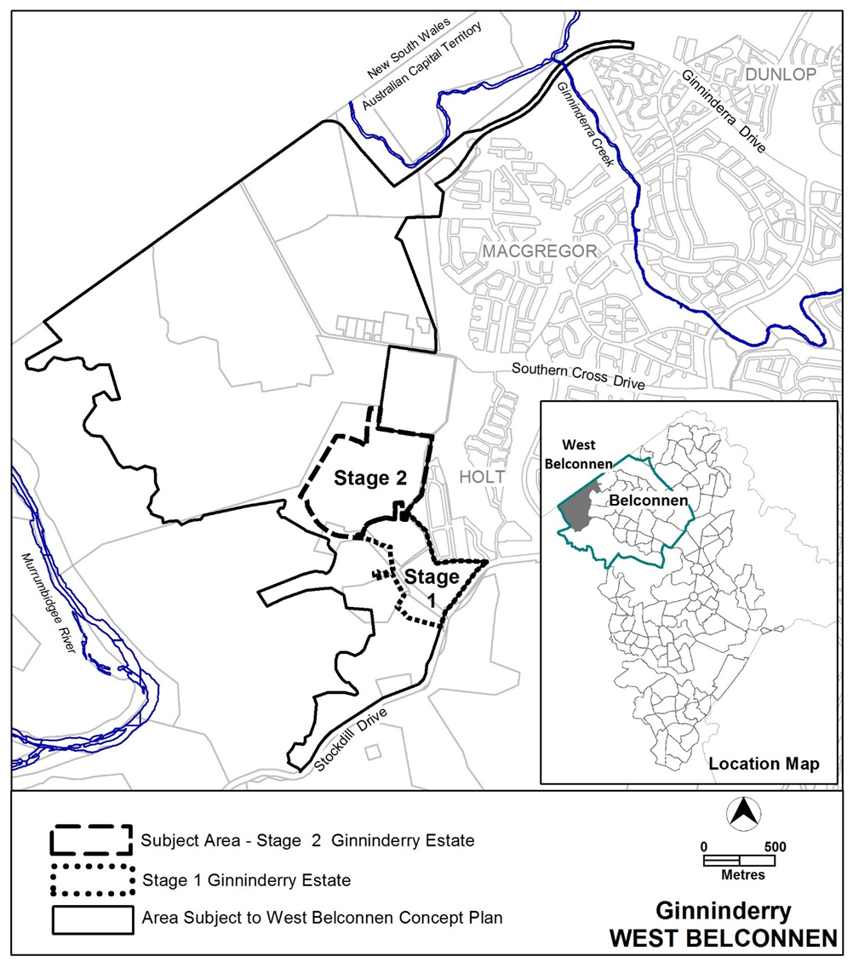

Figure 1 Location of Stage 2 Ginninderry Estate, West Belconnen

  - Current Territory Plan Provisions
Under the Territory Plan, all estate planning and subdivision of land in the ACT must comply with any relevant development code, concept plan or precinct code.
The requirement for the supply of utility services in Ginninderry Estate is currently subject to provisions in the Estate Development Code and the *West Belconnen Concept Plan:
(1) Under Rule 43 of the Estate Development Code, it is mandatory for utility services, including gas, to be provided to each block in new suburbs; and
(2) Rule 35 A of the West Belconnen Concept Plan overrides the mandatory requirement in the Estate Development Code for gas to be supplied to each block in Stage 1 of Ginninderry Estate
Variation 362 varies the existing provision in the West Belconnen Concept Plan to include Stage 2 of Ginninderry Estate. The provision allows for both Stage 1 and Stage 2 to override the mandatory requirement in the Estate Development Code for gas to be supplied to each block.
Under the Planning and Development Act 2007 (the Act), where more than one type of code applies to a development and there is inconsistency between provisions, the provisions in the concept plan take precedence over those in the Estate Development Code.
*Note: A concept plan is deemed to be precinct code under the Act.

  - Changes to the Territory Plan
Detailed changes to the Territory Plan are noted in section 2 of this document.

  - Consultation on the Draft Variation
Draft Variation No 362 (DV362) was released for public comment between Friday 7 December 2018 and Friday 8 February 2019. A consultation notice under section 63 of the Planning and Development Act 2007 (P&D Act) was published on the ACT Legislation Register on 7 December 2018.
No written submissions were received.
A report on consultation was prepared. No changes were made as a result of consultation. The outcomes of consultation were considered by the Minister responsible for planning prior to approval of this variation.

  - Revisions to the Draft Variation Recommended to the Minister
No changes were made to the draft variation recommended to the Minister.

- VARIATION
  - Variation to the Territory Plan
The Territory Plan map is varied in all of the following ways:

Variation to the West Belconnen Concept Plan
Part B Subdivision

Delete

16A Utility Services

R35A  Utility services, including water, sewer,  stormwater, electricity, gas and  telecommunications are provided to each block.  For Stage 1 Ginninderry Estate, the provision of gas to each block is not a mandatory requirement.  Note: A condition of development approval may be imposed to ensure compliance with this rule. | This is a mandatory requirement. There is no applicable criterion.

Substitute

16A Utility Services

R35A  Utility services, including water, sewer,  stormwater, electricity, gas and  telecommunications are provided to each block.  For Stages 1 and 2 Ginninderry Estate, the provision of gas to each block is not a mandatory requirement.  Note: A condition of development approval may be imposed to ensure compliance with this rule. | This is a mandatory requirement. There is no applicable criterion.

Interpretation service
