Australian Capital Territory
Heritage (Decision about Provisional Registration of TG1 (Tea Gardens 1), Ngunnawal) Notice 2019
Notifiable instrument NI2019–346
made under the
Heritage Act 2004, s 32 (Decision about provisional registration) and s 34 (Notice of decision about provisional registration)

1 Name of instrument
This instrument is the Heritage (Decision about Provisional Registration of TG1 (Tea Gardens 1), Ngunnawal) Notice 2019.
2 Decision about provisional registration
On 7 February 2019, the ACT Heritage Council (the Heritage Council) decided not to provisionally register TG1 (Tea Gardens 1), Block 2, Section 32 and road easement, Ngunnawal (the Place).
3 Description of the Place
The description of the Place is in the schedule.
4 Reasons for the decision
The Heritage Council is not satisfied on reasonable grounds that the Place is likely to have heritage significance as defined by section 10 of the Heritage Act 2004. A detailed statement of reasons, including an assessment against the heritage significance criteria, is provided in the schedule.
5 Date decision takes effect
The decision not to provisionally register the Place takes effect on 8 February 2019 (being the day after the Heritage Council made its decision in writing as set out in the schedule).
Fiona Moore
Secretary (as delegate for)
ACT Heritage Council
30 May 2019

Schedule
(See sections 3 and 4)
STATEMENT OF REASONS
DECISION NOT TO PROVISIONALLY REGISTER
TG1 (Tea Gardens 1)WamboinName of Place
Block 2 Section 32 and road easement, Ngunnawal
IN THE ACT HERITAGE REGISTER

In accordance with Section 32 of the Heritage Act 2004, the ACT Heritage Council has decided not to provisionally register TG1 (Tea Gardens 1), Ngunnawal. This Statement of Reasons provides an assessment of TG1 (Tea Gardens 1), Ngunnawal and finds that the place does not meet any of the criteria under s.10 of the Heritage Act 2004.

This statement refers to the location of the place as required in s.34(5)(b)(ii) of the Heritage Act 2004.
LOCATION OF THE PLACE

TG1 (Tea Gardens 1), Block 2 Section 32 and road easement, Ngunnawal.

This section refers to the description of the place as required in s.34(5)(b)(iii) of the Heritage Act 2004. The boundary of the place and extent of features listed below is illustrated at Image 1.

DESCRIPTION OF THE PLACE

TG1 (Tea Gardens 1), consisting of the following attributes:
- the buried ruins of a stone hut as evidenced by two rough courses of local field stone with a coarse cement mortar and any archaeological material associated with it.

This statement refers to the Council’s reasons for its decision as required in s.34(5)(b)(iv) of the Heritage Act 2004.
REASONS FOR DECISION

The Council is satisfied on reasonable grounds that the place is not likely to have heritage significance as defined by s.10 of the Heritage Act 2004.

This statement refers to the Council’s assessment of the place against the heritage significance criteria as a part of its reasons for its decision as required in s.34(5)(b)(iv) of the Heritage Act 2004.
ASSESSMENT AGAINST THE HERITAGE SIGNIFICANCE CRITERIA

The Council’s assessment against the criteria specified in s.10 of the Heritage Act 2004 is as follows.

In assessing the heritage significance of TG1 (Tea Gardens 1), Ngunnawal, the Council considered:
- the original nomination and documentary evidence supplied by the nominator;
- the Council’s Heritage Assessment Policy (March 2018);
- information provided by a site inspection on 16 November 2018 by ACT Heritage; and
- the report by ACT Heritage titled, Background Information TG1 (Tea Gardens 1), May 2019, containing photographs and information on history, description, condition and integrity

Pursuant to s.10 of the Heritage Act 2004, a place or object has heritage significance if it satisfies one or more of the following criteria. Future research may alter the findings of this assessment.
- importance to the course or pattern of the ACT’s cultural or natural history;
The Council has assessed TG1 (Tea Gardens 1) against criterion (a) and is satisfied that the place does not meet this criterion.
As a small, previously unrecorded outbuilding of the Tea Gardens property there is no evidence that TG1 has been important to the course or pattern of the ACT’s cultural history.
- has uncommon, rare or endangered aspects of the ACT’s cultural or natural history;
The Council has assessed TG1 (Tea Gardens 1) against criterion (b) and is satisfied that the place does not meet this criterion.
As there is very little known about TG1, its history or purpose, the Council does not have the evidence available to determine if it is of an uncommon type of pastoral outbuilding.
TG1 is the ruins of a 19th, or possibly 20th, century stone and mortar building that was an outbuilding of the Tea Gardens pastoralist estate. What role the site played in the overall property is unknown and its relationship to the rest of the property has been severely impacted by it being built over by the suburb of Ngunnawal. Additionally, its integrity has been impacted by its ruinous state; and the lack of information available about it and its former function mean that a complete assessment of its uncommonness, rarity or endangered aspects cannot be conducted, particularly in reference to how much of an impact its integrity level has (e.g. a very rare kind of place may meet the criterion regardless of integrity, while a more common type of place might only meet if it its high level of integrity is what makes it rare). The Council’s assessment against the criteria in s10 of the Act can only be concerned with if a place meets the criteria; the current lack of evidence relating to TG1 means that the Council cannot firmly conclude that TG1 does have uncommon, rare or endangered aspects of the ACT’s cultural history.
- potential to yield important information that will contribute to an understanding of the ACT’s cultural or natural history;
The Council has assessed TG1 (Tea Gardens 1) against criterion (c) and is satisfied that the place does not meet this criterion.
While TG1 does have the potential to yield information as an archaeological site conserved in-situ, there is no indication as to whether any information it may contribute would be considered important. Various outbuildings of early homesteads do have the potential to provide important archaeological information as they have previously been an ignored and un-studied aspect of the ACT’s cultural history; however, there is no indication as to what TG1 may have been used for or what period in history it relates to, so while it may provide important information, it is just as likely to provide no information. Until the nature of the site becomes clearer, through further research or excavation, the Council has no choice but to conclude that, at the time of this decision, TG1 does not meet the threshold for inclusion under this criterion. If further information is discovered at a later date, the place may be re-nominated for the Council to consider any new information.
- importance in demonstrating the principal characteristics of a class of cultural or natural places or objects;
The Council has assessed TG1 (Tea Gardens 1) against criterion (d) and is satisfied that the place does not meet this criterion.
TG1 is a buried ruin that is not visible without excavation of the overlying crushed granite parking area. Being covered means that the place is unable to demonstrate any of the characteristics of a ruin or a pre-FCT hut or outbuilding. As such, it does not meet the basic test for this criterion.
- importance in exhibiting particular aesthetic characteristics valued by the ACT community or a cultural group in the ACT;
The Council has assessed TG1 (Tea Gardens 1) against criterion (e) and is satisfied that the place does not meet this criterion.
TG1 is a buried ruin that is not visible without excavation of the overlying crushed granite parking area. Being covered means that the place is unable to exhibit any particular aesthetic characteristics that could be valued by the ACT community or a cultural group in the ACT. As such, it does not meet the basic test for this criterion.
- importance in demonstrating a high degree of creative or technical achievement for a particular period;
The Council has assessed TG1 (Tea Gardens 1) against criterion (f) and is satisfied that the place does not meet this criterion.
Stone huts were a ubiquitous type of construction for pre-FCT European settlers, combined with the ruined state of the building that precludes it from demonstrating all but the footings of a stone hut, mean that TG1 is not considered to be important in demonstrating a high degree of creative or technical achievement for that period.
- has a strong or special association with the ACT community, or a cultural group in the ACT for social, cultural or spiritual reasons;
The Council has assessed TG1 (Tea Gardens 1) against criterion (g) and is satisfied that the place does not meet this criterion.
TG1 consists of local stone that is similar to that from a nearby Aboriginal chert quarry PH13 in Girrawah Park. Photographs from 1992 show some of the stone in the wall has had its cortical surfaces removed through conchoidal fracture, with there being potential for this to be the result of Aboriginal quarrying to procure material for stone tools. If this is the case, then the use of this material by the European settlers is a physical emblem of dispossession and a link between pre and post-contact ways of life. Council determined to consult with the Representative Aboriginal Organisations (RAOs) regarding the potential for TG1 to be of significance as a site of dispossession. This consultation took the form of emails and phone calls over the period of 24 April 2019 to 9 May 2019 which described the site and this potential. No responses were received from RAOs on the issue by the date nominated for closure of responses. Council interprets this silence to mean the RAOs do not consider the site holds significance against the criterion.
- has a special association with the life or work of a person, or people, important to the history of the ACT.
The Council has assessed TG1 (Tea Gardens 1) against criterion (h) and is satisfied that the place does not meet this criterion.
TG1 is associated with the Tea Gardens homestead and the families that lived there. While the families have had important roles in the history of the ACT, there is no evidence that TG1 has a special association with any of them and, as such, is not considered to meet the basic tests to be considered against this criterion.

SITE PLAN

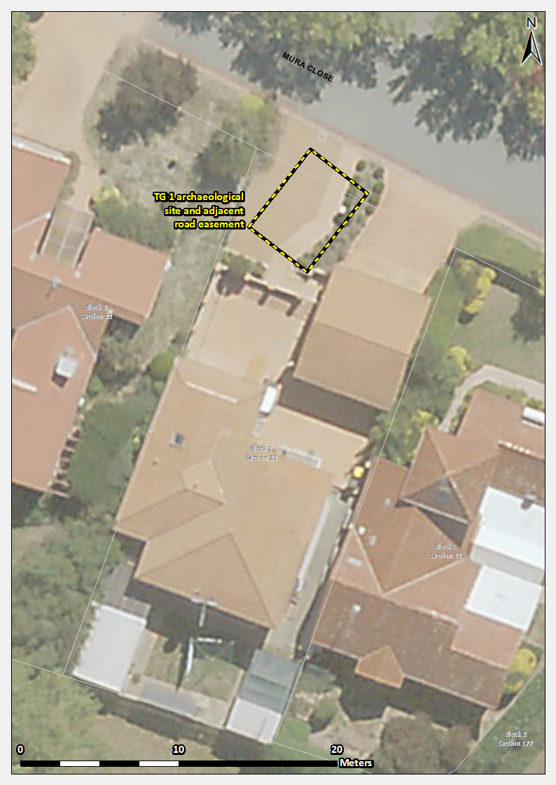
Image 1 TG1 (Tea Gardens 1) site boundary

