Heritage (Decision about Provisional Registration of Lutons Crutching Shed, Mount Clear) Notice 2019
Notifiable instrument NI2019–347
made under the
Heritage Act 2004, s 32 (Decision about provisional registration) and s 34 (Notice of decision about provisional registration)

1 Name of instrument
This instrument is the Heritage (Decision about Provisional Registration of Lutons Crutching Shed, Mount Clear) Notice 2019.
2 Decision about provisional registration
On 30 May 2019, the ACT Heritage Council (the Heritage Council) decided not to provisionally register Lutons Crutching Shed, Block 39, Mount Clear (the Place).
3 Description of the Place
The description of the Place is in the schedule.
4 Reasons for the decision
The Heritage Council is not satisfied on reasonable grounds that the Place is likely to have heritage significance as defined by section 10 of the Heritage Act 2004. A detailed statement of reasons, including an assessment against the heritage significance criteria, is provided in the schedule.
5 Date decision takes effect
The decision not to provisionally register the Place takes effect on
31 May 2019 (being the day after the Heritage Council made its decision in writing as set out in the schedule).
Fiona Moore
Secretary (as delegate for)
ACT Heritage Council
30 May 2019

Schedule
(See sections 3 and 4)
STATEMENT OF REASONS
DECISION NOT TO PROVISIONALLY REGISTER
Lutons Crutching ShedWamboinName of Place
Mount Clear
IN THE ACT HERITAGE REGISTER

In accordance with Section 32 of the Heritage Act 2004, the ACT Heritage Council has decided not to provisionally register Lutons Crutching Shed, Mount Clear. This Statement of Reasons provides an assessment of Lutons Crutching Shed, Mount Clear and finds that the place does not meet any of the criteria under s.10 of the Heritage Act 2004.

Contextually, Lutons Crutching Shed is located in a part of the Bobeyan valley, considered in the 19th century, to be amenable to European settlement and pastoral enterprise. The drop log fence associated with the complex dates from the 1950s and the crutching shed was built in the late 1960s for annual sheep crutching. The shed was used once and modified accordingly, for shearing during drought in the 1970s. Upon resumption of the shed into Gudgenby Nature Reserve in 1979 and then Namadgi National Park, significant gates and yards were removed and modifications made to the perimeter fence, these changes impact considerably on the integrity and intactness of the building and its ability to be read for stock management. Additionally, the intermittent and short duration of the buildings use also limits is significance. Currently ACT Parks and Conservation Service (ACT PCS) and the Kosciuszko Huts Association (KHA) are working together to maintain the complex and to complete limited building works - including re-creating the drop log fence.

This statement refers to the location of the place as required in s.34(5)(b)(ii) of the Heritage Act 2004.
LOCATION OF THE PLACE

Lutons Crutching Shed is in Block 39 of the Mount Clear District, within Namadgi National Park which is managed by the ACT Parks and Conservation Service (ACT PCS). The site is in the Bobeyan Valley and is accessed from the Namadgi Visitor Centre via the Bobeyan and then Old Bobeyan Road to a locked gate. From the gate, access is via Sam’s Creek Fire Trail.

This section refers to the description of the place as required in s.34(5)(b)(iii) of the Heritage Act 2004. The boundary of the place and extent of features listed below is illustrated at Image 1.

DESCRIPTION OF THE PLACE

Lutons Crutching Shed is in the Bobeyan Valley, the complex is situated on the north side of a prominent spur which descends from Sentry Box Hill between Naas Creek and Sheep Station Creek. The complex is located on a slope leading into the valley, just below the existing tree line. The main features of Lutons Crutching Shed are a large corrugated iron crutching shed and associated non intact perimeter fence line.

This statement refers to the Council’s reasons for its decision as required in s.34(5)(b)(iv) of the Heritage Act 2004.
REASONS FOR DECISION

The Council is satisfied on reasonable grounds that the place is not likely to have heritage significance as defined by s.10 of the Heritage Act 2004.

This statement refers to the Council’s assessment of the place against the heritage significance criteria as a part of its reasons for its decision as required in s.34(5)(b)(iv) of the Heritage Act 2004.
ASSESSMENT AGAINST THE HERITAGE SIGNIFICANCE CRITERIA

The Council’s assessment against the criteria specified in s.10 of the Heritage Act 2004 is as follows.

In assessing the heritage significance of Lutons Crutching Shed, Mount Clear, the Council considered:
- the Council’s Heritage Assessment Policy (March 2018);
- information provided by a site inspection on 10 February 2019 by ACT Heritage; and
- the report by ACT Heritage titled, Background Information Lutons Crutching Shed, March 2019, containing photographs and information on history, description, condition, integrity and a comparison with sites in nearby Orroral valley.

Pursuant to s.10 of the Heritage Act 2004, a place or object has heritage significance if it satisfies one or more of the following criteria. Future research may alter the findings of this assessment.
- importance to the course or pattern of the ACT’s cultural or natural history;
The Council has assessed Lutons Crutching Shed against criterion (a) and is satisfied that the place does not meet this criterion.

Lutons Crutching Shed represent the continuation of pastoralism in the Bobeyan valley that commenced in the 1830s. It also represents the shift from mostly cattle to mostly sheep which was a pattern played out across the backcountry of the ACT as trees were cleared and new drenches necessary for sheep survival in the mountainous areas became available. As a purpose built crutching shed, as opposed to the norm - a shearing shed where crutching was also completed - Luton’s Crutching Shed also represents an uncommon and practical response to the challenges of caring for sheep in a remote area. Whilst Lutons Crutching Shed represents pastoralism in the backcountry, it was only used once a year for crutching and likely for less than 20 years, these factors limit its ability to be assessed successfully against this criteria. The modifications to the shed resulting in the loss of significant fabric enabling the pastoral use of the building to be read is also to the overall detriment of the complex.
- has uncommon, rare or endangered aspects of the ACT’s cultural or natural history;
The Council has assessed Lutons Crutching Shed against criterion (b) and is satisfied that the place does not meet this criterion.
As a crutching shed, Lutons Crutching Shed is considered a type of woolshed. There remain 42 woolsheds across the ACT, so these buildings cannot be considered uncommon, rare or endangered. Lutons Crutching Shed is also associated with pastoralism in the back country of Namadgi National Park. While there remain only two buildings related to pastoralism in Namadgi, the short and intermittent use of Lutons Crutching Shed and the absence of significant fabric related to the pastoral use of the building, means Lutons Crutching Shed cannot be considered to have a substantial claim against this criteria.
- potential to yield important information that will contribute to an understanding of the ACT’s cultural or natural history;
The Council has assessed Lutons Crutching Shed against criterion (c) and is satisfied that the place does not meet this criterion.
The archaeology of the complex could be examined to reveal important details of missing significant elements – gates, yards, perimeter fence and race. Beyond revealing these details, it is however, unlikely that an archaeological excavation at the site – which was used intermittently only and for less than 30 years – would yield information that will contribute to the ACT’s cultural history. Additionally, the configuration and details of missing significant elements can likely be determined in consultation with the Luton family.
- importance in demonstrating the principal characteristics of a class of cultural or natural places or objects;
The Council has assessed Lutons Crutching Shed against criterion (d) and is satisfied that the place does not meet this criterion.
The crutching shed is not substantially distinct from a woolshed to warrant its consideration as a separate type. Additionally, the removal of significant fabric following resumption impacts adversely on the integrity and intactness of the building and yards and its ability to be read as a type or a representative of a class of cultural place. At the landscape scale, the building may partially represent its type by evoking a pastoral idyll centred on the woolshed, but again the absence of significant fabric – such as gates and yards - and lack of integrity and intactness of the perimeter fence detracts from the buildings ability to represent a class of cultural place at this scale.
- importance in exhibiting particular aesthetic characteristics valued by the ACT community or a cultural group in the ACT;
The Council has assessed Lutons Crutching Shed against criterion (e) and is satisfied that the place does not meet this criterion.
While the KHA, some ACT PCS staff and likely a small number of hikers are familiar with and likely value the place, the remoteness of the site and its lack of interpretation mean it is unknown to most of the ACT community. Additionally, according to the ACT Heritage Assessment Policy (2018) groups such as the KHA cannot be considered to represent the ACT community as follows;
- Professional groups and special interest groups do not constitute a community or cultural group for the purposes of this criterion. Common expertise or interest is not sufficient by itself to define a community or cultural group

- ‘Community’ is defined as follows; ‘all the people of a specific locality or country’ plus ‘a particular locality, considered together with its inhabitants’
- For the purposes of the Heritage Act 2004, ‘the community’ is defined as ‘the ACT community’ or ‘the community of the ACT’.
- importance in demonstrating a high degree of creative or technical achievement for a particular period;
The Council has assessed Lutons Crutching Shed against criterion (f) and is satisfied that the place does not meet this criterion.
In keeping with many rural and pastoral buildings Lutons Crutching Shed represent practicality and resourcefulness, rather than a high degree of creative or technical achievement. The absence of important detailing such as gates and yards, additionally does not allow for a claim against this criterion.
- has a strong or special association with the ACT community, or a cultural group in the ACT for social, cultural or spiritual reasons;
The Council has assessed Lutons Crutching Shed against criterion (g) and is satisfied that the place does not meet this criterion.
While the KHA, some ACT PCS staff and a likely small number of hikers are familiar with and likely value the place, the remoteness of the site and its lack of interpretation mean it is unknown to most of the ACT community. Additionally, according to the ACT Heritage Assessment Policy (2018) groups such as the KHA cannot be considered to represent the ACT community as follows;
- Professional groups and special interest groups do not constitute a community or cultural group for the purposes of this criterion. Common expertise or interest is not sufficient by itself to define a community or cultural group

- ‘Community’ is defined as follows; ‘all the people of a specific locality or country’ plus ‘a particular locality, considered together with its inhabitants’
- For the purposes of the Heritage Act 2004, ‘the community’ is defined as ‘the ACT community’ or ‘the community of the ACT’.
- has a special association with the life or work of a person, or people, important to the history of the ACT.
The Council has assessed Lutons Crutching Shed against criterion (h) and is satisfied that the place does not meet this criterion.
There is no historical evidence to suggest the place is connected with any person or group of people whose life or work made a contribution beyond the ordinary to the history of the ACT, or that any such achievement relates directly to the fabric of the complex. Whilst Lutons Crutching Shed is connected with the Luton family, Maurice, Noel and Greg Luton all resided at Shannon’s Flat in NSW, and the crutching shed and yards were used by them as an annexure to their main pastoral enterprise in NSW.

SITE PLAN

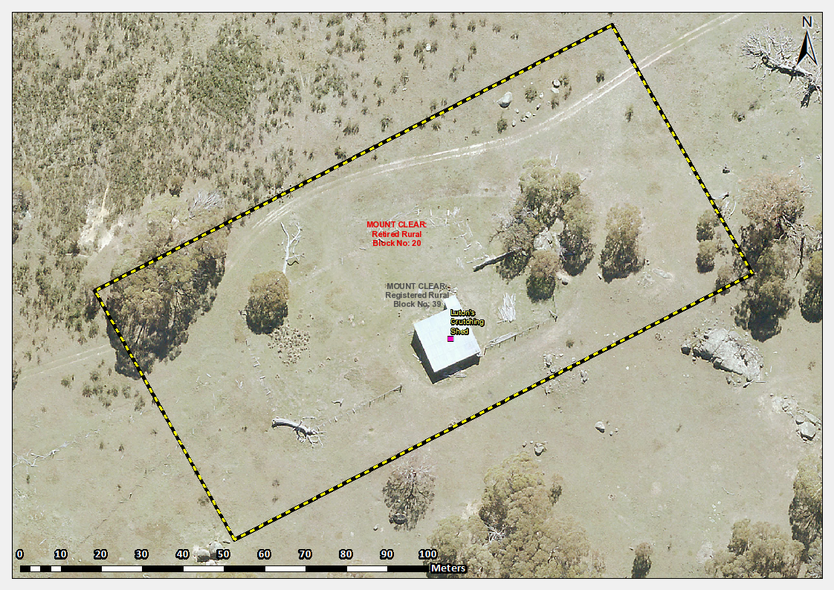
Image 1 Lutons Crutching Shed site boundary

