Australian Capital Territory
Heritage (Decision about Provisional Registration of Norwood Park Crematorium, Mitchell) Notice 2019
Notifiable Instrument NI2019–348
made under the
Heritage Act 2004, s32 (Decision about provisional registration) s34 (Notice of decision about provisional registration) and s37 (Public consultation about registration of place or object)

1 Name of instrument
This instrument is the Heritage (Decision about Provisional Registration of
Norwood Park Crematorium, Mitchell) Notice 2019.
2 Decision about provisional registration
On 30 May 2019, the ACT Heritage Council (the Heritage Council) decided to provisionally register Norwood Park Crematorium, Block 1, Section 54, Mitchell
(the Place).
3 Registration details of the Place
The registration details of the Place are in the schedule.
4 Reasons for the decision
The Heritage Council decided to provisionally register the Place because it is satisfied on reasonable grounds that it is likely to have heritage significance as it is likely to meet one or more of the heritage significance criteria in section 10 of the Heritage Act 2004 (the Act). A detailed statement of reasons, including an assessment against the heritage significance criteria, is provided in the schedule.
5 Date of provisional registration
The date of provisional registration is 31 May 2019 (being the day after the Heritage Council entered into the heritage register the registration details for the Place together with an indication that the registration is provisional).
6 Indication of the Heritage Council’s intention
The Heritage Council intends to decide whether to register the Place under Division 6.2 of the Act during the period of provisional registration.

7 Invitation to make written comments during public consultation period
(1) The Heritage Council invites written comments about the registration of the Place. Any written comments must be made within 4 weeks after the day this notice is notified.
(2) Written comments can be provided to the Council by the following methods:
(a) mail to
The Secretary
ACT Heritage Council
GPO Box 158
CANBERRA ACT 2601
(b) email to heritage@act.gov.au
(c) via the consultation website at www.yoursay.act.gov.au

Fiona Moore
Secretary (as delegate for)
ACT Heritage Council
30 May 2019

Schedule

(See sections 3 and 4)

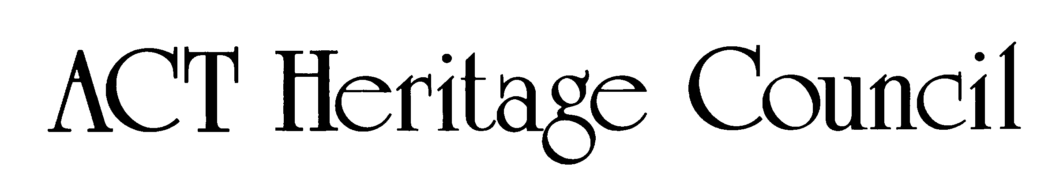
AUSTRALIAN CAPITAL TERRITORY
HERITAGE REGISTER
(Provisional Registration)

For the purposes of s. 33 of the Heritage Act 2004, a provisional entry to the heritage register has been prepared by the ACT Heritage Council for the following place:

Norwood Park Crematorium

Block 1 Section 54, Mitchell
DATE OF DECISION
30 May 2019
DATE OF PROVISIONAL REGISTRATION
31 May 2019 Notifiable Instrument: 2019–
PERIOD OF EFFECT OF PROVISIONAL REGISTRATION
Start Date: 31 May 2019 End Date: 30 October 2019

Extended Period (if applicable) Start Date ________ End Date ________

Copies of the Register Entry are available for inspection at ACT Heritage. For further information please contact:

The Secretary

ACT Heritage Council

GPO Box 158

CANBERRA ACT 2601

Telephone 13 22 81

This statement refers to the location of the place as required in s. 12 (b) of the Heritage Act 2004.
LOCATION OF THE PLACE

Norwood Park Crematorium, Block 1 Section 54, 65 Sandford Street, Mitchell.

This statement refers to the description of the place as required in s.12(c) of the Heritage Act 2004. The attributes described in this section form part of the heritage significance of the place. For the purposes of s. 12(c) of the Heritage Act 2004, the boundary of the place is at Image 1.
DESCRIPTION OF THE PLACE

Norwood Park Crematorium, consisting of the following attributes:
- the chapel, including:
  - catafalque;
  - dais that forms a continuous and integrated horizontal plane with the reflection pools flanking it in the courtyards, creating a raised platform for the catafalque and creating a contemplative space;
  - vestry to allow a separate space for the preparation of memorial services;
  - nave (large open space for various sized groups attending services);
  - porte-cochere as an extension of the horizontal plane of the roof allowing a covered area integrated with the rest of the building for a dignified entry space for the funeral party in all types of weather; and
  - the overall post-war modern design exemplified by the cubiform shape, large flat glass walls and doors and a simple elegance in its combination of forms, textures and lines that emphasise horizontal planes, light and lightness of structure; and in particular:
    - the flat steel-deck roof on steel frame that overhangs the building with wide fascias allow for the horizontal plane to extend, or ‘float’, over the non-structural walls;
    - the horizontal band of frameless glazing around the perimeter wall that add to the effect of the roof seeming to float with little support, which gains extra emphasis with the full height glazing;
    - the low facebrick entrance blade walls that add further to the horizontal emphasis and partially screen the courtyards on either side of the chapel;
    - the mix of colours emphasising natural, earthy tones (natural wood, copper, face brick and stone) juxtaposed with bright, white and translucent areas such as the sheer curtains;
    - the entire underside of the ceiling (fascias, soffits and ceiling) in the same material, adding to the horizontal emphasis and the floating effect of the roof as well as blurring the lines between interior and exterior;
    - the skylight in the porte-cochere to illuminate the entrance;
- the cremator section, including:
  - the twin chimney stacks as a pair of squat rectangular facebrick features that match the modern styling of the rest of the building while making them relatively unobtrusive;
  - cremators (these are a basic requirement of a crematorium and should be updated or replaced as required to meet current standards or best practice); and
  - connection to the chapel where the industrial side of the process is visually subservient to the publicly accessible and visible parts of the building;
- columbarium wall (as a memorial as well as a screening blade wall that forms an essential part of the design of the building);
- other memorials as demand grows (the crematorium should not be limited to the current set of memorials, but any new memorial areas within the central section should complement the building and setting); and
- the landscaping, including:
  - the long, low water features on either side of the chapel;
  - open courtyards on either side of the chapel that can integrate with the chapel;
  - the driveway to the porte-cochere;
  - the road surrounding the main building as a ceremonial driveway;
  - memorial gardens; and
  - large mature trees that are within and enclose the memorial gardens as well as screen nearby development and roads
    - the remaining original boundary plantings of White gum (Eucalyptus wandoo) that help screen outside development and provide a sense of enclosure, and
    - the post-1966 woodland eucalypts and the original pre-1966 woodland eucalypts, which include, but are not limited to Blakely’s red gum (Eucalyptus blakelyi), that together help create a sense of enclosure and add a natural, informal character and sense of age and permanency to the memorial gardens

While the condolence chapel, memorial gardens and various other memorials are included in the heritage listing boundary, they are not a specific part of the heritage significance of the place. They are included in a general sense, in that they complement the above features and use of the place and enhance the experience of a sense of arrival, but the physical fabric that comprises the non-listed features does not need to be preserved for the purposes of the heritage listing.

This statement refers to the heritage significance of the place as required in s.12(d) of the Heritage Act 2004.
STATEMENT OF HERITAGE SIGNIFICANCE

Norwood Park Crematorium has played an integral part in changing attitudes towards dealing with the dead, from a burial-based society in the early days of the federal capital to cremation being the preferred method. It demonstrates the principal characteristics of crematoriums in a creative design that allows it to be used by all religions and non-religious people alike, while the modern style links it with a period in history when cremation became much more socially acceptable and the process proliferated around the country and the Western world. It is also this welcoming design, open to all, that has made the Crematorium a special place for the community as a place of interment and remembrance [criteria (a), (d), (f) (g)].
CONSERVATION OBJECTIVE

The guiding conservation objective is that Norwood Park Crematorium shall be conserved and appropriately managed in a manner respecting its heritage significance.

The ACT Heritage Council may adopt heritage guidelines applicable to the place under s25 of the Heritage Act 2004.

For further information on guidelines applicable to the place, or for advice on proposed works or development, please contact ACT Heritage on 13 22 81.
REASON FOR PROVISIONAL REGISTRATION

The Council has assessed the Norwood Park Crematorium, Mitchell against the heritage significance criteria and is satisfied that the place is likely to have heritage significance when assessed against four criteria [(a), (d), (f) and (g)] under s.10 of the Heritage Act 2004.
ASSESSMENT AGAINST THE HERITAGE SIGNIFICANCE CRITERIA

The Council’s assessment against the criteria specified in s.10 of the Heritage Act 2004 is as follows.

In assessing the heritage significance of Norwood Park Crematorium, Mitchell, the Council considered:
- the original nomination and documentary evidence supplied by the nominator;
- the Council’s Heritage Assessment Policy (March 2018);
- information provided by a site inspection on 8 February 2019 by the Heritage Council;
- the report by ACT Heritage titled, Background Information Norwood Park Crematorium, May 2019, containing photographs and information on history, description, condition and integrity; and

Pursuant to s.10 of the Heritage Act 2004, a place or object has heritage significance if it satisfies one or more of the following criteria. Future research may alter the findings of this assessment.
importance to the course or pattern of the ACT’s cultural or natural history;
The Council has assessed Norwood Park Crematorium against criterion (a) and is satisfied that the place is likely to meet this criterion.
Norwood Park Crematorium has had an important influence on the ACT’s cultural history as the first, and for at least 50 years the only, crematorium. It has played an integral part in changing attitudes towards dealing with the dead, from a burial-based society in the early days of the federal capital, to a point in the 1990s when the number of cremations overtook the number of burials, to the current day when cremation is the preferred method. As the only local place for cremation services, its efficient, effective and clean operation and its thoughtful design that accommodates all, Norwood Park Crematorium helped to normalise the idea of cremation and is an important place for the bereaved to honour loved ones.
has uncommon, rare or endangered aspects of the ACT’s cultural or natural history;
The Council has assessed Norwood Park Crematorium against criterion (b) and is satisfied that the place is not likely to meet this criterion.
For the purpose of assessing this criterion, the Council has considered Norwood Park Crematorium against other places where people are memorialised (including, but not limited to burial, interring ashes, memorial plaques and statues, mausoleums, etc.). Comparing it to other crematoria in the ACT, of which it is currently the only one due to demand (i.e. there is nothing intrinsically making it the only crematorium), was considered to be self-fulfilling and not in the spirit of this criterion in judging a places uncommonness or rarity.
The first places for memorialisation in the region served small local populations in the mostly rural communities and included family plots on private property. The first public cemetery was the unofficial Oaks Estate cemetery, followed by the official Queanbeyan Riverside Cemetery and the St John’s Church graveyard in Reid. The number of places gradually grew over the years and now includes the Woden and Gungahlin Cemeteries, three cemeteries in Queanbeyan, as well as the numerous smaller village, rural or retired places of memorial of St Johns graveyard, Naas, Lanyon, Parkwood, Oaks Estate, Weetangera, Tharwa, the De Salis Cemetery and various smaller family plots on private property across the region. With the increasing number of places the style of memorialisation has changed over the years, initially with it was almost universal burial, then to a gradual acceptance of cremation and most recently with cremation being the predominant form. With cremation the form of memorialisation can then take the form of interment of ashes and some form of formal memorial (e.g. a plaque, statue or headstone), ashes kept in an urn for personal memorialisation (e.g. kept at home) or scattered with no permanent memorialisation.
potential to yield important information that will contribute to an understanding of the ACT’s cultural or natural history;
The Council has assessed Norwood Park Crematorium against criterion (c) and is satisfied that the place is not likely to meet this criterion.
As a modern, built and well-documented heritage place, it is unlikely that the Norwood Park Crematorium has any unknown information in its physical fabric that would yield important information that would contribute to an understanding of the ACT’s cultural history.
importance in demonstrating the principal characteristics of a class of cultural or natural places or objects;
The Council has assessed Norwood Park Crematorium against criterion (d) and is satisfied that the place is likely to meet this criterion.
In assessing this criterion the Council has defined the type of place for Norwood Park Crematorium as a crematorium because, while there is only one in the ACT, this criterion can look at the type of place more broadly and compare it with crematoria in other states in determining its importance in demonstrating the principal characteristics of the type in a general sense.
As a crematorium, Norwood Park Crematorium demonstrates the principal characteristics of:
- chapel (non-denominational), including:
  - catafalque for presenting coffins and transferring them to the cremators
  - dais for eulogies
  - vestry for preparations for whoever is leading the ceremony
  - nave (which can expand into the outdoor areas) to seat an audience/mourners
  - quality of the service space which is visually connected to the adjacent external courtyards through the continuous alignment of the dais and the reflective pools
- a separate part of the facility for the industrial processes of cremation, including:
  - cremators (or cremation chamber or retort)
  - chimney stacks (two)
  - cremulator (for reducing the cremated remains, to a fine consistency)
  - work areas (to prepare the coffins and bodies before the process)
- the industrial operations of the cremators connected to the chapel or public areas
- columbarium walls and other memorials
- memorial gardens
The Council also considers Norwood Park Crematorium to be important in demonstrating these characteristics as it is a particularly well-designed crematorium where all of these characteristics are integrated into the overall design that allow it to be used by all religions and non-religious people alike. Additionally, it does this in a modern design, linking it with a period in history when cremation became much more socially acceptable and the process proliferated around the country and the Western world.
importance in exhibiting particular aesthetic characteristics valued by the ACT community or a cultural group in the ACT;
The Council does not have sufficient evidence before it at this time to provisionally register the place under this criterion.
The Council notes that the ‘ACT community’ encompasses the broad community of the ACT, across the full geographical context, and a broad spectrum of society; while ‘a cultural group’ has a narrower focus, taken to be a ‘group of people within a society with a shared ethnic or cultural background’ or ‘a group of people connected through the same way of living, which has been transmitted from one generation to another’. The definition specifically precludes professional organisations or special interest groups.
importance in demonstrating a high degree of creative or technical achievement for a particular period;
The Council has assessed Norwood Park Crematorium against criterion (f) and is satisfied that the place is likely to meet this criterion.
Norwood Park Crematorium is important in demonstrating a high degree of creative achievement based on its sympathetic treatment of industrial and public areas within the place as an excellent response to the brief and for being sympathetic to grieving people.
The creative achievement of Norwood Park Crematorium lies in the deceptively simple design of the building in a clean, open modern style that takes advantage of the natural topography to give prominence to the chapel in a subtle design that accommodates all types of users and puts the focus on the proceedings, while visually removing the more industrial side of operations.
The building is sited on a rise, facing south where the topography slopes noticeably down from the front of the building. This gives the chapel prominence on the site with a commanding view over the memorial gardens, and because all views of the building are from below, helps to reinforce the viewers’ perception of it being a low building with a long flat roofline with a horizontal emphasis. This also has the additional benefit of helping to conceal the view of the chimney stacks for mourners. The topography has also been utilised in the design of the surrounding road, as a processional roadway, that controls how mourners perceive the building and the setting it is in. The original design of the processional roadway involved entering from the south, now Nirta Place, which would have had a greater effect on the overall experience, but as the entry is now from the north off Sandford Street the registration boundary is confined to just the road surrounding the main building complex.
The more industrial side of the building houses the cremators and is set back and lower than the chapel which it is attached to. This removes from view the transfer of the coffin from the catafalque in the chapel to the cremator where the remains are cremated. This separation is also evident in the design of the relatively low cremator chimneys and the wall surrounding the cremator access on the northern side of the building. This separating the ceremonial side of proceedings with the industrial procedure of incinerating the body eases the process for the bereaved as it can be unpleasant for some to visualise what is going on.
The place is valued by the Australian Institute of Architects (AIA) and is included in the RAIA (ACT Chapter) Register of Significant Twentieth Century Architecture as well as having received the RAIA Canberra Medallion and the RAIA 25 Year Award for sustained architectural excellence. The place may also be of interest to others with an appreciation of modern architecture.
has a strong or special association with the ACT community, or a cultural group in the ACT for social, cultural or spiritual reasons;
The Council has assessed Norwood Park Crematorium against criterion (g) and is satisfied that the place is likely to meet this criterion.
Norwood Park Crematorium has a special association with the ACT community for social, cultural and spiritual reasons as a place of interment and remembrance for all Canberrans that is flexible for all religious and non-religious memorialisation.
As the preferred method of dealing with the dead and the only crematorium in the region, combined with its flexible design allowing for all religions and non-religious people, Norwood Park Crematorium has a special association with the community that most people have, or will, experience. As a place that deals with mourning and memorialisation across the whole gamut of community backgrounds there are social, cultural and spiritual reasons why the community has a special association with the place.
has a special association with the life or work of a person, or people, important to the history of the ACT.
The Council has assessed Norwood Park Crematorium against criterion (h) and is satisfied that the place is not likely to meet this criterion.
Various architects, engineers, business people, etc. have been involved in the history of Norwood Park Crematorium and many more people have attended services or have been cremated or memorialised there; however, none of them can be considered to have both a special association with the place and be considered important to the history of the ACT. This includes the company of Rosman, Hastings and Sorel, including Peter Sorel as the lead architect and one of the main shareholders for Norwood Park Crematorium, as well as other members of the team working on the development of the place, Mervyn Hayman-Danker, Frank Dixon as the structural engineer (best known for designing his own house, Pole House along the Great Ocean Road) and Ray Margules who designed the memorial gardens.
SITE PLAN

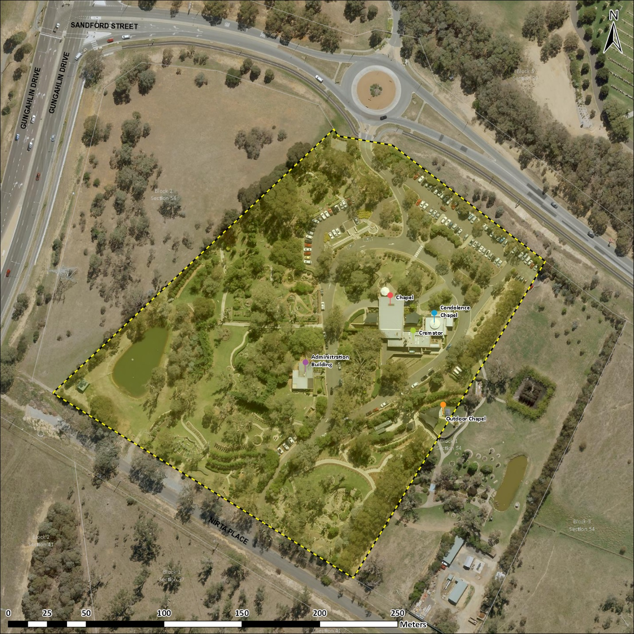
Image 1 Norwood Park Crematorium site boundary

