Australian Capital Territory
Planning and Development (Draft Variation No 367) Consultation Notice 2019
Notifiable instrument NI2019—593
made under the
Planning and Development Act 2007, s 63 (Public consultation—notification)

- Name of instrument
This instrument is the Planning and Development (Draft Variation No 367) Consultation Notice 2019.
- Commencement
This instrument commences on the day after its notification day.
- Draft variation to the Territory Plan
The planning and land authority (the Authority) has prepared a draft plan variation No 367 – Common Ground Dickson section 72 block 25: Zone change and amendments to the Dickson precinct map and code (the draft variation) to vary the Territory Plan. The draft variation will rezone block 25 section 72 Dickson from commercial CZ6 leisure and accommodation zone to community facility zone, and make amendments to the Dickson precinct map and code.
- Documents available for public inspection
(1) The Authority gives notice that the following documents are available for public inspection and purchase:
(a) the draft variation; and
(b) the background papers relating to the draft variation.
(2) Copies of the documents mentioned in section 3 (1) are available for inspection and purchase at Access Canberra Shopfront, Ground Floor South, Dame Pattie Menzies House, 16 Challis Street, Dickson, Monday to Friday (except public holidays) between 8:30am and 4:30pm for the period commencing on the day this notice commences and ending on 1 November 2019 (the consultation period).
(3) Copies of the documents mentioned in section 3 (1) are also available for inspection during the consultation period online at
https://www.act.gov.au/draftvariations

- Invitation to give written comments
(1) The Authority invites written comments about the draft variation during the consultation period. Comments should include reference to the draft variation and be addressed to the Territory Plan Section of the Environment, Planning and Sustainable Development Directorate (EPSDD). Please also provide your name and contact details to assist in the assessment of the comments provided and to enable the Authority to contact you in relation to your comments, if required.
(2) Written comments should be provided to the Authority by:
(a) email to terrplan@act.gov.au; or
(b) mail to Territory Plan Section, EPSDD, GPO Box 158, Canberra, ACT 2601; or
(c) hand delivery to Access Canberra Shopfront, Ground Floor South, Dame Pattie Menzies House, 16 Challis Street, Dickson.
Note All personal information will be managed in accordance with the Information Privacy Act 2014 and the EPSDD Information Privacy Policy which are available through the EPSDD website.
- Public inspection of written comments
(1) Copies of written comments about the draft variation given in response to the invitation in section 5, or otherwise, or received from the National Capital Authority will be available (unless exempted) for public inspection for a period of at least 15 working days starting 10 working days after the day the consultation period ends, at Access Canberra Shopfront, Ground Floor South, Dame Pattie Menzies House, 16 Challis Street, Dickson, Monday to Friday (except public holidays) between 8:30am and 4:30pm and may be published on the EPSDD website at www.planning.act.gov.au.
(2) You may apply under section 411 of the Planning and Development Act 2007 (the Act) for part of your consultation comments to be excluded from being made available to the public. A request for exclusion under this section must be in writing, clearly identifying what you are seeking to exclude and how the request satisfies the exclusion criteria. Please note that your name and contact details and other personal information will not be made public unless you request otherwise.
- Effect of the draft variation
Section 65 of the Act does not apply in relation to the draft variation and therefore it does not have interim effect as a result of notification of this instrument. Where a draft variation does not have interim effect, the current Territory Plan will continue to apply.
- Obtaining further information
Further information about the draft variation can be obtained through email correspondence with the Territory Plan Section, EPSDD, at terrplan@act.gov.au. A reference to the draft variation should be included in any email.

- Dictionary
In this instrument:
draft plan variation No 367 – Common Ground Dickson section 72 block 25: Zone change and amendments to the Dickson precinct map and code means the draft plan variation in the schedule.

Erin Brady
Delegate of the planning and land authority
11 September 2019

Schedule 1
(See section 9)

Planning and Development Act 2007

Draft
Variation to the
Territory Plan
No 367

Common Ground
Dickson section 72 block 25:
Zone change and amendments to the Dickson precinct map and code

September 2019

Draft variation for public consultation prepared
under s60 of the Planning and Development Act 2007

This page is intentionally blank.

Contents

1. INTRODUCTION 1
1.1 Summary of the Proposal 1
1.2 Outline of the process 2
1.3 This document 3
1.4 Public Consultation 3
2. EXPLANATORY STATEMENT 5
2.1 Background 5
2.2 Site Description 5
2.3 Current Territory Plan Provisions 7
2.4 Proposed Changes 8
2.4.1 Proposed Changes to the Territory Plan Map 8
2.4.2 Proposed Changes to Territory Plan 8
2.5 Reasons for the Proposed Draft Variation 8
The reasons for this draft variation are as follows: 8
2.6 Planning Context 9
2.6.1 National Capital Plan 9
2.6.2 ACT Planning Framework 9
2.7 Interim Effect 12
2.8 Consultation with Government Agencies 12
3. DRAFT VARIATION 15
3.1 Variation to the Territory Plan Map 15
3.2 Variation to the Territory Plan 16

This page is intentionally blank.

- INTRODUCTION
  - Summary of the Proposal
This draft variation proposes to rezone block 25 section 72 Dickson from commercial CZ6 leisure and accommodation zone to CFZ community facility zone to facilitate development of the Common Ground housing model.
The CZ6 zone is not appropriate for the development of Common Ground as the objectives of the CZ6 zone aim to primarily provide for the development of entertainment, commercial accommodation, and leisure facilities. Uses allowed in the CZ6 zone include club, caravan park, drink establishment, and tourist facility.
Common Ground is a housing model that accommodates people who are homeless or at risk of homelessness, as well as low-income tenants. Supportive housing is prohibited in the commercial CZ6 zone and community housing is currently not defined in the Territory Plan.
The proposed development will include 40 dwellings with a mix of 1, 2 and 3-bedroom units, plus communal and commercial spaces.
A minimum of 50% of the total dwellings will be for supportive housing. The remaining dwellings (up to a maximum of 50%) can be for community housing comprising affordable rental that will be managed by a community housing provider.
Shops and restaurants, will only be allowed where undertaken as a part of a social enterprise. A social enterprise exists to create social benefit and may include employment and skills development for on-site residents.
Definitions of community housing and social enterprise are proposed to be inserted into the Dickson Precinct Code.
The Common Ground Dickson proposal was presented to the interim National Capital Design Review Panel earlier this year. The Panel was broadly supportive of the proposal, particularly the building form, height, indicative dwelling mix and associated community functions.

  - Outline of the process
The Commonwealth’s Australian Capital Territory (Planning and Land Management) Act 1988 allows for the Legislative Assembly to make laws to establish a Territory Planning Authority and for that Authority to prepare and administer a Territory Plan. The Planning and Development Act 2007 (the Act) establishes the planning and land authority as the Authority that prepares and administers the Territory Plan, including continually reviewing and proposing amendments as necessary. The functions of the planning and land authority are administered by the Environment, Planning and Sustainable Development Directorate (EPSDD). The Director-General of EPSDD is the planning and land authority.
The Territory Plan is comprised of a written statement and a map. The written statement contains a number of parts, namely governance; strategic directions; zones (including objectives and development tables and zone or centre development codes); precinct codes; general codes; overlays; definitions; structure plans, concept plans and development codes for future urban areas.
The Territory Plan Map graphically represents the applicable land use zones (under the categories of residential, commercial, industrial, community facility, urban parks and recreation, transport and services and non-urban), precincts and overlays. The zone, precinct and overlay requirements are detailed in the volumes of the Territory Plan.
Draft variations to the Territory Plan are prepared in accordance with the Act. Following the release of the draft variation under section 63 of the Act, submissions from the public are invited. At the conclusion of the consultation period the EPSDD (planning and land authority) submits a report on consultation and a recommended final variation to the Minister responsible for planning for referral to the Legislative Assembly standing committee responsible for planning. The Minister must consider the findings of the committee before deciding whether to approve the draft variation. If the Minister approves the variation, the variation and associated documents will be tabled in the Legislative Assembly. Unless disallowed by the Legislative Assembly within five sitting days, the variation commences on a day nominated by the Minister.

  - This document
This document contains the background information in relation to the proposed variation. It comprises the following parts
Part 1 This Introduction
Part 2 An Explanatory Statement, which gives reasons for the proposed variation and describes its effect
Part 3 The Draft Variation, which details the precise changes to the Territory Plan that are proposed
  - Public Consultation
Written comments about the draft variation are invited from the public by 1 November 2019.
Comments should include reference to the draft variation and be addressed to the Territory Plan Section, EPSDD. Please also provide your name and contact details to assist in the assessment of the comments provided, and to enable EPSDD to contact you in relation to your comments, if required. Your personal information will be managed in accordance with the Information Privacy Act 2014 and the EPSDD Information Privacy Policy, which is available for viewing on EPSDD’s website.
Comments can be:
- emailed to terrplan@act.gov.au
- mailed to Territory Plan Section, GPO Box 158, Canberra, ACT 2601
- delivered to the Access Canberra Customer Service Centre at 16 Challis Street, Dickson
Copies of written comments received with respect to the draft variation will be made available for public inspection for no less than 15 working days starting 10 working days after the closing date for comment. The comments will be available at the Access Canberra customer service centre in Dickson and may be published on EPSDD’s website. Comments made available will not include personal contact details unless you request otherwise.
A request may be made for parts of a submission to be excluded under section 411 or 412 of the Planning and Development Act 2007. A request for exclusion under these sections must be in writing, clearly identifying what parts of your submission you are seeking to exclude and how the request satisfies the exclusion criteria.

Further Information
The draft variation, fact sheets and background documents are available online at www.act.gov.au/draftvariations until the closing date for written comments.
Printed copies of the draft variation (this document) and background documents are available for inspection and purchase at the Access Canberra Customer Service Centre, 16 Challis Street, Dickson, Monday to Friday (except public holidays) between 8:30am and 4:30pm. Please call 6207 1923 to arrange a copy for purchase.

- EXPLANATORY STATEMENT
  - Background
The Environment Planning and Sustainable Development Directorate engaged with the community during 2018 about the revitalisation of Section 72 Dickson. This included specific reference to a second Common Ground being developed on Block 25. The community expressed a strong desire to see more community facilities in Section 72 and were generally supportive of some community and private housing to complement these uses.
Common Ground is a housing initiative focused on providing quality tenant outcomes for people at risk of, or experiencing, chronic homelessness and low-income tenants.
Canberra’s first Common Ground was built in Gungahlin and comprises 40 one-bedroom unit dwellings. Common Ground Dickson will comprise approximately 40 units with a mix of one, two and three bedroom dwellings.
The draft variation will rezone the subject site to community facility zone, reinforcing the community benefit of the proposed Common Ground development, along with amendments to the Dickson precinct map and code to allow uses that are associated with the proposed development.
  - Site Description
The subject site is block 25 section 72 Dickson and is accessed from Hawdon Place. It is situated within the established suburban area of Dickson. To the north of the site is the Canberra Parklands Central Hotel Apartments. The Dickson District Playing Fields are located to the east. To the west is a vacant block that is currently leased by the Salvation Army. To the south there is a stormwater channel with a row of mature trees that separate the site from Dumaresq Street.
The subject site is within 500 metres of the Dickson Group Centre, which has a range of facilities including a large supermarket, chemist, banks, medical centres, post office and library. It is located less than 1km from the Dickson bus interchange located on Cape Street and the Dickson light rail interchange located on Northbourne Avenue. It is well served by the Dickson pool, Dickson district playing fields, a dance school and the nearby Majura community hall which accommodates Northside Community Service, the Majura Men’s Shed and Majura Early Childhood Centre. There are several schools within walking distance, including Dickson College, Daramalan College, North Ainslie Primary School, and Pinocchio Early Learning Centre.

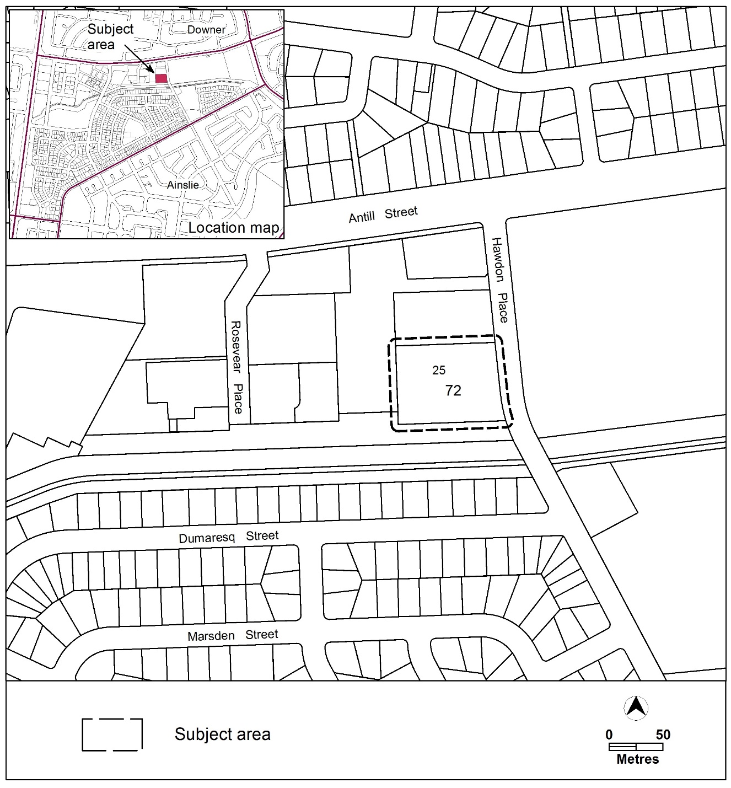
Figure 1: Location map

  - Current Territory Plan Provisions
The Territory Plan map zone for the area subject to this variation is shown in Figure 2. The subject block is currently zoned commercial CZ6 leisure and accommodation.
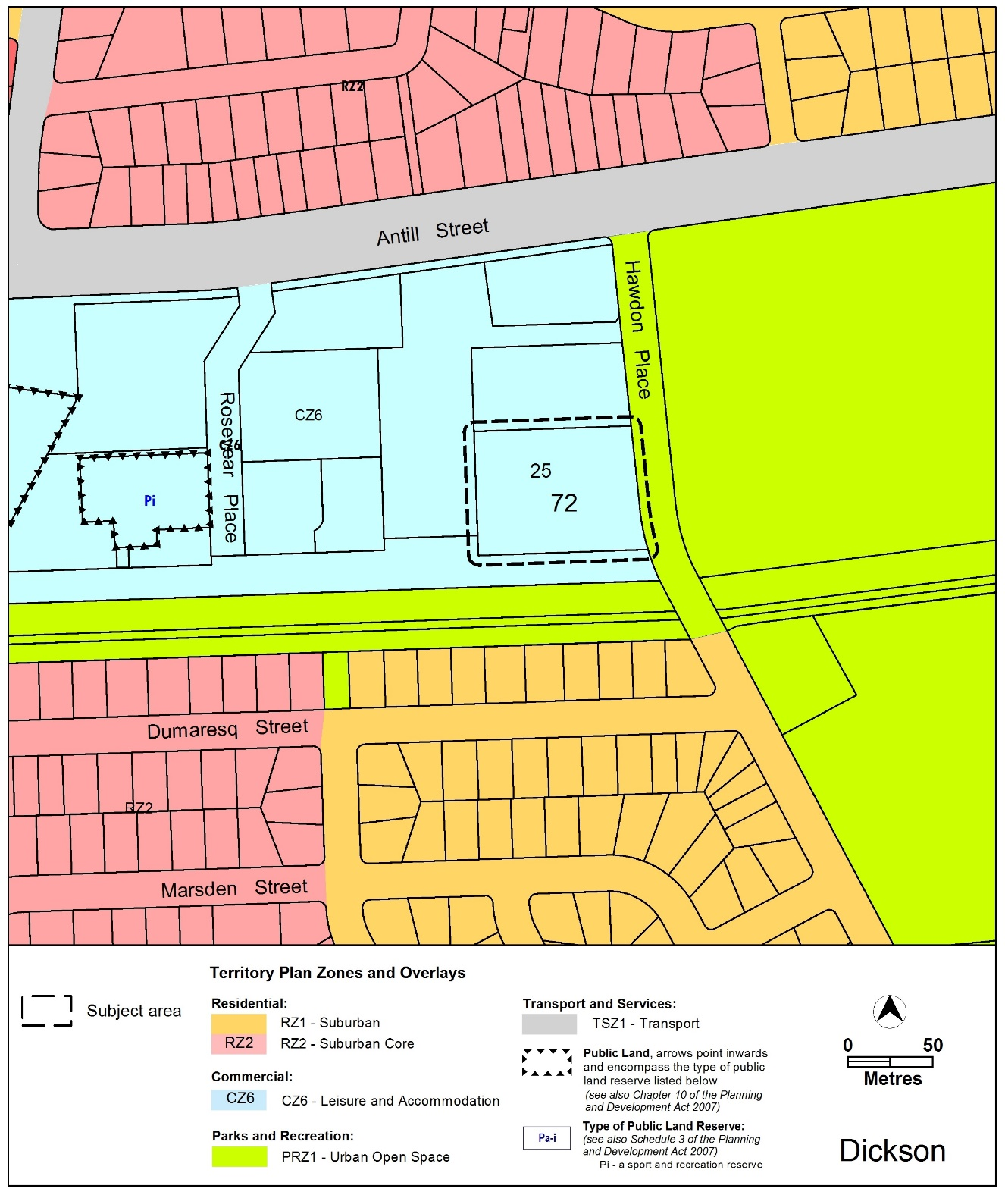
Figure 2: Territory Plan Zones Map

  - Proposed Changes
    - Proposed Changes to the Territory Plan Map
The proposed changes to the Territory Plan map are indicated in Figure 3 at Part 3 of this document and involve rezoning block 25 section 72 Dickson from commercial CZ6 leisure and accommodation zone to CFZ community facility zone.
The draft variation map indicates the proposed zone boundaries as accurately as possible but may be subject to adjustments following detailed surveys.
    - Proposed Changes to Territory Plan
It is proposed to amend the Dickson precinct map and code to insert provisions for:
- Maximum building of 23m and no more than 6 storeys on the middle portion of the site, including roof top plant
- Additional merit track development includes craft workshop, community housing, pedestrian plaza and social enterprise
- Definitions for community housing and social enterprise
- Minimum building setbacks
- Maximum of 50% of dwellings are community housing
  - Reasons for the Proposed Draft Variation

The reasons for this draft variation are as follows:
- The site is appropriate for the range of uses in the CFZ community facility zone
- Increases the supply of housing for those at risk of, or experiencing, homelessness, as well as to those with complex social needs
- Increases the number of affordable housing options for low-income residents
- The site is well located close to existing services in the Dickson group centre
- The site has good access to public transport
- Supports intergenerational equity and improved outcomes over time, including improved participation in society, stable capacity to maintain a tenancy, and enable transition to independent participation in the housing market
  - Planning Context
    - National Capital Plan
The Australian Capital Territory (Planning and Land Management) Act 1988 established the National Capital Authority (NCA) with two of its functions being to prepare and administer a National Capital Plan (NCP) and to keep the NCP under constant review and to propose amendments to it when necessary.
The NCP, which was published in the Commonwealth Gazette on 21 January 1990 is required to ensure that Canberra and the Territory are planned and developed in accordance with their national significance. The Planning and Land Management Act 1988 also requires that the Territory Plan is not inconsistent with the NCP.
    - ACT Planning Framework
Statement of Strategic Directions
The Statement of Strategic Directions sets out the principles for giving effect to the main objective of the Territory Plan as required by the Planning and Development Act 2007. The proposal is consistent with the Territory Plan’s statement of strategic directions in terms of environmental, economic and social sustainability and spatial planning and urban design principles.
1.1 Planning processes and decisions will be focused on the combined achievement of economic vitality, community wellbeing, and environmental quality. Broad community involvement will be a key element in the pursuit of sustainable development, as will complementary regional strategies and agreements.
The proposal is within walking distance from amenities such as public transport, shops, schools and community centres. The site will provide an opportunity to provide low cost supportive housing to address homelessness in the ACT as outlined in the ACT Housing Strategy.
1.3 Economic, social and environmental objectives will be pursued in a balanced and integrated way, having regard to both short-term and long-term factors, such that present needs can be met without prejudicing the welfare of future generations, and without serious or irreversible loss of life-supporting natural resources or damage to the environment.
Common Ground Dickson will:
- Increase the supply of housing to those at risk of or experiencing homelessness, as well as to those with high and complex social needs
- Increase the number of affordable housing options to low-income Canberrans
- Be well-integrated into the broader precinct and provide access to essential services located in Dickson, such as transport, health and community services
- Allow for a diverse social mix of people and households at risk of homelessness to be accommodated in permanent supportive housing
- Support intergenerational equity and improved outcomes over time, including improved participation in society, capacity to maintain a tenancy, and enable transition to independent participation in the housing market.
1.10 Integrated land use and transport planning will seek to maximise accessibility and transport efficiency, reduce energy consumption, support the preferred pattern of development, promote safety, safeguard environmental quality, and minimise greenhouse gas emissions.
The proposal is within walking distance from essential services such as public transport, shops, schools and community centres. The site will provide an opportunity to provide low cost housing to address the homelessness in the ACT as outlined in the ACT Housing Strategy.
1.18 Provision will be made for a comprehensive range of readily accessible community, cultural, sporting and recreational facilities, distributed according to the varying needs of different localities and population groups. In major centres and developing areas, sites will be safeguarded where necessary for particular community needs.
Common Ground Dickson will have communal and commercial space on the ground floor to enable flexibility in use for meeting spaces, a social enterprise, break-out spaces, and areas for recreation.
The proposed development will help to promote community vitality and safety through its communal style design. The pedestrian plaza space will be designed to promote interaction amongst local residents and also has direct positive benefits for crime prevention.
1.21 Provision of affordable, adaptable and special-needs housing will be promoted throughout the city, as well as modification or redevelopment of existing stock to meet emerging social needs.
Common Ground Dickson will provide 40 dwellings of 1, 2 and 3 bedrooms which will cater for approximately 70 tenants.
A minimum of 50% of dwellings at Common Ground Dickson will be for supportive housing. A maximum of 50% of dwellings can be community housing which has been defined as the use of land for affordable residential rental which is managed by a community housing provider. The community housing provider will manage the affordable rental housing mix between the 1, 2 and 3-bedroom units considering allocations, safety, and relative needs of tenants.
There is proposed to be communal spaces on the ground floor to enable flexible usage such as meeting spaces, break-out spaces, and areas for recreation. There may be a shop and/or restaurant if it meets the definition of a social enterprise which has been defined as a commercial organisation that exists to create social rather than economic benefit which may include employment and skills development for on-site residents.
1.23 The needs of people with disabilities will be recognised in all facets of urban planning, particularly including the design and operation of transport and access systems and the assessment of development proposals.
All units in the development will be designed to meet Class C Adaptable standards.
2.5 A wide range of housing types will be permitted in identified residential areas close to commercial centres and some major transport routes to increase choice; maximise opportunities for affordable housing; and secure some intensification of development consistent with maintaining residential amenity. Outside of these areas, planning policies will protect the typically low density, garden city character of Canberra’s suburban areas.
The proposal is consistent with providing social and affordable housing located within close proximity to local centres and transport network.

2.6 Higher density development will be encouraged within and near major centres, and in other suitable locations that are well served by public transport.
The proposal is consistent with providing appropriate density for the Common Ground Dickson development within the adjacent residential context. The community facility zone allows up to 4 storey development and a part of the site will allow up to 6 storeys.

The draft variation is consistent with the ACT Planning Strategy and Transport for Canberra as it will facilitate development that is compact and efficient, diverse, sustainable and resilient, liveable, and accessible, within proximity to services, transport connections and community facilities.
  - Interim Effect
Section 65 of the Planning and Development Act 2007 does not apply in relation to the draft variation so it does not have interim effect. The Minister for Planning and Land Management will consider whether to apply interim effect when a recommended draft variation is referred following public consultation.
  - Consultation with Government Agencies
The EPSDD is required to, in preparing a draft variation under section 61(b) consult with each of the following in relation to the proposed draft variation:
- the National Capital Authority
- the Conservator of Flora and Fauna
- the Environment Protection Authority
- the Heritage Council
- the Land Custodian, if the draft variation would, if made, be likely to affect unleased land or leased public land – each custodian for the land likely to be affected.
National Capital Authority
The National Capital Authority provided the following comments on 21 August 2019:
This site is within ‘Urban Areas’ within the ‘General Policy Plan- Metropolitan Canberra’ of the National Capital Plan (the Plan). The proposed variations to Dickson are not inconsistent with the Plan and the NCA has no objections.
Response
Noted.
Conservator of Flora and Fauna
The Conservator of Flora and Fauna provided the following comments on 26 August 2019:
Please note that there is no comment from the Conservator of Flora and Fauna on this draft variation.
Response
Noted.

Environment Protection Authority
The Environment Protection Authority provided the following comments on 28 August 2019:
The Environment Protection Authority has reviewed the Preliminary Site Investigation (PSI) report dated 18 June. The PSI report does not comment on the site’s suitability for its proposed CFZ land uses. In accordance with the requirements of Information Sheet 7 - Guidance for Undertaking Preliminary Contamination Investigations for Development/Lease Variation Purposes the report must be updated to “provide a clear statement as to the site’s suitability, from a contamination perspective, for its permitted uses under the Territory Plan”.
Following its revision the updated report must be forwarded to the Environment Protection Authority (the Authority) for review and endorsement in accordance with the Authority’s report submission requirements
Response
Noted. The contamination report will be reviewed in light of these comments in consultation with the EPA and the site suitability for the community facility zone will be addressed and considered for endorsement by the EPA.
Heritage Council
The Heritage Council provided the following comments on 19 August 2019:
ACT Heritage identifies that no heritage places or objects are located within the subject block. The block has been subject to previous ground disturbance associated with development, and further development of the block is unlikely to damage Aboriginal places or objects.

On this basis, the Council raises no objection to Draft Variation 367.
Response
Noted.
Land Custodian
The Suburban Land Agency (SLA) provided the following comments on 22 August 2019:
The Suburban Land Agency supports the draft variation and provides the following comments for consideration please.
The Suburban Land Agency understands that the 2019-20 Housing Targets (to be established by EPSDD under the City Renewal Authority and Suburban Land Agency Act 2017 will list 40 dwellings against this site for release as community housing.
Clarification is sought as to whether this is adequately explained to the community in the draft Territory Plan Variation, as the document currently reads as though there will be a 50:50 split between ‘affordable’ (which could refer to either purchase or rental) and ‘social’ (which could refer to public housing or community housing). Both public and community housing could be considered ‘supportive housing’ under the Territory Plan, as both require support services to be provided to tenants by a registered provider. Members of the community may not understand the terminology or the differences between this terminology.
Consider contributing to offsite works in creating a pedestrian connection (along the north side of the channel, potentially upgrading the existing gravel path) from the site to Cowper Street, past the Dickson pool – for the benefit of residents and also others.

Encourage solar PV and solar hot water or heat pumps and electric car charging in the car parks. Avoid connection and use of gas.

Note that the site is adjacent to the Dickson Chanel floodway and avoid risk of flooding any underground car parks, particularly with increased severity of storm events with a changing climate (as happened in the inner north storm and flooding last year, with the flooding of many basements).

Ensure that any reference in the reports to “Sullivans Creek” be replaced with Dickson Channel.

Response
A definition of community housing has been developed for incorporation into the Dickson precinct code. Supportive housing is already defined in the definitions section of the Territory Plan.
A minimum of 50% of dwellings at Common Ground Dickson will be for supportive housing. A maximum of 50% of dwellings can be community housing.
The proponent will consider contributing to off-site works. The proponent will also consider incorporating solar electric infrastructure and the need to connect to gas as part of the development application.

Potential flooding of the site has been considered in the Flood Study which was submitted as part of the planning report. It shows the site is above the 1% AEP flood level. Flood impact will be further considered during the development application stage.

The proponent has been advised to replace references to Sullivans Creek with Dickson Channel.
- DRAFT VARIATION
  - Variation to the Territory Plan Map
The Territory Plan map is varied as indicated in Figure 3.
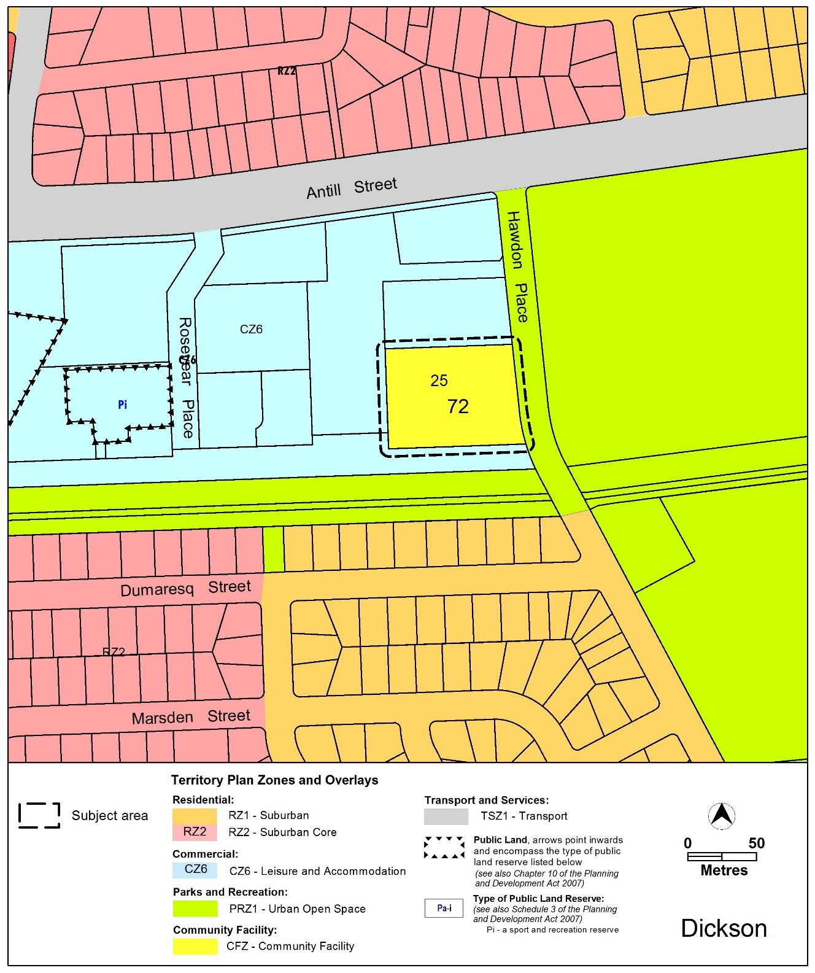
Figure 3: Areas subject to rezoning

  - Variation to the Territory Plan

The Territory Plan written document is varied as follows:

Variation to the Dickson precinct map and code
- Dickson precinct map

Substitute

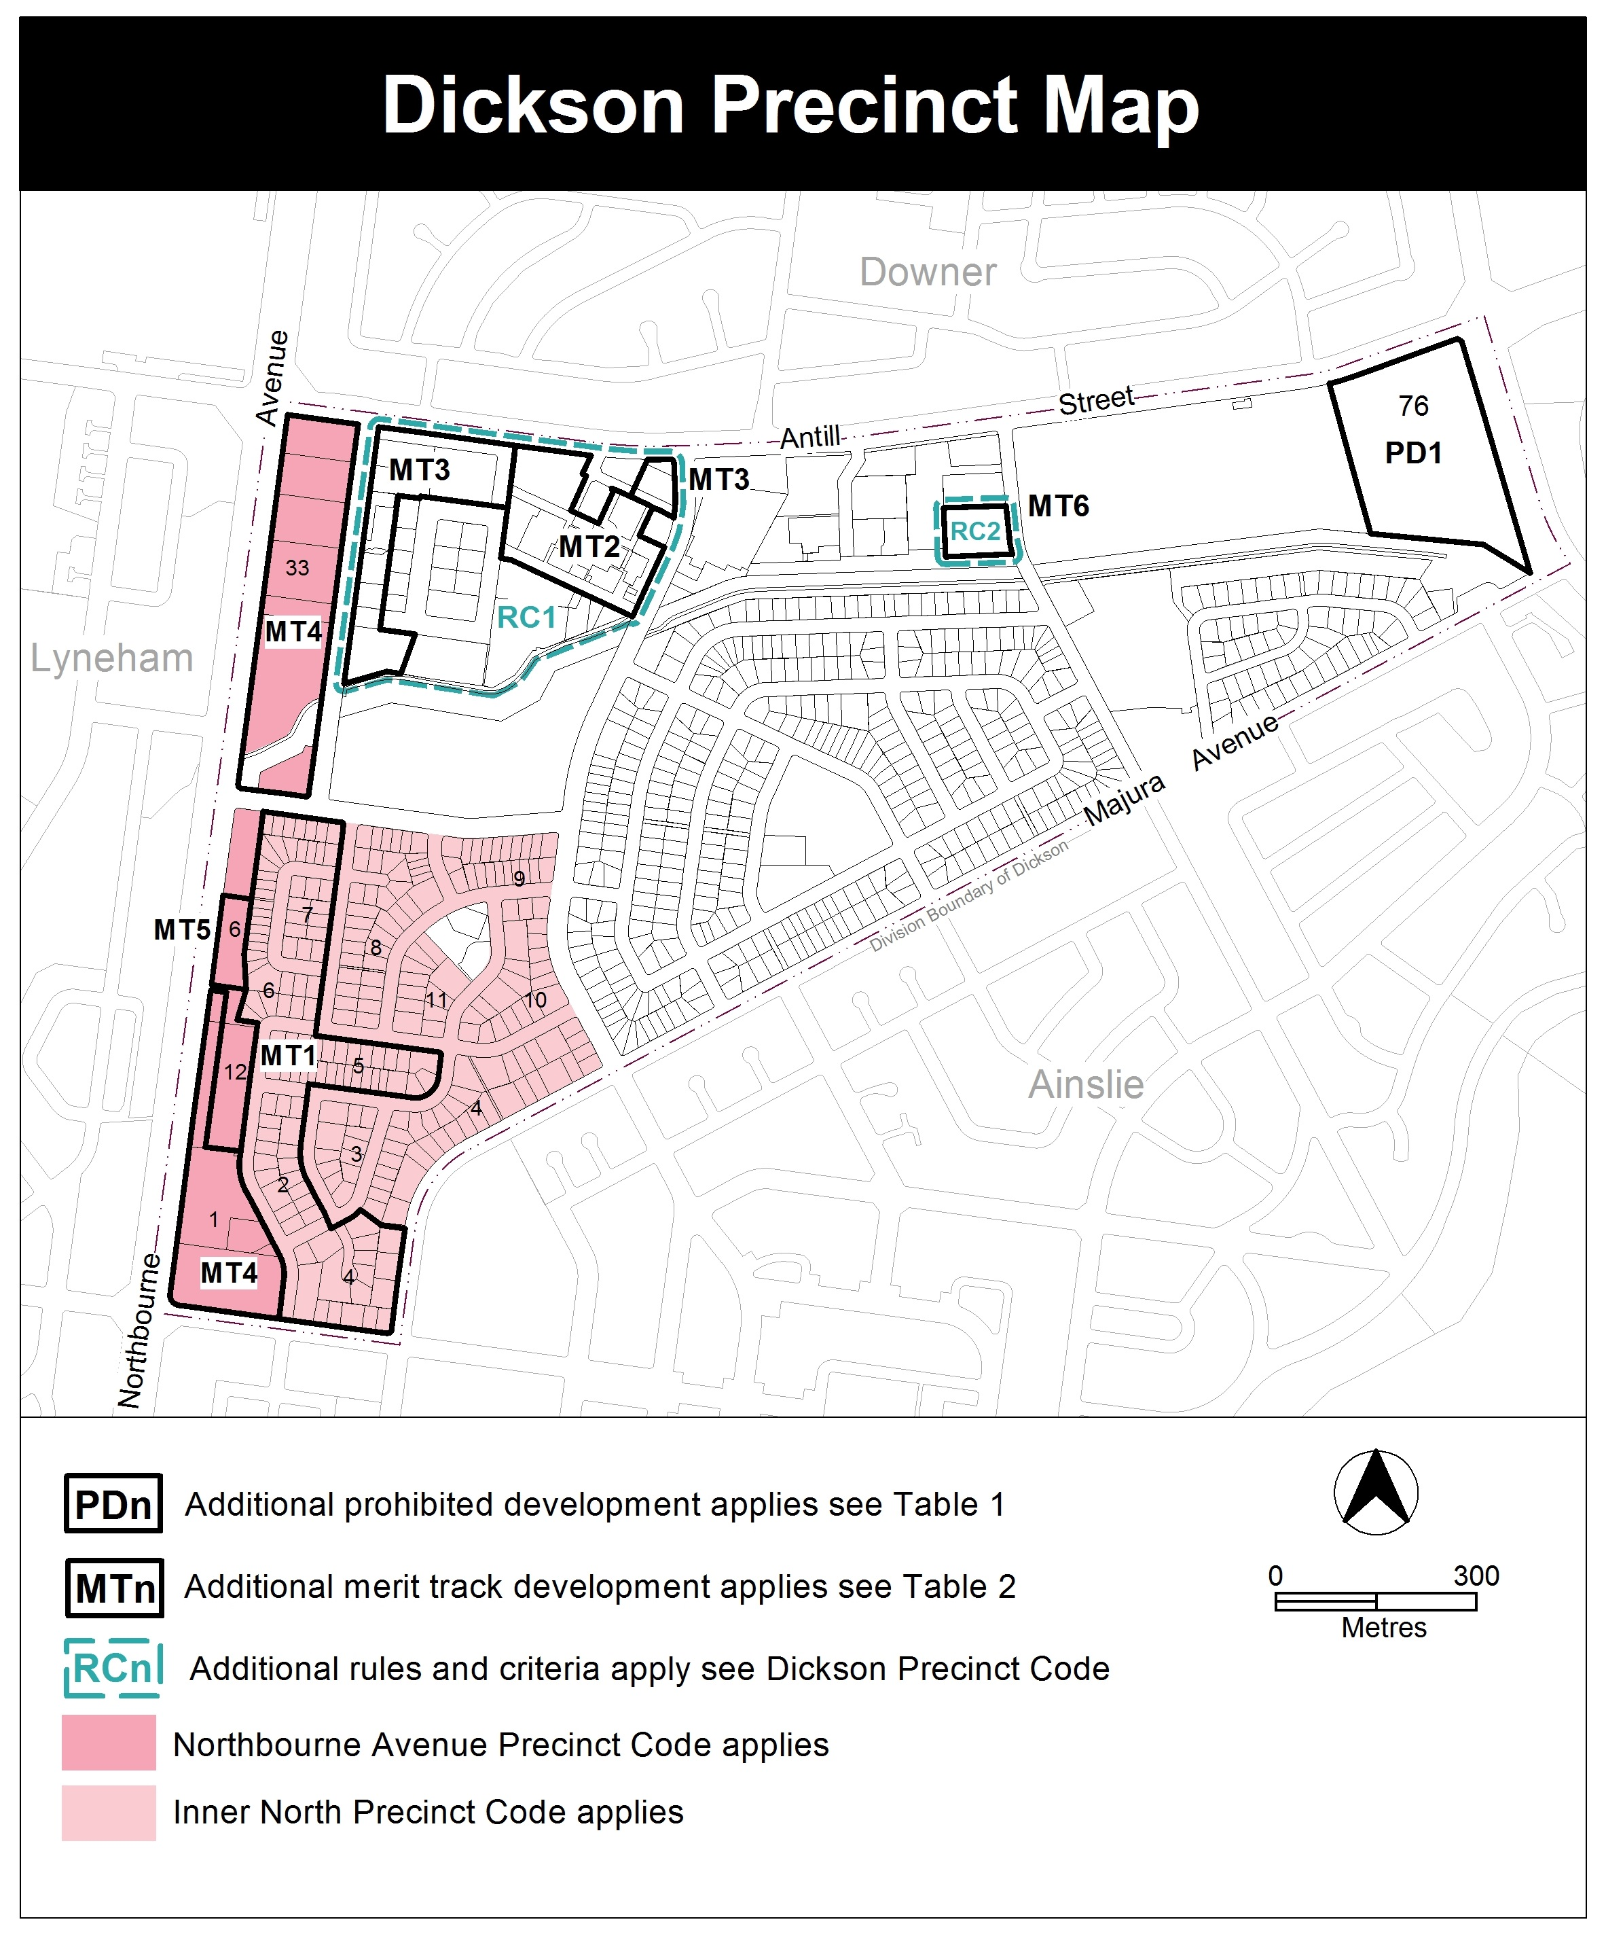

- Assessment tracks, Table 2 – Additional merit track development

Add

Suburb precinct map label | Zone | Development
MT6 | CFZ | craft workshop  community housing  pedestrian plaza  social enterprise

- Introduction, Definitions

Substitute second paragraph with:

Definitions of terms used in this code are listed in part 13 of the Territory Plan or, for terms applicable only to this code listed below.

Community housing means the use of land for affordable residential rental which is managed by a community housing provider.

Social enterprise is a commercial organisation that exists to create social rather than economic benefit which may include employment and skills development for on-site residents.

- Additional rules and criteria, RC1 – Dickson Group Centre, Element 4: Entity (Government Agency) endorsement

Insert after Rule R28

RC2 – Common Ground
This part applies to blocks and parcels identified in area RC2 shown on the Dickson Precinct Map.
Element 5: Buildings
Rules | Criteria
5.1 Building heights
R29  This rule applies to Area A shown in figure 4.  The maximum height of building is 23m (6 storeys).  Building height measurement includes all of the following:  - roof top plant  - lift overruns  - antennas  - photovoltaic panels  - air conditioning units  - chimneys, flues and vents.  Note: 4 storeys is permitted on the remainder of the site in accordance with the Community Facility Zone Development Code. | This is a mandatory criterion. There is no applicable rule.
5.2 Setbacks
R30  Development complies with all of the following:  - Setback to frontage along Hawdon Place is a minimum of 3m  - Setback fronting proposed road reserve on the southern boundary is a minimum of 0m  - Setback on western boundary is a minimum of 0m.  - Setback fronting proposed road reserve on the northern boundary is a minimum of 3m. | This is a mandatory criterion. There is no applicable rule.

Rules | Criteria
5.3 Community housing
R31  Community housing is a maximum of 50% of the total dwellings provided. | This is a mandatory criterion. There is no applicable rule.
R32  Community housing complies with the Multi Unit Housing Development Code. | This is a mandatory criterion. There is no applicable rule.

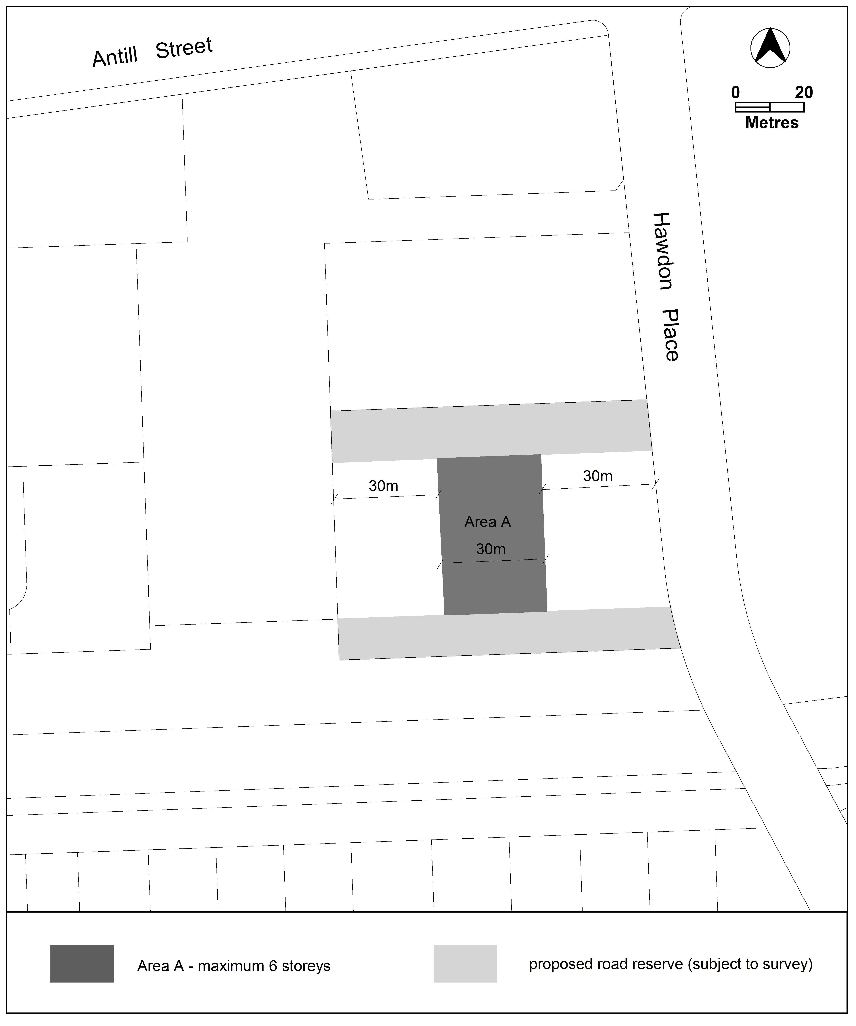 Figure 4: Building height limit

Interpretation service
