Australian Capital Territory

Nature Conservation (High Country Bogs and Associated Fens) Conservation Advice 2019

Notifiable instrument NI2019–66
made under the
Nature Conservation Act 2014, s 90C (Conservation advice)

1 Name of instrument
This instrument is the Nature Conservation (High Country Bogs and Associated Fens) Conservation Advice 2019.

2 Commencement
This instrument commences on the day after its notification day.

3 Conservation advice for High Country Bogs and Associated Fens
Schedule 1 sets out the conservation advice for the High Country Bogs and Associated Fens.

Arthur Georges
Chair, Scientific Committee
31 January 2019

Schedule 1
(see s 3)

Conservation Advice
High Country Bogs and Associated FENS ECOLOGICAL community

ELIGIBILITY
The ACT Scientific Committee has determined that the ecological community ‘High Country Bogs and Associated Fens’ is eligible for inclusion in the ACT Threatened Ecological Communities List.
Most ACT High Country Bogs and Associated Fens communities are consistent with the nationally listed Alpine Sphagnum Bogs and Associated Fens ecological community. In January 2009, the Australian Government listed the ‘Alpine Sphagnum Bogs and Associated Fens’ ecological community as Endangered under the Environment Protection and Biodiversity Conservation Act 1999 (Cth) (EPBC Act) due to:
- its small geographic distribution coupled with significant demonstrable threats (including climate change and fire);
- continued decline of functionally important species; and
- the severe reduction of the community’s integrity across its range.
Most patches of the ecological community are small. Listing the community as Endangered recognises that its long-term survival is under threat, and aims to prevent any further decline and to promote and assist its recovery (DEWHA 2009). Listing in the ACT also results in the development of a statutory Action Plan which outlines conservation and protection proposals including those to minimise the effect of threatening processes.

DESCRIPTION
The High Country Bogs and Associated Fens ecological community (hereafter referred to as bogs and fens) is described by the Commonwealth listing information for Alpine Sphagnum Bogs and Associated Fens under the EPBC Act (DEWHA 2009).
A more recent classification and mapping of alpine vegetation, undertaken by Mackey, Jacobs and Hugh (2015), describes the Commonwealth listed ecological community as follows:
“Alpine Sphagnum Bogs and Associated Fens occur in waterlogged and permanently wet treeless areas, such as along streams, drainage lines, valley edges and valley floors generally between 1200m to 1800m ASL. They differ from Wet Heathland and Sedgeland in that they contain Sphagnum spp. (which is typically underlain by peat), the most common of which is Sphagnum cristatum, along with a diversity of sedges, herbs and shrubs. Species commonly include Empodisma minus, Epacris glacialis, E. paludosa, Baeckea gunniana, B. utilis, Pratia surrepens and Richea continentis. Fens adjoin the bog and are devoid of woody vegetation, commonly dominated by sedges such as Carex gaudichaudiana”.
Some bogs and fens in the ACT differ from that definition in that a few do not contain Sphagnum (particularly post fire or other disturbance), and some occur at lower altitudes (as low as 720m). Fens are considered to be “associated” with bogs and part of the ecological community if they are within the same general region or are connected by drainage lines or ecological function. Bogs and fens in the ACT are generally comprised of the plant communities listed below.
Key plant communities:
- a2: Baeckea gunniana — Epacris paludosa — Richea continentis — Sphagnum cristatum wet heathland of the Australian Alps bioregion (Bog)
- a8: Carex gaudichaudiana — Myriophyllum pedunculatum — Deschampsia cespitosa sedgeland of the Australian Alps Bioregion (Fen)
- a9: Carex gaudichaudiana - Ranunculus amphitrichus — Phragmites australis aquatic herbfield of waterways in the Australian Alps and South Eastern Highlands Bioregion

Associated plant communities:
- a14: Poa costiniana — Carex gaudichaudiana subalpine valley grassland of the Australian Alps bioregion
- e59: Hakea microcarpa — Baeckea utilis — Leptospermum myrtifolium subalpine wet heathland on escarpment and eastern tableland ranges of the South Eastern Highlands Bioregion
- u193: Hakea microcarpa — Epacris brevifolia — Epacris paludosa subalpine wet heathland of the Australian Alps and western South Eastern Highlands Bioregions

Significance of the community
ACT bogs and fens are valued for their natural and cultural significance for past, present and future generations. The natural significance of an ecological community has environmental, scientific, social, aesthetic and life-support values (Australian Heritage Commission 2002). The cultural significance is the sum of the qualities or values that a community has, including its aesthetic, historic, scientific, social and spiritual values (Australia International Council on Monuments and Sites 2013). These values may overlap, be interrelated or be composites.

Ecological significance
Bogs and fens are significant because:
- they contain endemic plant species and provide significant habitat for endemic and threatened animal species, including the Critically Endangered Northern Corroboree Frog (Pseudophryne pengilleyi), the Broad-toothed Rat (Mastacomys fuscus mordicus) and Verreaux’s Alpine Tree Frog (Litoria verreauxii alpina) which are protected under the EPBC Act.
- they provide critical refuge for endemic plant and animal species, many of which are at risk of extinction, as threats such as global warming continue to marginalise their specialised habitats.
- they play an important role in protecting water quality within the ACT’s water catchment.
- peat contains pollen and charcoal deposits that provide a botanical and climatic timeline dating back thousands of years, giving a picture of past climatic conditions and fire regimes that greatly assists our understanding of ongoing climate change and its effects.
The Ginini Flats Wetland Complex Ramsar site is the largest intact bog and fen community in the Australian Alps and is of international significance through its listing under the Ramsar Convention in 1996. Ginini Flats provides habitat for international migrating species such as Latham’s Snipe (Gallinago hardwickii), and for this reason is also subject to various international agreements to protect migratory species (ACT Government 2017). Migratory species protected under international agreements are matters of national environmental significance under the EPBC Act. The bogs also contain Reik’s Crayfish (Euastacus reiki) and Alpine Spiny Crayfish (Euastacus crassus), which are protected from take under the Fisheries Act 2000 (ACT Government 2017).
Seven other bog and fen sites in the ACT are listed as nationally important under the Directory of Important Wetlands in Australia due to their good condition or outstanding historical or cultural significance: Nursery Swamp, Rotten Swamp, Cotter Source Bog, Rock Flats, Snowy Flats, Cotter Flats, and Upper Naas Creek (Lintermans 2001).

Distribution
Small, discrete and isolated patches of bogs and fens occur throughout the Australian Alps (NSW and Victoria) and in Tasmania (Department of the Environment 2015).
Bogs and fens occurring within the ACT represent some of the most northerly extent of the ecological community’s distribution. Patches of bogs and fens are found in montane and subalpine areas, primarily within the Namadgi National Park (NNP) (see Figure 1) at elevations from 720 m to 1718 m above sea level. This includes the Ramsar-listed Ginini Flats Wetland Complex. Bogs and fens often occur in locations where cold air drainage prevents the growth of trees (e.g. frost hollows) and, as small patches, under tree cover at higher altitudes.
Two occurrences of bogs and fens are located outside of NNP and are managed by ACT Parks and Conservation Service:
- the small Sphagnum bog on the eastern side of Corin Road at Gibraltar, in an area that was formerly pine forest (Ex Gibraltar Pines — Upper, the Gibraltar Forest Regeneration Area), and
- the Sphagnum bog and fen at Blundells Flat (Lower Cotter Catchment) — the lowest elevation occurrence of the community at 720 m (Butz 2004).

Threats
Most ACT occurrences of bogs and fens are within NNP and are therefore protected from development impacts, such as soil loss and erosion. However, alpine and subalpine vegetation is particularly susceptible to environmental change, due in part to the restricted growing season and the very fragile nature of some systems (Pickering, Good and Green 2004). This is particularly true of the High Country Bogs and Associated Fens ecological community.
Climate change and its associated impacts poses the greatest threat in the long-term, with potentially severe consequences. Increased temperatures and altered rainfall regimes have been predicted for the Australian Alps under climate change scenario modelling, which may in turn affect carbon and water cycle processes in the wetlands (Muller, et al. 2016). The impact of increased temperatures may be both positive and negative, with increased vegetation growth rates likely, however, increased rates of evapotranspiration and decay of peat surfaces are also expected. Future higher temperatures and altered rainfall patterns may result in the demise of bogs at the hottest and driest margins of their Australian distribution. Drier and hotter regimes would increase the risk of fire, and the possibility of surrounding heath and woodland encroaching as the effect of frost hollows is lessened.
In the short-term, fire, weed invasion, trampling and wallowing by hooved pest animals, and tourism and recreational activities are key threats to bogs and fens in the ACT (ACT Government 2010). Hard-hooved animals can be particularly destructive (Department of the Environment 2015), and changes to feral horse policy in NSW combined with the increase and spread of feral deer means that the risk is increasing.
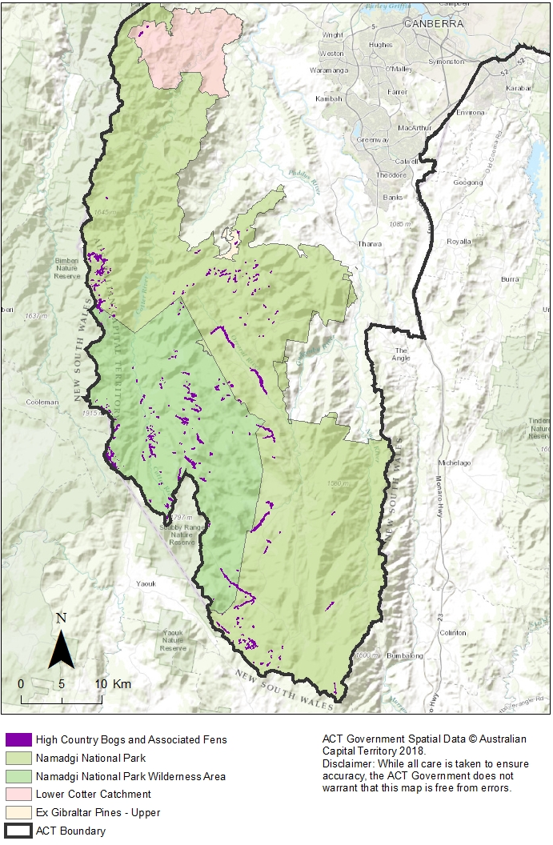
Figure 1. Extent of High Country Bogs and Associated Fens in the ACT – Ginini Flats Ramsar site circled in red.

Current Protection and management in the ACT
Namadgi National Park is managed for biodiversity conservation, water supply, appropriate recreation, natural and cultural heritage conservation, visual character, research and education. Although the Namadgi National Park Plan of Management 2010 (NNP PoM) (ACT Government 2010) applies to most of the areas in which bogs and fens occur, the NNP PoM does not provide detailed management actions for this ecological community.
The Ginini Flats Ramsar site is managed under a Ramsar management plan (ACT Government 2017).
The majority of ACT bogs and fens occur in Zone 1 of the NNP management zones (NNP PoM p. 225). This is the Remote Zone, the core conservation and catchment area, which includes the Bimberi Wilderness and the middle Cotter Catchment and adjacent areas. The larger fens and several bogs occur in Zone 2, the Semi-remote Zone, which is managed for conservation and recreation.

Major conservation objectives
The overall objective is to conserve High Country Bogs and Associated Fens in perpetuity as a viable and well-represented community across its natural geographic range in the ACT. This includes the maintenance and improvement of natural ecological and evolutionary processes within the community.
Specific objectives are:
- protect all areas of bogs and fens in the ACT through reservation.
- manage threats (particularly hard-hooved animals and fire) to maintain the ecological values of bogs and fens to promote ecosystem function, resilience and biodiversity.
- improve the condition and ecological function of bogs and fens by retaining flora, structural features and hydrology, and undertaking restoration actions.
- improve understanding of bog and fen ecology, restoration principles and best practice threat management, particularly in light of climate change.
- strengthen stakeholder and community collaboration in the conservation of bogs and fens.

Other Relevant Advices, plans or Prescriptions

Commonwealth
- Commonwealth Listing Advice on Alpine Sphagnum Bogs and Associated Fens (2009)
- Approved Conservation Advice for Alpine Sphagnum Bogs and Associated Fens (2008)

New South Wales
- Montane Peatlands and Swamps of the New England Tableland, NSW North Coast, Sydney Basin, South East Corner, South Eastern Highlands and Australian Alps bioregions - threatened ecological community listing - final determination (2005)

Tasmania
- Flora Technical Note No. 6: Sphagnum Communities (2011)

Listing Background
Under s.70 (3) of the Nature Conservation Act 2014 (NC Act) an ecological community is eligible to be included in the endangered category in the threatened ecological communities list if— it is not critically endangered; but it is facing a very high risk of extinction in the wild in the near future.
Section 90A of the NC Act provides that the Minister may include an ecological community in the ecological community list if it already listed under the EPBC Act following consultation with the ACT Scientific Committee and considering any recommendations from the Committee. It must be listed in the same category as listed under the EPBC Act.

REFERENCES
ACT Government 2017. Ginini Flats Wetland Complex Management Plan. EPSDD, Canberra.
ACT Government 2010. Namadgi National Park Plan of Management. Department of Territory and Municipal Services, Canberra.
Australia International Council on Monuments and Sites 2013. The burra Charter: the Australian ICOMOS charter for the conservation of places of cultural significance. Australia ICOMOS Incorporated.
Australian Heritage Commission 2002. Australian Natural Heritage Charter for the conservation of places of natural heritage significance. Australian Heritage Commission and the Australian Committee for the International Union for the Conservation of Nature, Canberra.
Butz M 2004. Blundells Flat area, ACT: management of natural and cultural heritage values – background study for the Friends of ACT Arboreta. Friends of ACT Arboreta, Canberra.
Department of the Environment 2015. National recovery plan for the Alpine Sphagnum Bogs and Associated Fens ecological community. Department of the Environment, Canberra.
DEWHA 2009. Alpine Sphagnum Bogs and Associated Fens: a nationally threatened ecological community. EPBC Act 1999 Policy Statement 3.16. Department of Environment, Water, Heritage and the Arts, Canberra.
Environment Australia 2001. “Chapter 5: Australian Capital Territory.” In A Directory of Important Wetlands in Australia, Third Edition, pp. 29-33. Environment Australia, Canberra.
IUCN 2016. Guidelines for the Application of IUCN Red List of Ecosystems Categories and Criteria. Edited by L. M. Keith, D. A. Murray, N. J. and J. P. Rodriguez, Bland. Version 1, Gland, Switzerland. http://iucnrle.org/static/media/uploads/references/key-documents/bland-etal-2016-iucn-rle-guidelines-v1-en-pdf.
Lintermans M 2001. Chapter 5: Australian Capital Territory. In A Directory of Important Wetlands in Australia, Third Edition. pp. 29-33. Environment Australia, Canberra.
Mackey B, Jacobs P and Hugh S 2015. Classifying and mapping the Australian Alps Native Vegetation. Cunninghamia 15: 185-199.
Muller R, Nicholson A, Wooldridge A, Cowood A, Cook W, Jenkins B and Grant S 2016. Hydrogeological Lanscapes for the Australian Capital Territory. Office of Environment and Heritage, Wagga Wagga, NSW.
Pickering C, Good R, and Green K 2004. Potential Effects of Global Warming on the Biota of the Australian Alps. Australian Greenhouse Office, Commonwealth of Australia, Canberra.

Further Information
Further information can be obtained from the Environment, Planning and Sustainable Development Directorate (EPSDD).Phone: (02) 132281, EPSDD Website: http://www.environment.act.gov.au

