Australian Capital Territory
Heritage (Decision about Registration of Signadou and Blackfriars Precinct, Watson) Notice 2019
Notifiable Instrument NI2019—70
made under the
Heritage Act 2004, s40 (Decision about registration)

1 Name of instrument
This instrument is the Heritage (Decision about Registration of Signadou and Blackfriars Precinct, Watson) Notice 2019.
2 Decision about registration
On 7 February 2019, the ACT Heritage Council (the Heritage Council) decided to register the Signadou and Blackfriars Precinct (the Place).
3 Registration details of the Place
The registration details of the Place are in the schedule.
4 Reasons for the decision
The Heritage Council is satisfied on reasonable grounds that the Place has heritage significance as it meets one or more of the heritage significance criteria in section 10 of the Heritage Act 2004. A detailed statement of reasons including an assessment against the heritage significance criteria is provided in the schedule.
5 Date registration takes effect
The registration of the Place takes effect on the day after this notice is notified.

6 Revocation
The Heritage (Decision about Provisional Registration of Signadou and Blackfriars Precinct, Watson) Notice 2018 (NI2018—296) is revoked.

Fiona Moore
Secretary (as delegate for)
ACT Heritage Council
7 February 2019

Schedule
See sections 3 and 4

AUSTRALIAN CAPITAL TERRITORY
HERITAGE REGISTER
(Registration)

For the purposes of s. 40 of the Heritage Act 2004, an entry to the heritage register has been prepared by the ACT Heritage Council for the following place:

Signadou and Blackfriars Precinct

Block 1, Block 7, Section 49, Watson
DATE OF REGISTRATION
7 February 2019 Notifiable Instrument: 2019 –70

Copies of the Register Entry are available for inspection at ACT Heritage. For further information please contact:

The Secretary

ACT Heritage Council

GPO Box 158

CANBERRA ACT 2601

Telephone 13 22 81

This statement refers to the location of the place as required in s. 12 (b) of the Heritage Act 2004.
LOCATION OF THE PLACE

Signadou and Blackfriars Precinct, Block 1, Block 7, Section 49 Watson.

This statement refers to the description of the place as required in s.12(c) of the Heritage Act 2004. The attributes described in this section form part of the heritage significance of the place. For the purposes of s. 12(c) of the Heritage Act 2004, the boundary of the place is at Image 1.
DESCRIPTION OF THE PLACE

Signadou and Blackfriars Precinct, also known as the Australian Catholic University, Watson, consisting of the following attributes:
- The prominent siting of the Blackfriars Building and Signadou Building at the intersection of Antill Street and Philip Avenue, Watson, creating a sense of arrival and monumentality;
- Motifs of religion integral to the aesthetic of the buildings, specifically:
  - the verticality in fenestration and blue-stone external detailing on Blackfriars and Signadou buildings, also contributing to a sense of monumentality;
  - Blackfriars cloister, including:
    - continuous, ground floor walkway;
    - open air courtyard
    - wall-mounted mosaics, specifically:
      - St Thomas addressed by the crucifix (Father Maurice Keating, O.P.);
      - St Bernadette at the Lourde Grotto (Father Maurice Keating, O.P.);
      - St Catherine of Sienna addressing the Pope at Avalon telling him to return to Rome (Father Maurice Keating, O.P.);
      - St John the Evangelist. Latin: “The word became flesh” (Father Maurice Keating, O.P.);
      - Our Lady (Brother Francis McKinnon);

  - Features made by Dominicans, specifically:
    - ‘Romanesque’ arches lining the cloister; and
    - Wall-mounted mosaics (see above);
  - St Dominic’s Orange Tree;
  - Signadou Chapel, specifically:
    - choir loft intended for use by Dominican Sisters;
    - four rows of wooden stalls intended for use by Dominican Sisters;
    - stained glass windows, including those designed by Stephen Moor, depicting the Mysteries of the Rosary, and representations of the Dominican Order;
  - Signadou open-air courtyard;
  - the names ‘Signadou’ and ‘Blackfriars’ which relate directly to the story and past of the Dominican Order.

This statement refers to the heritage significance of the place as required in s.12(d) of the Heritage Act 2004.
STATEMENT OF HERITAGE SIGNIFICANCE

The Signadou and Blackfriars Precinct has made an important contribution to the educational development of the ACT, providing the rapidly growing national capital with teaching staff during a time of unprecedented growth of the Catholic school system in the ACT and region. The opening of the Blackfriars Priory and Signadou Teaching College occurred during a formative period of educational development in Canberra when the Catholic Church was making considerable investments in the sector, and in the national capital in particular. The place represents a distinct phase of ACT history, wherein different orders within the Catholic Church were consolidating and uniting with increased presence within the ACT [Criterion (a)].
CONSERVATION OBJECTIVE

The guiding conservation objective is that Signadou and Blackfriars Precinct shall be conserved and appropriately managed in a manner respecting its heritage significance.

The ACT Heritage Council may adopt heritage guidelines applicable to the place under s25 of the Heritage Act 2004.

For further information on guidelines applicable to the place, or for advice on proposed works or development, please contact ACT Heritage on 13 22 81.
REASON FOR REGISTRATION

The Council has assessed the Signadou and Blackfriars Precinct, Watson against the heritage significance criteria and is satisfied that the place is likely to have heritage significance when assessed against criterion a under s.10 of the Heritage Act 2004.
ASSESSMENT AGAINST THE HERITAGE SIGNIFICANCE CRITERIA

The Council’s assessment against the criteria specified in s.10 of the Heritage Act 2004 is as follows.

In assessing the heritage significance of Signadou and Blackfriars Precinct, Watson, the Council considered:
- the original nomination and documentary evidence supplied by the nominator;
- the Council’s Heritage Assessment Policy (2018);
- information provided by a site inspection on 6 June 2016, and 30 March 2017 by ACT Heritage; and 3 September 2018 by members of the Council;
- the report by ACT Heritage titled, Background Information Signadou and Blackfriars Precinct, February 2019 containing photographs and information on history, description, condition and integrity; and
- Comments received during public consultation. One of the four submissions received suggested the place may meet additional heritage significance criteria. The Council considered these suggestions against the necessarily high thresholds required by the heritage significance criteria and against the Heritage Assessment Policy (2018), and decided to maintain its assessment against criterion a.

Pursuant to s.10 of the Heritage Act 2004, a place or object has heritage significance if it satisfies one or more of the following criteria. Future research may alter the findings of this assessment.
importance to the course or pattern of the ACT’s cultural or natural history;
The Council has assessed Signadou and Blackfriars Precinct against criterion (a) and is satisfied that the place is likely to meet this criterion.
The Signadou and Blackfriars Precinct is significant for the role it has played within the Catholic education sector in educating the teachers of the ACT and providing the ACT’s schools with teaching staff, particularly during the growth and expansion years of the ACT under the administration of the National Capital Development Commission (NCDC). The place represents an important period of consolidation in the provision of educational training and services in the ACT and an unprecedented period of cohesion and cooperation between Catholic religious orders in the ACT and region.
The Signadou and Blackfriars Precinct symbolises a notable level of dedication and commitment of the Catholic education system and its role in teacher training in the ACT. The place demonstrates distinctive design and artistic elements which are integral to its significance in this regard, particularly in expressing confidence in the role of religious orders, and their communities, in education. These elements include religious motifs central to the aesthetic of the building, some of which were constructed by Dominicans themselves. Among them are: the Blackfriars cloister, the Signadou Chapel, wall-mounted mosaics, internal timberwork, and a strong sense of verticality in fenestration and blue-stone detailing that contributes to a sense of monumentality.
The Signadou and Blackfriars buildings were completed several years apart, with Signadou being the initial focus for teacher training and tertiary education. Nonetheless the Catholic Church’s investment in education and teacher training in the ACT is exemplified by the precinct as a whole, as the two buildings demonstrate an integrated vision, aesthetic unity and cohesiveness of architectural form.
Under the NCDC, which was tasked with completing Canberra as the seat of government, Canberra grew from a population of 40,000 to 300,000, with this boom accelerating in the late 1950s. On average, the NCDC was building a primary school every year and a high school every second year. The Catholic population of Canberra and the diocesan primary school system was also growing, and the Archbishop of the Canberra and Goulburn Archdiocese responded to this concern by establishing a tertiary teaching college in the ACT.
On his appointment in 1953 as Archbishop in Canberra and Goulburn, Dr Eris O’Brien encouraged previously disparate religious orders to move their headquarters to Canberra and many did. Unusually for the times, he fostered close cooperation between religious orders including the Dominicans

Signadou represents a shift in the attitude towards government funding of non-government schools, and investment in education in the 1960s by the Commonwealth government. When the training college opened in the 1960s, the Commonwealth Government was taking a stronger role in funding and accrediting tertiary institutions and their programs, as well as providing direct funding to non-government primary and secondary schools for the first time. State governments were under pressure to address funding issues in non-government schools, as evidenced by the well-known Goulburn protest of 1962 that led to the state funding of vital facilities at Our Lady of Mercy Primary School.
The Parish Church, Holy Rosary Church, Watson, on Block 6 Section 49, has not been included under the assessment. The church was constructed around a decade after the Signadou and Blackfriars Buildings, and not to original design. Further, it held a separate function as parish church, and its association with the training college, university, and priory is not considered strong or enduring enough to be included in this assessment.
Rosary School on (part) Block 3, Section 49, has not been included in this assessment. Rosary School was built as an observatory school in association with Signadou Training College. The Council acknowledges the historical association between Signadou and Blackfriars Precinct and Rosary School, but notes that the school has been extensively refurbished, and any fabric relating to its past function (such as observatory classrooms) is no longer extant.
has uncommon, rare or endangered aspects of the ACT’s cultural or natural history;
The Council has assessed Signadou and Blackfriars Precinct against criterion (b) and is satisfied that the place is not likely to meet this criterion.
The Signadou and Blackfriars Precinct is not considered rare in the context of the ACT. As with the ACT’s other tertiary institutions, the Australian National University (ANU), and the University of Canberra (UC), the Signadou and Blackfriars Precinct has an association with the history of the establishment and expansion of cultural/educational institutions in the ACT during the NCDC era.
Rarity by itself is not sufficient to meet this criteria. The ‘type,’ or ‘category’ of place or object must be shown to have contributed to the history of the ACT to an exceptional degree. In this context, it is noted that the Blackfriars building is the only Monastic structure of ‘monumental’ scale within the ACT, but there is insufficient evidence before the Council at this time to indicate that buildings or structures of this type have made a strong, noticeable or influential contribution to the history of the ACT to a high enough degree to meet this criterion.
potential to yield important information that will contribute to an understanding of the ACT’s cultural or natural history;
The Council has assessed Signadou and Blackfriars Precinct against criterion (c) and is satisfied that the place is not likely to meet this criterion.
There is insufficient evidence before the Council to demonstrate that the Signadou and Blackfriars Precinct has the potential to yield important information that will contribute to a wider understanding of the ACT’s cultural or natural history. The Council does not anticipate a reasonable likelihood that the Signadou and Blackfriars Precinct contains substantial physical evidence – currently obscured and of high integrity – pertaining to a defined, significant research interest, and it is unlikely to provide key information that will fill an important gap in existing knowledge about the history of the ACT.
Every historic place has the potential to contribute to the body of historical knowledge for a particular subject or field of research. For a place to meet this criterion, however, there should be some form of evidence of real, proven or established potential, such as might derive from expert testing or professional examination.
importance in demonstrating the principal characteristics of a class of cultural or natural places or objects;
The Council has assessed Signadou and Blackfriars Precinct against criterion (d) and is satisfied that the place is not likely to meet this criterion.
The Blackfriars and Signadou Precinct expresses aspects of stylised monastic design. The Blackfriars building in particular demonstrates an exceptionally intact cloister for communing, studying, and taking exercise, surrounding open areas that provided ample light and air for acolytes. Rodrigues (2015: 17) observes the importance of cloisters and the garden spaces they enclose as representing the cornerstones of monastic observance. Other characteristics include mosaics by Br Francis McKinnon O.P. and Fr Maurice Keating O.P. embellishing the Blackfriars cloister. These depict key spiritual and religious moments and themes, fundamental to Dominican philosophies, and further illustrate the place’s function as a priory. However, while these key features relating to the place’s monastic function are comprehensively represented and conserved, ‘monastic buildings’ are not readily identified as a class of place that has made a strong, noticeable or influential contribution to the cultural history of the ACT to a high enough degree to meet thresholds against this criterion.
importance in exhibiting particular aesthetic characteristics valued by the ACT community or a cultural group in the ACT;
The Council has assessed Signadou and Blackfriars Precinct against criterion (e) and is satisfied that the place is not likely to meet this criterion.
As with all seven of the Australian Catholic University campuses in Australia, Signadou and Blackfriars Precinct houses a collection of artworks. These include free-standing pieces as well as stained glass windows and mosaics. The Australian Catholic University as a whole has contributed to the Catholic intellectual tradition through its collection, display, patronage, and support of art and symbol, and in the context of religious life/vocation, aesthetics and beauty are considered to be important in the development of spirituality.
The Council may consider the Catholic Church and its adherents to constitute a cultural group in the ACT, however there is insufficient evidence demonstrating that the Signadou and Blackfriars Precinct exhibits particular aesthetic characteristics – such as art or architecture – which are valued by this cultural group to a degree high enough to distinguish it from other religious institutions, churches or ecclesiastical buildings. It is noted that all seven campuses of the Australian Catholic University have contributed to Catholic artistic and intellectual tradition in Australia, however, there is no evidence before the Council that the collections and characteristics within the Signadou and Blackfriars Precinct are valued by the Catholic Church and its adherents more than those at other campuses.
Further, the Council may receive some anecdotal accounts of how the Catholic Church or its adherents appreciate certain aesthetic attributes, such as stained glass windows, mosaic artwork, or the interior layout. Such informal, undocumented accounts do not constitute evidence that the Catholic community as a whole strongly values a place’s aesthetic characteristics.
importance in demonstrating a high degree of creative or technical achievement for a particular period;
The Council has assessed Signadou and Blackfriars Precinct against criterion (f) and is satisfied that the place is not likely to meet this criterion.
The place houses a collection of artworks by notable, eminent artists including Stephen Moor, Jose Espelta, Leopoldine Mimovich, Linda Klarfeld, Guy Boyd, and Father Maurice Keating. Potential future nomination and assessment of individual pieces may reveal that they meet thresholds to a high enough degree to meet this criterion. In order to do so the pieces must demonstrate breakthroughs in design, represent an innovative departure from established norms in art, or expand upon established method or technique. An example in the ACT of where this has been achieved, is the Expansion Mosaic Mural Wall (Braddon), registered on the ACT Heritage Register. The mural represents one of the earliest examples of mosaic mural in Abstract Expressionist style in the ACT, constructed from hand-cut, irregular shaped glass, vitreous and porcelain tiles laid closely on a full-sized painted cartoon. There is no evidence before the Council at this time that suggests pieces in the art collection at Signadou and Blackfriars Precinct demonstrate high levels of creative achievement.
The Council acknowledges that the Signadou and Blackfriars buildings demonstrate some degree of creative achievement. At the outset, buildings were required to fulfil several functions: as residences for those in religious vocations, as a national headquarters for the Dominican Order, and, in the case of the Signadou building, also an educational facility. The challenges of these multiple functions are reflected in certain elements of the buildings’ design. For example, both Signadou and Blackfriars buildings incorporated ground floor cloisters. In the case of Signadou, this was especially important as it allowed for segregated movement for Sisters while leaving the rest of the building relatively communal to accommodate pupils of the teacher training college. The chapel in this building, too, was designed for general access at the same time as enabling segregation for the Sisters. This is evidenced most strongly by the small balcony on the upper level, a choir loft designed to provide access to the chapel for sisters who were unwell in the infirmary on the first floor. Both the Signadou and Blackfriars buildings achieved the provision of gender segregated space, spaces for worship, and public, administrative areas in a single building, while still creating a sense of community by including open courtyards at the centre of each building.
However, the place does not meet this criterion, as these aspects of creative design cannot be said to be of a high degree, within the context of the ACT or more broadly, for the period in which the place was built. The internal layout of the Signadou building has been significantly altered, and while the open courtyards and nun’s balcony remain, the ground floor cloisters have been built in and are no longer continuous.
Further, neither the Blackfriars nor Signadou buildings demonstrate a breakthrough in design, represent an innovative departure from established norms in architecture, or expand upon established technology. The place is not recognised in the field of architecture as important for demonstrating elements of creative design.
has a strong or special association with the ACT community, or a cultural group in the ACT for social, cultural or spiritual reasons;
The Council has assessed Signadou and Blackfriars Precinct against criterion (h) and is satisfied that the place is not likely to meet this criterion.
The Council considers the Catholic Church to constitute a cultural group in the ACT, and acknowledges that Signadou and Blackfriars Precinct has some social, cultural, and spiritual association with the Catholic Church, as it functioned as a combined place of residence, worship, learning and teaching for its adherents from the early 1960s to the early 1990s. However, there is no evidence suggesting the Catholic Church claims a social, cultural, or spiritual association with the place that can be considered strong, special, or above the ordinary in the context of its other facilities and institutions in the ACT and Australia.
While the Catholic Archdiocese of Canberra and Goulburn retains operational and financial ties with the place as an educational institution, there is no evidence demonstrating a broader Catholic community attachment to the place that is enduring, nor is there evidence suggesting it is valued as the site of an event that has had a profound effect on the Catholic Church, or the adherents to its faith. For example, the Signadou and Blackfriars Precinct is not a place where there are known associations with important figures in Catholic history in Australia such as, for example, Saint Mary MacKillop.
There is no evidence that the place symbolically represents some aspect of the past which contributes to a sense of identity for the Catholic community. For example, it is not recognised as the first, oldest, or most spiritually important Catholic place of administration or worship in the ACT, nor does the Catholic Church consider it important, above the ordinary, or critical in the context of the contribution of the Catholic Church, and the Catholic story, of the ACT.
has a special association with the life or work of a person, or people, important to the history of the ACT.
The Council has assessed Signadou and Blackfriars Precinct against criterion (h) and is satisfied that the place is not likely to meet this criterion.
The Signadou and Blackfriars Precinct was designed by Fr Bonaventure Leahy, with assistance from Kevin J. Curtin and Partners.
Fr Bonaventure Leahy had undertaken architectural training before he joined the Dominican order in Ireland. Prior to working on the Signadou and Blackfriars buildings, he collaborated with other architects on the design and planning of the Chapel at Santa Sabina Convent, Strathfield NSW. He designed the Toodyay stone Church of our Lady of the Holy Rosary, Woodlands, WA. This church is listed on the local heritage list for the City of Sterling, Western Australia as an excellent example of Late Twentieth Century Organic architecture. However, there is insufficient evidence before the Council suggesting either the Signadou or Blackfriars buildings are widely recognised as Fr Bonaventure’s most commendable work. Further, his architectural contribution cannot be said to have contributed to or shaped the history of the ACT to a degree high enough to meet this criterion.
Kevin Curtin designed churches, office buildings, schools, public buildings, and hospitality buildings in the ACT during the course of his career. He was awarded a papal medal for his architectural service to the Catholic Church. While Curtin made a strong contribution to the architectural fabric of the ACT, there is no evidence suggesting the association between Curtin and the Signadou and Blackfriars Precinct is special or above what would ordinarily be expected of an architect and their work. Of the ecclesiastical buildings Curtin designed, or helped design, neither Signadou nor Blackfriars is regarded as his most commendable work.

This stands in contrast to places such as Holy Trinity Catholic Church, Curtin, and St Joseph’s Church, O’Connor, the latter of which is listed on the ACT Heritage Register, and the Australian Institute of Architects considers to be one of Curtin’s finest church designs, appearing on the Register of Significant Twentieth Century Architecture (ACT, Item No. R135).

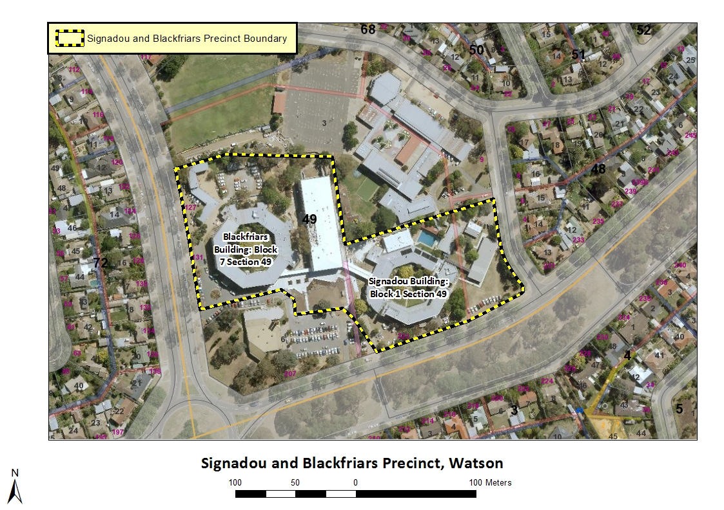
Image 1 Signadou and Blackfriars Precinct site boundary

The Council does not possess an inventory of features constructed by Dominicans. Only where the Council can confirm construction by Dominicans have features been listed under Description.
The cloister in the Signadou building is no longer continuous, and cannot be readily identified as a ‘cloister.’

