Australian Capital Territory
Corrections Management (Emergency) Declaration 2019 (No 2)
Notifiable instrument NI2019-714
made under the
Corrections Management Act 2007, section 26 (Declaration of emergency)

1 Name of instrument
This instrument is the Corrections Management (Emergency) Declaration 2019 (No 2).
2 Commencement
This instrument commences on 9 November 2019 and terminates
12 November 2019.
3 Declaration

I declare that an emergency exists at the Alexander Maconochie Centre that is likely to threaten the security or good order at the centre.

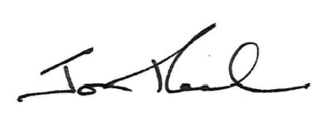

Jon Peach
Executive Director
ACT Corrective Services
8 November 2019

