Australian Capital Territory
Corrections Management (Emergency) Declaration Revocation 2019
Notifiable instrument NI2019-718
made under the
Corrections Management Act 2007, section 26 (Declaration of emergency)

1 Name of instrument
This instrument is the Corrections Management (Emergency) Declaration Revocation 2019.
2 Commencement
This instrument commences at 1.30pm on 11 November 2019.
3 Revocation
This instrument revokes the Corrections Management (Emergency) Declaration 2019 (No 2) [NI2019-714].

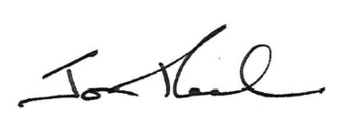

Jon Peach
Executive Director
ACT Corrective Services
11 November 2019

