Australian Capital Territory
Planning and Development (Plan Variation No 359) Approval 2019

Notifiable Instrument NI2019-72
made under the
Planning and Development Act 2007, section 76 (Minister’s powers in relation to draft plan variations)

1 Name of instrument
This instrument is the Planning and Development (Plan Variation No 359) Approval 2019.
2 Approval of draft plan variation
(1) I approve under section 76(2)(a) of the Planning and Development Act 2007 the draft plan variation No 359 to the Territory Plan.
(2) In this section:
Draft plan variation No 359 to the Territory Plan means the draft plan variation in the schedule.

Mick Gentleman MLA
Minister for Planning and Land Management
6 February 2019

Planning and Development Act 2007

Variation to the
Territory Plan
No 359

Changes to the Tharwa Precinct Map and Code and removal of public land overlay

February 2019

Final variation prepared under s76 of the
Planning and Development Act 2007

Contents

1. EXPLANATORY STATEMENT 1
1.1 Background 1
1.2 Summary of the Proposal 1
1.3 The National Capital Plan 2
1.4 Current Territory Plan Provisions 2
1.5 Changes to the Territory Plan 3
1.6 Consultation on the Draft Variation 3
1.7 Revisions to the draft variation recommended to the Minister 3
2. DRAFT VARIATION 4
2.1 Variation to the Territory Plan 4

APPENDICES
Appendix 1 Tharwa Precinct Map and Code

- EXPLANATORY STATEMENT
  - Background
The Tharwa Village Plan provides an overview and background analysis of the area including the cultural and planning history for the area. Feedback from key stakeholders and the community was sought through the process of developing the plan. As a result of the gathering and analysing of information and feedback, existing and potential opportunities for the village have been identified.
The Tharwa Village Plan recommends a vision and overarching spatial framework with planning principles and strategies that identify the outcomes and actions to be implemented. The plan recommends changes to planning policies, opportunities for some residential land release, public domain upgrades and further studies.
Variation No 359 (V359) incorporates the key planning policy recommendations contained within the Tharwa Village Plan and Design Guidelines. The Tharwa Village Plan was developed to
- provide a long-term vision and planning framework to guide its enhancement and viability into the future, and
- define what is important about Tharwa and how its rural character and qualities can be kept while providing sustainable lifestyle opportunities to live and work in a unique rural village setting.
The Tharwa Village Plan and Design Guidelines are available at:
https://www.planning.act.gov.au/tools_resources/plans-registers/plans/master_plans

  - Summary of the Proposal
V359 incorporates the outcomes and recommendations of the Tharwa Village Plan. The variation makes the following changes:
- removes the sport and recreation reserve public land overlay from the Territory Plan Map for Block 10 Section 6 Tharwa as this is a historical mapping error and is not applicable to this block; and
- introduces built form controls into the Tharwa Precinct Map and Code including building and height controls, setbacks and plot ratio restrictions to reflect the existing or desired character of the village.
  - The National Capital Plan
The Australian Capital Territory (Planning and Land Management) Act 1988 established the National Capital Authority (NCA) with two of its functions being to prepare and administer a National Capital Plan (NCP) and to keep the NCP under constant review and to propose amendments to it when necessary.
The NCP, which was published in the Commonwealth Gazette on 21 January 1990 is required to ensure that Canberra and the Territory are planned and developed in accordance with their national significance. The Planning and Land Management Act 1988 also required that the Territory Plan is not inconsistent with the NCP.
In accordance with section 10 of the Australian Capital Territory (Planning and Land Management) Act 1988, the National Capital Plan defines the planning principles and policies for Canberra and the Territory, for giving effect to the object of the NCP and sets out the general policies to be implemented throughout the Territory, including the range and nature of permitted land uses.
It also sets out the detailed conditions of planning, design and development for areas that have special significance to the National Capital known as designated areas and identifies special requirements for the development of some other areas.
  - Current Territory Plan Provisions
The northern part of Tharwa village is predominately zoned residential RZ1 Suburban Zone with several CFZ Community Facility Zone (CFZ) blocks and the store which has a commercial CZ4 Local Centre zoning. The southern portion of the village containing a number of leased blocks, including Cuppacumbalong Homestead, is zoned non-urban NUZ4 River Corridor zone. The surrounding land to the north, east and south is also zoned NUZ4 River Corridor zone, while the land to the west is zoned non-urban NUZ3 Hills, Ridges and Buffer zone.
Development is generally subject to the Tharwa Precinct Map and Code, while the residential area is also subject to the Single Dwelling Housing Development Code, Multi Unit Housing Development Code and Residential Zones Development Code. The commercial site is subject to the Commercial Zones Development Code while the Community Facility zoned land is subject to the Community Facility Zone Development Code. The River Corridor and Hills, Ridges and Buffer zoned land is subject to the Non-Urban Zones Development Code. The general codes may also apply to development across all zones. These codes are all located in the Territory Plan and have statutory effect.
Selected areas are also subject to Territory Plan overlays, which normally identify where additional controls or measures are applicable. Block 10 Section 6 Tharwa currently has a public land overlay, identified as a sport and recreation reserve (shown as Pi on the Territory Plan Map). The River Corridor land along the Murrumbidgee River also has a public land overlay, identified as a special purpose reserve. The entire subject area is also contained within the Lanyon Bowl Special Requirements area identified in the National Capital Plan.
A substantial number of sites within Tharwa are also either nominated or registered on the ACT Heritage Register, which places additional requirements on the sites identified with heritage value, separate from the Territory Plan requirements.
  - Changes to the Territory Plan
Detailed changes to the Territory Plan are noted in section 2 of this document.
  - Consultation on the Draft Variation
DV359 was released for public comment between 11 September 2018 and 24 October 2018. A consultation notice under section 63 of the Planning and Development Act 2007 (P&D Act) was published on the ACT Legislation Register on 11 September 2018.
No written submissions were received on the draft variation.
The outcomes of consultation were considered by the Minister responsible for planning prior to approval of this variation.
  - Revisions to the draft variation recommended to the Minister
No changes were made to the draft variation recommended to the Minister.

- DRAFT VARIATION
  - Variation to the Territory Plan
The Territory Plan is varied in all of the following ways:

Variation to the Territory Plan Map
- Tharwa

Substitute

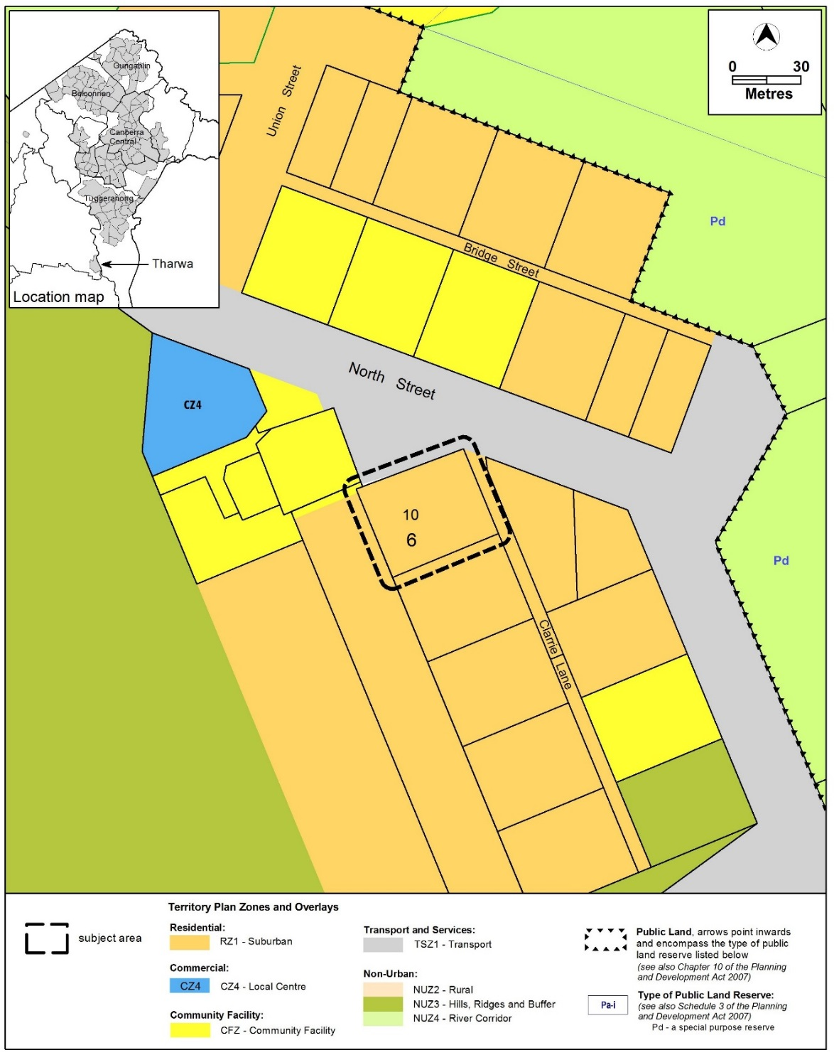

Variation to the Territory Plan Written Statement
- Tharwa Precinct Map and Code

Substitute
Tharwa Precinct Map and Code at Appendix 1

Interpretation service
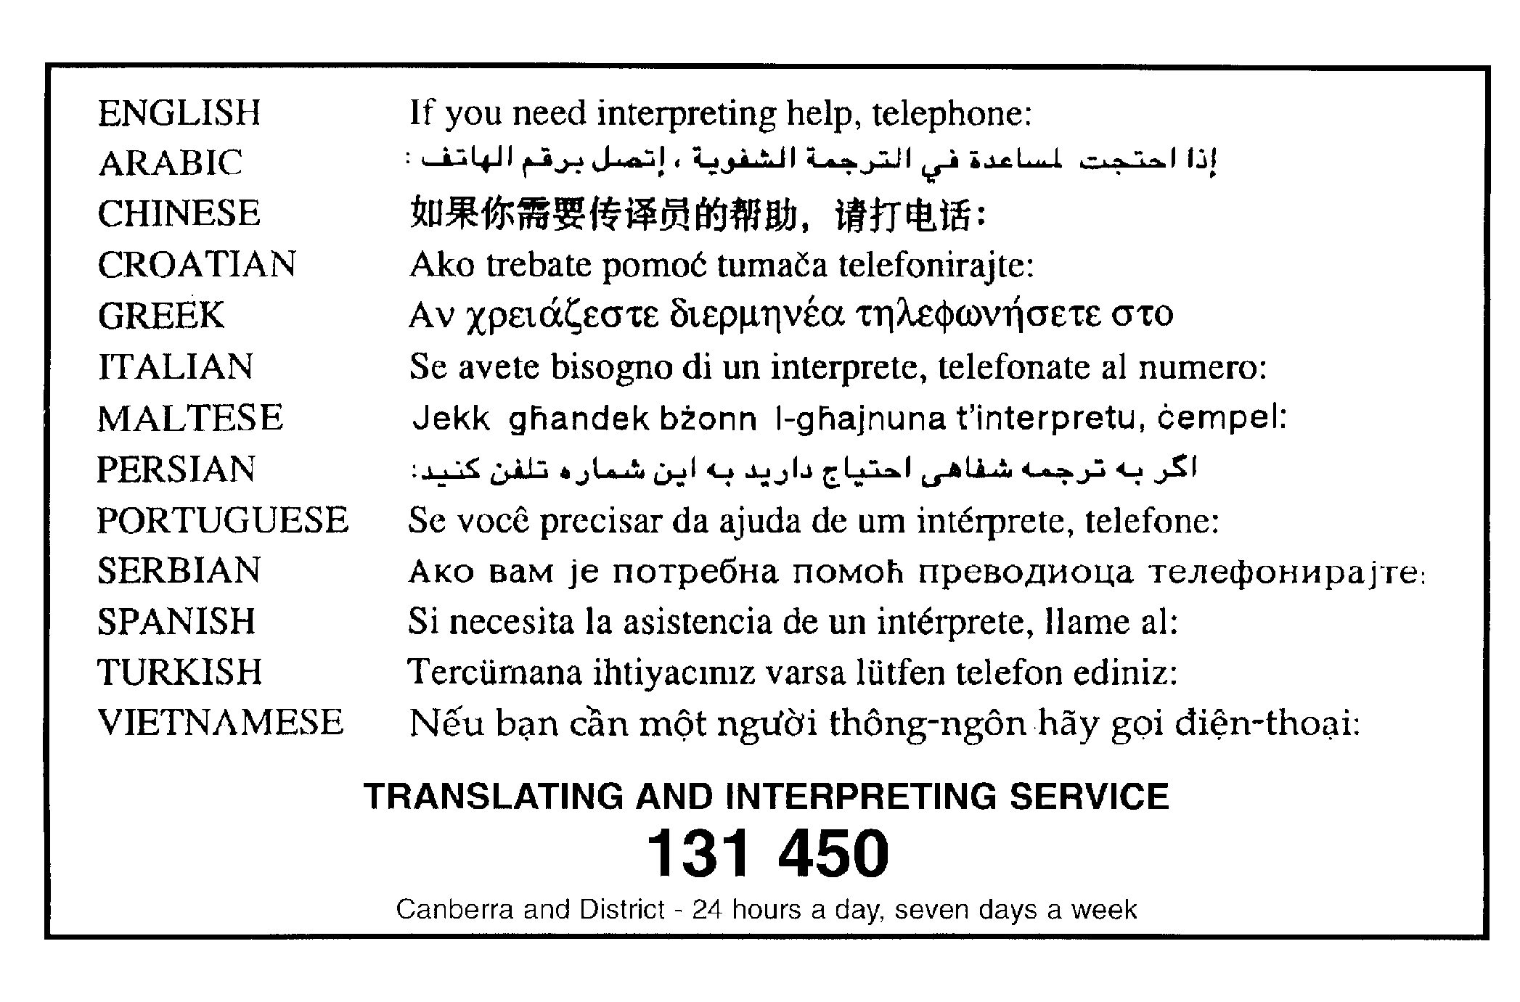

Appendix 1
Tharwa Precinct Map and Code

Tharwa Precinct Map and Code

This page is intentionally blank.

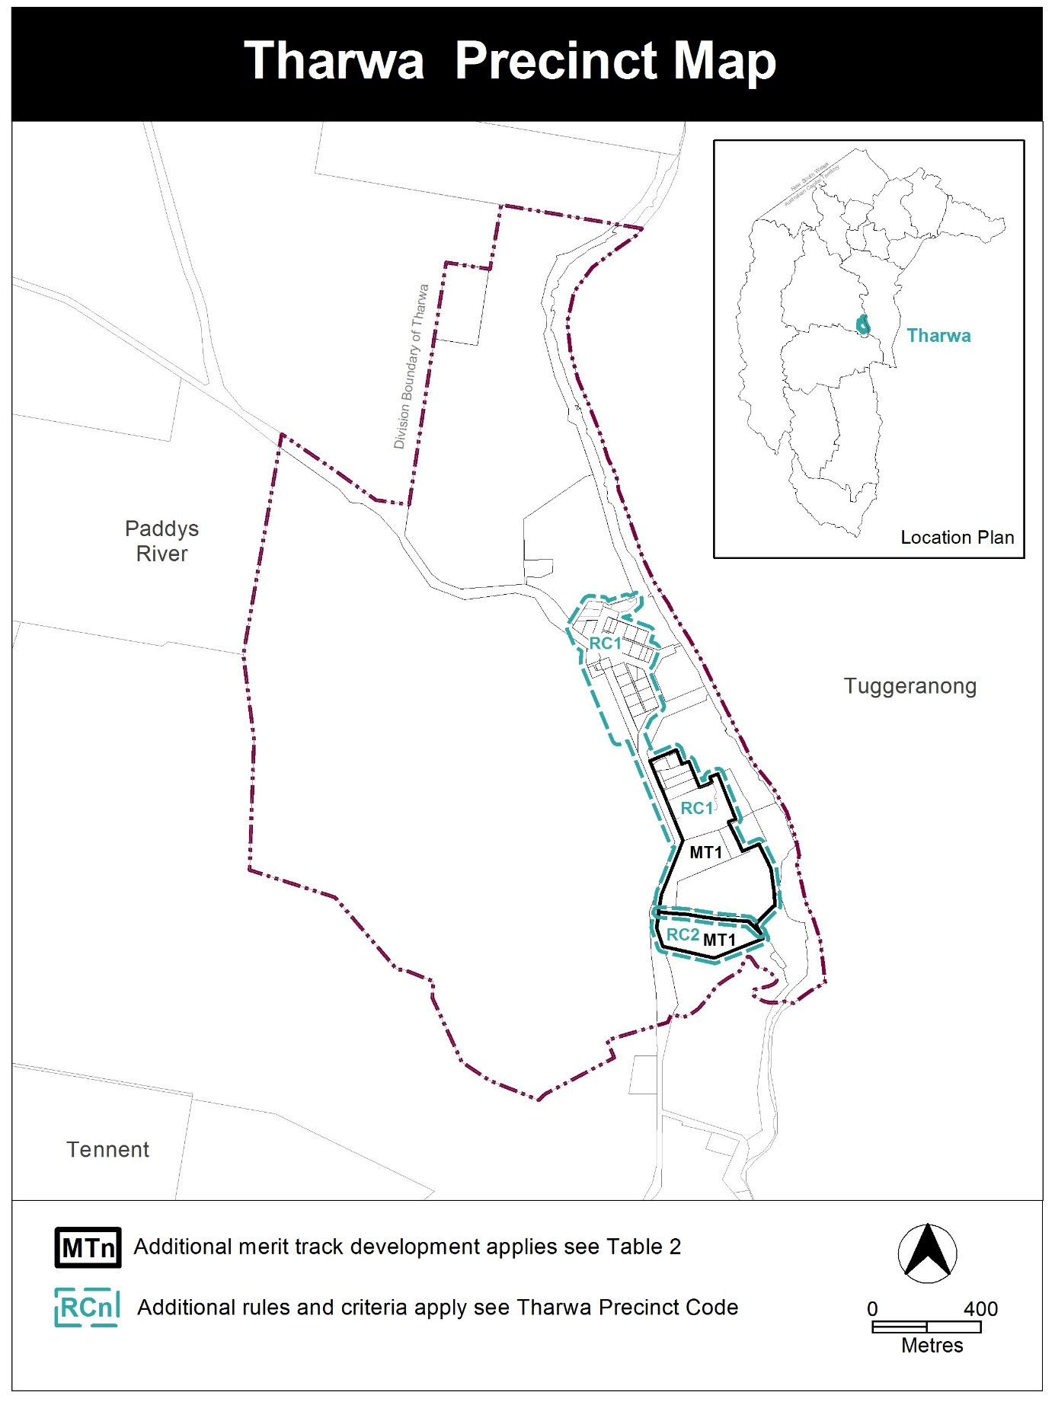

Assessment Tracks

The following tables identify the additional prohibited development and additional merit track development for blocks and parcels shown in the Tharwa Precinct Map (identified as PDn or MTn). Development that is exempt from requiring development approval, other prohibited development and the minimum assessment track applicable to each development proposal is set out in the relevant zone development table.

The following table constitutes part of the relevant zone development table.

Table 2 – Additional merit track development
Additional merit track development that may be approved subject to assessment
Suburb precinct map label | Zone | Development
MT1 | NUZ4 | group or organised camp  overnight camping area  tourist facility

Tharwa Precinct Code

Contents

Introduction 3
Additional rules and criteria 5
RC1 – Tharwa Village 5
Element 1: Use 5
1.1 Campsite and tourist facility 5
1.2 Restrictions on use 5
Element 2: Buildings and Structures 8
2.1 Bushfire protection 8
2.2 Building height 9
2.3 Setbacks 9
2.4 Verandahs 9
2.5 Roofs 9
2.6 Garages, carports and sheds 10
2.7 Driveways 10
2.8 Fences and courtyard walls 10
2.9 Rainwater tanks 11
Element 3: Environment 12
3.1 Topography 12
3.2 On-site wastewater treatment 12
3.3 Water sensitive urban design 12
Element 4: Heritage 12
4.1 Heritage character and significance 12
RC2 – River Corridor 13
Element 5: Use 13
5.1 Development 13
Element 6: Environment 13
6.1 On-site wastewater treatment 13
Figures
Figure 1 – Area 1 6
Figure 2 – Area 2 7
Figure 3 – Residential Bushfire protection 8

This page is intentionally blank

Introduction
Name
The name of this code is Tharwa Precinct Code.
Application
The code applies to the Division of Tharwa.
Purpose
This code provides additional planning, design and environmental controls for specific areas or blocks and may also contain references to provisions in other codes.
In conjunction with other relevant codes it will be used by the Authority to assess development applications and offer guidance to intending applicants in designing development proposals and preparing development applications.
Structure
This code contains additional rules and/or criteria for particular blocks or parcels identified as areas RCn on the precinct map, to be read in conjunction with the relevant development code. It may also contain sub-parts.
Each element has one or more rules and, unless the respective rule is mandatory, each rule has an associated criterion. Rules provide quantitative, or definitive, controls. By contrast, criteria are chiefly qualitative in nature.
In some instances rules are mandatory. Such rules are accompanied by the words “This is a mandatory requirement. There is no applicable criterion.” Non-compliance with a mandatory rule will result in the refusal of the development application. Conversely, the words “There is no applicable rule” is found where a criterion only is applicable.
Code hierarchy
Under the Planning and Development Act 2007, where more than one type of code applies to a development, the order of precedence if there is inconsistency of provisions between codes is: precinct code, development code and general code.
If more than one precinct code applies to the site, the most recent precinct code takes precedence to the extent of any inconsistency.
Definitions
Defined terms, references to legislation and other documents are italicised.
Definitions of terms used in this code are listed in part 13 of the Territory Plan or, for terms applicable only to this code, associated with the respective rule.
Acronyms
EPA ACT Environment Protection Authority
ESA ACT Emergency Services Agency
EPSDD Planning, Environment and Sustainable Development Directorate
NCA National Capital Authority
P&D Act Planning and Development Act 2007
TCCS Transport Canberra and City Services Directorate

Additional rules and criteria
This part applies to blocks and parcels identified in the Tharwa Precinct Map (RCn). It should be read in conjunction with the relevant zone development code and related codes.
Desired character
New buildings and associated utility buildings will reflect the existing rural village character and scale of traditional houses within the streetscape. New buildings will complement the historic features of Tharwa’s older houses, heritage places and community buildings.
RC1 – Tharwa Village
This part applies to blocks and parcels identified in area RC1 shown on the Tharwa Precinct Map.
- Use
Rules | Criteria
  - Campsite and tourist facility
There is no applicable rule. | This provision applies to ‘Area 2’ in Figure 2.  Development is of low intensity on large blocks permitting point source retention of storm water runoff and opportunities for large scale landscaping. Stormwater runoff should be containable on site.
There is no applicable rule. | This provision applies to ‘Area 2’ in Figure 2.  Development, including existing uses, incorporates measures to minimise impacts on the ecology and improve the visual character of the locality.
  - Restrictions on use
R3  Maximum plot ratio for residential buildings is 25%. | This is a mandatory requirement. There is no applicable criterion.
R4  This rule applies to ‘Area 1’ in Figure 1.  The maximum number of detached dwellings on each block within the residential zone is 1. | This is a mandatory requirement. There is no applicable criterion.
R5  This rule applies to ‘Area 1’ in Figure 1.  Subdivision or consolidation of blocks is not permitted. | This is a mandatory requirement. There is no applicable criterion.

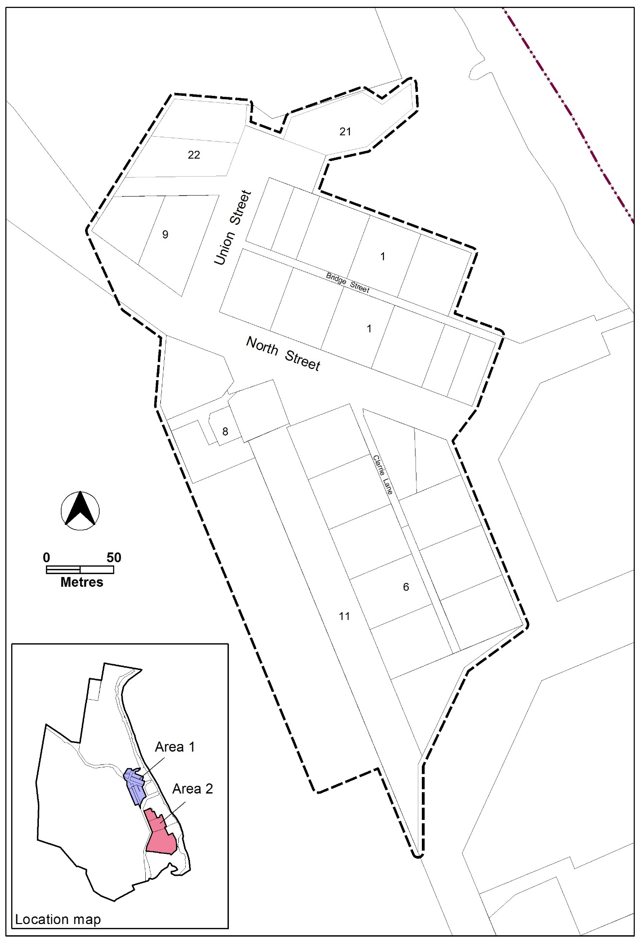
Figure 1 – Area 1

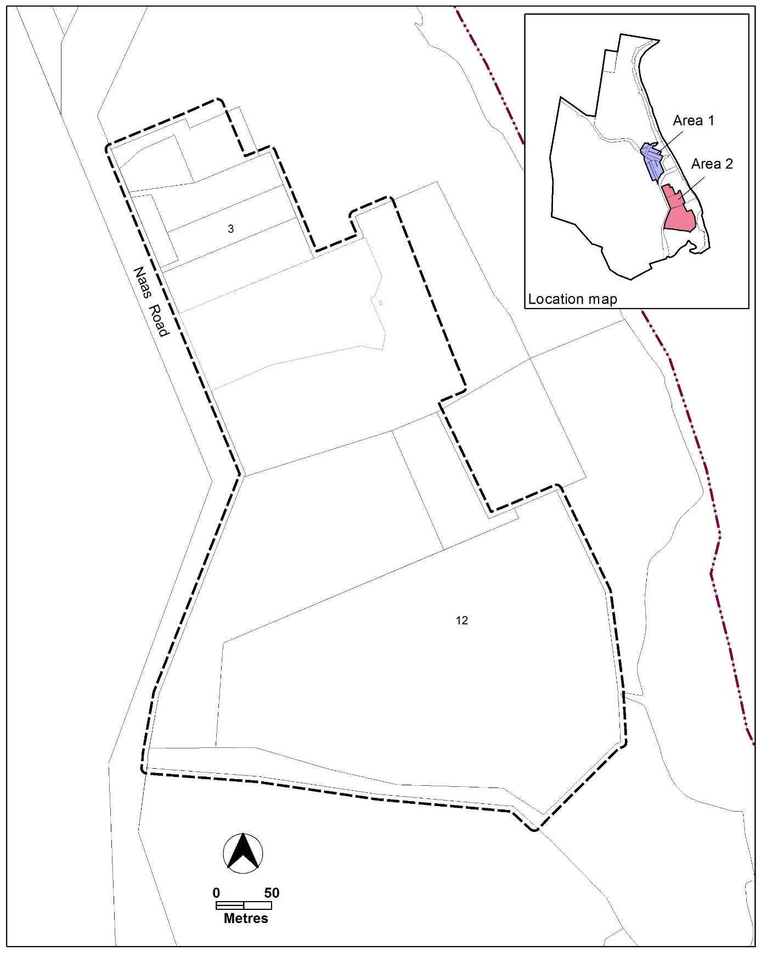
Figure 2 – Area 2

- Buildings and Structures
Rules | Criteria
  - Bushfire protection
R6  This rule applies to the blocks identified in Figure 3.  Development meets the required Bushfire Attack Level (BAL) ratings. | C6  The Bushfire Attack Level rating may be reviewed through an independent bushfire risk assessment undertaken by a suitably qualified person, and with written endorsement by the relevant government agency.

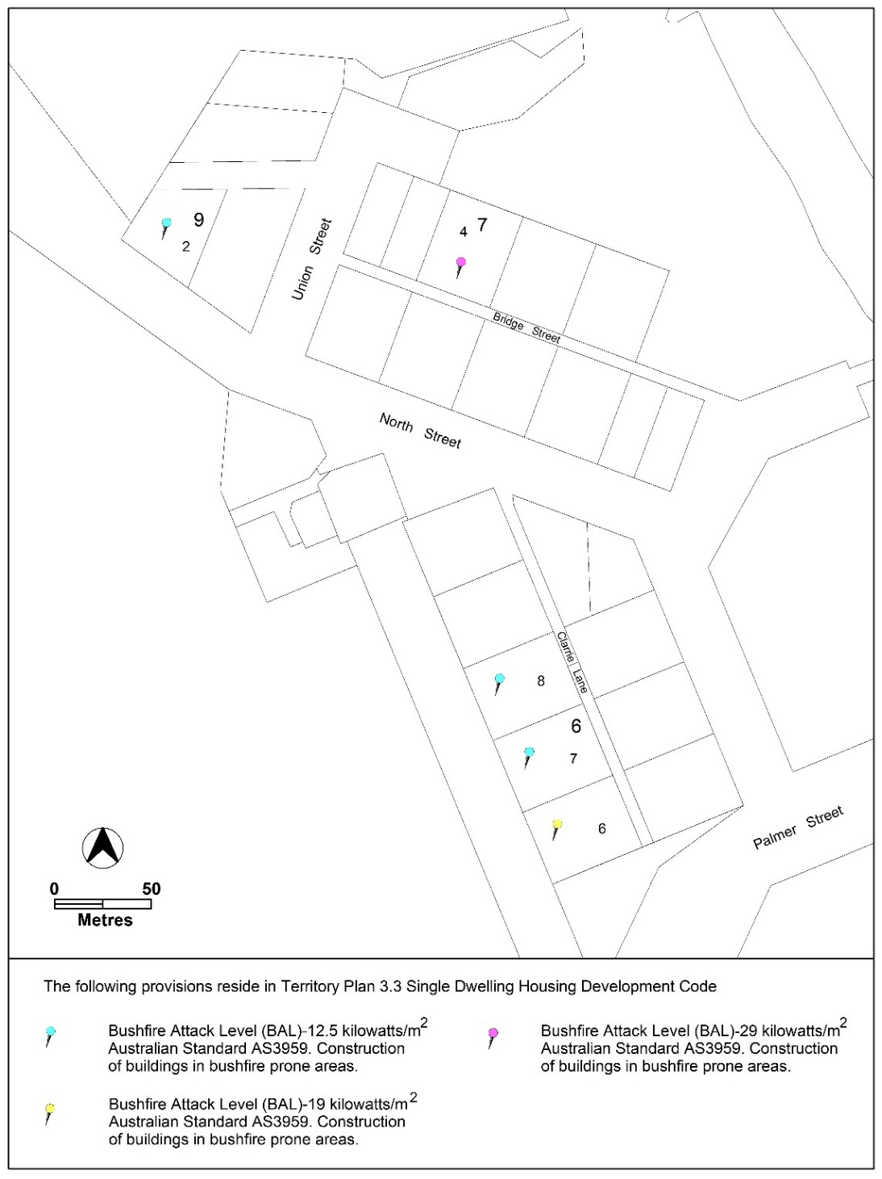
Figure 3 – Residential Bushfire protection

Rules | Criteria
  - Building height
R7  Buildings are a maximum of one storey. | This is a mandatory requirement. There is no applicable criterion.
R8  Maximum floor to roof apex height of buildings is 6m. | This is a mandatory requirement. There is no applicable criterion.
R9  Minimum floor to ceiling height for residential buildings is 2.7m at the front of the building. | C9  Roofs are a prominent feature of dwellings and recognisable as a separate element to the verandah.
  - Setbacks
R10  This rule applies to ‘Area 1’ in Figure 1.  Minimum front setback for buildings is 7m. | C10  This criterion applies to ‘Area 1’ in Figure 1.  Buildings in the village respect the predominant front setback and orientation of Tharwa’s traditional buildings, with the front façade facing the front boundary and oriented to the street.
R11  This rule applies to ‘Area 1’ in Figure 1.  Minimum side boundary setback 1 is 3m.  Minimum side boundary setback 2 is 4.5m. | C11  This criterion applies to ‘Area 1’ in Figure 1.  Buildings in the village respect the predominant side setbacks and orientation of Tharwa’s traditional buildings.
  - Verandahs
R12  All residential buildings incorporate a verandah for at least 50% of the width of the front façade. | This is a mandatory requirement. There is no applicable criterion.
R13  Minimum depth of verandahs is 2m. | This is a mandatory requirement. There is no applicable criterion.
  - Roofs
R14  Roofs are of a steep pitched gable and/or hip roof design (between 30º and 45º). | This is a mandatory requirement. There is no applicable criterion.
There is no applicable rule. | C15  Roofs are constructed using corrugated metal, or similar, in a neutral and non-reflective colour or traditional galvanised finish.
  - Garages, carports and sheds
R16  Garages and carports are permitted where they meet all of the following:  - Detached from the primary building and external walls are separated by a minimum of 1.5m  - Located a minimum distance of 5m behind the front facade of the primary building  - Do not impact on the scale of the primary building and the streetscape | C16  Attached garages may be considered where they are located behind the front façade of the primary building and screened from the street.  Basement garages may be considered only where the access is located at the rear of the primary building and screened from the street.
There is no applicable rule. | C17  Detached sheds may be considered where these are located in the rear zone, are single storey, and are secondary in scale to the primary building.
There is no applicable rule. | C18  Materials and finishes used in the construction of garages, carports and sheds are consistent with those used in the primary building.
  - Driveways
R19  Driveways are predominantly constructed of permeable surfaces such as gravel, concrete wheel strips or permeable paving in order to minimise sealed hardstand areas and minimise stormwater run-off.  Note: Concrete surfacing is permitted between the road edge and the front property boundary, including where required for footpath cross-overs in accordance with the requirements of the ACT Government agency responsible for approving offsite works. | C19  Concrete driveways may be considered in areas where site topography and overland stormwater run-off present a high likelihood of erosion.
  - Fences and courtyard walls
R20  Fences are permitted in the front zone where they meet all of the following:  - Maximum 1.2m height above ground level  - Made using transparent materials such as wire, wire mesh or open timber  - Privacy screening is provided through landscape planting  Note: non-transparent fences such as sheet metal are not permitted. | This is a mandatory requirement. There is no applicable criterion.
R21  Fences are permitted in the primary building zone and rear zone where they meet all of the following:  - Maximum 1.8m height above ground level  - Made of transparent materials such as wire, wire mesh and open timber  - Privacy screening is provided through landscape planting  Note: non-transparent fences such as sheet metal are not permitted. | This is a mandatory requirement. There is no applicable criterion.
R22  Courtyard walls are not permitted in the front zone or for use as boundary fencing. | This is a mandatory requirement. There is no applicable criterion.
There is no applicable rule. | C23  Courtyard walls may be considered for use as a landscape feature where they are located in the rear zone, or are integrated with the primary building.
  - Rainwater tanks
R24  This rule applies to all new dwellings.  The minimum size of rainwater tanks required to provide adequate water supply to dwellings is:  - For dwellings less than or equal to 150m² in size – 45,000l  - For dwellings greater than 150m² in size – 90,000l  Note: These are required minimum sizes only. Consideration should be given to ensure appropriate tank size to provide optimal capacity and meet bushfire safety requirements. | This is a mandatory requirement. There is no applicable criterion.
There is no applicable rule. | C25  Tanks are to be constructed using corrugated metal, or similar, in a neutral and non-reflective colour or traditional galvanised finish.
There is no applicable rule. | C26  Tanks are to be placed behind the primary building, or placed underground, or screened using landscape planting.
- Environment
Rules | Criteria
  - Topography
There is no applicable rule. | C27  The natural ground level of the site shall be retained to respect the natural topography and overland stormwater run-off.
There is no applicable rule. | C28  Where earthworks are required, battered soil slopes in conjunction with ground-cover plantings should be used to accommodate level changes in preference to engineered retaining walls. Where they are used, retaining walls should be a maximum of 1m in height and incorporated with the primary building to minimise visual impacts.
  - On-site wastewater treatment
R29  Any new development or re-development of on-site wastewater treatment systems located within 300m of a waterway will be required to be referred to the ACT EPA for assessment. | This is a mandatory requirement. There is no applicable criterion.
  - Water sensitive urban design
There is no applicable rule. | C30  This provision applies to ‘area 1’ in Figure 1.  Development encourages urban design that reduces water consumption and increases recycling of wastewater.
- Heritage
Rules | Criteria
  - Heritage character and significance
There is no applicable rule. | C31  The existing road pattern, cottages and other items of heritage significance are conserved, consistent with relevant heritage requirements.
RC2 – River Corridor
This part applies to blocks and parcels identified in area RC3 shown on the Tharwa Precinct Map.
- Use
Rules | Criteria
  - Development
There is no applicable rule. | C32  Development is of low intensity on large blocks permitting point source retention of storm water runoff and opportunities for large scale landscaping. Stormwater runoff should be containable on site.
There is no applicable rule. | C33  Development, including existing uses, incorporates measures to minimise impacts on the ecology and improve the visual character of the locality.

- Environment
Rules | Criteria
  - On-site wastewater treatment
R34  Any new development or re-development of on-site wastewater treatment systems located within 300m of a waterway will be required to be referred to the ACT EPA for assessment. | This is a mandatory requirement. There is no applicable criterion.

