Australian Capital Territory
Planning and Development (Plan Variation No 342) Approval 2019

Notifiable instrument NI2019-74
made under the
Planning and Development Act 2007, s 76 (Minister’s powers in relation to draft plan variations)

1 Name of instrument
This instrument is the Planning and Development (Plan Variation No 342) Approval 2019.
2 Approval of draft plan variation
(1) I approve under section 76 (2) (a) of the Planning and Development Act 2007 draft plan variation No 342 to the Territory Plan.
(2) In this section:
draft plan variation No 342 to the Territory Plan means the draft plan variation in the schedule.

Mick Gentleman MLA
Minister for Planning and Land Management
11 February 2019

This page is intentionally blank.

Planning and Development Act 2007

Variation to the
Territory Plan
No 342

Belconnen town centre:
Zone changes and amendments to the
Belconnen precinct map and code

Final variation prepared under s76 of the
Planning and Development Act 2007

This page is intentionally blank.

Contents

1. EXPLANATORY STATEMENT 1
1.1 Background 1
1.2 Summary of the Proposal 1
1.3 The National Capital Plan 2
1.4 Site Description 2
1.5 Current Territory Plan Provisions 4
1.6 Changes to the Territory Plan 6
1.7 Consultation on the Draft Variation 6
2. VARIATION 7
2.1 Variation to the Territory Plan map 7
2.2 Variation to the Territory Plan 8

This page is intentionally blank.

- EXPLANATORY STATEMENT
  - Background
The variation incorporates the key planning policy recommendations contained within the Belconnen town centre master plan approved in 2016.
While a number of recommendations from the previous 2001 Belconnen master plan have been realised, there have been a number of strategic planning documents released since then, such as the ACT Planning Strategy 2012, which encourage the consideration of urban intensification measures for the centre.
In addition to the zone changes for a number of specific sites, the review of the provisions applying across the town centre has also involved the identification of the need for additional measures in the Belconnen precinct code. This includes stipulation of maximum building heights for the town centre, identifying new development opportunities and improving pedestrian activity through the centre.

  - Summary of the Proposal
Variation to the Territory Plan No 342 (V342) Belconnen town centre incorporates the key recommendations of the approved 2016 Belconnen town centre master plan, which provides guidance on the desired future built form and character of the town centre as it develops over the next 10 to 20 years.
The Belconnen master plan’s vision for the centre identifies that the town centre’s features, including the lake, open spaces, layout and nearby institutions provide unique economic and environmental advantages. The master plan aims to improve and strengthen these aspects to ensure the town centre is an attractive, accessible and desirable place for people to live, work and enjoy.
V342 rezones a number of areas within the town centre and surrounding areas, including:
- two blocks within the service trades area from service trades commercial to urban open space to retain access to existing open space areas for workers and visitors
- an area along Lathlain Street from trades and services to commercial business zone and urban open space, to promote activity west of the mall and revitalise the area; and
- a residential area on College Street from suburban core to high density residential to expand the existing area of high density residential development close to the town centre, and provide a more appropriate interface between the centre and surrounding residential land.

The variation further amends the permitted uses in selected areas within the town centre, including prohibiting residential use in the service trades area and permitting a supermarket within the commercial business zone near the Emu Bank and Eastern Valley Way intersection. The variation also introduces building heights to the centre up to 28 storeys in selected locations, accommodating the height of approved development within the town centre. Building setbacks and active frontage requirements in accordance with the approved master plan are incorporated to ensure interesting and safe public spaces for pedestrians. Awning requirements are also included to ensure all weather protection along the main pedestrian areas.

  - The National Capital Plan
The Australian Capital Territory (Planning and Land Management) Act 1988 established the National Capital Authority (NCA) with two of its functions being to prepare and administer a National Capital Plan (NCP) and to keep the NCP under constant review and to propose amendments to it when necessary.
The NCP, which was published in the Commonwealth Gazette on 21 January 1990 is required to ensure that Canberra and the Territory are planned and developed in accordance with their national significance. The Planning and Land Management Act 1988 also required that the Territory Plan is not inconsistent with the NCP.
In accordance with section 10 of the Australian Capital Territory (Planning and Land Management) Act 1988, the National Capital Plan defines the planning principles and policies for Canberra and the Territory, for giving effect to the object of the NCP and sets out the general policies to be implemented throughout the Territory, including the range and nature of permitted land uses.
It also sets out the detailed conditions of planning, design and development for areas that have special significance to the National Capital known as designated areas and identifies special requirements for the development of some other areas.

  - Site Description
The subject area is the Belconnen town centre and a section of the residential area to the south, as identified in Figure 1. This figure also identifies the sites to be rezoned under V342. The town centre lies to the south of Lake Ginninderra, an artificial lake providing stormwater management and recreation opportunities for the town centre.
The town centre is a significant employment base within the ACT, with Commonwealth departments and retail businesses being the biggest employers. The centre also contains a number of important community, education and recreation uses including Belconnen library, Lake Ginninderra College and the Canberra International Sports and Aquatic Centre.
The town centre contains a wide range of building heights, from the single and two storey service trades area to the central business area with development ranging from four storeys up to 27 storeys.
Surrounding areas are predominately low density residential suburban to the south, west and north of the centre, and the University of Canberra within walking distance of the town centre to the east.
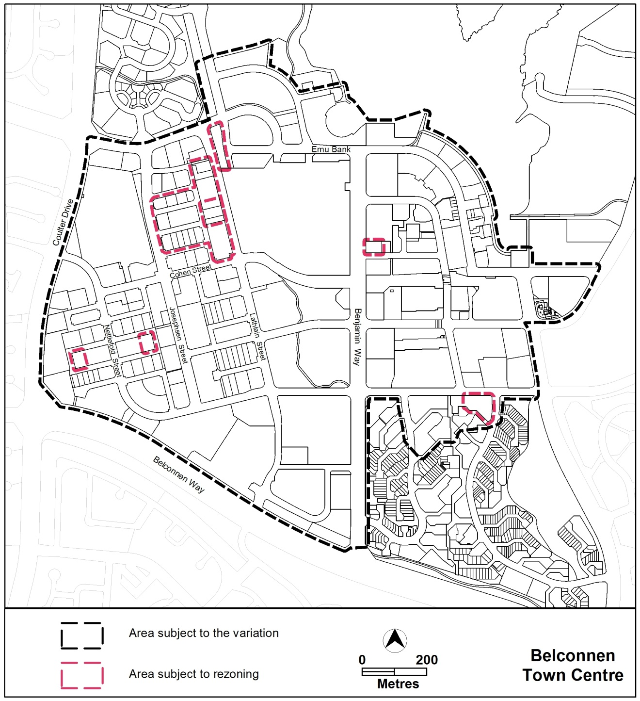
Figure 1 Site Plan
  - Current Territory Plan Provisions
The Territory Plan map for the area subject to this variation is shown in Figure 2.
The town centre is predominately zoned CZ2 commercial business zone, with a central CZ1 core zone containing the Westfield Belconnen shopping centre adjoining the lake. The town centre also contains a substantial CZ3 service trades area forming the western portion of the town centre, containing the predominant service trades uses.
The town centre contains a wide range of building heights, with the CZ3 zoned area predominately single and two storeys, while the CZ1 core are and CZ2 business zone ranging between six to 12 storeys, along with an approved 28 storey tower development.
Development along Lake Ginninderra within the subject area is zoned CZ6 leisure and accommodation zone, with single and two storey buildings, with RZ5 High Density Residential zoned land behind containing a number of multi storey unit complexes around four storeys tall.
The town centre is subject to the Commercial Zone development code and the Belconnen precinct map and code. The adjoining residential areas are subject to the Residential Zones Development code, Single Dwelling Housing development code and the Multi Unit Housing development code. The community facility land is subject to the Community Facility Zones development code, with the public open space subject to the Parks and Recreation Zone development code. The general codes may also apply.
It should be noted that Belconnen sections 43, 44, 45(part), 49 and 50, while being identified as being subject to the Territory Plan provisions, are ‘National Land’, and are subject to the provisions of the National Capital Plan and associated Development Control Plans. In this regard, the Territory Plan provisions do not apply to these sites.
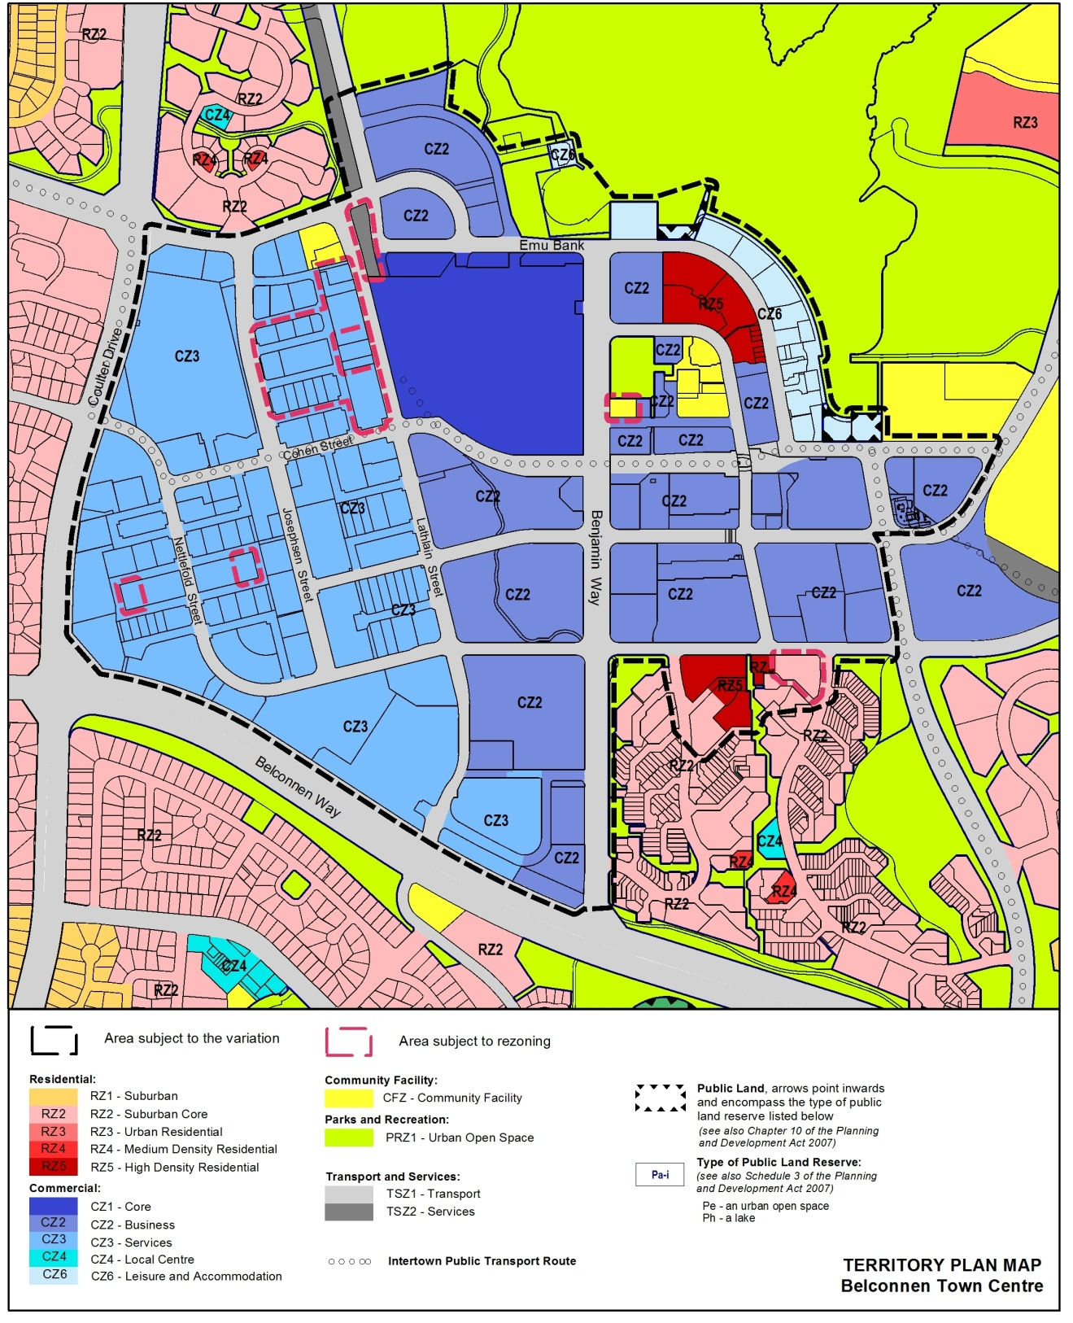
Figure 2 Territory Plan Zones Map

  - Changes to the Territory Plan
Detailed changes to the Territory Plan are noted in section 2 of this document.

  - Consultation on the Draft Variation
Draft Variation No 342 (DV342) was released for public comment between 4 May 2018 and 22 June 2018. A consultation notice under section 63 of the Planning and Development Act 2007 (P&D Act) was published on the ACT Legislation Register on 4 May 2018.
A total of twenty one written submissions were received, which included 9 submissions from Belconnen residents, 8 submissions from commercial interests, or groups representing commercial interests, within the centre, 3 submissions from community organisations and one submissions from a cycling advocate.
Main issues raised by submitters included:
- Concern with the proposed building heights, with the majority of submissions seeking additional building heights over one or more sites, and several submissions concerned with the proposed 16 storey building height permitted on the corner of Belconnen Way and Benjamin Way
- Concern with the rezoning of the community facility zoned land adjacent to Margaret Timpson Park, block 41 section 54 to commercial business zone, and potential future use of the site
- Concern with the proposed rezoning of the CZ3 services area west of Lathlain Street through potential impacts of development and potential loss of a future employment area
- Concern with the two storey restriction and prohibition on residential uses in the CZ3 services area; and
- Comments around the provision permitting a supermarket along the northern end of Eastern Valley Way, outside of the central commercial area, with both support and objection to the proposal.
The above issues were considered and are detailed in a report on consultation, which is available at www.act.gov.au/recommendedvariations. Changes to the draft variation 342 were informed by the issues raised in the public submissions.

- VARIATION
  - Variation to the Territory Plan map
The Territory Plan map is varied as indicated in Figure 3.
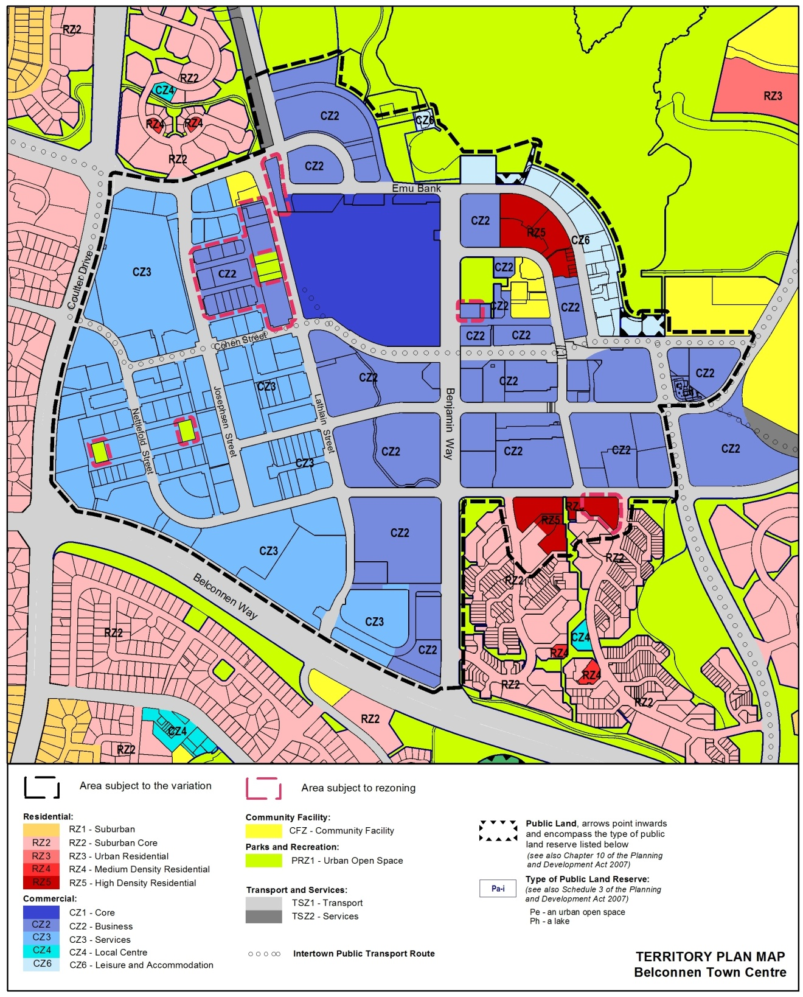
Figure 3: Areas subject to rezoning

  - Variation to the Territory Plan
The Territory Plan written statement is varied in all of the following ways:

Variation to the Belconnen precinct map and code
- Precinct maps and codes, Belconnen precinct map and code
substitute the following with the nominated attachment:
Belconnen precinct map and development tables with Attachment A
RC1 – Residential area 1, RC2 – Belconnen Town Centre and RC3 – Residential area 2 with Attachment B
Interpretation service

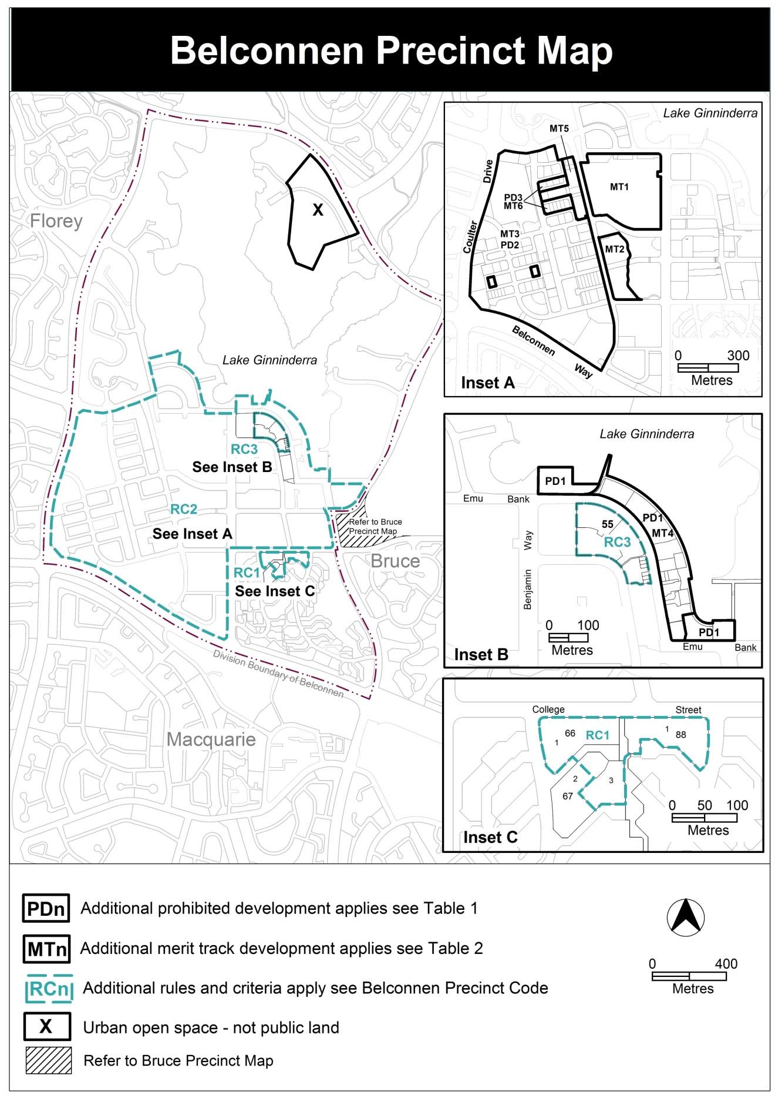

Assessment Tracks
The following tables identify the additional prohibited development and additional merit track development for blocks and parcels shown in the Belconnen Precinct Map (identified as PDn or MTn). Development that is exempt from requiring development approval, other prohibited development and the minimum assessment track applicable to each development proposal is set out in the relevant zone development table.
The following tables constitute part of the relevant zone development table.
Table 1 – Additional prohibited development
Additional prohibited development
Suburb precinct map label | Zone | Development
PD1 | CZ6 | caravan park / camping ground  drive in cinema group or organised camp overnight camping area
PD2 | CZ3 | RESIDENTIAL USE
PD3 | CZ2 | RESIDENTIAL USE

Table 2 – Additional merit track development
Additional merit track development that may be approved subject to assessment
Suburb precinct map label | Zone | Development
MT1 | CZ1 | produce market
MT2 | CZ2 | service station
MT3 | CZ3 | corrections facility
MT4 | CZ6 | office  RESIDENTIAL USE
MT5 | CZ2 | Industrial trades  light industry  plant and equipment hire establishment  store  veterinary hospital  warehouse
MT6 | CZ2 | light industry  plant and equipment hire establishment  store  veterinary hospital  warehouse

add definitions to Belconnen precinct code:
Active Frontage: ground level building facades adjoining public spaces that encourage pedestrian interaction through display windows, public entrances, shop fronts and the like.
Podium: refers to the lower storeys of a building addressing public space, designed to present a human scale to the public space. Upper floor levels are set back to reduce apparent bulk and scale.

RC1 – Residential area 1
This part applies to blocks and parcels identified in area RC1 shown on the Belconnen Precinct Map.
- Buildings
Rules | Criteria
  - Number of storeys
There is no applicable rule. | Buildings are predominately the lesser of three storeys and 11 metres, with a maximum height of building the lesser of six storeys and 21 metres where development addresses College Street.
  - Solar access
There is no applicable rule. | Development does not significantly impact on solar access to main daytime living areas and areas of principal private open space of dwellings on adjacent blocks.

RC2 – Belconnen Town Centre
This part applies to area RC2 shown on the Belconnen Precinct Map. RC2 includes the larger part of the Belconnen Town Centre. See also the Bruce Precinct Code which contains part of the Belconnen Town Centre.
- Use
Rules | Criteria
  - Ground floor uses
This rule applies to sites in CZ1 with boundaries to primary active frontages shown in figure 1.  Only the following uses are permitted along the primary active frontage at the ground floor level:  - business agency  - club  - community activity centre  - drink establishment  - financial establishment  - hotel  - indoor entertainment facility  - indoor recreation facility  - public agency  - restaurant  - SHOP. | This is a mandatory requirement. There is no applicable criterion.
There is no applicable rule. | This criterion applies to sites in CZ2 and CZ6 with boundaries to primary active frontage shown in figure 1.  Buildings incorporate uses on the ground floor that generate activity in the public space.
  - SHOP – floor area limit
This rule applies to CZ2.  The maximum gross floor area of any SHOP is 200m².  In the hatched area shown in figure 1, the maximum gross floor area of supermarket is 1,500m² per section. | SHOPS are limited to a scale appropriate to providing convenient shopping and personal services for the local workforce and residents.  This criterion does not apply to supermarket in the hatched area in figure 1.

Rules | Criteria
  - Office and residential use
This rule applies to section 65 in CZ6.  The following uses are not permitted on the ground floor level:  - office  - RESIDENTIAL USE. | This is a mandatory requirement. There is no applicable criterion.

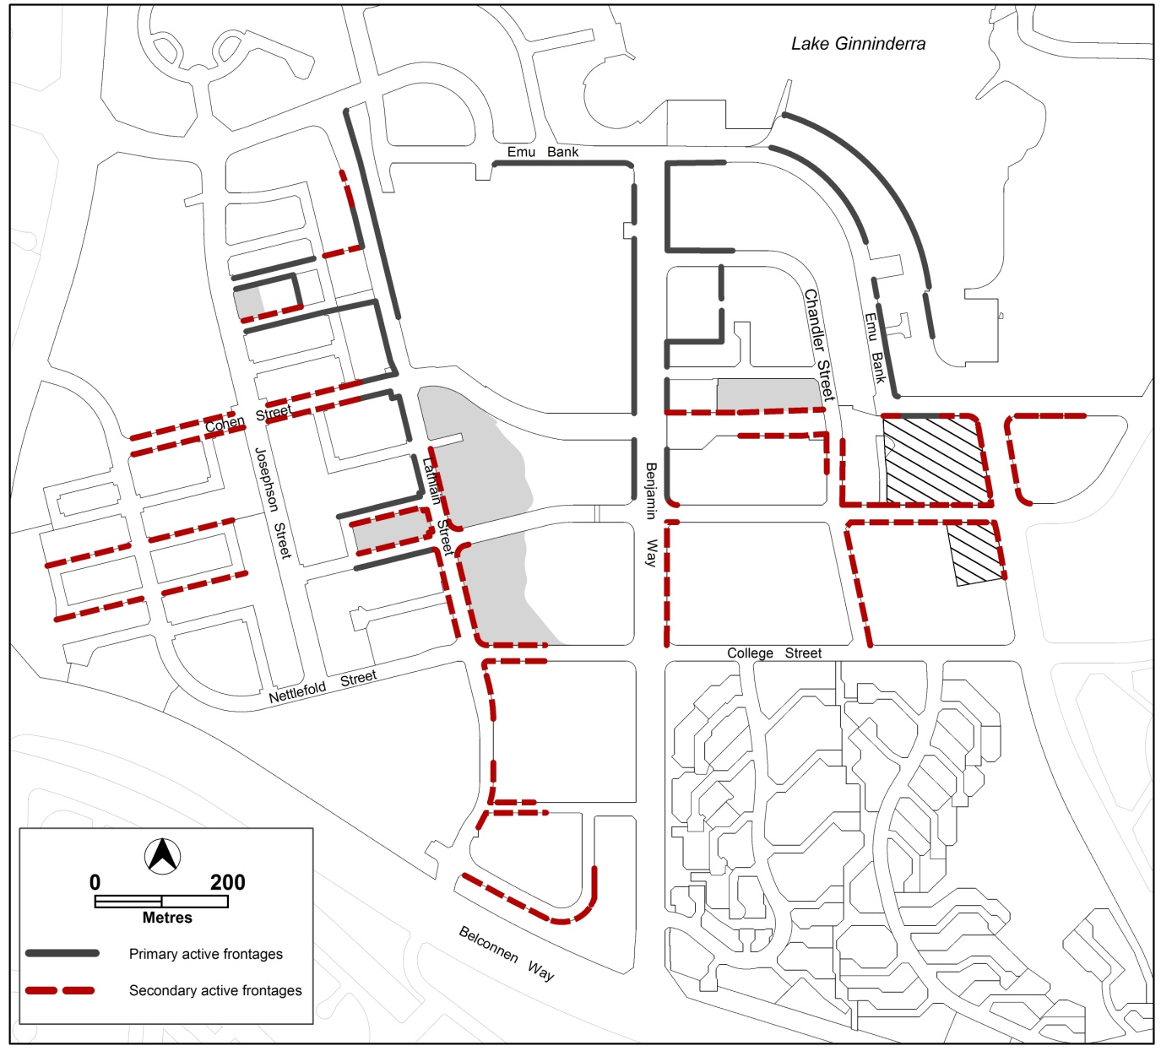
- Active frontages, car parking areas and permitted supermarket area in CZ2

Rules | Criteria
This rule applies to section 23 and 21.  RESIDENTIAL USE is not permitted on the ground and/or first level along Lathlain Street. | This is a mandatory requirement. There is no applicable criterion.
This rule applies to section 21.  RESIDENTIAL USE is not permitted within 100m of block 23 section 21. | Development applications for development that includes residential use are submitted with written endorsement from the Environment Protection Authority.
  - Service station
This rule applies to the areas shaded grey shown in figure 1.  Development of a service station, where permitted by the Belconnen precinct map, is only permitted in association with a structured car park. | This is a mandatory requirement. There is no applicable criterion.
  - Development on nominated car parking areas
This rule applies to the areas shaded grey shown in figure 1.  Development complies with all of the following:  - the existing number of car parking spaces is retained on the site and made available for public use at all times; and  - provides car parking that is generated by the development on site in accordance with the Parking and Vehicular Access General Code in addition to the spaces required by item a). | Development achieves all of the following:  - any additional parking provision requirements (under the Parking and Vehicular Access General Code) for the development; and  - makes a substantial contribution to the long term publicly accessible parking supply at the town centre as endorsed by the Territory.

- Buildings
Rules | Criteria
  - Building heights
This rule applies to areas shown in figure 2 and figure 3.  Maximum height of building is:  - for area ‘a1’: the lesser of 28 storeys and 96m  - for area ‘a2’: the lesser of 25 storeys and 80m  - for area ‘b’: the lesser of 23 storeys and 76m  - for area ‘c’: the lesser of 20 storeys and 66m  - for area ‘d’: the lesser of 18 storeys and 60m  - for area ‘e’: the lesser of 12 storeys and 42m  - for area ‘f’: the lesser of 10 storeys and 35m  - for area ‘g’: the lesser of 8 storeys and 29m  - for area ‘h’: the lesser of 6 storeys and 23m  - for area ‘i’: the lesser of 4 storeys and 16m  - for area ‘j’: the lesser of 3 storeys and 12m  - for area ‘NCA’: RL613.7  - for area k: the lesser of 2 storeys and 9m.  Plant room set back a minimum of 3m from the building facade of the floor immediately below is not included in the number of storeys.  Plant room screening and other non gross floor area rooftop architectural features are not included in building height.  Note: Maximum building heights that are not nominated in Figure 2 are as per the relevant zone development code requirements. | The maximum height of building in areas ‘b’ and ‘c’ may be increased by an additional four storeys or twelve metres, whichever is the lesser, where development achieves all of the following:  - where a block contains more than one taller building element, there is clear difference in height between elements  - the development achieves a high quality design outcome; and  - development is close to public transport stops and/or stations.

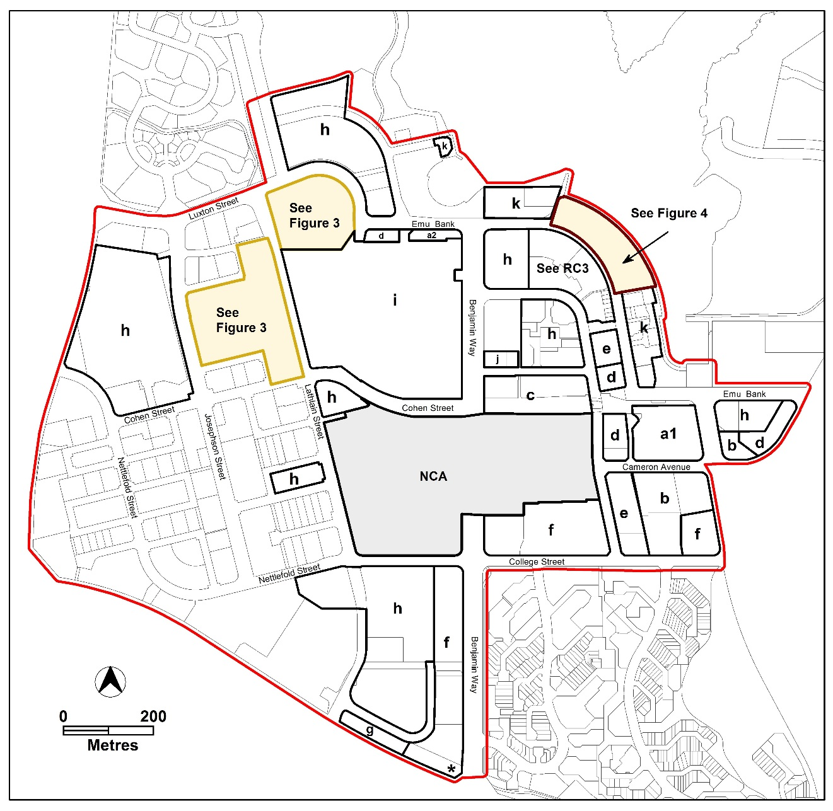
- Building heights

Rules | Criteria
There is no applicable rule. | This criterion applies to development in the area indicated by an asterisk shown in figure 2, at the corner of Benjamin Way and Belconnen Way.  One higher building element up to the lesser of 16 storeys and 55m may be permitted where development suitably addresses the adjoining Benjamin Way and Belconnen Way intersection.

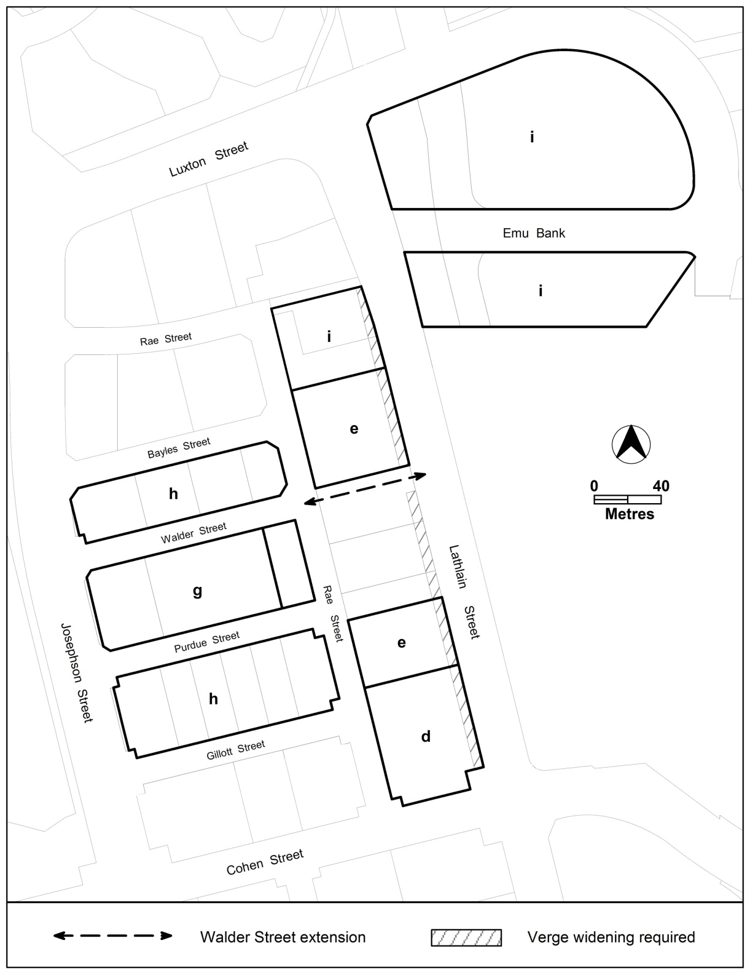
- Lathlain Street precinct

Rules | Criteria
There is no applicable rule. | This criterion applies to area ‘i’ in section 52 and section 151, shown in figure 3.  Development up to the lesser of 12 storeys or 42m, measured from the Emu Bank frontage, is permitted subject to the preparation of a master plan for the site that achieves all of the following:  - A clear public pedestrian connection linking Lathlain Street to the lower end of Luxton Street or Emu Bank.  - Opportunities for the lower levels of the block to be used for a structured carpark.  - vehicle access to be provided from Joynton Smith Drive or Emu Bank only  - Enable the existing road (Joynton Smith Drive) and proposed cycle / pedestrian path to continue under the development.  - Any podium levels along Lathlain Street are limited to a maximum two storey height limit to Lathlain Street.
This rule applies to the subject area shown in figure 4.  Development complies with all of the following:  - The maximum height of building is:  - in area ‘a’ – the lesser of two storeys and 9 metres  - in area ‘b’ – the lesser of four storeys and 15 metres  - The minimum building setback to Ginninderra Lake boundary, including basements, is 10m  - The four storey elements located between Emu Bank and Lake Ginninderra comply with all of the following:  - the total combined area of all of the four storey elements within a block does not exceed 40% of the block area  - each four storey element is separated from the pedestrian connections shown in figure 4 and each side boundary by a minimum of 4m  - each four storey element has a maximum width of 16m when viewed from Emu Bank front boundary, and  - each four storey element has a minimum separation from any other four storey element of 10m. | This is a mandatory requirement. There is no applicable criterion.

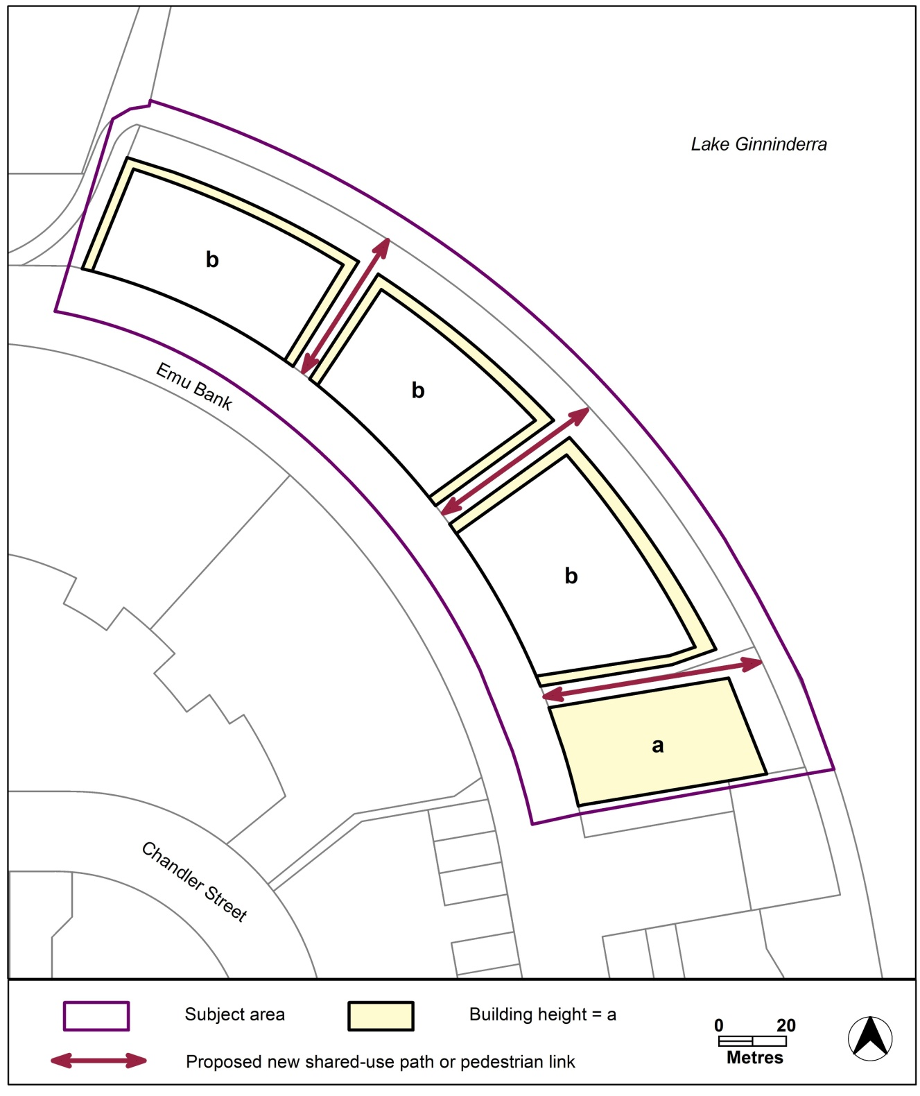
- Emu Bank development

Rules | Criteria
  - Built form
This rule applies to development of 12 storeys or more.  Buildings are built to the front boundary at the ground floor level.  The minimum front boundary setbacks above ground floor level are:  - 0m for the portion of development up to 6 storeys  - 3m for the portion of development above 6 storeys up to 12 storeys  - 6m for the portion of development above 12 storeys. | Minor departures from the building setbacks are permitted at the ground level up to 6 storeys where development:  - contributes to the pedestrian orientated environment  - reflects the existing street character; and  - accommodates active uses, building entrances and/or landscaped areas.  Departures from the building setbacks above 6 storeys are permitted where development:  - demonstrates exceptional design quality  - provides a strong relationship with the public domain; and  - avoids towers that continue to the ground.
There is no applicable rule. | This criterion applies to development of 8 storeys or more in height.  Development applications include a visual impact assessment that addresses landscape setting of the town centre and analysis of the town centre urban form to demonstrate how the development positively contributes to the future desired character. The assessment will include a site context plan that illustrates the developments relationship to primary pedestrian routes, streetscape and nearby development.
There is no applicable rule. | Large blocks supporting more than one building above 12 storeys are required to provide a clear variety in building heights, and avoid having several buildings all at or near the maximum height limit.
  - Consolidation
This rule applies to CZ2 zoned blocks in section 22, 185 and section 186.  Development of more than 2 storeys in each section is not permitted until all of the blocks in each section are consolidated into one block. | Development above 2 storeys in sections 185 and 186 demonstrates that adjoining blocks within the section are capable of developing up to the maximum building height.
This rule applies to development in area B shown in figure 5.  Development of 2 storeys or more is not permitted until all of the blocks are consolidated into one block. | This is a mandatory requirement. There is no applicable criterion.
  - Subdivision
There is no applicable rule. | Development of section 5 and/or section 11 includes subdivision of the section to retain the PRZ1 zoned land as a separate block.
  - Boundary re-alignment
This rule applies to the hatched area in figure 3.  Development incorporates a re-alignment of the Lathlain Street boundary to ensure a minimum 6m verge width to Lathlain Street. | This is a mandatory requirement. There is no applicable criterion.
  - Structured car parks
This rule applies to structured car parks or podium car parks located along active frontage areas shown in figure 1.  Structured car parks, or the podium car park component of a building, comply with all of the following:  - have a maximum height of building of six storeys  - have commercial development along the street frontage at ground level  - do not permit vehicle access along the frontage to main pedestrian areas  - provides an unimpeded, permanently open pedestrian path of travel from the front boundary to public car parking spaces within the development. | Structured car parks and podium car parks provide active frontages at street level, minimise potential pedestrian/vehicle conflicts and where public parking is provided, ensure public access is provided at all times.
  - Building design
The minimum ground floor level floor to ceiling height is:  - in CZ1 and CZ2 – 3.6m  - in CZ3 – 4m. | The ground floor level of buildings is adaptable for commercial uses.
There is no applicable rule. | Buildings achieve all of the following:  - contribution to the character and amenity of adjacent public spaces  - interesting, functional and attractive facades that contribute positively to the streetscape and pedestrian experience; and  - articulated building forms.
Residential development along primary or secondary active frontages shown in figure 1 or public open space areas includes balconies and/or windows to main living areas addressing each street frontage and public spaces. | Residential development provides opportunities for passive surveillance of public spaces and pedestrian areas.
There is no applicable rule. | Ground floor public entrances, including residential lobby and lift areas are clearly visible from external public spaces.
There is no applicable rule. | Ground floor dwellings addressing unleased territory land retain privacy and safety for the residents without obstructing opportunities for passive surveillance.  This may be achieved through:  - elevation of private open space areas above the territory land level  - providing sill heights that minimise sight lines into dwellings, and/or  - integrating constructed or vegetative screens into the external design.
  - Setbacks to Lake Ginninderra
This rule applies to development in area A shown in figure 5.  The minimum setback to each boundary is 0m. | This is a mandatory requirement. There is no applicable criterion.
  - Section 22 setback
This rule applies to section 22.  Development complies with all of the following:  - Buildings, including basement, are setback a minimum of 20m from the Rae Street front boundary.  - Development within the setback area is limited to:  - landscaping  - pedestrian paths  - awnings  - street furniture  - utilities  and remains publicly accessible at all times. | Development provides a substantial area of landscaped publicly accessible open space along the Rae Street front boundary.
  - Pedestrian access
This rule applies to development in the subject area shown in figure 4.  A pedestrian easement is provided in each of the areas identified as containing a proposed new shared-use path or pedestrian link that complies with all of the following:  - has a minimum internal unobstructed width of 6m  - provides direct pedestrian access between Emu Bank street frontage and Lake Ginninderra frontage  - remains permanently open and publicly accessible. | Development provides permanently accessible unobstructed pedestrian access between Emu Bank front boundary and the lake.
There is no applicable rule. | Development of large sites provides a fine grain and permeable movement network that supports filtering of pedestrians through the centre, and supports the main pedestrian areas.
There is no applicable rule. | Commercial and or residential units located on the ground floor have individual entries directly accessible from public space.
  - Solar access
Development retains a minimum 3 hours solar access to the main daytime living areas and private open space of dwellings on adjoining blocks between the hours of 9am and 3pm on the winter solstice (21 June). | Development retains reasonable solar access to dwellings on adjoining blocks and their associated area of principal private open space.

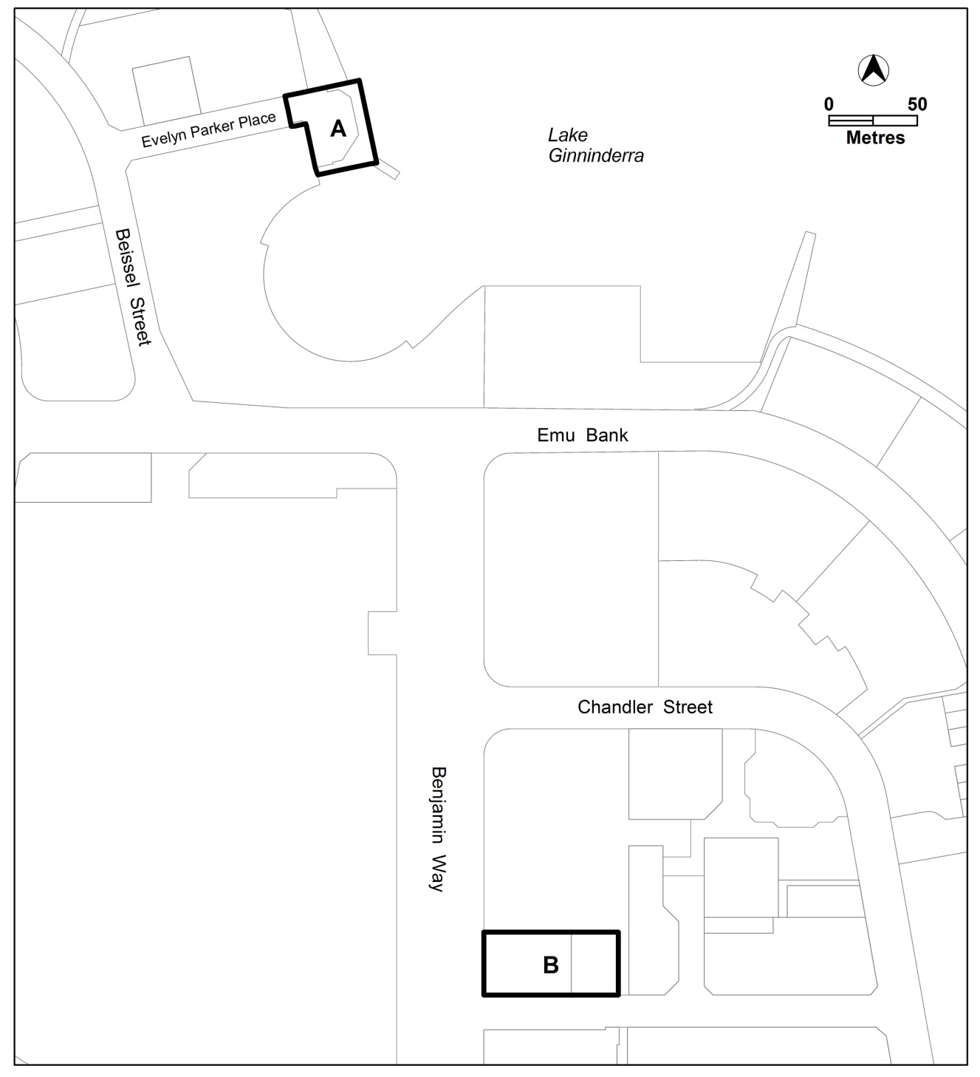

Rules | Criteria
  - Active frontages
For buildings located along primary active frontage areas identified in figure 1, frontages and building design comply with all of the following:  - buildings incorporate clear display windows and/or shop fronts at the ground floor level  - buildings incorporate direct pedestrian access at grade with the verge level for access and egress for persons with disabilities  - any small areas of walls without windows contain displays, showcases and/or public art, with a maximum of 30% blank frontage per tenancy  - blank facades, open structured car parks and/or loading docks are not located along the frontage. | This is a mandatory requirement. There is no applicable criterion.
For buildings located along secondary active frontage areas identified in figure 1, frontages and building design complies with all of the following:  - buildings incorporate clear display windows and shop fronts at the ground floor level  - buildings incorporate direct pedestrian access at grade with the verge level for access and egress for persons with disabilities. | Development at ground floor level achieves all of the following:  - is adaptable for shops  - where building access is provided, direct pedestrian access at street level, and  - provide opportunities for views into and out of the building.
There is no applicable rule. | For buildings located along secondary active frontages, building facades are not dominated by extensive lengths of blank facades, open structured carparks, loading docks, substations or other service infrastructure
There is no applicable rule. | Utility infrastructure such as electricity substations and water boosters located along primary active frontages shown in figure 1 are minimised and/or screened where possible.
There is no applicable rule. | This criterion applies to development along primary and secondary active frontages shown in figure 1.  Commercial uses with both internal public access and external public access are designed to ensure the external frontage provides the primary public access point.
  - Awnings
This rule applies to buildings fronting primary active frontage areas shown in figure 1.  Awnings are provided that comply with all of the following:  - extend the full length of the building frontage  - are a minimum height of 3m above finished pavement or ground level of the verge  - are integrated into the building design at the first floor level, and  - have a minimum 3m cantilever depth, except where:  - opposing primary active frontages are 6m apart or less, awning depth may be reduced to ensure awnings are separated by at least 0.5m, and/or  - a reduction in awning depth is required to accommodate existing infrastructure and/or street trees. | Awnings provide continuous all weather pedestrian shelter and activity in a form compatible with existing awnings.
  - New roads
This rule applies to development in section 21.  Redevelopment incorporates the proposed road shown in figure 2. | Development does not preclude the future provision of an access road connecting Walder Street to Lathlain Street.
  - Easements
There is no applicable rule. | This criterion applies to area A shown in figure 5.  Development complies with all of the following:  - A right of way easement is provided along the entire eastern and southern boundaries to facilitate pedestrian access along the lake foreshore  - Any and all encroachments over utility easements are endorsed by the relevant utility provider; and  - any and all encroachments over right of way easements:  - do not obstruct access to the right of way, and  - are endorsed by the Territory.
  - Parking rate – CZ6
There is no applicable rule. | This criterion applies to development in CZ6. Short and/or long stay parking is located on site or within 500m of the subject site.

RC3 – Residential area 2
This part applies to blocks and parcels identified in area RC3 shown on the Belconnen Precinct Map.

- Buildings
Rules | Criteria
  - Number of storeys
This rule applies to the area shown in figure 6.  The maximum height of building is:  - in area ‘a’ – the lesser of four storeys and 14 metres  - in area ‘b’ – the lesser of six storeys and 20 metres. | This is a mandatory requirement. There is no applicable criterion.

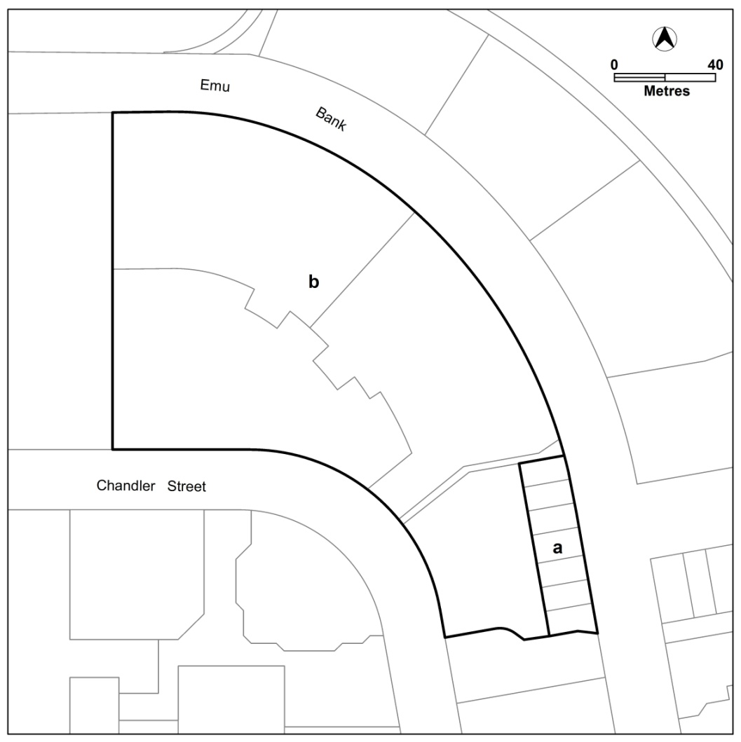
- building heights

