Australian Capital Territory

Nature Conservation (Closed Reserves—Total Fire Ban) Declaration 2019 (No 8)*

Notifiable instrument NI2019–776
made under the
Nature Conservation Act 2014, s 259 (Conservator may close reserve)

1 Name of instrument
This instrument is the Nature Conservation (Closed Reserves—Total Fire Ban) Declaration 2019 (No 8).

2 Commencement
This instrument commences on the day it is signed.
Note: Section 259 (5) of the Nature Conservation Act 2014 provides that a closed reserve declaration may commence on a day or at a time earlier than its notification date.

3 Declaration
I declare public access to the reserves specified in column 2 of schedule 1 is prohibited during the period specified in the corresponding entry in column 3 of schedule 1.
4 Expiry
This instrument expires on 6 December 2019.
Scott Farquhar
Delegate of the Conservator of Flora and Fauna

5 December 2019

Schedule 1 Closed reserves
(see s 3)

column1  item | column 2  reserve | column 3  times when public access is prohibited
1 | The area identified in schedule 2 known as Tidbinbilla Nature Reserve | 5 December 2019
2 | The area identified in schedule 3 known as Lower Molonglo River Corridor | 5 December 2019
3 | The area identified in schedule 4 known as Molonglo Gorge Nature Reserve | 5 December 2019
4 | The area identified in schedule 5 known as Mulligans Flat Woodland Sanctuary | 5 December 2019

Schedule 2 Tidbinbilla Nature Reserve
(see sch 1 item 1)

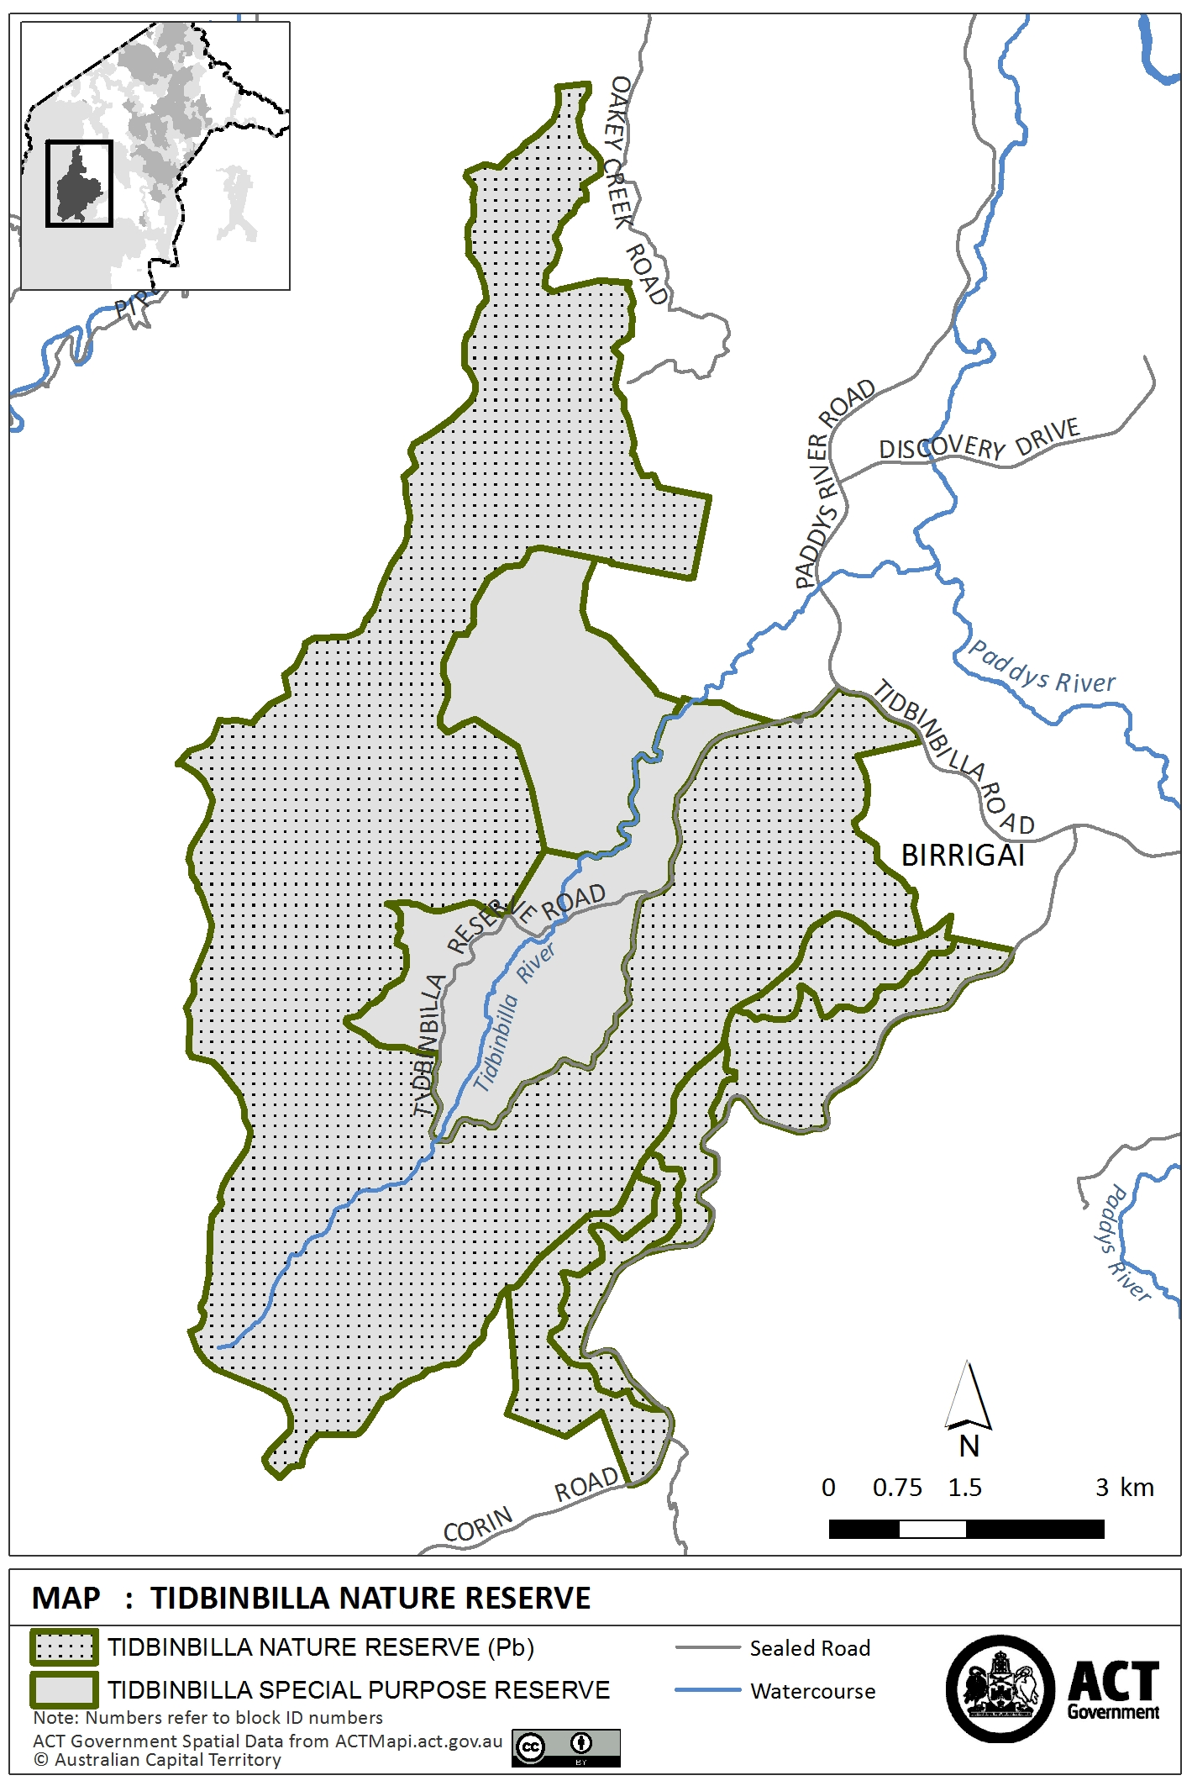

Schedule 3 Lower Molonglo River Corridor
(see sch 1 item 2)

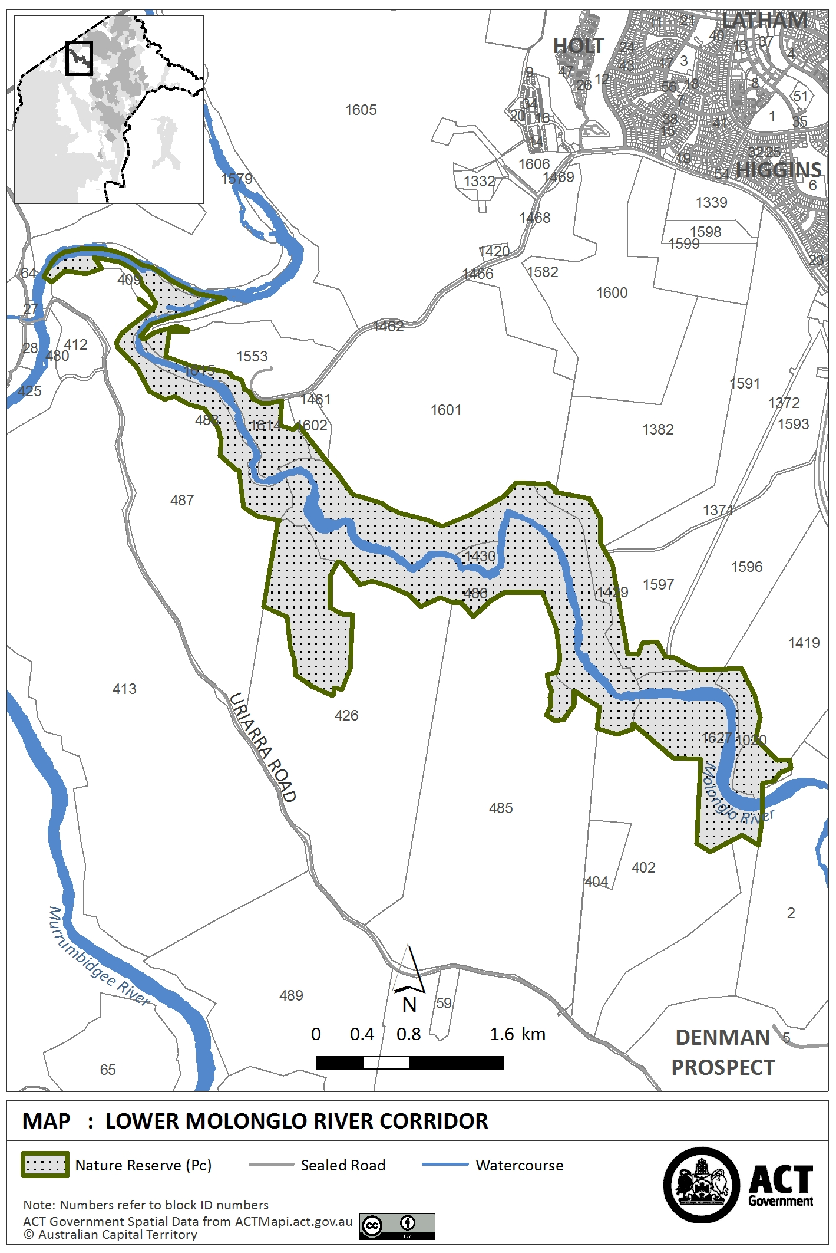

Schedule 4 Molonglo Gorge Nature Reserve
(see sch 1 item 3)

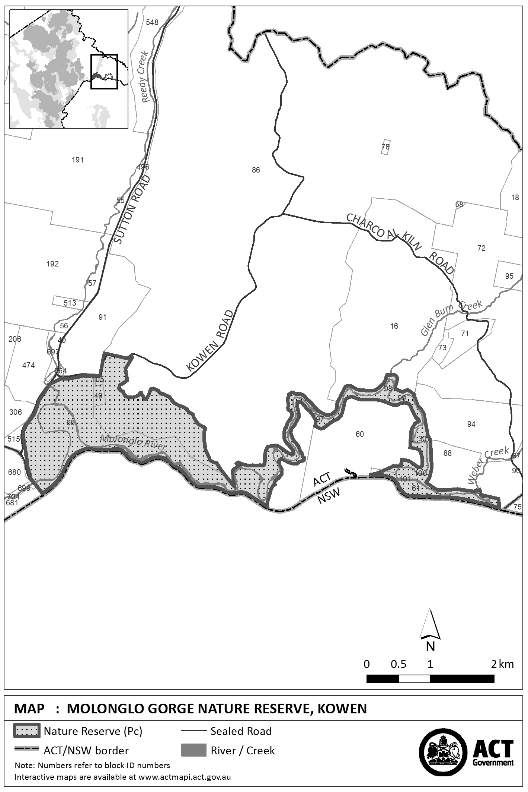

Schedule 5 Mulligans Flat Woodland Sanctuary
(see sch 1 item 4)

