Australian Capital Territory
Corrections Management (Bail) Procedure Revocation 2019
Notifiable instrument NI2019-789
made under the
Corrections Management Act 2007, s 14 (Corrections policies and operating procedures)

1 Name of instrument
This instrument is the Corrections Management (Bail) Procedure Revocation 2019.

2 Commencement
This instrument commences on the day after its notification day.
3. Revocation
This instrument revokes the Corrections Management (Bail) Procedure 2010 [NI2010-388].

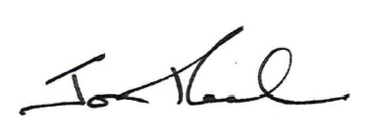

Jon Peach
Executive Director
ACT Corrective Services
9 December 2019

