Australian Capital Territory
Planning and Development (Technical Amendment—Taylor) Plan Variation 2019 (No 3)

Notifiable instrument NI2019—808
Technical Amendment No 2019-16
made under the
Planning and Development Act 2007, s 89 (Making technical amendments)

- Name of instrument
This instrument is the Planning and Development (Technical Amendment—Taylor) Plan Variation 2019 (No 3).
2 Commencement
This instrument commences on the day after its notification day.
3 Technical amendment
I am satisfied under section 89 (1) (a) of the Planning and Development Act 2007 (the Act) that the Taylor plan variation is a technical amendment to the Territory Plan.
4 Meaning of Taylor plan variation
In this instrument:
Taylor plan variation means the technical amendment to the Territory Plan, variation 2019-16, in the schedule.
Note No consultation was required in relation to the Taylor plan variation under section 87 of the Act.
Carolyn O’Neill
Delegate of the planning and land authority
12 December 2019

Planning & Development Act 2007

Technical Amendment
to the Territory Plan
Variation 2019-16

Correction to the Taylor Precinct Map and Code for Block 15 Section 66 Taylor

December 2019

This page is left intentionally blank

Table of Contents

1. INTRODUCTION 3
1.1 Purpose 3
1.2 Public consultation 3
1.3 National Capital Authority 3
1.4 Process 3
1.5 Types of technical amendments under the Act 3
2. EXPLANATION 5
2.1 Background 5
2.2 Variation to the Taylor Precinct Map and Code 5
3. TECHNICAL AMENDMENT 7
3.1 Taylor Precinct Map and Code 7

This page is left intentionally blank

- INTRODUCTION
  - Purpose
This technical amendment corrects an error in the Taylor Precinct Map and Code in the Territory Plan relating to the location of the nominated side setback boundary 2 for Block 15 Section 66 as shown in Figure 8 of the ongoing provisions.
Further details can be found in Part 2 of this document.
  - Public consultation
Under section 87 of the Planning and Development Act 2007 (the Act) this type of technical amendment is not subject to public consultation.
  - National Capital Authority
The National Capital Authority does not need to be advised of this technical amendment as per 1.2.
  - Process
This technical amendment has been prepared in accordance with section 87 and made in accordance with section 89 of the Planning and Development Act 2007 (the Act).
  - Types of technical amendments under the Act
The following categories of technical amendments are provided under section 87 of the Act:
- Each of the following territory plan variations is a technical amendment for which no consultation is needed before it is made under section 89:
(a) a variation (an error variation) that –
- would not adversely affect anyone’s rights if approved; and
- has as its only object the correction of a formal error in the plan;
(b) a variation to change the boundary of a zone or overlay under section 90A (Rezoning – boundary changes);
(c) a variation, other than one to which subsection (2) (d) applies, in relation to an estate development plan under section 96 (Effect of approval of estate development plan);
(d) a variation required to bring the territory plan into line with the national capital plan;
(e) a variation to omit something that is obsolete or redundant in the territory plan.
- Each of the following territory plan variations is a technical amendment for which only limited public consultation is needed under section 90:
- a variation (a code variation) that –
- would only change a code; and
- is consistent with the policy purpose and policy framework of the code; and
- is not an error variation;
- a variation to change the boundary of a zone under section 90B (Rezoning – development encroaching on adjoining territory land);
- a variation in relation to a future urban area under section 90C (Technical amendments – future urban areas);
- a variation in relation to an estate development plan under section 96 (Effect of approval of estate development plan) if it incorporates an ongoing provision that was not included in the plan under section 94 (3) (g);
- a variation to clarify the language in the territory plan if it does not change the substance of the plan;
- a variation to relocate a provision within the territory plan if the substance of the provision is not changed.
TA2019-16 has been prepared in accordance with section 87 (1) (a).

- EXPLANATION
  - Background
This part of the technical amendment document explains the changes to be made to the Territory Plan, the reasons for the change, and a statement of compliance against the relevant section of the Act.
  - Variation to the Taylor Precinct Map and Code
The Estate Development Plan (EDP) for Taylor 2 was approved in June 2019. The site specific provisions in the EDP were transferred into the Taylor Precinct Map and Code in the Territory Plan via technical amendment TA2019-05. It has since been identified that the nominated zero side setback boundary 2 for Block 15 Section 66 Taylor was incorrectly located on the southern boundary of the block, which conflicts with a 2.5m wide sewer easement also located on the southern boundary. This precludes development within the easement and voids the build-to-boundary allowances for that side of the block. As the sewer easement was not shown on the final plan, the nominated zero side setback for boundary 2 was incorrectly placed on the southern boundary. This technical amendment corrects this error and moves the nominated side setback boundary 2 to the northern boundary to facilitate optimal development of the block.

Compliance with the Planning and Development Act 2007
Section | Statement
s87(1)(a)  (a) a variation (an error variation) that—  (i) would not adversely affect anyone’s rights if approved;  and  (ii) has as its only object the correction of a formal error in the plan; | Compliant. This amendment corrects a formal error in the plan when Technical Amendment TA2019-05 took effect.

Existing Figure 9 Taylor residential area ongoing provisions
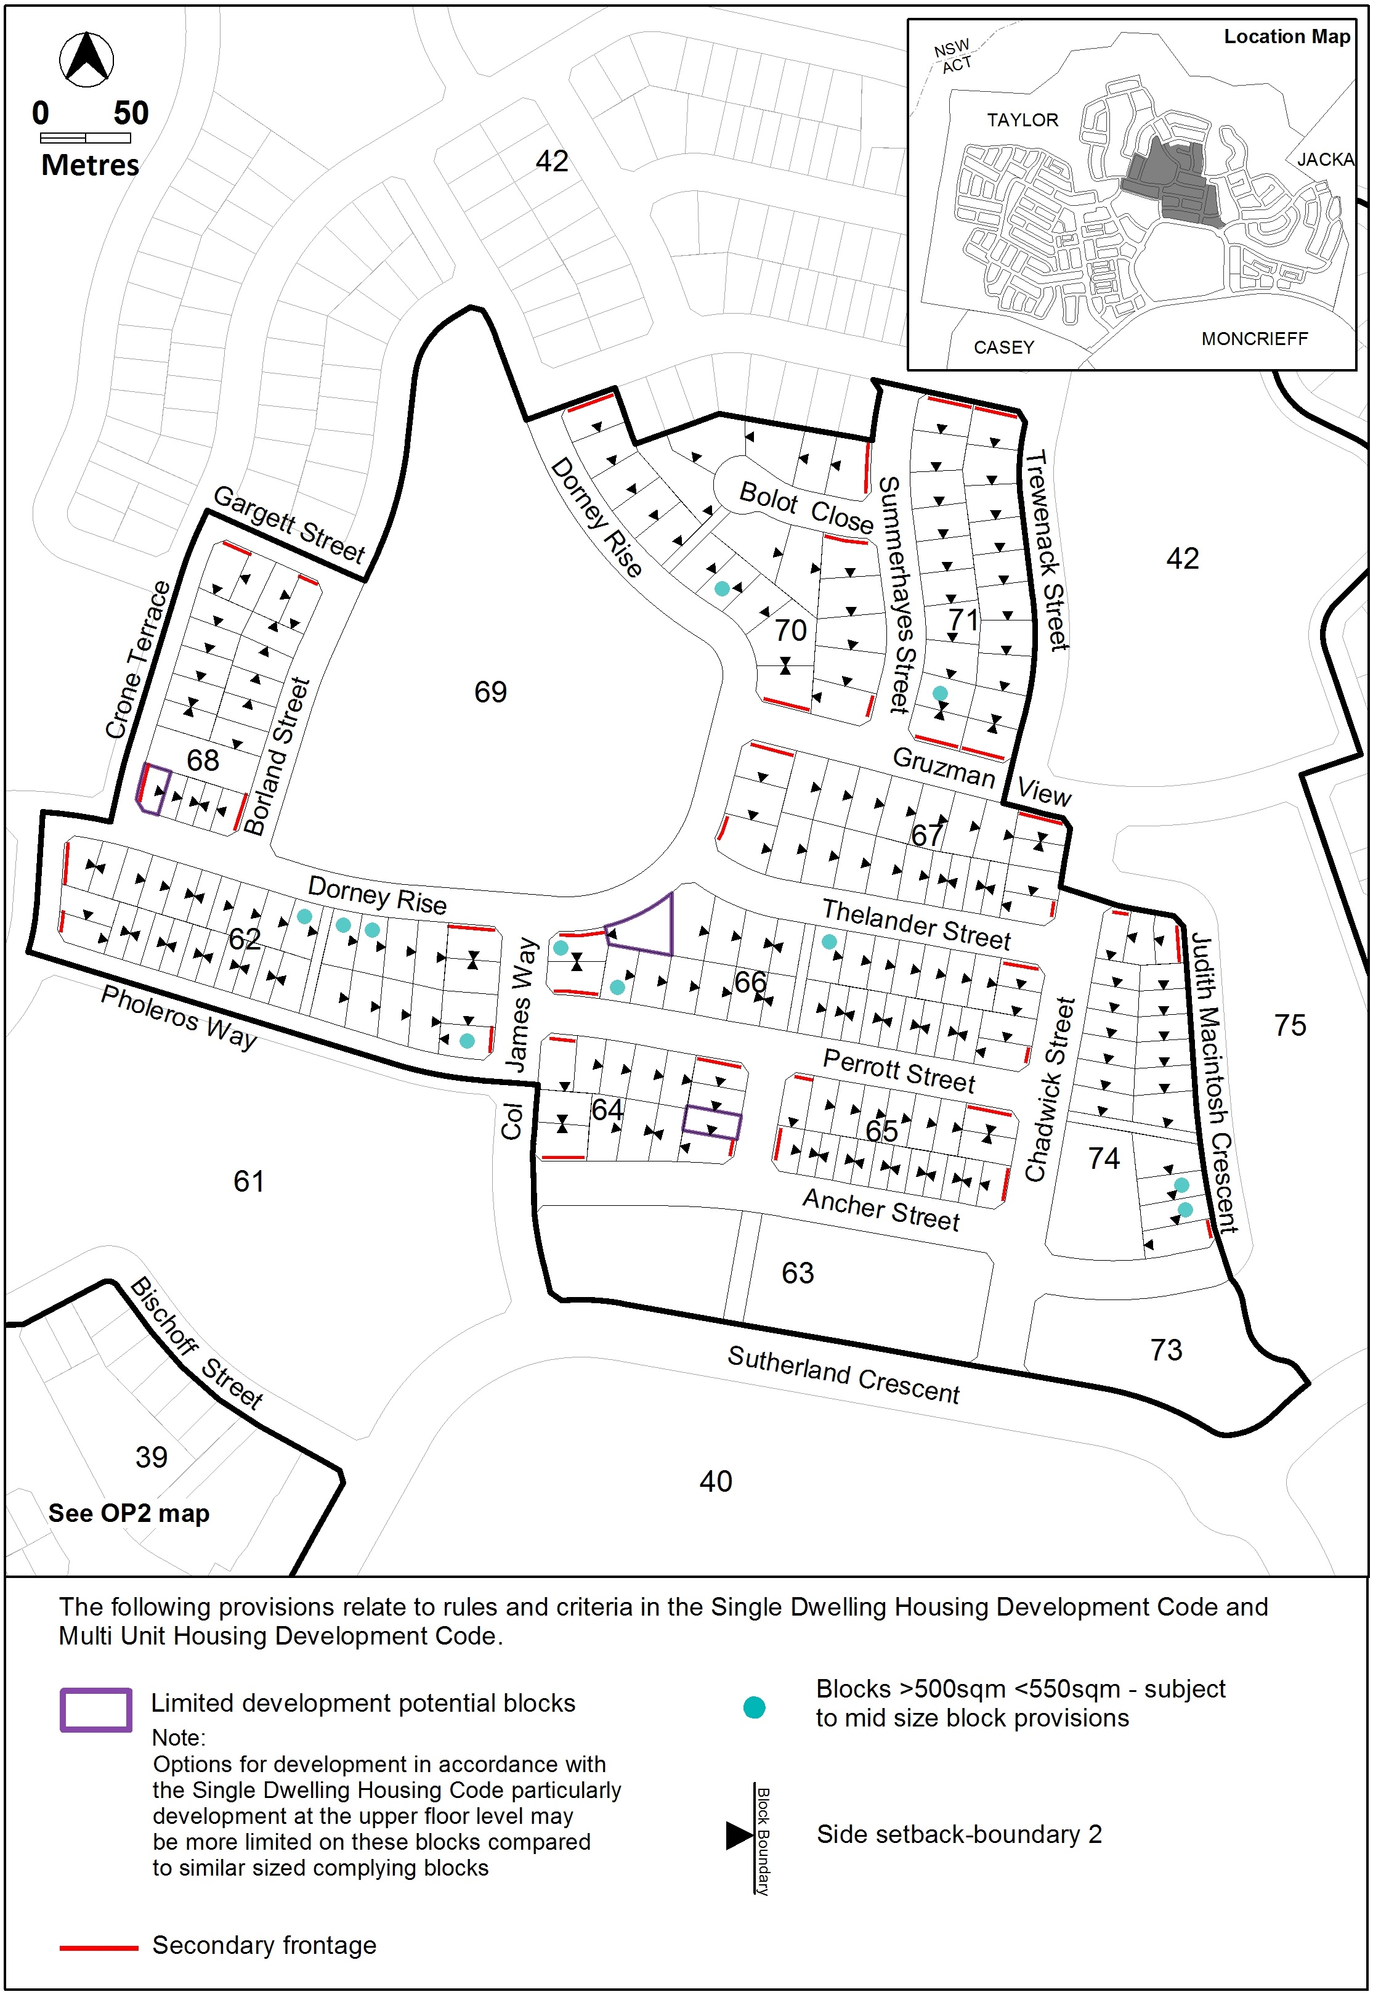

Proposed Figure 9 Taylor residential area ongoing provisions
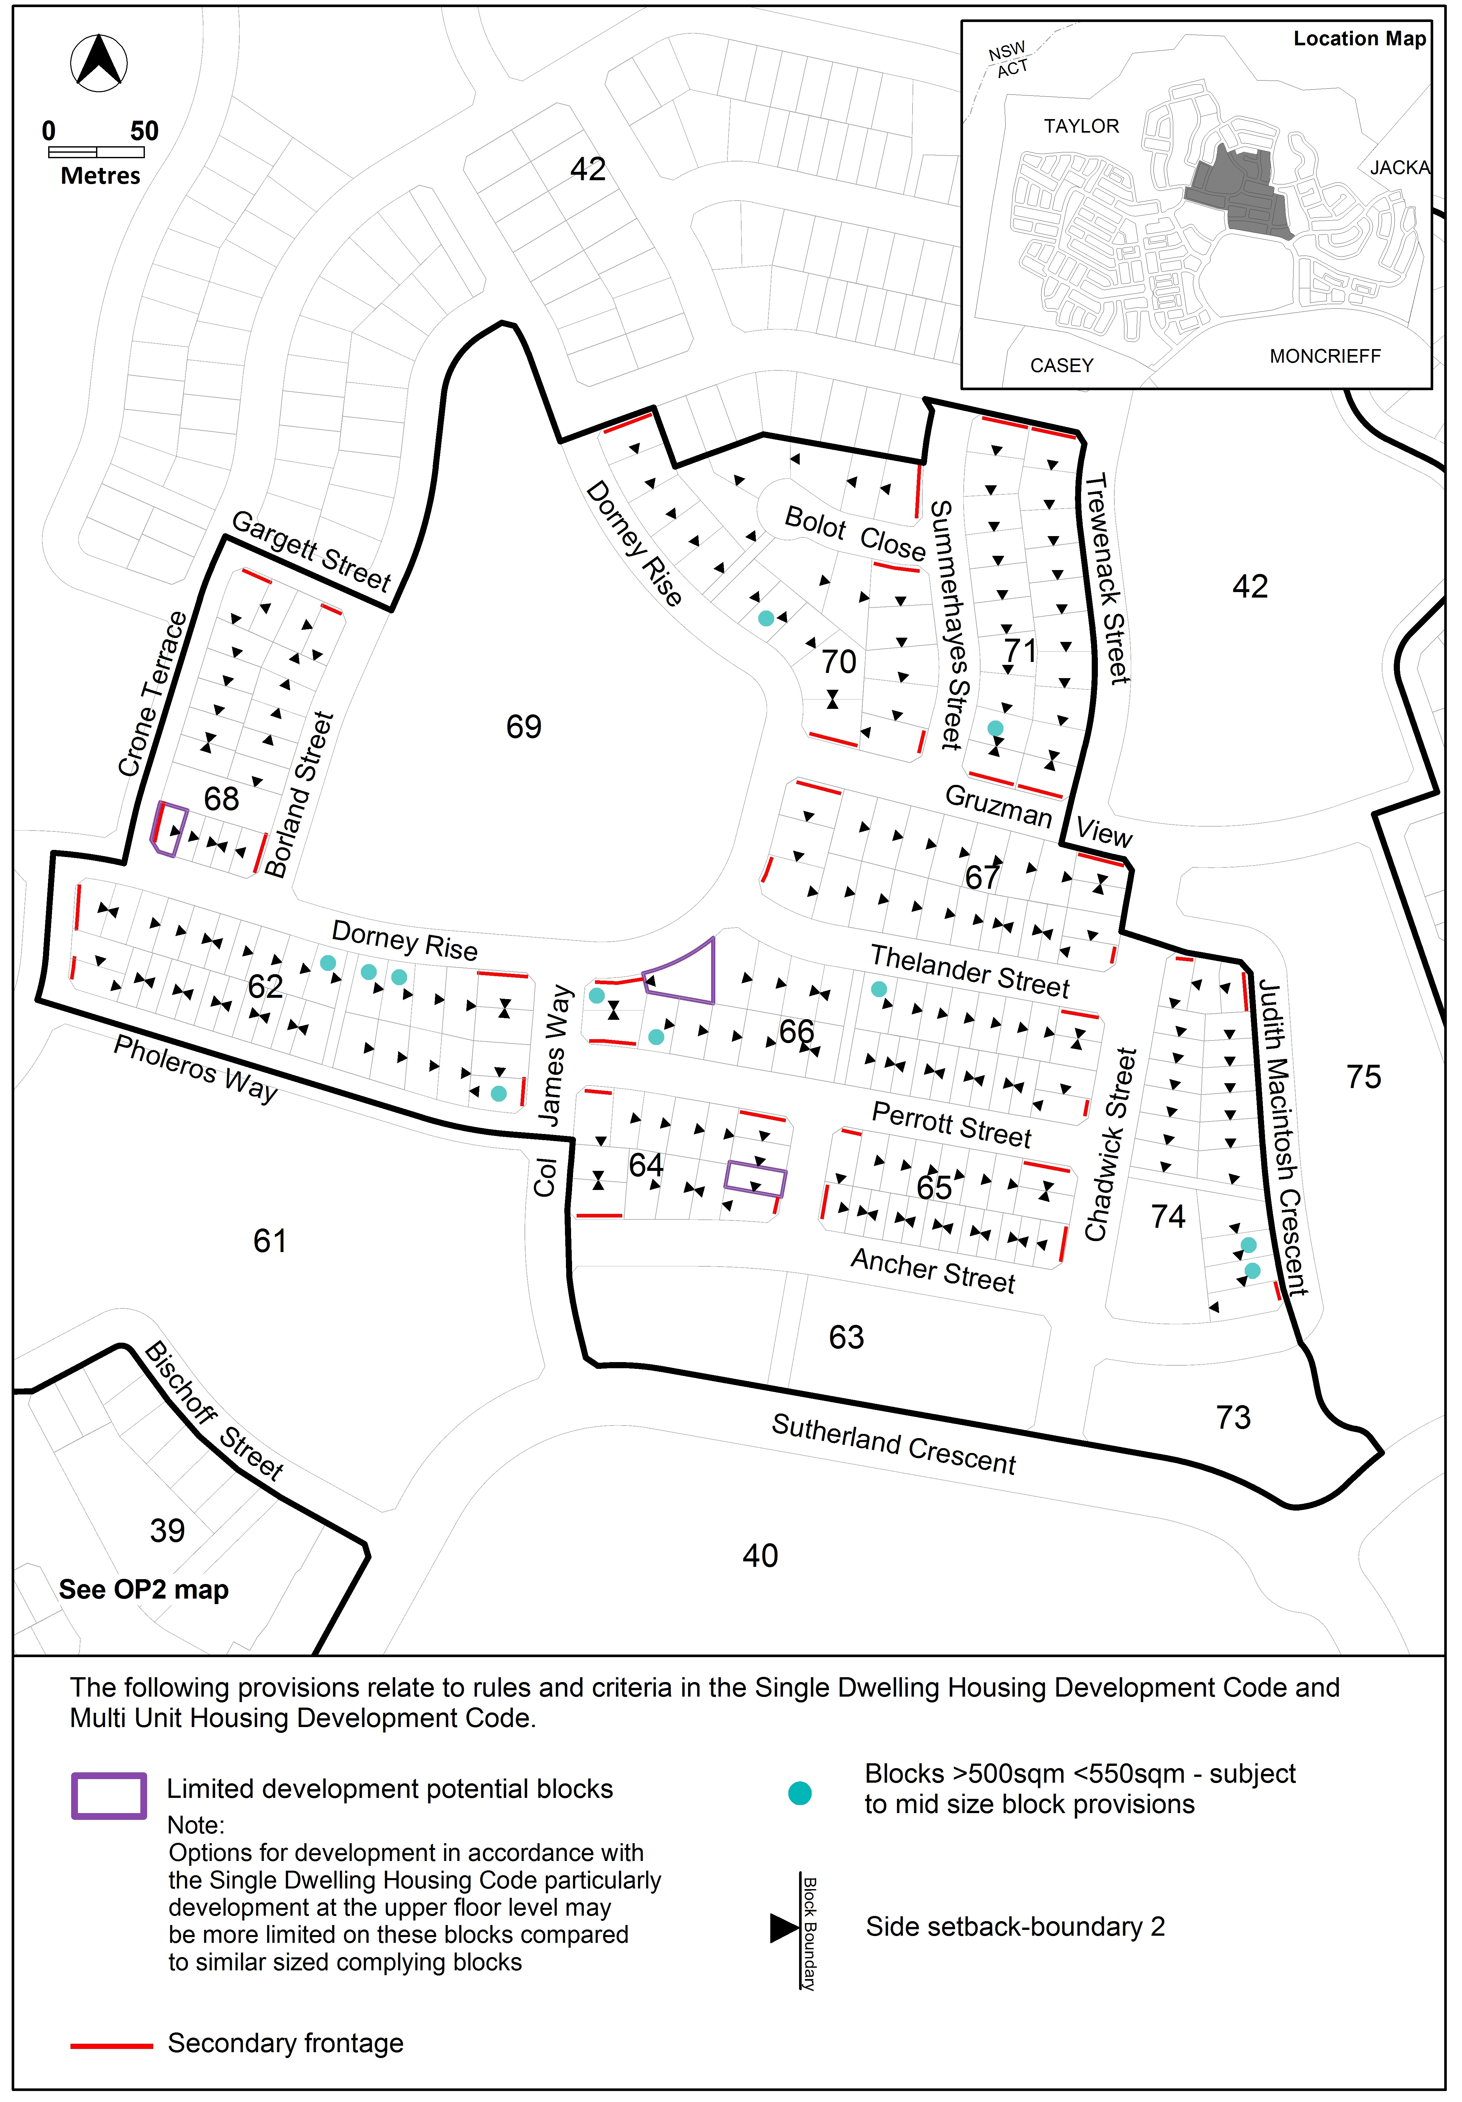

- TECHNICAL AMENDMENT
This section of the technical amendment document provides the actual instructions for implementing the changes to the Territory Plan.
  - Taylor Precinct Map and Code

- Other ongoing provisions; OP4 – Taylor Residential Area; Figure 9 Taylor residential area ongoing provisions

Substitute

Interpretation service
