Australian Capital Territory
Liquor (Temporary Alcohol-Free Place) Declaration 2019 (No 2)
Notifiable instrument NI2019-823
made under the
Liquor Act 2010, s 198 (alcohol-free places)

1 Name of instrument
This instrument is the Liquor (Temporary Alcohol-Free Place) Declaration 2019 (No 2).
2 Commencement
This instrument commences at 10am on 2 January 2020.
3 Declaration
I declare the following locations as temporary alcohol-free areas from 10am 2 January 2020 to midday 6 January 2020:
  - The Federal Highway within the Australian Capital Territory;
  - Northbourne Avenue, north of the southernmost point of its intersection with Macarthur Avenue and Wakefield Avenue;
  - The hatched area shown on the attached map in Attachment 1 that is within the heavy black line on the map and is a public place.
  - Any unleased land adjoining a public place mentioned in paragraphs a) to c).
But excluding:
  - The areas designated for Summernats 33, highlighted by the bold red line on the map at Attachment 2.
  - licensed premises or permitted premises; or
  - premises where food is sold for consumption at the premises; or
  - at a place that is within 50m from premises mentioned in paragraph (f) or (g) by a person using furniture or other facilities provided by the proprietor or lessee of the premises.
4 Expiry
This instrument expires at midday on 6 January 2020.

David Snowdon
Commissioner for Fair Trading
16 December 2019
Attachment 1
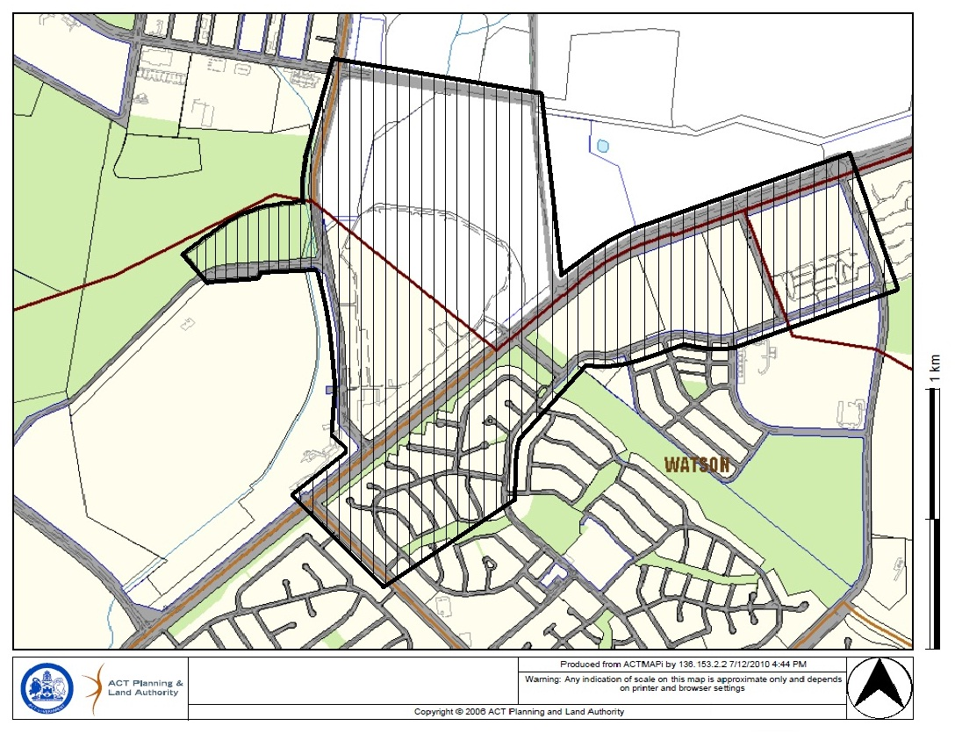

Attachment 2
