Australian Capital Territory
Gaming Machine (Peripheral Equipment) Approval 2019 (No 8)
Notifiable instrument NI2019-851
made under the
Gaming Machine Act 2004, section 69 (Approval of gaming machines and peripheral equipment)

1 Name of instrument
This instrument is the Gaming Machine (Peripheral Equipment) Approval 2019 (No 8)

2 Commencement
This instrument commences the day after the date of notification.

- Approval
I approve the peripheral equipment described in the attached Schedule to this instrument.

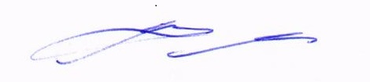
Matt Miles
Delegate
ACT Gambling and Racing Commission

28 November 2019

For further information please contact the approved supplier.

IGT (Australia) Pty Ltd
Subject: In-venue Gaming System Software Update
System Details | IGT Systems Club
Specification Numbers | 18.CAPT0  18.SET02  18.SET04
Application Reference Number | 18-A1340/S01
Specific Approval Condition
This approval does not permit the operation of cashless gaming technologies, nor cashless gaming, with the exception of TITO, in the ACT.

IGT (Australia) Pty Ltd
Subject: In-venue Gaming System Supporting Component Software Update
System Details | Universal Game Adaptor (UGA)
Version | UGAF0013
Application Reference Number | 18-A1339/S01
Specific Approval Condition
The above-mentioned device is approved to operate with the following in-venue gaming system:
System Name | IGT Systems Club
Specification Numbers | 18.CAPT0  18.SET02  18.SET04

