Australian Capital Territory
Corrections Management (Intelligence Framework) Policy Revocation 2020
Notifiable instrument NI2020-229
made under the
Corrections Management Act 2007, s 14 (Corrections policies and operating procedures)

1 Name of instrument
This instrument is the Corrections Management (Intelligence Framework) Policy Revocation 2020.

2 Commencement
This instrument commences on the day after its notification day.
3. Revocation
This instrument revokes the Corrections Management (Intelligence Framework) Policy 2018 [NI2018-401].

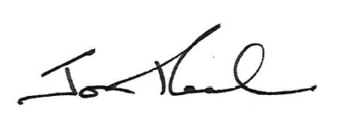

Jon Peach
Commissioner
ACT Corrective Services
17 April 2020

