Australian Capital Territory
Planning and Development (Plan Variation No 366) Approval 2020

Notifiable instrument NI2020-290
made under the
Planning and Development Act 2007, s 76 (Minister’s powers in relation to draft plan variations)

1 Name of instrument
This instrument is the Planning and Development (Plan Variation No 366) Approval 2020.
2 Approval of draft plan variation
(1) I approve under section 76 (2) (a) of the Planning and Development Act 2007 the draft plan variation No 366 to the Territory Plan.
(2) In this section:
Draft plan variation No 366 to the Territory Plan means the draft plan variation in the schedule.

Mick Gentleman MLA
Minister for Planning and Land Management
18 May 2020

Planning and Development Act 2007

Variation to the
Territory Plan
366

Franklin Grasslands
Environmental Offset Site

Final variation prepared under s76 of the
Planning and Development Act 2007

Contents

1. EXPLANATORY STATEMENT 1
1.1 Background 1
1.2 Summary of the Proposal 1
1.3 The National Capital Plan 3
1.4 Current Territory Plan Provisions 4
1.5 Changes to the Territory Plan 5
1.6 Consultation on the Draft Variation 5
2. VARIATION 6
2.1 Variation to the Territory Plan 6

- EXPLANATORY STATEMENT
  - Background
Variation to the Territory Plan 366 incorporates a new area into Canberra’s nature reserve system as an environmental offset site. The new site is Block 5 Section 47 Franklin, known as the ‘Franklin Grasslands’.
An ACT Government capital works project involving the construction of a 130 metre access road into the proposed Canberra Brickworks Precinct and the upgrading (widening and minor realignment) of Dudley Street in Yarralumla has been determined to have residual impacts on matters of national environmental significance (MNES) protected under the Commonwealth’s Environment Protection and Biodiversity Conservation Act 1999 (the EPBC Act). This relates specifically to the golden sun moth (a critically endangered species) and natural temperate grasslands of the South Eastern Highlands (a critically endangered ecological community).
To meet the conditions of approval of the EPBC decision (EPBC 2017/8072) for the proposed road works, the Franklin Grasslands site was identified as a suitable environmental offset site for the impacts to the MNES.
The Environment Planning and Sustainable Development Directorate (the Directorate) will be responsible for the preparation and implementation of an Offset Management Plan in accordance with the Commonwealth’s conditions of approval.
Management of the site as a nature reserve for habitat improvement and long term resilience of MNES will need to include weed and pest control, review of grazing regimes, and management of biomass. Investment in site infrastructure (fencing, access tracks etc) and remediation and reseeding of the spoil site on the south edge of the offset area will also be required.

  - Summary of the Proposal
This variation adds a nature reserve public land reserve overlay on the Territory Plan Map to Block 5 Section 47 Franklin known as the ‘Franklin Grasslands’ site (the site).
The site is required to offset impacts on matters of national environmental significance (MNES) protected under the Commonwealth’s Environment Protection and Biodiversity Conservation Act 1999 (the EPBC Act). The impact is due to the construction of an access road into the proposed Canberra Brickworks Precinct and the upgrading of Dudley Street in Yarralumla. The project has been determined to have residual impacts on golden sun moth (a critically endangered species) and natural temperate grasslands of the South Eastern Highlands (a critically endangered ecological community).
Known environmental values of the site include natural temperate grassland, golden sun moth, Ginninderra peppercress, Yellow Box – Red Gum Grassy Woodland, foraging habitat for the superb parrot, striped legless lizard habitat, and the perunga grasshopper.
The EPBC decision requires the offset site to be legally protected and to remain an environmental conservation offset in perpetuity. This is achieved by classifying the site as a nature reserve and identifying on the Territory Plan Map as ‘Pc – a nature reserve’ Public Land Reserve overlay. There is no change to the current non-urban NUZ3 Hills Ridges and Buffer zone.
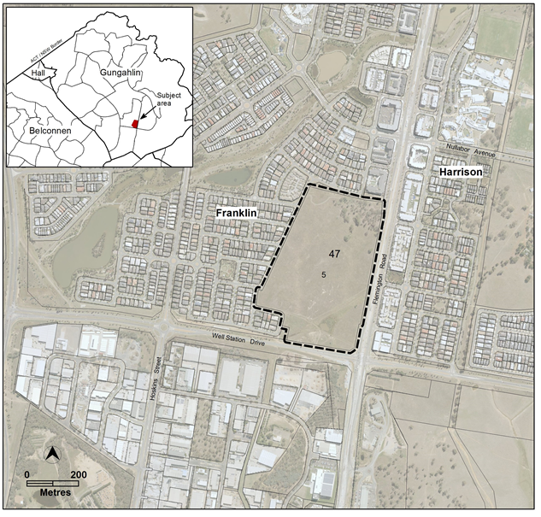
Figure 1 Location plan

  - The National Capital Plan
The Australian Capital Territory (Planning and Land Management) Act 1988 established the National Capital Authority (NCA) with two of its functions being to prepare and administer a National Capital Plan (NCP) and to keep the NCP under constant review and to propose amendments to it when necessary.
The NCP, which was published in the Commonwealth Gazette on 21 January 1990 is required to ensure that Canberra and the Territory are planned and developed in accordance with their national significance. The Planning and Land Management Act 1988 also required that the Territory Plan is not inconsistent with the NCP.
In accordance with section 10 of the Australian Capital Territory (Planning and Land Management) Act 1988, the NCP defines the planning principles and policies for Canberra and the Territory, for giving effect to the object of the NCP and sets out the general policies to be implemented throughout the Territory, including the range and nature of permitted land uses.
It also sets out the detailed conditions of planning, design and development for areas that have special significance to the National Capital known as designated areas and identifies special requirements for the development of some other areas.

  - Current Territory Plan Provisions
The Territory Plan map for the area subject to this variation is shown in Figure 2.
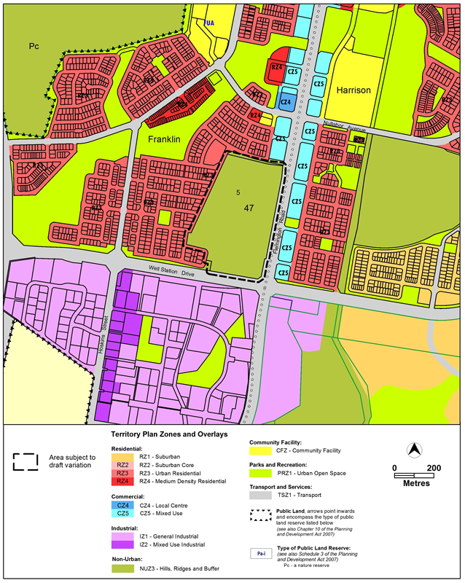
Figure 2 Current Territory Plan map

  - Changes to the Territory Plan
Detailed changes to the Territory Plan are noted in section 2 of this document.

  - Consultation on the Draft Variation
DV366 was released for public comment between 8 November 2019 and 20 December 2019. A consultation notice under section 63 of the Planning and Development Act 2007 (P&D Act) was published on the ACT Legislation Register on 8 November 2019.
One written submission was received on the draft variation. The main comments were:
- the draft variation is supported
- the grasslands provide an excellent opportunity to create a conservation and recreation reserve in which the public can participate
- a draft ‘concept plan’ for the grasslands was prepared by the submitter
The above comments in support of the draft variation were noted and are detailed in a report on consultation which is available at www.act.gov.au/recommendedvariations. No changes were made as a result of consultation. The Minister responsible for planning considered the outcomes of consultation prior to approval of this variation.

- VARIATION
  - Variation to the Territory Plan
The Territory Plan map is varied in all of the following ways:

Variation to the Territory Plan map
Substitute
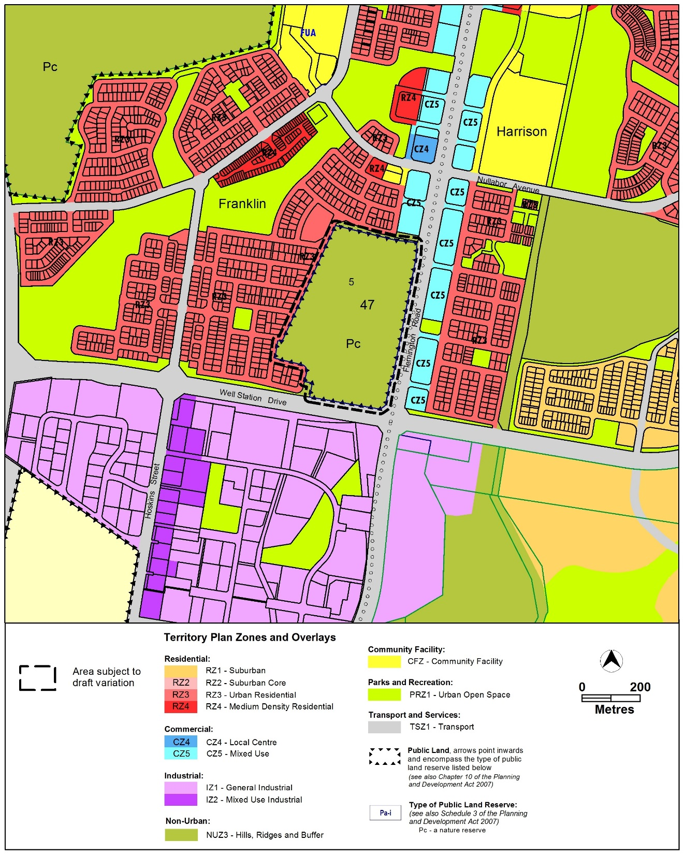
Interpretation service
