Australian Capital Territory

Nature Conservation (White-throated Needletail) Conservation Advice 2020

Notifiable instrument NI2020–302
made under the
Nature Conservation Act 2014, s 90C (Conservation advice)

1 Name of instrument
This instrument is the Nature Conservation (White-throated Needletail) Conservation Advice 2020.

2 Commencement
This instrument commences on the day after its notification day.

3 Conservation advice for the White-throated Needletail
Schedule 1 sets out the conservation advice for the White-throated Needletail (Hirundapus caudacutus).

Arthur Georges
Chair, Scientific Committee
22 May 2020
Schedule 1
(see s 3)

Conservation Advice
White-throated Needletail
Hirundapus caudacutus

Conservation Status
The White-throated Needletail Hirundapus caudacutus Latham, 1801 is recognised as threatened in the following jurisdictions:
National Vulnerable, Environment Protection and Biodiversity Conservation Act 1999
ACT Vulnerable, Nature Conservation Act 2014
VIC Threatened, Flora and Fauna Guarantee Act 1988
Vulnerable, Advisory List of Threatened Vertebrate Fauna 2013

ELIGIBILITY
The White-throated Needletail is listed as Vulnerable in the ACT Threatened Native Species List under IUCN Criterion A — A2(b). The factors that make it eligible include: estimated total numbers have undergone a substantial reduction nationally (>30–50% over 3 generations – 25.5 years). The reduction is ongoing and the causes are not understood. (Threatened Species Scientific Committee (TSSC) 2019).

DESCRIPTION AND ECOLOGY
The White-throated Needletail is a large swift (20cm in length and 115-120g in weight (TSSC 2019)) with long curved wings and a short, square-shaped tail (when folded) with protruding needle-like feather shafts. The plumage is predominantly grey-brown, glossed with green, and contrasting white on the throat and undertail (Birdlife Australia 2019). While juveniles have a similar appearance they are duller than adults (Higgins 1999).
The White-throated Needletail is an aerial species and feeds on flying insects. Birds are commonly seen moving with wind fronts and usually feed in rising thermal currents coupled with storm fronts and bushfires, they also drink in flight (Birdlife Australia 2019).
White-throated Needletail – aerial feeding (David Cook – Canberra Birds)
The White-throated Needletail breeds in north-east Asia in late May to early June, arrive in north-eastern Australia in October and a month or two later in the south-east. Generation length is estimated at 8.5 years (Birdlife International 2018).

Distribution and Habitat
The White-throated Needletail migrates to eastern Australia in late spring and flies back to the Northern Hemisphere in early autumn where breeding occurs. It is recorded in all coastal areas of Queensland and NSW and into the inland western slopes of the Great Dividing Range. Its range also extends to Victoria, Tasmania and SE South Australia (TCSS 2019). The sub-species H. c. caudacutus, which migrates to Australia, breeds in north-east Asia (Birdlife Australia 2019).
Aerial sightings of the White-throated Needletail have been recorded across the ACT (Canberra Nature Map (CNM) 2019; Figure 1 - COG 2018).
For the 2016–17 period there were 216 birds sighted in groups of around 13 between January and April (COG 2018). This was down by almost 86% on the 30-year average and a continuation of the long-term overall decline in numbers (Fig.1 and Canberrabirds.org 2019). In the 2017–18 period there were 310 birds sighted including a large group of about 50 birds (COG 2019).
While the preferred roosting habitat of the White-throated Needletail is in tree canopies amongst dense foliage or in hollows there are no identified roosting sites and no records of the species being observed perching or resting anywhere on the ground or in vegetation in the ACT (ACT Government 2018).

Threats

Of the main threats to the White-throated Needletail identified in the Commonwealth Conservation Advice (TSSC 2019) there is little evidence or likelihood of any occurring in the ACT including:
- collision with wind turbines, overhead wires, windows and lighthouses
- insecticide use, especially organochlorides reducing prey or secondary poisoning
- habitat loss and fragmentation – loss of roosting sites in Australia and possible reduction in prey
- logging and hunting in the Northern Hemisphere breeding areas.

Major Conservation Objectives
The ACT is not regarded as a key site or breeding site for the White-throated Needletail as groups of the species are only infrequent aerial visitors.

Conservation Issues
Specific management actions for the White-throated Needletail are not required as the species occurs infrequently in the ACT and rarely lands on the ground. The species is included in the ACT Migratory Species Action Plan.

Other Relevant Advice, plans or Prescriptions
- ACT Migratory Species Action Plan (ACT Government 2018)
- Commonwealth Conservation Advice — White-throated Needletail (TSSC 2019)

Figure 1: Distribution of White-throated Needletail records in the ACT region – 1982–2017
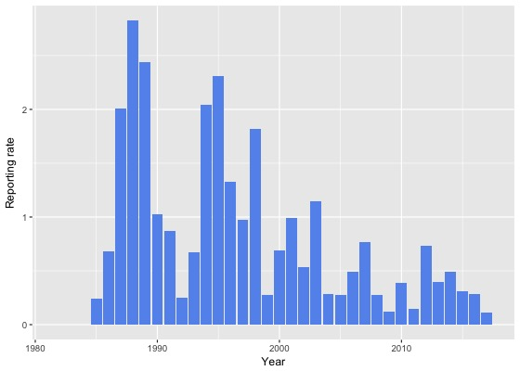
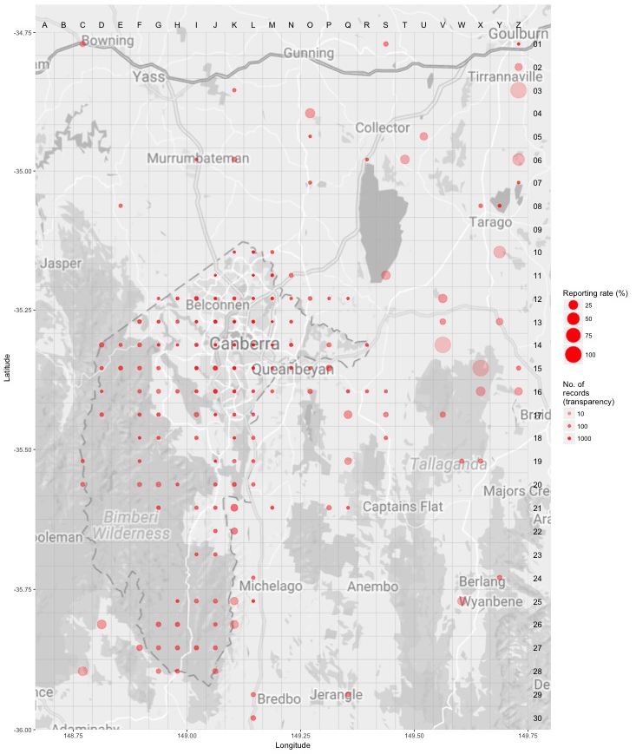Source: Canberrabirds.org.au. (2019). Note: Reporting rate (%) is the proportion of all surveys in which the species was present. These data were collected by volunteer birdwatchers using various survey methods and, on some occasions, more than one person may have recorded bird sightings on the same day, which may skew the data.

Listing Background
The White-throated Needletail was listed as a Vulnerable species under the Environment Protection and Biodiversity Conservation Act 1999 (EPBC Act) on 4 July 2019. It was assessed as Vulnerable under Criterion 1 (A2b) of the EPBC Act. In 2019, under the Nature Conservation Act 2014, the ACT Scientific Committee recommended the White-throated Needletail be listed in the Vulnerable category in the ACT Threatened Native Species List to align with the EPBC Act listing.

References
ACT Government 2018. Action Plan for Listed Migratory Species. Environment, Planning and Sustainable Development Directorate, ACT Government, Canberra.
BirdLife Australia 2019. White-throated Needletail Profile. Birdlife.org.au. Accessed 19 June 2019 from: http://www.birdlife.org.au/bird-profile/white-throated-needletail
BirdLife International 2016. Hirundapus caudacutus. The IUCN Red List of Threatened Species 2016. Accessed 18 June 2020 from: http://dx.doi.org/10.2305/IUCN.UK.2016-3.RLTS.T22686677A93121487.en
BirdLife International 2018. Species factsheet: Hirundapus caudacutus. Accessed 19 June 2019 from: http://datazone.birdlife.org/species/factsheet/white-throated-needletail-hirundapus-caudacutus
Canberrabirds.org.au 2019. White-throated Needletail Hirundapus caudacutus data sheet. Accessed 18 June 2019 from: http://canberrabirds.org.au/wp-content/bird_data/334_White-throated%20Needletail.html
Canberra.naturemapr.org (CNM) 2019. Canberra Nature Map. Accessed 19 June 2019 from: https://canberra.naturemapr.org/Community/Species/Sightings/15231
COG 2018. Annual Bird Report: 1 July 2016 to 30 June 2017. Canberra Bird Notes 43(1): 1–110.
COG 2019. Annual Bird Report: 1 July 2017 to 30 June 2018. Canberra Bird Notes 44(1): 1–108.
Higgins PJ (ed) 1999. Handbook of Australian, New Zealand and Antarctic Birds. Volume Four - Parrots to Dollarbird. Oxford University Press, Melbourne.
Threatened Species Scientific Committee (TSSC) 2019. Conservation Advice Hirundapus caudacutus White-throated Needletail. Department of the Environment and Energy, Commonwealth of Australia, Canberra.

Further Information
Further information on this or other threatened species and ecological communities can be obtained from the Environment, Planning and Sustainable Development Directorate (EPSDD).
Phone: (02) 132281, EPSDD Website: http://www.environment.act.gov.au/cpr

