Australian Capital Territory

**Discrimination (BAE Systems Australia Ltd,** **BAE Systems Australia Defence Pty Ltd, and ASC Shipbuilding Pty Limited) Exemption 2020 (No 1)**

**Notifiable instrument NI2020–385**

made under the

***Discrimination Act 1991*, section 109 (Grant of exemptions)**

**1 Name of instrument**

This instrument is the *Discrimination (BAE Systems Australia Ltd,* *BAE Systems Australia Defence Pty Ltd, and ASC Shipbuilding Pty Limited) Exemption 2020 (No 1*).

**2 Exemption decision—Discrimination Act, s 109**

The conditions of the exemption are set out in the attached decision of the Human Rights Commission under the *Discrimination Act 1991*, section 109 (Grant of exemptions).

**3 Commencement**

This instrument commences on 15 July 2020.

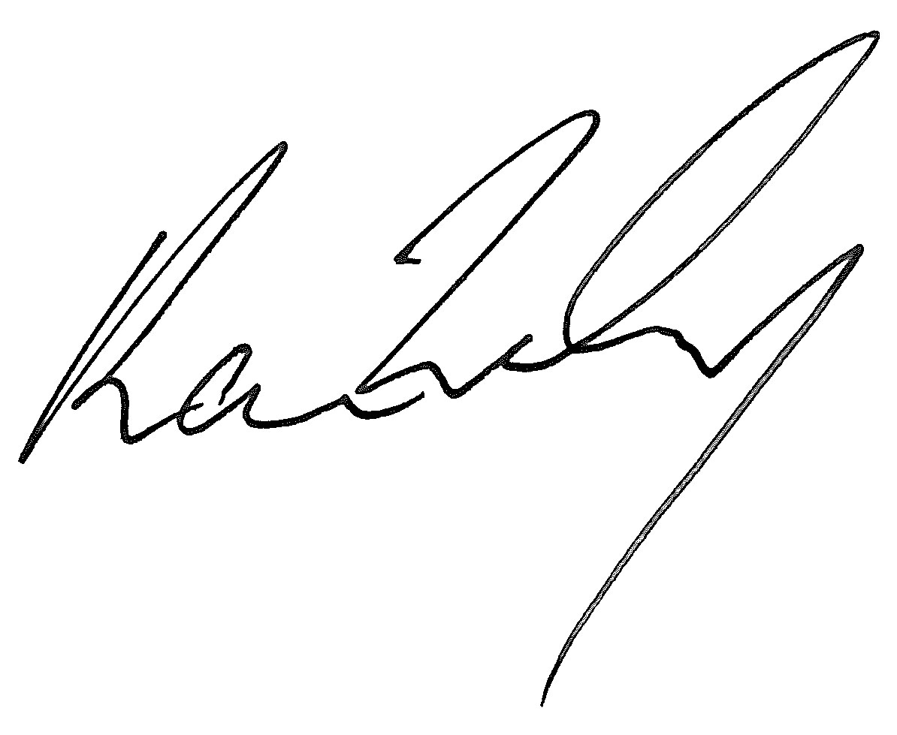

Karen Toohey  
Discrimination Commissioner

Dated: 2 July 2020

**Pursuant to section 109 of the *Discrimination Act* *1991* (ACT), the Human Rights and Discrimination Commissioner grants BAE Systems Australia Ltd,** **BAE Systems Australia Defence Pty Ltd, and ASC Shipbuilding Pty Limited (collectively, ‘the BAE Systems Entities’) an exemption from the operation of sections 10, 13, 23 and 69 of the Discrimination Act subject to the following terms:**

**CONDUCT**

The BAE Systems Entities may engage in the following conduct in the Australian Capital Territory:

**Security Officer and Assistant Security Officer**

1. Request nationality or citizenship information from any person holding or applying to hold the positions of Security Officer or Assistant Security Officer (as defined in the Australian Defence Security Manual) within the BAE Systems Entities.
2. Require any person holding the positions of Security Officer or Assistant Security Officer within the BAE Systems Entities to be an Australian citizen.

**Australian security clearances**

1. Record information relating to security clearances granted to employees of the BAE Systems Entities (**employees**) and employees of contractors who perform work on the BAE Systems Entities’ premises and who are subject to the BAE Systems Entities’ control and direction (**contract workers**).

**Applicants for employment**

1. Inform applicants for employment in roles which will require access to material (**ITAR controlled material**) subject to contractual obligations arising from the *Arms Export Control Act* 22 USC § 2778 (2004), *International Traffic in Arms Regulations* (**ITAR**) and the *Export Administration Regulations* and any permit, licence or approval granted, or agreement made, under those laws (**ITAR controls**) that they may be adversely affected by ITAR controls if they are not an Australian citizen or if they hold dual nationality and / or citizenship.

**Request for information about nationality**

1. Request nationality information from applicants for employment who will be required to work with ITAR controlled material, providing this request for information is limited to information for determining whether an application for authorisation would be required for the applicant to undertake the work in that position.
2. Request nationality information from employees and contract workers who will be required to work with ITAR controlled material.

**Use of nationality information**

1. Impose a condition on any offer of employment in roles which will require access to ITAR controlled material that the person must, pursuant to ITAR controls, be authorised to access that material whether pursuant to an individual clearance obtained from the United States Government or otherwise.
2. Take an employee or contract worker's nationality into account when determining whether that person may be offered a role or allocated work that involves access to ITAR controlled material.
3. Maintain records of the nationalities of all persons who have or will have access to ITAR controlled material.
4. Ensure that ITAR controlled material is disclosed only to persons who are authorized by ITAR controls to receive it.
5. Impose limitations or prohibitions on access to ITAR controlled material on persons not authorised to access that material.
6. Establish security systems that will prevent the unauthorized re‑export or re‑transfer of ITAR controlled material.
7. If and when required, disclose to:
   * 1. USA based contractors for whom the BAE Systems Entities perform work under subcontract;
     2. the United States Department of State;
     3. the United States Department of Commerce; and
     4. the United States Department of Defence;

the nationalities of all employees and contract workers who have access to ITAR controlled materials in the performance of the subcontract.

**CONDITIONS**

1. The exemption applies only to a BAE Systems Entity's conduct where:
   * 1. it is necessary to enable it to perform contractual obligations which involve access to ITAR controlled material;
     2. it has taken all steps that are reasonably available to avoid engaging in conduct which would otherwise be in breach of sections 10, 13, 23 and 69 of the Act, including:
        1. where an applicant for employment, employee or contract worker is a national or dual national of a country not approved for access to ITAR-controlled material in a relevant contract, then the BAE Systems Entity will apply to the United States Department of State to amend the relevant contract and approve the addition of the person’s nationality, which, if successful, would enable a person to have access to ITAR-controlled material; and
        2. in the event that the United States Department of State requires the BAE Systems Entity to provide further information specific to the person, then with the consent of that person, the BAE Systems Entity will provide all relevant information to the United States Department of State so that an application for approval may be made in relation to that person.
2. Where, pursuant to this exemption, a BAE Systems Entity wishes to reserve the right to make a conditional offer of employment in relation to a position which will involve access to ITAR‑controlled material, any advertisement, invitation for expressions of interest, or other promotional information referring to the position must include the information that:
   * 1. the position is subject to ITAR controls and that any person occupying the position must be able to satisfy ITAR-based requirements which may require specific authorisation for that person to access ITAR-controlled material; and
     2. if a person is concerned as to whether or not they will satisfy the requirement in (a), they should contact a nominated employee of the BAE Systems Entity who is able to provide relevant information, including information set out in condition 3 below.
3. The BAE Systems Entities must provide in writing to any applicant for employment, employees and contract workers:
   * 1. express notice that they may be adversely affected by the ITAR controls if they are not an Australian national, if they hold dual nationality citizenship and /or citizenship, or if they are not of Australian national origin;
     2. notice that the BAE Systems Entities have an exemption under the Actto enable it to take steps to prevent access to ITAR controlled material;
     3. a reasonable explanation in plain English of the nature of any such adverse effects;
     4. advice that any necessary application for specific authorisation for a person to access ITAR-controlled material would be made by the BAE Systems Entities;
     5. information about how they can apply for Australian citizenship; and
     6. information regarding their rights under Australian Federal, State and Territory discrimination laws.
4. Where, pursuant to this exemption, an employee or contract worker who is not authorized pursuant to ITAR controls to have access to ITAR controlled material (including pursuant to any individual clearance), is moved from a project involving access to ITAR controlled material to any other work controlled by the BAE Systems Entities or any of their related entities, the BAE Systems Entities must, through a duly authorized officer, explain to the person why he or she is being transferred and must otherwise take all reasonable steps to avoid or limit harm or loss to that person.
5. Where the BAE Systems Entities use a system of security passes to reflect the fact of access to ITAR controlled material or levels of access to material subject to Australian security restrictions, the passes may be coded but not in such a manner that the nationality can obviously be identified from the coding.
6. All information relating to security passes, security clearance levels and access to ITAR controlled material shall be restricted to the Chief Counsel, Head of Export Controls & Security, and to their properly appointed nominees on a "need to know" basis.
7. The BAE Systems Entities' employment policies shall continue to refer to the terms of this exemption, including all conditions attaching to it, and to make clear that the purpose of the request for information regarding nationality is made solely for the purposes of compliance with contractual obligations imposed pursuant to laws of the United States.
8. The BAE Systems Entities are required to provide a written report to the ACT Human Rights Commission every six months from the date of this instrument of exemption, over the three year period of the exemption, detailing:
   * 1. the steps it has taken to comply with the above conditions;
     2. the number of persons affected by this exemption, the nature of the effects, and the steps taken to address any adverse effects;
     3. the anti-discrimination training of employees and contract workers provided by the BAE Systems Entities; and
     4. implementation and compliance generally with the terms of this exemption order.

The exemption is granted for a period of three years starting on 15 July 2020 and expiring on 14 July 2023.

This decision is a notifiable instrument and must be notified under the [*Legislation Act*](http://www.austlii.edu.au/au/legis/act/consol_act/la2001133/).

**SIGNED by the ACT Discrimination Commissioner**

**Dated 2 July 2020**