Australian Capital Territory

Nature Conservation (Closed Reserves—Total Fire Ban) Declaration 2020 (No 2)*

Notifiable instrument Nl2020–4

made under the

Nature Conservation Act 2014, s 259 (Conservator may close reserve)

Name of instrument
This instrument is the Nature Conservation (Closed Reserves—Total Fire Ban) Declaration 2020 (No 2).

Commencement
This instrument commences on 30 December 2019.

Note Section 259 (5) of the Nature Conservation Act 2014 provides that a closed reserve declaration may commence on a day or at a time earlier than its notification date.

Declaration
I declare public access to the reserves specified in column 2 of schedule 1 is prohibited.

Expiry
This instrument expires at 0600 on 1 January 2020.

Tony Scherl
Delegate of the Conservator of Flora and Fauna 29 December 2019

(see s 3)

column1  item | column 2  reserve
I | The area identified in schedule 2 known as Tidbinbilla Nature Reserve
2 | The area identified in schedule 3 known as Lower Molonglo River Corridor
3 | The area identified in schedule 4 known as Molonglo Gorge Nature Reserve
4 | The area identified in schedule 5 known  as Mulligans Flat Woodland Sanctuary
5 | The area identified in schedule 6 known  as Namadgi National Park
6 | The area identified in schedule 7 known as Lower Cotter Catchment
7 | The area identified in schedule 8 known as Bullen Range Nature Reserve, west of  the Murrumbidgee River
8 | The area identified in schedule 9 known  as Stony Creek Nature Reserve, west of the Murrumbidgee River
9 | The area identified in schedule I0 known as Sherwood Forest Special  Purpose Reserve



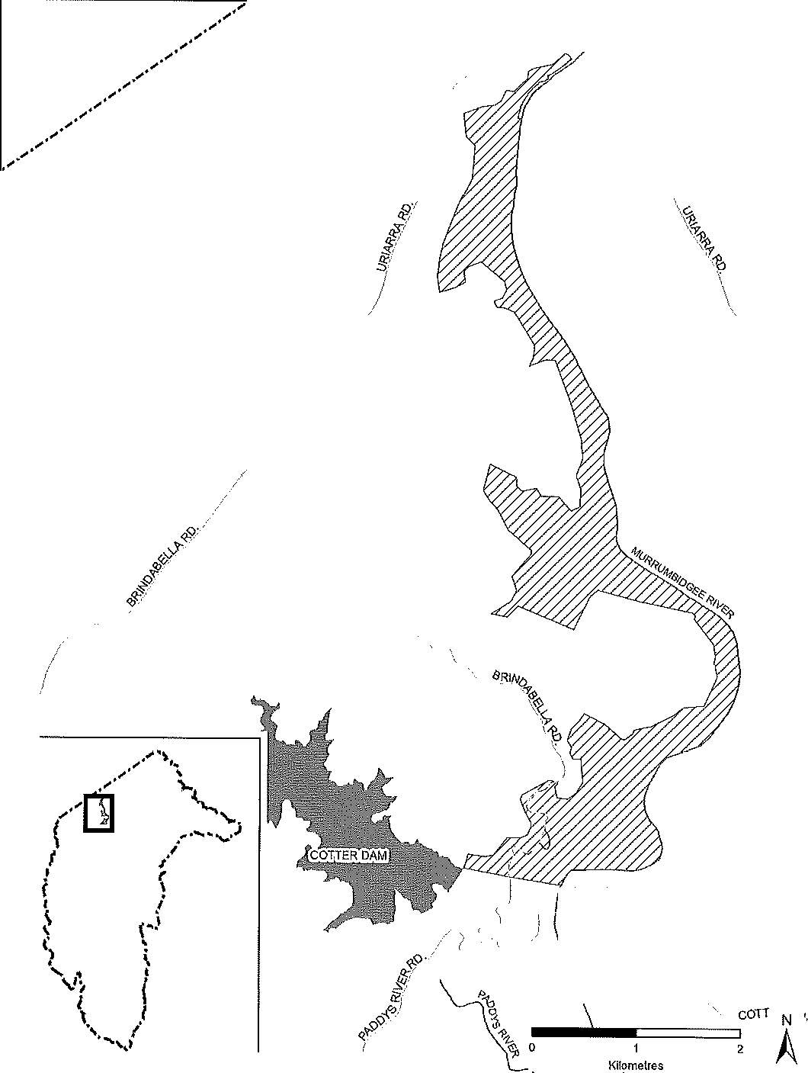
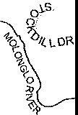

(see sch 1 item 9)

