Australian Capital Territory

Nature Conservation (Closed Reserves) Declaration 2020 (No 8)

Notifiable instrument NI2020–52
made under the
Nature Conservation Act 2014, s 259 (Conservator may close reserve)

1 Name of instrument
This instrument is the Nature Conservation (Closed Reserves) Declaration 2020 (No 8).

2 Commencement
This instrument commences on the day it is signed.

3 Declaration
I declare public access to the reserves specified in column 2 of schedule 1 is prohibited.
4 Expiry
This instrument expires on 31 January 2020.
Ian Walker
Conservator of Flora and Fauna
28 January 2020

Schedule 1 Closed reserves
(see s 3)
column 1  item | column 2  reserve
1 | The area identified in schedule 2 known as Goorooyarroo Nature Reserve
2 | The area identified in schedule 3 known as Mulligans Flat Woodlands Sanctuary

Schedule 2 Goorooyarroo Nature Reserve
(see sch 1 item 1)
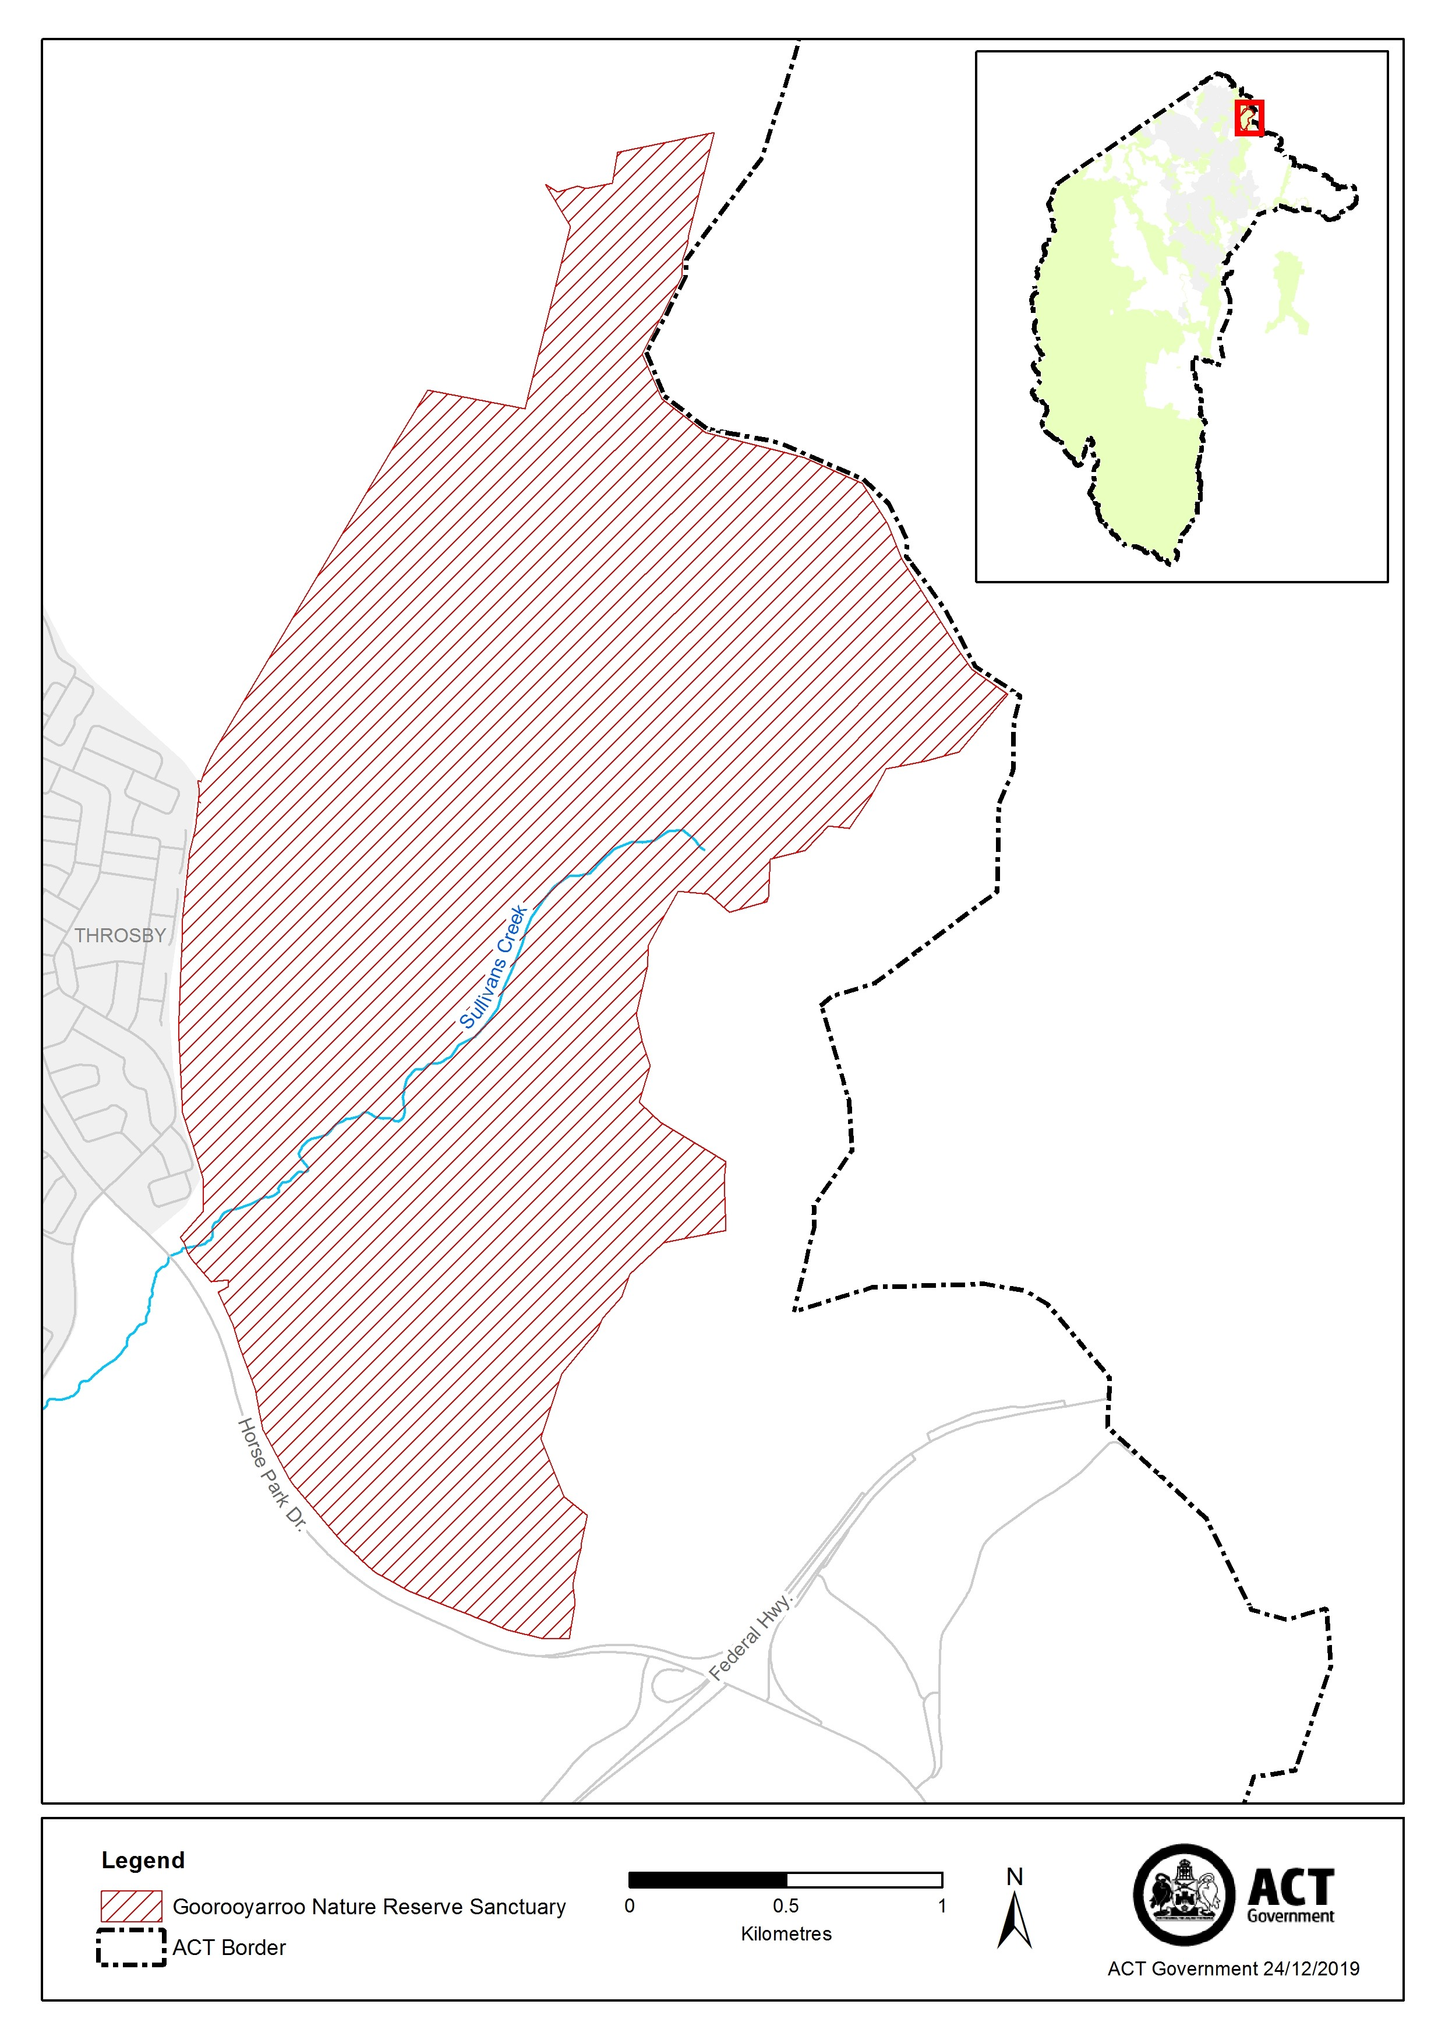

Schedule 3 Mulligans Flat Woodland Sanctuary
(see sch 1 item 2)
