Australian Capital Territory
Heritage (Decision about Registration of
The Civic Square Precinct, City) Notice 2020
Notifiable instrument NI2020—620
made under the
Heritage Act 2004, s 40 (Decision about registration)

1 Name of instrument
This instrument is the Heritage (Decision about Registration of The Civic Square Precinct, City) Notice 2020.
2 Decision about registration

On 17 September 2020, the ACT Heritage Council (the Heritage Council) decided to register The Civic Square Precinct, (part) Blocks 3, 18-23 and 26 Section 19, City (the Place).
3 Registration details of the Place
The registration details of the Place are in the schedule.
4 Reasons for the decision
The Heritage Council is satisfied on reasonable grounds that the Place has heritage significance as it meets one or more of the heritage significance criteria in section 10 of the Heritage Act 2004. A detailed statement of reasons including an assessment against the heritage significance criteria is provided in the schedule.
5 Date registration takes effect
The registration of the Place takes effect on the day after this notice is notified.

6 Revocation
The Heritage (Decision about Provisional Registration of The Civic Square Precinct, City) Notice 2019 (NI2019—611) is revoked.

Fiona Moore
Secretary (as delegate for)
ACT Heritage Council
17 September 2020

Schedule

(See sections 3 and 4)

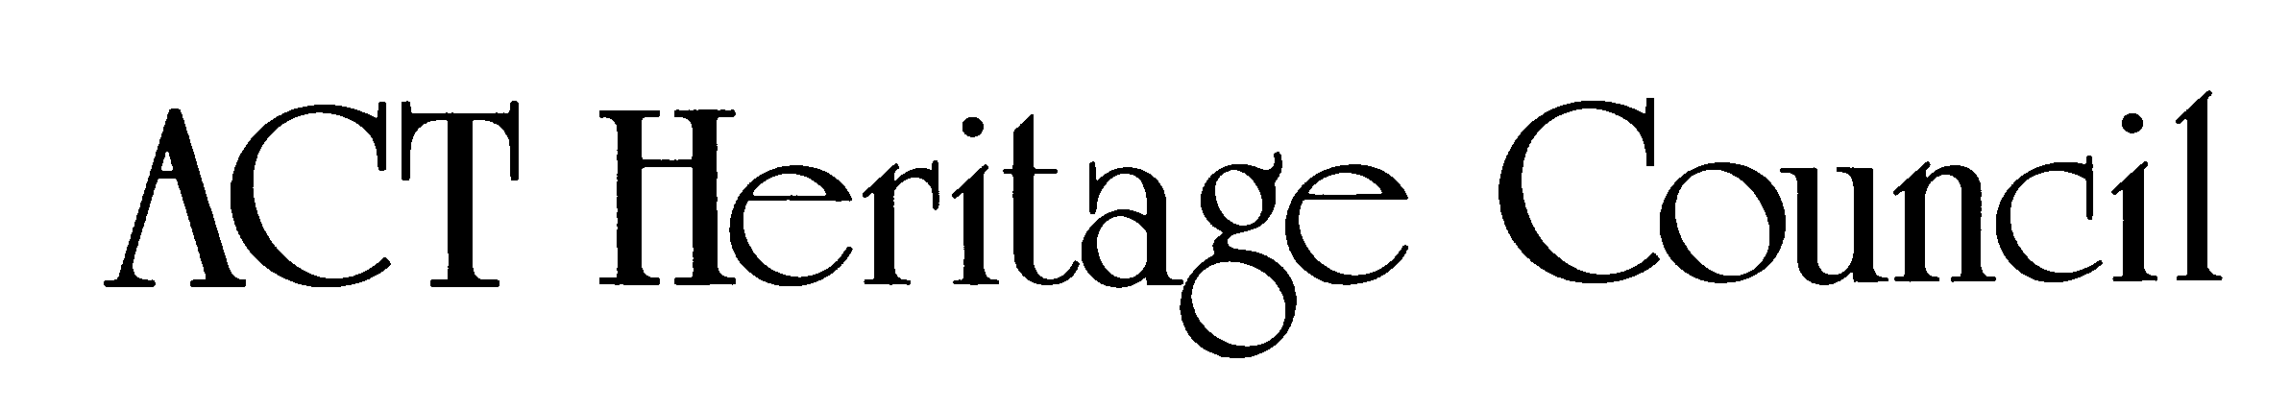
AUSTRALIAN CAPITAL TERRITORY
HERITAGE REGISTER
(Registration)

For the purposes of s40 of the Heritage Act 2004, an entry to the heritage register has been prepared by the ACT Heritage Council for the following place:

The Civic Square Precinct

(part) Blocks 3, 18-23 and 26 Section 19, City
DATE OF REGISTRATION
17 September 2020 Notifiable Instrument: 2020–

Copies of the Register Entry are available for inspection at ACT Heritage. For further information please contact:

The Secretary

ACT Heritage Council

GPO Box 158

CANBERRA ACT 2601

Telephone 13 22 81

This statement refers to the location of the place as required in s12(b) of the Heritage Act 2004.
LOCATION OF THE PLACE

The Civic Square Precinct, (part) Blocks 3, 18-23 and 26 Section 19, City.

This statement refers to the description of the place as required in s12(c) of the Heritage Act 2004. The attributes described in this section form part of the heritage significance of the place. For the purposes of s12(c) of the Heritage Act 2004, the boundary of the place is at Image 1.
DESCRIPTION OF THE PLACE

The Civic Square Precinct, consisting of the following attributes (items marked with an asterisk “*” are a type of feature that should always be a part of the precinct as a planning principle; however, the current item, its current physical fabric, or current location within the Precinct are not intrinsic to the heritage significance of the place):
- The Civic Square Precinct, consisting of:
  - open space of 60x65m forming Civic Square;
  - the outer square formed by the vertical sides of the buildings (the relatively flat planes formed by the facades), taking the form of a wall enclosing the square, while maintaining easy access from all corners;
  - landscaping and amenities that are suitable for passive recreation (such as seating, lighting, shaded areas and places to gather) while maintaining a large open space suitable for large gatherings of people;
  - water features such as a pond, pool or fountain*;
  - hard paving as the predominant ground surface*;
  - lighting*;
  - the access laneways between the North and South Buildings and the Canberra Theatre Centre*;
  - the form, scale, character and function of the original steps and a large landing looking out over the Square that can act as a podium or stage in front of the Canberra Theatre Centre* (note that this does not extend to the more recent stairs from the podium over the link towards City Hill); and
  - the spatial quality of the design intent, based on the dimensions of the North and South Buildings, where all other built elements in the Precinct are designed based on dimensions taken from these buildings.
- Ainslie Place, consisting of:
  - landscaping and amenities that are suitable for passive recreation (such as seating, lighting, shaded areas and places to gather) and create a sense of enclosure at a human-scale including raised planter beds* separating the central path from surrounding traffic as well as paths on the outer edges;
- The original North and South Buildings, consisting of:
  - the form, scale and massing of each building surrounding the Square;
  - the gold gilt mosaic tiles designed by Frank Hinder to the columns on the ground level;
  - open colonnades surrounding the buildings;
  - full height glazing to the ground floor;
  - the fenestration patterns of the ground level and the upper levels;
  - the original façade lights;
  - the inlaid river cobbles surrounding ground floor glazing; and
  - long, low current height and repetitive facades in the stripped classical style;
- The Canberra Theatre Centre consisting of:
  - the original Canberra Theatre building;
  - The scale and massing (which reflects the original design intent) of the Link (building) and Playhouse, thus ensuring the square is flanked by lower scale buildings that do not dominate or shade Civic Square, and which allow for the appreciation of the broad open vista on the City Hill-Mount Ainslie axis;
- Sculptures and artwork that relate directly to The Civic Square Precinct, civic pride and community use:
  - Ethos (in a prominent position within the square; also note that it is independently registered as a heritage object);
  - the ACT Coat of Arms (above the entrance to the ACT Legislative Assembly);
  - Thespis (in a prominent position related to the Canberra Theatre Centre);
  - the Canberra Times Fountain (in its current location);
  - the ACT Memorial (in its current location); and
  - the ACT Honour Walk (in its current location);
- Artwork recognising Ngunnawal connection to the land, including Fireline, and other contributory artworks, sculptures and installations*
- City Hill-Mount Ainslie axis within the registered boundary area as evidenced by:
  - symmetry and balance of features on either side of the axis; and
  - maintaining open space along the axis so as not to restrict views and movement along the axis.

It should also be noted that there are many other features of The Civic Square Precinct that may contribute to some degree or are neutral and not inconsistent with its heritage significance. These include, but are not limited to, the flagpoles, signage, planter-boxes, shops within the buildings, artworks and temporary features associated with events in the Precinct.

The Council also notes that many of the significant features noted in the Description of the Place have been altered or reduced in extent; in these cases, the remaining original material is considered significant and that reinstating the full extent of these features is considered to be an ideal conservation outcome.

This statement refers to the heritage significance of the place as required in s12(d) of the Heritage Act 2004.
STATEMENT OF HERITAGE SIGNIFICANCE

The Civic Square Precinct is significant to the ACT for social and cultural values as an important central location and open space for public use, celebrations and cultural events and for expressions of democratic freedoms through protest. [criteria (a) (b) (g)]

It is also significant for its planning and design as a place that put the people ahead of built scale by providing an open contemporary and accessible space for them, and for maintaining Griffin’s spatial planning characteristics for City Hill; and for its association with the local administration of the city that has been maintained from its original Commonwealth Government inception, through to ACT self-government; and with the Precinct’s designer, Roy McGowan Simpson AO, for Yuncken Freeman, who helped shape many of the ACT’s important public spaces, as an exemplar of his design philosophy. [criteria (a) (d) (h)]

The framing of the Square is significant. It comprises the North and South Buildings designed by Yuncken Freeman in a stripped-back classical form, with ground-floor open colonnaded facades and gold-mosaic decorated columns and, to the west, the podium and Canberra Theatre Centre, with its cultural contribution to Canberra. [criterion (b)]
CONSERVATION OBJECTIVE

The guiding conservation objective is that The Civic Square Precinct shall be conserved and appropriately managed in a manner respecting its heritage significance.

The ACT Heritage Council may adopt heritage guidelines applicable to the place under s25 of the Heritage Act 2004.

For further information on guidelines applicable to the place, or for advice on proposed works or development, please contact ACT Heritage on 13 22 81.
REASON FOR REGISTRATION

The Council has assessed The Civic Square Precinct, City, against the heritage significance criteria and is satisfied that the place has heritage significance when assessed against five criteria [(a), (b), (d) (g) and (h)] under s10 of the Heritage Act 2004.
ASSESSMENT AGAINST THE HERITAGE SIGNIFICANCE CRITERIA

The Council’s assessment against the criteria specified in s10 of the Heritage Act 2004 is as follows.

In assessing the heritage significance of The Civic Square Precinct, the Council considered:
- the original nomination based on the citation on the Register of the National Estate;
- the Council’s Heritage Assessment Policy (March 2018);
- information provided by a site inspection on 19 September 2019 by ACT Heritage;
- the report by ACT Heritage titled, Background Information Civic Square Precinct, September 2020, containing photographs and information on history, description, condition and integrity;
- information and comments received during the public consultation period under s37 of the Act on the provisional registration of Civic Square Precinct:
  - 13 submissions were received during public consultation.
  - The Council considered two additional submissions made outside of the public consultation period.
- During the provisional registration period, the Council made provisions for greater collaboration with interested persons and stakeholders responsible for the Precinct.

Pursuant to s10 of the Heritage Act, a place or object has heritage significance if it satisfies one or more of the following criteria. Future research may alter the findings of this assessment.
importance to the course or pattern of the ACT’s cultural or natural history;
The Council has assessed The Civic Square Precinct against criterion (a) and is satisfied that the place meets this criterion.
The Civic Square Precinct is important to the course and pattern of the ACT’s cultural history as a site for the civic administration of the city, a centre of cultural facilities, as a ‘town square’ that provides a forum for public events, performances, artwork, protest and celebration and also for the design and its implementation by the National Capital Development Authority (NCDA) (later the National Capital Development Commission (NCDC)) and the square’s planning that reinforces the spatial characteristics of Griffin’s plan as the city evolved.
The Civic Square Precinct includes a significant suite of infrastructure and buildings that form the Square, and public open space. The buildings have housed government administration since it opened in 1960, initially for the Commonwealth Department of the Interior, the ACT Advisory Council, and, after a brief interlude following self-government, the ACT Legislative Assembly.
The Square itself is an important space for holding public events and activities, including celebrations, protests and performances. The space continues to host various forms of temporary public art exhibitions. ‘Ethos’, designed by Tom Bass (1961), is a permanent sculpture prominently located within the square, representing the ‘spirit of the community’ and reflecting the philosophy of the space.
The civic role of the place in hosting cultural events and promoting culture in the ACT extends further, with the Cultural Facilities Corporation managing the Canberra Theatre Centre, the Canberra Museum and Gallery (CMAG) and the Nolan Collection. Additionally, the North Building houses various community-based cultural organisations.
Very little activity had occurred in the City Hill area, until the middle of the century, when the Courts Precinct and The Civic Square Precinct were constructed under the NCDC. The NCDC commissioned the development of the Precinct, which was designed by Roy McGowan Simpson, AO, of Yuncken Freemen, with the purpose of reinforcing the spatial characteristics of Griffin’s plan for Canberra for the concentration of civic and municipal administration around City Hill, with land axis links to the Capitol (now Parliament House) and a retail area (now the Russell Offices/Defence administration area).
The functions of The Civic Square Precinct fitted in with Griffin’s plan to situate the local administration in that area with the Civic Offices (now the North and South Buildings) housing the local administration branch of the Department of the Interior as well as the public library and being the location for the city square. It also reinforced Griffin’s overall planning for Canberra by maintaining his main axial lines.
As part of The Civic Square Precinct, the original Canberra Theatre Centre was designed by Yuncken Freeman in 1961 and included an innovative early use of continuous copper roof decking.
has uncommon, rare or endangered aspects of the ACT’s cultural or natural history;
The Council has assessed The Civic Square Precinct against criterion (b) and is satisfied that the place meets this criterion.
The Civic Square Precinct is planned for civic uses and includes a public square with a focus on municipal and cultural use.
The success of NCDC’s planning for the location of a civic square was dependent on developing the rest of City Hill as the civic and municipal centre that Griffin envisaged. The Civic Square Precinct is the only dedicated civic, open space in the ACT, designed to be in a central location for civic administration, community and cultural events, public celebrations and demonstrations.
The Canberra Theatre Centre frames the western side of the Square and provides a complementary function to the civic space. In Australia, it was the first major government-funded performing arts centre. It was built in response to the needs of a growing community, and its opening in 1965 marked a major step forward in the cultural life of Canberra.
potential to yield important information that will contribute to an understanding of the ACT’s cultural or natural history;
The Council has assessed the Civic Square Precinct against criterion (c) and is satisfied that the place does not meet this criterion.
The Civic Square Precinct does not have the potential to yield important information that will contribute to further understanding of the ACT’s cultural history. There is sufficient information available about the function, uses, design, planning and historic development of The Civic Square Precinct, therefore it is unlikely to yield additional information that would give a greater understanding of the cultural history of the ACT.
importance in demonstrating the principal characteristics of a class of cultural or natural places or objects;
The Council has assessed The Civic Square Precinct against criterion (d) and is satisfied that the place meets this criterion.
The Civic Square Precinct is important for demonstrating the principal characteristics of a civic space.
The Civic Square Precinct is used for cultural activities including concerts, markets, festivals, displays, celebrations and planned community events, as well as for public activism through demonstrations and protests. It has a variety of amenities, when taken as a whole incorporating Ainslie Place, including the Civic Library, CMAG, the Canberra Theatre Centre, the fountain (pool), specifically designed sculptures for the civic space, the City Hill-Mount Ainslie axis/vista, places to sit in the shade and various cafes along the edges. It is generally seen as being clean and safe.
Roy Simpson, of Yuncken Freeman and primary architect of the Square, in his AS Hook address (an address given by recipients of the Australian Institute of Architects Gold Medal) noted that the overall precinct design is more important than the individual elements within it. There was a hierarchy of importance, with the buildings subservient to the precinct and the precinct subservient to the city. Simpson’s design philosophy is evident in The Civic Square Precinct, where it has been planned around Griffin’s City Hill group and axial lines while the buildings themselves are fairly subdued, creating the open square as the focus. There have been several changes to the Precinct, some of which have given priority to movement and sightlines along Griffin’s axis, but are not necessarily complementary to the original design intent. These changes are not a part of the significance of the place.
This highlights the collective importance of the elements– the architecture, the spatial qualities and relationships and the overall aesthetic of the precinct to deliver the qualities which were envisaged by Simpson when he designed it.
importance in exhibiting particular aesthetic characteristics valued by the ACT community or a cultural group in the ACT;
The Council has assessed The Civic Square Precinct against criterion (e) and is satisfied that the place does not meet this criterion.
That the aesthetic characteristics are valued by the ACT community or cultural groups in the ACT has not been tested, although this may emerge more clearly in the future.
The Square’s design emphasises the overall precinct within the greater city plan and frames the views and axial lines between City Hill and Mount Ainslie.
The Civic Square Precinct has aesthetic characteristics as a designed space for public, cultural and ceremonial activities of about 60 x 60 metres. The design demonstrates classical civic design principles within a ‘post-modern’ aesthetic. The classical layout for civic spaces involves the arrangement of significant buildings on elevated platforms or podiums.
The North and South Buildings, both administrative and community buildings, create the ‘square’, and the sequencing of the podiums that culminate in the Canberra Theatre Centre. The Civic Square Precinct also has an ascending sequence of spaces, with the highest terminating point at City Hill, the elevated podium of the Canberra Theatre Centre at the western side, with its grand original staircase, providing prominence to the theatre, a place of cultural activities for the community and the City.
Originally the pool, a large rectangular element of 945m^{2,} was an integral part of the design and had an aesthetic function, providing the central focus of the square, with several fountain jets surrounded by spillage drains and a bed of uneven, polished river rocks set in concrete.
The simplicity and purity of the square’s design is complemented by its public art, with ‘Ethos’, an iconic sculpture for Canberra, symbolising the spirit of the community and celebrated since its installation in 1961. The Square is the setting of major site-specific artworks and many activities that respond to the place, its form and function.
importance in demonstrating a high degree of creative or technical achievement for a particular period;
The Council has assessed The Civic Square Precinct against criterion (f) and is satisfied that the place does not meet this criterion.
The design of the Square was in line with international urban design standards and influenced by post-war contemporary town squares. There are creative and technical achievements including the gold gilt mosaic tiles and the previous incorporation of the cooling system within the original pond designed by Tom Bass. However, The Civic Square Precinct does not demonstrate the high degree of creative or technical achievement or meet the threshold for this criterion.
has a strong or special association with the ACT community, or a cultural group in the ACT for social, cultural or spiritual reasons;
The Council has assessed The Civic Square Precinct against criterion (g) and is satisfied that the place meets this criterion.
The Civic Square Precinct has a special association with the ACT community for social and cultural reasons. The place has an enduring special association with the ACT Community.
It is an important location for celebration of sporting and other local achievements, protests, cultural events and significant social gatherings like New Year, NAIDOC Week and the Multicultural Festival.
As a designed public square that incorporates the local administration, it is a place frequently used by Canberrans to voice their concerns publicly in protest. It is also the place where, for the benefit of the ACT’s cultural life, the Cultural Facilities Corporation, though the Canberra Theatre Centre, presents and produces a broad array of live performance and, through CMAG, presents exhibitions, and education and community programs.
has a special association with the life or work of a person, or people, important to the history of the ACT.
The Council has assessed The Civic Square Precinct against criterion (h) and is satisfied that the place meets this criterion.
Roy Simpson was an accomplished architect and planner with a design philosophy of being sensitive to context rather than creating more noticeable and grandiose buildings. His contribution to the history of the ACT is evidenced by his design of The Civic Square Precinct, the Law Courts Precinct, various projects within the ANU as well as guiding its overall design for 12 years, Canberra Grammar School’s science wing, 18 houses for the Chief of Defence Service (the first NCDC commission), planning the Cotter Reserve as well as overseeing aspects of renovations to the Lodge and the Governor General’s Residence at Yarralumla. Simpson used The Civic Square Precinct as one of the three examples, along with the Melbourne Diocesan Centre and the La Trobe University master plan that exemplified his work and design philosophy in his A S Hook memorial address. He wrote the address in response to winning the RAIA Gold Medal but it was delivered posthumously by his wife Donne Simpson.
The Civic Square Precinct, including the North and South Buildings and the Canberra Theatre Centre, has maintained a strong and special association with local level administration of the ACT from the initial use by the Department of the Interior, to its current use as site for the ACT Legislative Assembly. This association is strengthened by efforts to adapt and refurbish the South Building to accommodate the changing needs of the Assembly while maintaining the original design intent of the Precinct; as evidenced by the addition of the Chamber to the courtyard and continuing efforts to contain the Assembly in the same place as its needs change over the years. This association is considered to be special as there is a continuing history of the square beside these offices as a place of protest that is publicly visible and directly associated with the administration since 1988. The association is also considered to be special as the ACT administration, particularly prior to self-government when the Commonwealth could have located the department anywhere, is located at the municipal zone in Griffin’s plan.
The Civic Square Precinct is associated with the Canberra Theatre Trust (set up under the Canberra Theatre Trust Ordinance 1965, which established that the Trust would use the Canberra Theatre Centre and make it available while promoting and encouraging the development and presentation of the arts in Canberra). The Cultural Facilities Corporation was established in 1997 under the Cultural Facilities Corporation Act 1997 to take over the Trust’s responsibilities for managing the Canberra Theatre Centre and also to manage CMAG, the Nolan Collection and ACT Historic Places (Lanyon, Calthorpe’s House and Mugga-Mugga). Through the work of the Trust and, subsequently, the Cultural Facilities Corporation, the Canberra Theatre Centre was developed as the Canberra region’s premier performing arts venue and a major player on the national touring circuit for theatre productions, as well as hosting local productions.
The Canberra Theatre Centre has continued to change and expand over the years, such as with the changes to the Link and The Playhouse, in order to keep up with modern standards and future changes are likely in order to maintain the continued significance of the place as Canberra’s cultural centre.
While the place has a connection with Walter Burley Griffin’s plan by reinforcing the spatial characteristics of his axial lines it is on such a broad level that he has no direct or special association with The Civic Square Precinct specifically. This association of the place to Griffin has not met the threshold for this criterion.
SITE PLAN

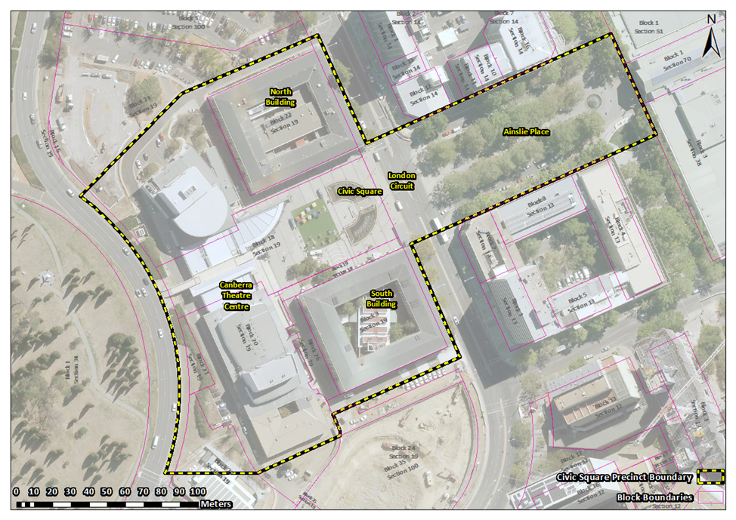
Image 1 The Civic Square Precinct registration boundary

