Australian Capital Territory
Heritage (Decision about Provisional Registration of the Macedonian Orthodox Church, Narrabundah) Notice 2020
Notifiable instrument NI2020–621
made under the
Heritage Act 2004, s34 (Notice of decision about provisional registration)

1 Name of instrument
This instrument is the Heritage (Decision about Provisional Registration of the Macedonian Orthodox Church, Narrabundah) Notice 2020.
2 Decision about provisional registration
On 17 September 2020, the ACT Heritage Council (the Heritage Council) decided not to provisionally register the Macedonian Orthodox Church, Block 11, Section 100, Narrabundah (the Place).
3 Description of the Place
The description of the Place is in the schedule.
4 Reasons for the decision
The Heritage Council is not satisfied on reasonable grounds that the Place is likely to have heritage significance as defined by section 10 of the Heritage Act 2004. A detailed statement of reasons, including an assessment against the heritage significance criteria, is provided in the schedule.
5 Date decision takes effect
The decision not to provisionally register the Place takes effect on 18 September 2020 (being the day after the Heritage Council made its decision in writing as set out in the schedule).

Fiona Moore
Secretary (as delegate for)
ACT Heritage Council
17 September 2020

Schedule
See sections 3 and 4
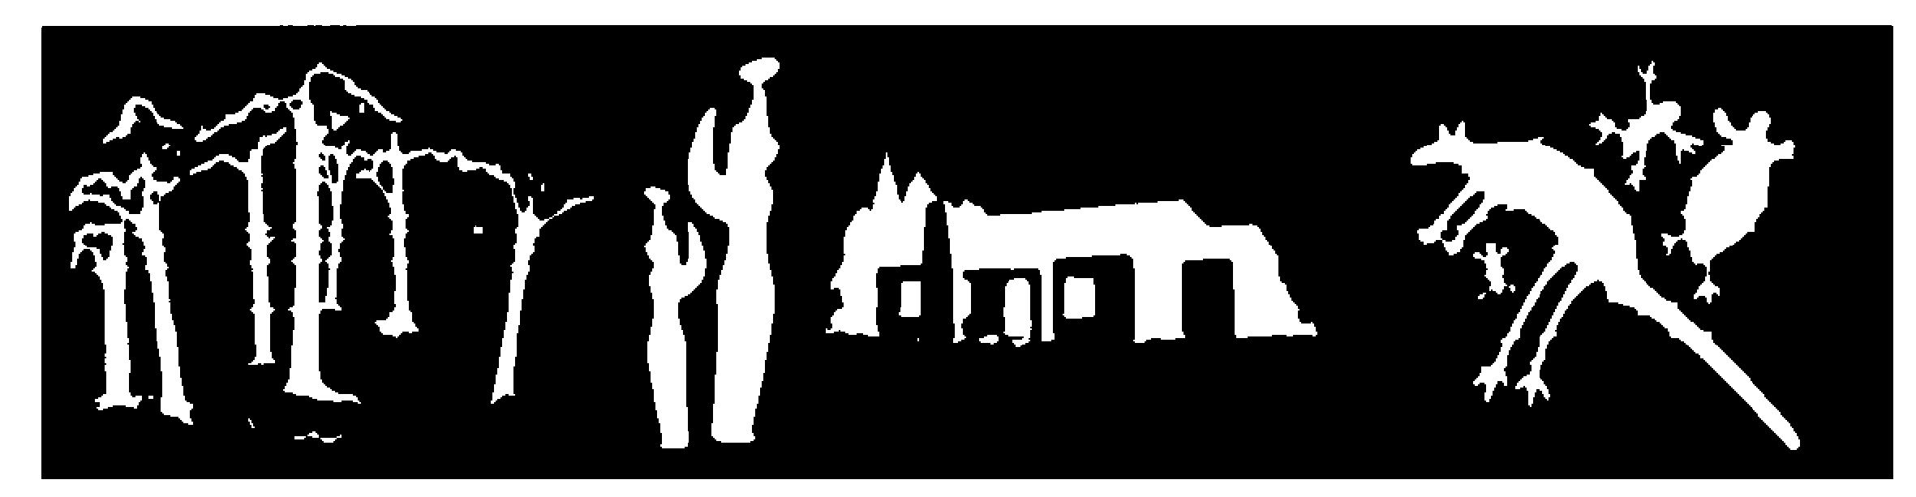
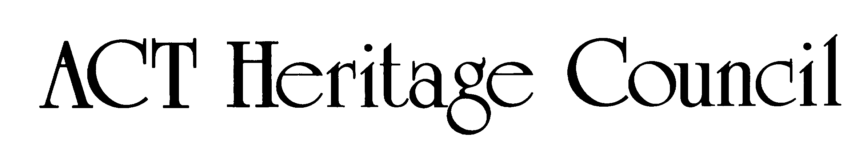
STATEMENT OF REASONS
DECISION NOT TO PROVISIONALLY REGISTER
Macedonian orthodox church
block 11 section 100, narrabundah
IN THE ACT HERITAGE REGISTER

In accordance with s32 of the Heritage Act 2004, the ACT Heritage Council has decided not to provisionally register the Macedonian Orthodox Church, Narrabundah. This Statement of Reasons provides an assessment of the Macedonian Orthodox Church, Narrabundah, and finds that the place does not meet any of the criteria under s10 of the Heritage Act 2004.

This statement refers to the location of the place as required in s34(5)(b)(ii) of the Heritage Act 2004.
LOCATION OF THE PLACE

Macedonian Orthodox Church, Block 11 Section 100, 313 Goyder Street, Narrabundah.

This section refers to the description of the place as required in s34(5)(b)(iii) of the Heritage Act 2004. The boundary of the place and extent of features listed below is illustrated at Image 1.

DESCRIPTION OF THE PLACE

Macedonian Orthodox Church St Kliment of Ohrid is an ecclesiastical building designed in a modern style after the Church of St Kliment of Ohrid in Skopje Macedonia. The building has a central dome on a drum surrounded by four large apses forming a cross, aligned to the cardinal points. The exterior walls of the church are composed entirely of the four apses in a cross and are made from buff-coloured brick.

This statement refers to the Council’s reasons for its decision as required in s34(5)(b)(iv) of the Heritage Act 2004.
REASONS FOR DECISION

The Council is satisfied on reasonable grounds that the place is not likely to have heritage significance as defined by s10 of the Heritage Act 2004.

This statement refers to the Council’s assessment of the place against the heritage significance criteria as a part of its reasons for its decision as required in s34(5)(b)(iv) of the Heritage Act 2004.

ASSESSMENT AGAINST THE HERITAGE SIGNIFICANCE CRITERIA

The Council’s assessment against the criteria specified in s10 of the Heritage Act 2004 is as follows.

In assessing the heritage significance of the Macedonian Orthodox Church, Narrabundah, the Council considered:
- the original nomination and documentary evidence supplied by the nominator;
- the Council’s Heritage Assessment Policy (March 2018);
- information provided by site inspections on 11 August 2019 by ACT Heritage and 25 August 2019 by the Council; and
- the report by ACT Heritage titled, Background Information Macedonian Church, September 2020 containing photographs and information on history, description, condition and integrity; and

Pursuant to s10 of the Heritage Act, a place or object has heritage significance if it satisfies one or more of the following criteria. Future research may alter the findings of this assessment.
- importance to the course or pattern of the ACT’s cultural or natural history;
The Council has assessed the Macedonian Orthodox Church, Narrabundah against criterion (a) and is satisfied that the place does not meet this criterion.

At this time, there is an absence of necessary evidence before the Council to demonstrate the place has made a strong, noticeable or influential contribution to the evolution or pattern of the ACT’s cultural history to the high degree required on an enduring basis since its completion in 1988. The place cannot be said to meet this criterion when compared with other, stronger examples of churches and ecclesiastical buildings that can be said to have influenced the course of the ACT’s cultural history. For example, places such as Shakespeare Hall (Braddon, registered) St Andrew’s Church Precinct (Forrest, registered), St Christopher’s Cathedral Precinct, (Forrest, registered) St Paul’s Church (Griffith, registered) and Reid Uniting Church (registered), have significant associations with the establishment of places of worship and the spiritual fabric of early Canberra. These places have iconic and enduring associations with formative legislation to the fabric of the ACT, the Church Lands Lease Ordinance 1924. This established that each religious denomination with a presence in the Federal Capital Territory (FCT) was exempt from taking a 99 year lease, and granted a single lease at peppercorn rental in perpetuity, with a view to ensuring the spiritual needs of the population of the FCT would be met.
The role of immigrants and associated orthodox churches post-WWII has had an important role in the development of the ACT’s, and Australia’s, culture. However, as a place that is yet to be fully realised, noting that the murals, architecture and landscaping are part of a long-term plan that is still in progress, the Macedonian Orthodox Church has a great potential to meet this criterion in the fullness of time as the Macedonian community’s aspirations for the place come to fruition and its affect on the course or pattern of the ACT’s cultural history is further developed. After its completion and it has had an appropriate amount of time to demonstrate its role in the community, the Council encourages a new nomination to the ACT Heritage Register.
- has uncommon, rare or endangered aspects of the ACT’s cultural or natural history;
The Council has assessed Macedonian Orthodox Church against criterion (b) and is satisfied that the place does not meet this criterion.
The Macedonian Orthodox Church is the only Church of the Macedonian Orthodox faith in the ACT. Whilst it could be argued that this makes the Church uncommon or rare, the argument for assigning significance to it for it being the only Macedonian Orthodox Church in the ACT is not compelling, and represents a sub-category of ‘place’ with too many qualifying terms to hold meaning against this criterion as per the Council’s Heritage Assessment Policy (2018). It is also noted that the place remains a contemporary work in progress and for this reason Council is unable assign significance to the fabric of the place against this criterion.

Other examples of significant ecclesiastical architecture in the ACT include:
- Shakespeare Hall, Braddon, (registered, formerly the Presbyterian Hall in Ainslie)
- St Andrew’s Church Precinct, Forrest (registered)
- St Christopher’s Cathedral Precinct, Forrest (registered)
- St Paul’s Anglican Church, Griffith (registered)
- Reid Uniting Church (registered)
- St John the Baptist Church and Churchyard, Reid (registered)
- All Saints Church, Ainslie (registered)
- St Joseph’s Catholic Church, O’Connor (registered)
- Ukranian Orthodox Church, Turner (nominated)
- Greek Orthodox Church, Kingston (nominated)
The places listed have been identified by the Council as good or excellent examples of certain styles of ecclesiastical architecture, and/or are still occupied or in use, in good condition, and/or are adequately maintained. As such, the Council does not consider ecclesiastical architecture to be an endangered aspect of the ACT’s cultural history.
The Council also notes that within the class of ‘ecclesiastical architecture’ the Macedonian Orthodox Church could be considered an unusual sub-class of a modern Byzantine aesthetic, but a common feature of ecclesiastical architecture is reference to earlier classical or romanticised styles of architecture; so while this particular style is uncommon, it is not a practice that sets it apart from other ecclesiastical designs that reference other early architectural styles. Its marrying of the buff and terracotta colour scheme typical of early Canberra buildings, mid-century design aesthetic and reference to the church at Skopje—a melange of Canberra and Macedonia in architectural form—does however make it a distinctive element in the ACT’s ecclesiastical buildings. When the church and grounds are fully realised, they may have the potential to satisfy this criterion.
The Council notes that the examples listed above do not represent an exhaustive list of nineteenth and twentieth century churches present in the ACT.
- potential to yield important information that will contribute to an understanding of the ACT’s cultural or natural history;
The Council has assessed Macedonian Orthodox Church against criterion (c) and is satisfied that the place does not meet this criterion.
The history of the Macedonian Orthodox Church is relatively recent and is well documented in ACT Government files and within living memory of members of the Macedonian community. There is currently no substantial evidence to suggest further study of the built fabric of the place or the archaeology of the surrounding block would address a deficit in what is known regarding the recent history of the building.
- importance in demonstrating the principal characteristics of a class of cultural or natural places or objects;
The Council has assessed Macedonian Orthodox Church against criterion (d) and is satisfied that the place does not meet this criterion.
As is typical with orthodox churches, the building footprint of the Macedonian Orthodox Church is in the shape of a cross aligned with the cardinal points and it is topped with a dome. The interior of the building is also in keeping with an orthodox church in that it contains a sanctuary in the eastern apse, a narthex in the western apse. In addition, standard ecclesiastical elements are present in the form of the current iconostasis fronting the sanctuary and the part-complete iconographic fresco.
As above, the Macedonian Orthodox Church possesses standard characteristics of a class of place, (i.e. an orthodox church). However, the expression of the building, in terms of its ecclesiastical elements and beautification, is not yet fully expressed. Therefore, assessed against this criterion the church does not demonstrate the principal characteristics of a class of place.
- importance in exhibiting particular aesthetic characteristics valued by the ACT community or a cultural group in the ACT;
The Council has assessed Macedonian Orthodox Church against criterion (e) and is satisfied that the place does not meet this criterion.
The Macedonian community has demonstrated their commitment to their church with notable community-led improvements such as the first stage of an iconographic fresco, completed in 2017. Consultation with the Council throughout 2019, as well as evidence demonstrating community-support for the iconographic fresco, leaves no doubt that the Macedonian community values the aesthetic characteristics of the 2017 fresco.
As with criterion (d), it is noted that the beautification of the building is not yet fully expressed. In the case of the fresco, this is evidenced by the intention of the community to install a second fresco in the future. As the aesthetic values of this element of the church is not fully realised, the place cannot be said to meet thresholds against this criterion (e) at this time.
The Council’s Heritage Assessment Policy (2018) requires that significant associations between cultural groups and places, including their aesthetic values, must not only be above the ordinary, they must also be enduring, demonstrably sustained for approximately 20 years. In light of policy requirements, the very recent history of the fresco, and the evolving nature of the project, it is determined that the place cannot meet this criterion. However, the Council considers that future information may alter this conclusion and would welcome further submissions of evidence at a later time.
- importance in demonstrating a high degree of creative or technical achievement for a particular period;
The Council has assessed Macedonian Orthodox Church against criterion (f) and is satisfied that the place does not meet this criterion.

The Church building cannot be said to meet this criterion as it does not represent development of new technology, or a breakthrough in fabrication or construction techniques that contributed significantly to the field of architecture and construction. This also applies to the fresco which, while installed by artisans with qualifications in a specialised skill, does not represent an influential breakthrough or innovation in the craft. In terms of creativity, the building itself is based on the design of a pre-existing structure, and as such cannot be said to be sufficiently innovative enough to meet creativity thresholds against this criterion.
- has a strong or special association with the ACT community, or a cultural group in the ACT for social, cultural or spiritual reasons;
The Council has assessed Macedonian Orthodox Church against criterion (g) and is satisfied that the place does not meet this criterion.
The efforts of the Macedonian community to realise their church and add to its religious meaning and beautification over time, means significance is appropriately and principally held in the meaning of the church to its community. The Council acknowledges the association with the Macedonian community of the ACT and the Macedonian Orthodox Church in Narrabundah.
Historically and on a contemporary basis, most parishes support varied or specific migrant communities. A comparative example can be seen in St Patrick’s Catholic Church, Braddon, which hosted German Masses for the German-speaking Catholic community for some decades. A second example is evinced by St Joseph’s Catholic Church, O’Connor, whose Parishioners donated substantial time and finances to restore the church after sustaining fire damage in 2007. Attendance, funding and patronage of migrant communities in itself does not constitute a strong or special association with one or several cultural groups to an extent required to meet this criterion. It is common for a religious institution to receive community time and fiscal donations to assist with its construction, opening, ongoing maintenance, and running of church programs. Community contribution is not sufficient as evidence, beyond the ordinary, of a strong or special association between Parishioners and church for social or cultural reasons.
- has a special association with the life or work of a person, or people, important to the history of the ACT.
The Council has assessed Macedonian Orthodox Church against criterion (h) and is satisfied that the place does not meet this criterion.
There is currently no information available to the Council demonstrating that the design or construction of the building has a special association with the life or work of a person/people who distinctively shaped the history of the ACT, or that any such association would directly relate to the fabric of the Church.

SITE PLAN

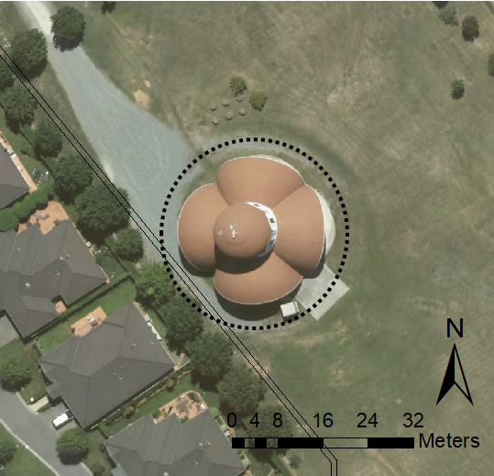
Image 1 Macedonian Orthodox Church site boundary.

ACT Civil and Administrative Appeals Tribunal. (2013). Trustees of the Roman Catholic Church for the Archdiocese of Canberra and Goulburn v ACT Heritage Council & ORS (Administrative Review) ACAT 62.

