Australian Capital Territory
Corrections Management (Incident Response) Operating Procedure 2020
Notifiable instrument NI2020-640
made under the
Corrections Management Act 2007, s14 (Corrections policies and operating procedures), s15 (Exclusion from notified corrections policies and operating procedures)

1 Name of instrument
This instrument is the Corrections Management (Incident Response) Operating Procedure 2020*.

2 Commencement
This instrument commences on the day after its notification day.
3 Operating procedure
I make this operating procedure to facilitate the effective and efficient management of correctional services.
4 Revocation
This instrument revokes the Corrections Management (Incident Response) Policy 2014 [NI 2014-540] and Corrections Management (AMC Incident Response) Procedure 2011 [NI 2011-139].
5 Exclusion from notification
The material in this operating procedure has been excluded from notification as I believe, on reasonable grounds, that the material would be likely to disclose information that may endanger public safety or undermine justice, security or good order at a correctional centre.

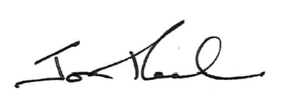

Jon Peach
Commissioner
ACT Corrective Services
25 September 2020

