Australian Capital Territory

Nature Conservation (Tidbinbilla) Activities Declaration 2020

Notifiable instrument NI2020–641
made under the
Nature Conservation Act 2014, s 256 (Conservator may make activities declarations)

Name of instrument
This instrument is the Nature Conservation (Tidbinbilla) Activities Declaration 2020.

Commencement
This instrument commences on the day after its notification day.

Application
This instrument applies to the area hatched and shown as “Tidbinbilla Nature Reserve” (Tidbinbilla) in the map in schedule 1.
Note Under section 169 of the Nature Conservation Act 2014 (the Act) the area of Tidbinbilla is a ‘reserve’ because the area is public land reserved in the territory plan as a nature reserve and special purpose reserve under section 315 (c) and (d) of the Planning and Development Act 2007.

Declaration
I declare that in the Tidbinbilla area hatched and shown as “Tidbinbilla Nature Reserve” in schedule 1—
  - an activity listed in schedule 2 is prohibited; and
  - an activity listed in schedule 3 is restricted and may only be carried out if the requirements applying to the activity are complied with.
Note 1 If an activity is a ‘prohibited activity’ it means the activity cannot be carried out under any circumstance in the part of the reserve outlined in bold in schedule 1. For example, ‘collection of firewood or timber’ is declared to be a prohibited activity. This means that wood or timber cannot be collected in Tidbinbilla under any circumstance.
Note 2 If an activity is a ‘restricted activity’ it means the activity may only be carried out in the part of the reserve outlined in bold in schedule 1 if the requirements applying to the activity are complied with. For example, the activity of ‘camping’ is a restricted activity as this activity is listed in schedule 3. This means that the activity of camping cannot be carried out in Tidbinbilla hatched and shown as Tidbinbilla Nature Reserve in schedule 1 unless it is carried out in a way that complies with the requirements stated in schedule 3.
Note 3 The Act includes general offences which apply to all reserves (including Tidbinbilla) The Act may be found at http://www.legislation.act.gov.au/a/2014-59/default.asp.

Revocation
The Nature Conservation (Tidbinbilla) Activities Declaration 2015 (No 1) (NI2015-407) is revoked.

Definitions
In this instrument:
camping means—
- setting up any tent, shelter, bivouac, swag, hammock, sleeping bag, mattress or bedding; or
- setting up any stationary vehicle for the purpose of lying down or sleeping in, on or under the vehicle; or
(c) lying down or sleeping in, on or under any stationary vehicle, tent, shelter, bivouac, swag, hammock, sleeping bag, mattress or bedding between sunset and 2 hours after sunrise.

Ian Walker
Conservator of Flora and Fauna
25th September 2020

Schedule 1
(See section 3)
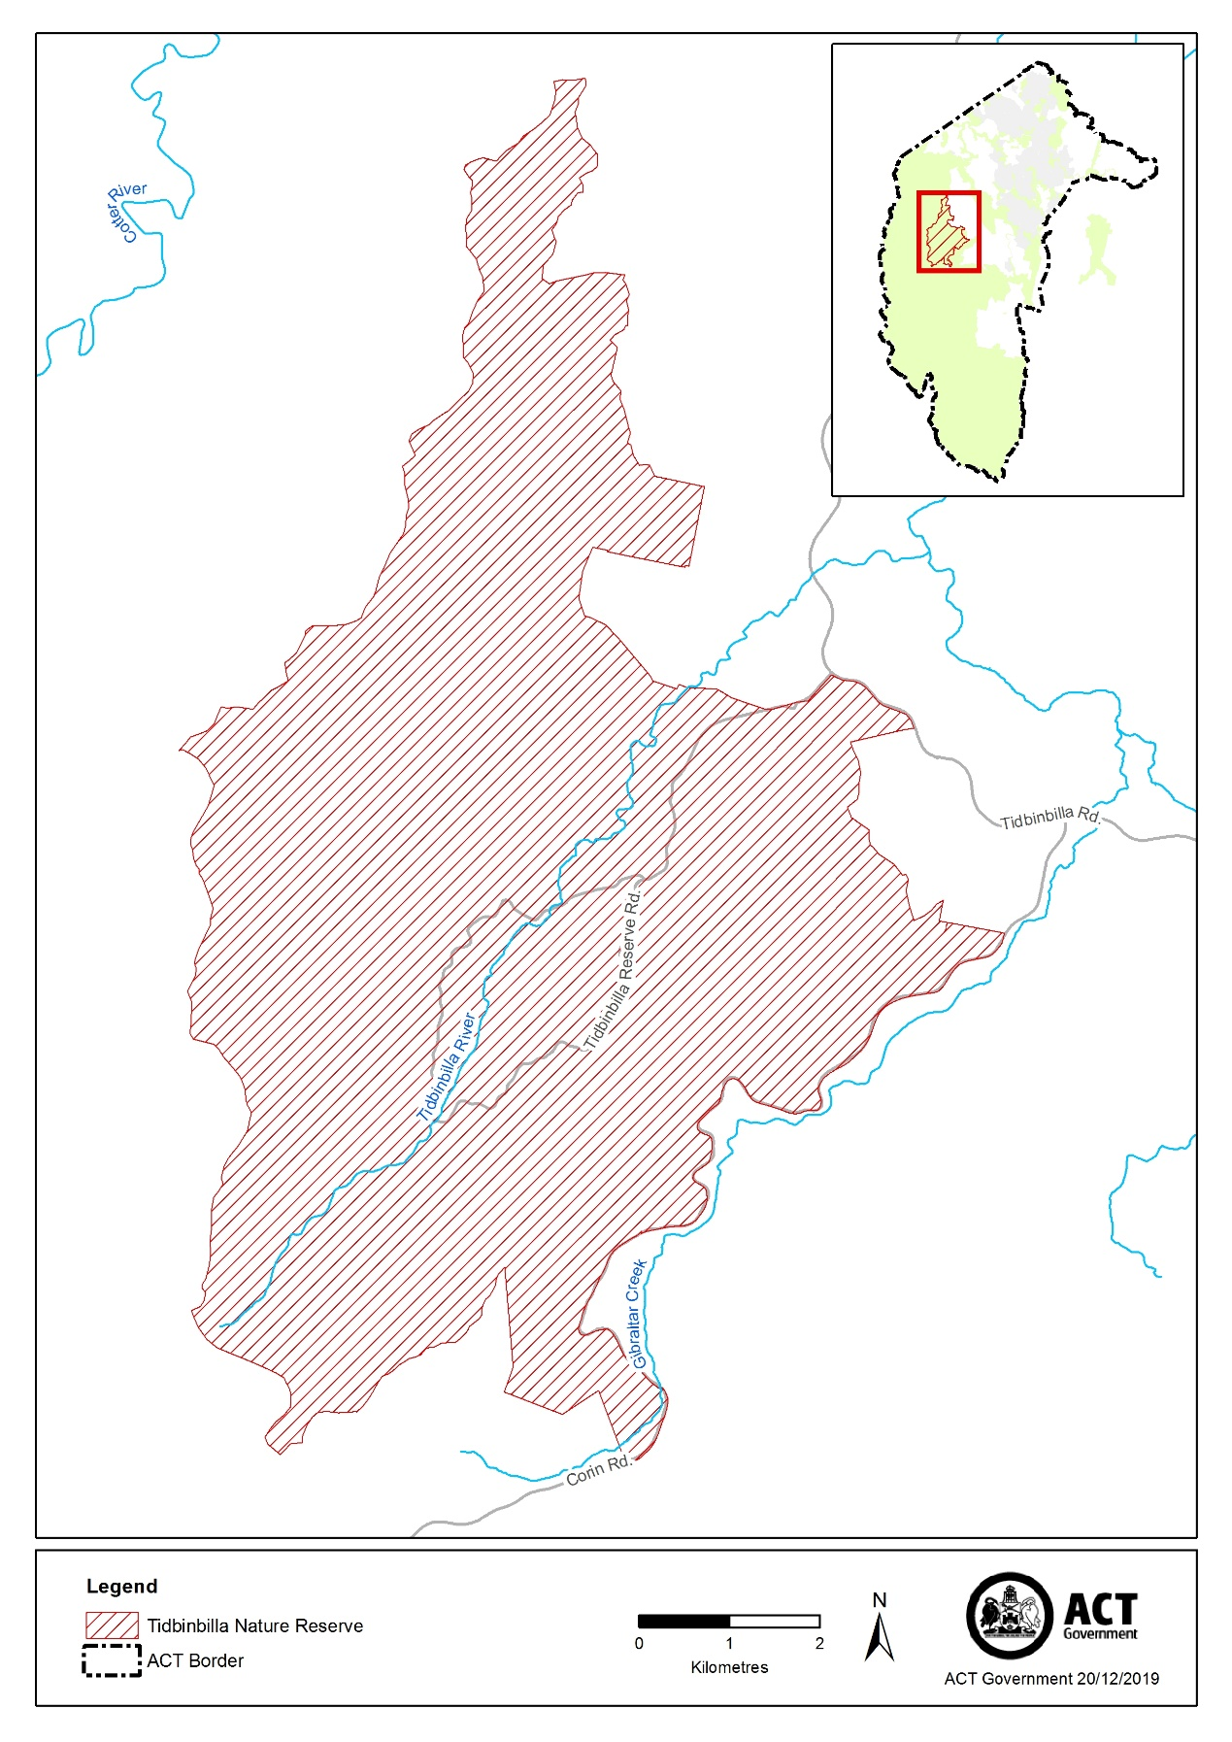

Schedule 2 - Activities Declaration
Prohibited Activities
(See section 4)

PROHIBITED ACTIVITIES

- NO DOGS
- NO COLLECTING WOOD OR TIMBER
- NO EQUESTRIAN ACTIVITIES

Schedule 3 - Activities Declaration

Restricted Activities
(See section 4)

RESTRICTED ACTIVITIES

- USE OF MOTORISED VEHICLES
It is a requirement that a motorised vehicle is only used:
- on a road that is a sealed road; and
- if access to the road is not denied by a gate, barrier or signpost placed by authority of the ACT Parks and Conservation Service.

- USE OF BICYCLES
It is a requirement that a bicycle is only used:
- on roads on which motorised vehicles are permitted, or
- on tracks that are designed to be used by motorised four-wheeled vehicles (such as fire trails) and sign posted multi-use trails only.

- TAKING PART IN VOLUNTEER ENVIRONMENTAL ACTIVITIES
It is a requirement that:
- volunteer environmental activities are carried out in accordance with a volunteer environmental activities program; and
- the program is authorised by the ACT Parks and Conservation Service.

- TAKING PART IN ON-SITE OVERNIGHT CAMPING
It is a requirement that:
- onsite overnight camping is carried out in accordance with a visitor activities program; and
- the program is authorised by the ACT Parks and Conservation Service.

- FIRES
It is a requirement that:
- fires are only allowed in designated fireplaces.

- ROCKCLIMBING AND ABSEILING
It is a requirement that:
- rock-climbing and abseiling are permitted to be undertaken across the reserve unless signposted otherwise.

