Australian Capital Territory
Planning and Development (Technical Amendment—Weetangera) Plan Variation 2020 (No 1)

Notifiable instrument NI2020—656
Technical Amendment No 2020-12
made under the
Planning and Development Act 2007, section 89 (Making technical amendments)

- Name of instrument
This instrument is the Planning and Development (Technical Amendment—Weetangera) Plan Variation 2020 (No 1).
2 Commencement
This instrument commences on the day after its notification day.
3 Technical amendment
I am satisfied under section 89(1)(a) of the Planning and Development Act 2007 (the Act) that the Weetangera plan variation is a technical amendment to the Territory Plan.
4 Meaning of Weetangera plan variation
In this instrument:
Weetangera plan variation means the technical amendment to the Territory Plan, variation 2020-12 in the schedule.
Note: No consultation was required in relation to the Weetangera plan variation under section 87 of the Act.
Lesley Cameron
Delegate of the planning and land authority
7 October 2020

Planning & Development Act 2007

Technical Amendment
to the Territory Plan
Variation 2020-12

Zone and overlay corrections to
Weetangera section 38 block 11

October 2020

This page is left intentionally blank

Table of Contents

1. INTRODUCTION 1
1.1 Purpose 1
1.2 Public consultation 1
1.3 National Capital Authority 1
1.4 Process 1
1.5 Types of technical amendments under the Act 1
2. EXPLANATION 3
2.1 Background 3
2.2 Variation to Weetangera block 11 section 38. 3
3. TECHNICAL AMENDMENT 6
3.1 Territory Plan map 6

- INTRODUCTION
  - Purpose
This technical amendment makes the following changes to the Territory Plan:
Territory Plan Map
- Minor zone and overlay amendments to Weetangera block 11 section 38 to correct a formal legacy error in the plan.

  - Public consultation
Under section 87 of the Planning and Development Act 2007 (the Act) this type of technical amendment is not subject to public consultation.

  - National Capital Authority
The National Capital Authority does not need to be advised of this technical amendment as per 1.2.

  - Process
This technical amendment has been prepared in accordance with section 87 and made in accordance with section 89 of the Act.

  - Types of technical amendments under the Act
The following categories of technical amendments are provided under section 87 of the Act:
- Each of the following territory plan variations is a technical amendment for which no consultation is needed before it is made under section 89:
(a) a variation (an error variation) that –
- would not adversely affect anyone’s rights if approved; and
- has as its only object the correction of a formal error in the plan;
(b) a variation to change the boundary of a zone or overlay under section 90A (Rezoning – boundary changes);
(c) a variation, other than one to which subsection (2)(d) applies, in relation to an estate development plan under section 96 (Effect of approval of estate development plan);
(d) a variation required to bring the territory plan into line with the national capital plan;
(e) a variation to omit something that is obsolete or redundant in the territory plan.

- Each of the following territory plan variations is a technical amendment for which only limited public consultation is needed under section 90:
- a variation (a code variation) that –
- would only change a code; and
- is consistent with the policy purpose and policy framework of the code; and
- is not an error variation;
- a variation to change the boundary of a zone under section 90B (Rezoning – development encroaching on adjoining territory land);
- a variation in relation to a future urban area under section 90C (Technical amendments – future urban areas);
- a variation in relation to an estate development plan under section 96 (Effect of approval of estate development plan) if it incorporates an ongoing provision that was not included in the plan under
section 94(3)(g);
- a variation to clarify the language in the territory plan if it does not change the substance of the plan;
- a variation to relocate a provision within the territory plan if the substance of the provision is not changed.

TA2020-12 has been prepared in accordance with section 87 (1) (a) of the Act.

- EXPLANATION

  - Background
This part of the technical amendment document explains the changes to be made to the Territory Plan, the reasons for the change, and a statement of compliance against the relevant section of the Act.

  - Variation to Weetangera block 11 section 38.

Weetangera section 38 block 11 is zoned Parks and Recreation PRZ1 Urban Open Space in the current Territory Plan and prior to 2008 the site was in the Urban Open Space land use policy area since 1993. In draft plans from 1991 the block was proposed to be in the Residential land use policy area.

Section 38 block 11 has was issue in 1971 for a Single Residential Dwelling and the block has been developed for a single residential dwelling and has a well-established garden. Inadvertently the incorrect land use zone has been applied in the Territory Plan. This technical amendment seeks to rectify this error by correcting the land use zone from Parks and Recreation PRZ1 Urban Open Space to Residential RZ1 Suburban and removing the ‘Pe - an urban open space’ public land overlay.

Compliance with the Planning and Development Act 2007
Section | Statement
s87(1)(a)  (a) a variation (an error variation) that—  (i) would not adversely affect anyone’s rights if approved; and  (ii) has as its only object the correction of a formal error in the plan; | Compliant.  The change corrects a formal error in the plan to the zoning originally intended, being Residential RZ1 Suburban at Weetangera section 38 block 11.  It removes the restrictions that Parks and Recreation PRZ1 Urban Open Space zoning and a ‘Pe – an urban open space’ public land overlay places on a block intended for residential purposes.

Current Territory Plan Map for block 11 Section 38 Weetangera

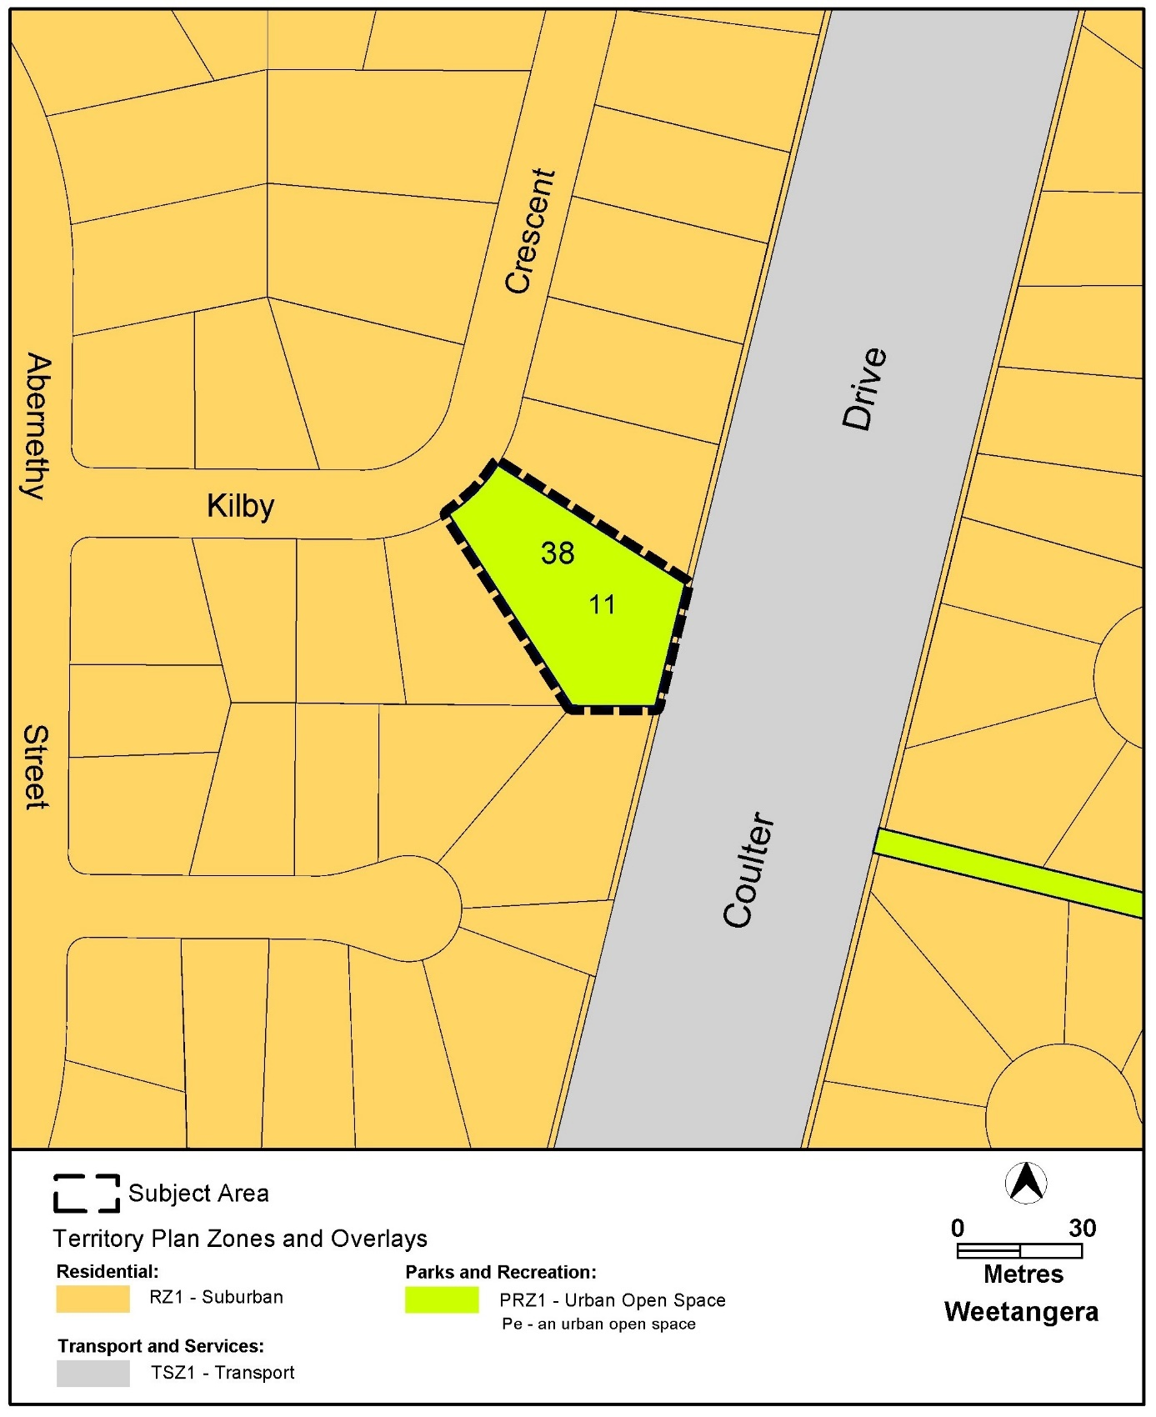

Changes to the Territory Plan Map for block 11 Section 38 Weetangera

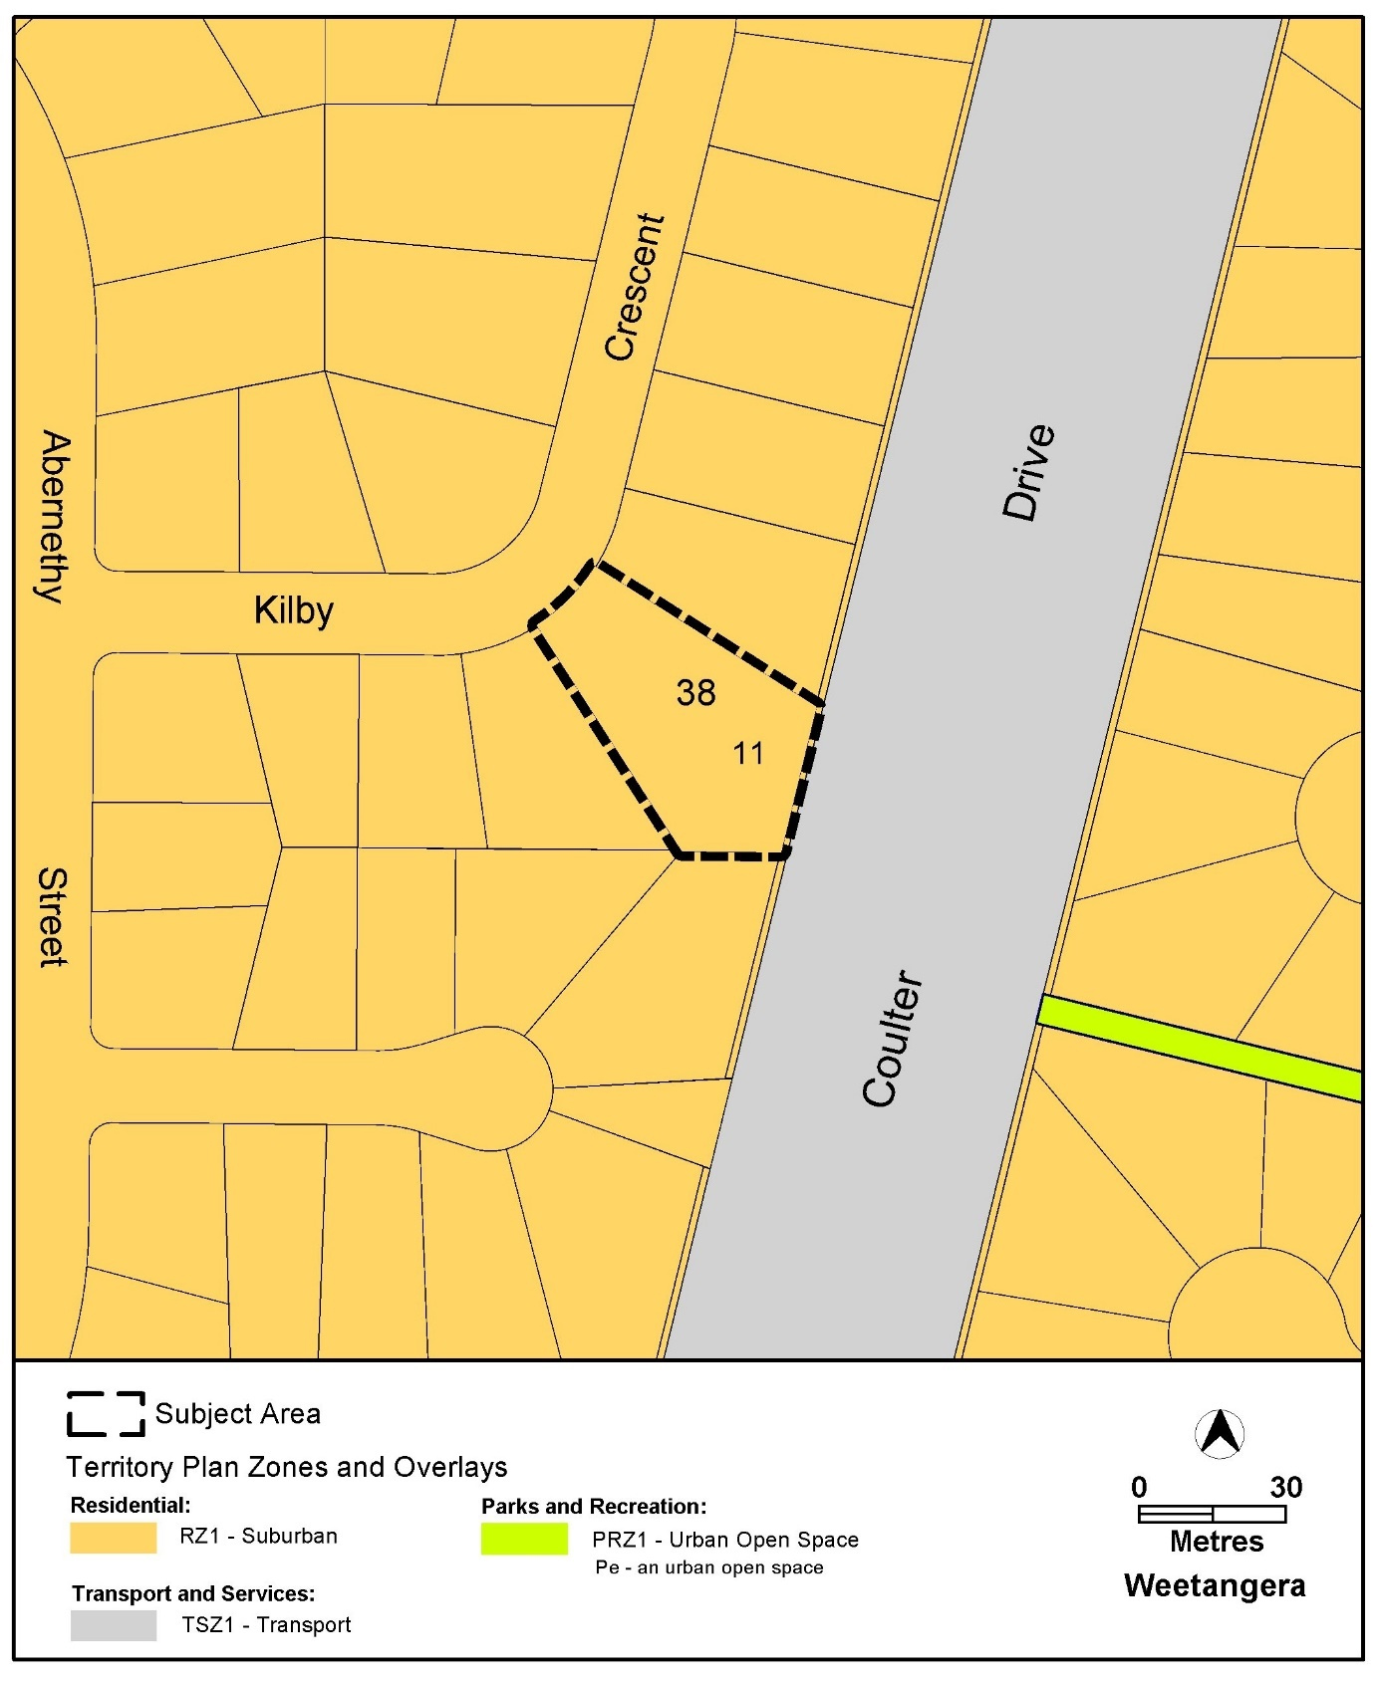

- TECHNICAL AMENDMENT
This section of the technical amendment document provides the actual instructions for implementing the changes to the Territory Plan.

  - Territory Plan map

- Territory Plan Map

The Territory Plan map is varied as indicated below to identify the zoning that applies to block 11 section 38 Weetangera

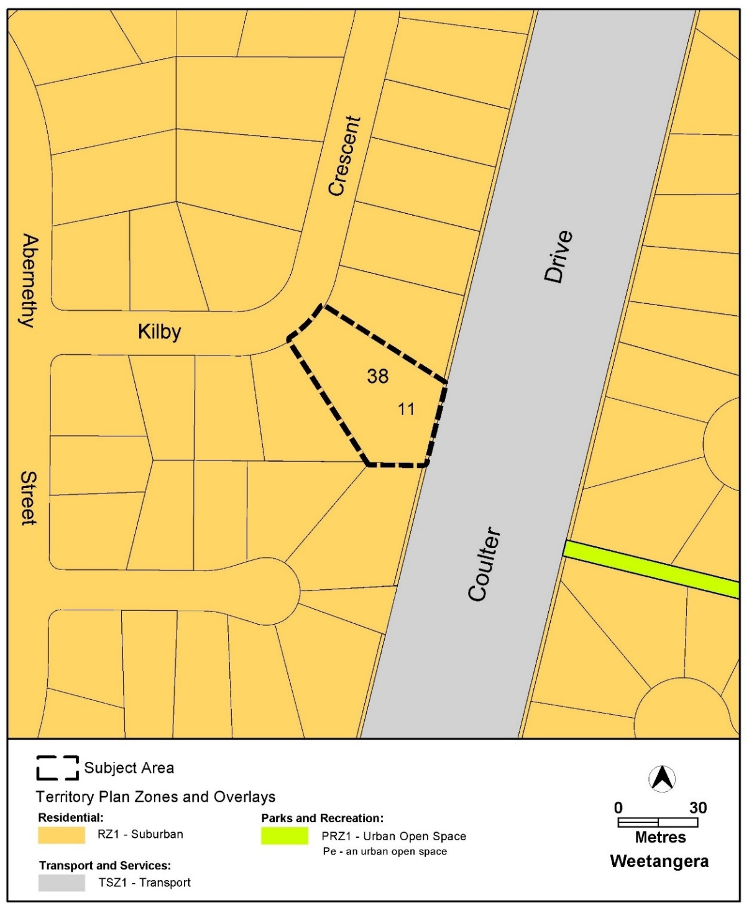

Interpretation service
