Australian Capital Territory
Planning and Development (Technical Amendment—Strathnairn) Plan Variation 2020 (No 3)

Notifiable instrument NI2020-700
Technical Amendment No 2020-08
made under the
Planning and Development Act 2007, section 89 (Making technical amendments)

- Name of instrument
This instrument is the Planning and Development (Technical Amendment—Strathnairn) Plan Variation 2020 (No 3).
2 Commencement
This instrument commences on the day after its notification day.
3 Technical amendment
I am satisfied under section 89(1)(a) of the Planning and Development Act 2007 (the Act) that the Strathnairn plan variation is a technical amendment to the Territory Plan.
4 Meaning of Strathnairn plan variation
In this instrument:
Strathnairn plan variation means the technical amendment to the Territory Plan, variation 2020-08, in the schedule.
Note: No consultation was required in relation to the Strathnairn plan variation under section 87 of the Act.
Lesley Cameron
Delegate of the planning and land authority
29 October 2020

Planning & Development Act 2007

Technical Amendment
to the Territory Plan
Variation 2020-08

Changes to the Strathnairn
Precinct Map and Code

October 2020

This page is left intentionally blank

Table of Contents

INTRODUCTION 1
1.1 Purpose 1
1.2 Public consultation 1
1.3 National Capital Authority 1
1.4 Process 1
1.5 Types of technical amendments under the Act 2
2. EXPLANATION 3
2.1 Background 3
2.2 Variation to the Strathnairn Precinct Map and Code 3
3. TECHNICAL AMENDMENT 5
3.1 Strathnairn Precinct Map and Code 5

INTRODUCTION
  - Purpose
This technical amendment makes the following changes to the Territory Plan:
Strathnairn Precinct Map and Code

- indicates that rule R1 does not apply to carports and garages and incorporates notes, and
- removes rule R13.

  - Public consultation
Under section 87 of the Planning and Development Act 2007 (the Act) this type of technical amendment is not subject to public consultation.

  - National Capital Authority
The National Capital Authority does not need to be advised of this technical amendment as per 1.2.
  - Process
This technical amendment has been prepared in accordance with section 87 and made in accordance with section 89 of the Act.

  - Types of technical amendments under the Act
The following categories of technical amendments are provided under section 87 of the Act:
- Each of the following territory plan variations is a technical amendment for which no consultation is needed before it is made under section 89:
(a) a variation (an error variation) that –
- would not adversely affect anyone’s rights if approved; and
- has as its only object the correction of a formal error in the plan;
(b) a variation to change the boundary of a zone or overlay under section 90A (Rezoning – boundary changes);
(c) a variation, other than one to which subsection (2)(d) applies, in relation to an estate development plan under section 96 (Effect of approval of estate development plan);
(d) a variation required to bring the territory plan into line with the national capital plan;
(e) a variation to omit something that is obsolete or redundant in the territory plan.

- Each of the following territory plan variations is a technical amendment for which only limited public consultation is needed under section 90:
- a variation (a code variation) that –
- would only change a code; and
- is consistent with the policy purpose and policy framework of the code; and
- is not an error variation;
- a variation to change the boundary of a zone under section 90B (Rezoning – development encroaching on adjoining territory land);
- a variation in relation to a future urban area under section 90C (Technical amendments – future urban areas);
- a variation in relation to an estate development plan under section 96 (Effect of approval of estate development plan) if it incorporates an ongoing provision that was not included in the plan under section 94(3)(g);
- a variation to clarify the language in the territory plan if it does not change the substance of the plan;
- a variation to relocate a provision within the territory plan if the substance of the provision is not changed.
TA2020-08 has been prepared in accordance with sections 87(1)(c) and 87(1)(e) of the Act.

- EXPLANATION
  - Background
This part of the technical amendment document explains the changes to be made to the Territory Plan, the reasons for the change, and a statement of compliance against the relevant section of the Act. Changes are detailed in Part 3 of this document.

  - Variation to the Strathnairn Precinct Map and Code
The Strathnairn Precinct Map and Code is varied to incorporate rules and criteria that are consistent with the approved estate development plan.

    - Rule R1 – Setback provisions
Existing Provision

Rules | Criteria
1.1 Setbacks
R1  This rule applies to blocks or parcels in locations identified in Figures 5, 6, 7, 8, 9, 10, 11, 12, 13,  14, 15, 16, 17, 18 and 19.  Minimum boundary setbacks to lower floor level  and/ or upper floor level are nominated. | This is a mandatory requirement. There is no applicable criterion.

Proposed Provision

Rules | Criteria
1.1 Setbacks
R1  Minimum boundary setbacks to lower floor level and/or upper floor level are identified in Figures 5, 6, 7, 8, 9, 10, 11, 12, 13,14, 15, 16, 17, 18 and 19.  This rule does not apply to setbacks for garages and/or carports.  Notes:  - Where setbacks are not identified, or for garages and/or carports, the provisions of the Single Dwelling Housing Development Code or the Multi Unit Housing Development Code apply.  - Side boundary 1 and side boundary 2 are nominated by the applicant unless otherwise specified in this precinct code. | This is a mandatory requirement. There is no applicable criterion.

Compliance with the Planning and Development Act 2007
Section | Statement
s87(1)(c)  a variation, other than one to which subsection (2)(d) applies, in relation to an estate development plan under section 96 (Effect of approval of estate development plan); | Compliant. This amendment adds a provision to Rule R1 from the Strathnairn Estate Development Plan.

    - Rule R13 – 1.10 Side and Rear Setbacks
The Strathnairn Precinct Map and Code is varied to omit Rule R13, which is considered redundant. Based on the hierarchy of codes this rule is not required. Notes added to Rule R1 indicate where the Single Dwelling Housing Development Code or the Multi Unit Housing Development Code apply.
Compliance with the Planning and Development Act 2007
Section | Statement
s87(1)(e)  a variation to omit something that is obsolete or redundant in the territory plan. | Compliant. This amendment omits Rule R13 which is redundant due to the hierarchy of codes and notes are added to Rule R1 to remove any doubt about the application of the codes.

- TECHNICAL AMENDMENT
This section of the technical amendment document provides the actual instructions for implementing the changes to the Territory Plan.

  - Strathnairn Precinct Map and Code
- Strathnairn Precinct Map and Code

Substitute

Rules | Criteria
1.1 Setbacks
R1  Minimum boundary setbacks to lower floor level and/or upper floor level are identified in Figures 5, 6, 7, 8, 9, 10, 11, 12, 13,14, 15, 16, 17, 18 and 19.  This rule does not apply to setbacks for garages and/or carports.  Notes:  - Where setbacks are not identified, or for garages and/or carports, the provisions of the Single Dwelling Housing Development Code or the Multi Unit Housing Development Code apply.  - Side boundary 1 and side boundary 2 are nominated by the applicant unless otherwise specified in this precinct code. | This is a mandatory requirement. There is no applicable criterion.

- Strathnairn Precinct Map and Code

Omit

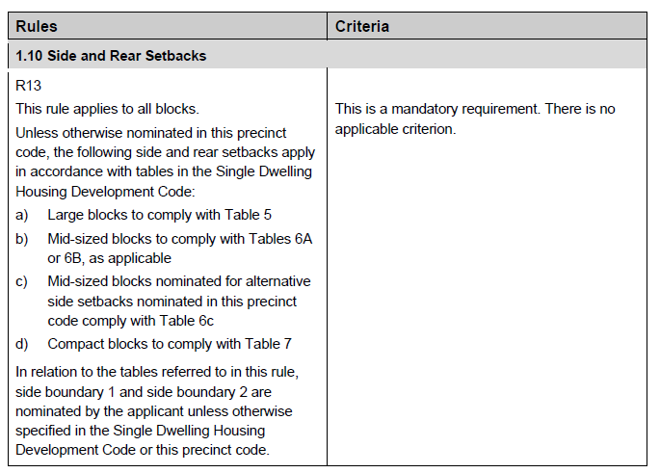

Interpretation service
