Australian Capital Territory
Heritage (Decision about Provisional Registration of Timothy Beard’s Station Site, Jerrabomberra) Notice 2020
Notifiable instrument NI2020–721
made under the
Heritage Act 2004, s 32 (Decision about provisional registration) and s 34 (Notice of decision about provisional registration)

1 Name of instrument
This instrument is the Heritage (Decision about Provisional Registration of Timothy Beard’s Station Site, Jerrabomberra) Notice 2020.
2 Decision about provisional registration
On 12 November 2020, the ACT Heritage Council (the Heritage Council) decided not to provisionally register Timothy Beard’s Station Site, Blocks 21 and 2081, Jerrabomberra
(the Place).
3 Description of the Place
The description of the Place is in the schedule.
4 Reasons for the decision
The Heritage Council is not satisfied on reasonable grounds that the Place is likely to have heritage significance as defined by section 10 of the Heritage Act 2004. A detailed statement of reasons, including an assessment against the heritage significance criteria, is provided in the schedule.
5 Date decision takes effect
The decision not to provisionally register the Place takes effect on 13 November 2020 (being the day after the Heritage Council made its decision in writing as set out in the schedule).

Brian Prince
A/g Secretary (as delegate for)
ACT Heritage Council
12 November 2020

Schedule
(See sections 3 and 4)
STATEMENT OF REASONS
DECISION NOT TO PROVISIONALLY REGISTER
Timothy Beard’s Station Site
Blocks 21 and 2081, JerrabomberraWamboinName of Place
IN THE ACT HERITAGE REGISTER

In accordance with s32 of the Heritage Act 2004, the ACT Heritage Council has decided not to provisionally register Timothy Beard’s Station Site, Jerrabomberra. This Statement of Reasons provides an assessment of Timothy Beard’s Station Site, Jerrabomberra, and finds that the place does not meet any of the criteria under s10 of the Heritage Act 2004.

Timothy Beard’s Station Site coined the name (but not the spelling) of the later established Queanbeyan and was the site of one of the earliest squatting runs in the ACT. However, no signs of the site have been located that could provide the location or material fabric required in order to meet any of the criteria for heritage listing at this time.

This statement refers to the location of the place as required in s34(5)(b)(ii) of the Heritage Act 2004.
LOCATION OF THE PLACE

Timothy Beard’s Station Site, Blocks 21 and 2081, Jerrabomberra.

This section refers to the description of the place as required in s34(5)(b)(iii) of the Heritage Act 2004. The boundary of the place and extent of features listed below is illustrated at Image 1.

DESCRIPTION OF THE PLACE

Timothy Beard’s Station Site, consisting of the following attributes:
- The intact areas of land that correspond to the closest recorded position for the site of Timothy Beard’s Station and nearby areas of high potential for early European squatting site locations.

This statement refers to the Council’s reasons for its decision as required in s34(5)(b)(iv) of the Heritage Act 2004.
REASONS FOR DECISION

The Council is not satisfied on reasonable grounds, being that there is no discernible physical evidence, that the place is likely to have heritage significance as defined by s10 of the Heritage Act 2004; the Council, however, notes that the place may be renominated and reassessed if physical evidence is discovered in the future.

This statement refers to the Council’s assessment of the place against the heritage significance criteria as a part of its reasons for its decision as required in s34(5)(b)(iv) of the Heritage Act 2004.
ASSESSMENT AGAINST THE HERITAGE SIGNIFICANCE CRITERIA

The Council’s assessment against the criteria specified in s10 of the Heritage Act 2004 is as follows.

In assessing the heritage significance of Timothy Beard’s Station Site, Jerrabomberra, the Council considered:
- the Council’s Heritage Assessment Policy (March 2018);
- information provided by a site inspection on 30 August 2019 by members of the Council and ACT Heritage as well as 13 August 2020 and 2 September 2020 by ACT Heritage; and
- the report by ACT Heritage titled, Background Information Timothy Beard’s Station Site, November 2020, containing photographs and information on history, description, condition and integrity.

Pursuant to s10 of the Heritage Act, a place or object has heritage significance if it satisfies one or more of the following criteria. Future research may alter the findings of this assessment.
- importance to the course or pattern of the ACT’s cultural or natural history;
The Council has assessed Timothy Beard’s Station Site against criterion (a) and is not satisfied that the place meets this criterion.
Timothy Beard’s Station Site is the earliest known squatting station in the ACT which has the potential to be an important site in understanding the course and pattern of the ACT’s cultural history. A short-lived station, it was likely built with temporary, readily available local materials to provide shelter for the men stationed there, however there is little remnant material evidence as it was not set up for long-term settlement. Unfortunately, there is so little evidence that even the possible location is not clear. While the story of Timothy Beard and his enterprises in the region are an important part of the European settlement of Canberra, due to the lack of evidence of materials and location, the place is unable to meet the thresholds for inclusion under this criterion at this time.
- has uncommon, rare or endangered aspects of the ACT’s cultural or natural history;
The Council has assessed Timothy Beard’s Station Site against criterion (b) and is not satisfied that the place meets this criterion.
Timothy Beard’s Station Site, as an early small squatting station that was bought out by one of the larger neighbouring landholders, is an uncommon aspect of the ACT’s cultural history; however, due to the lack of evidence of materials and location, the place is unable to meet the thresholds for inclusion under this criterion at this time.
- potential to yield important information that will contribute to an understanding of the ACT’s cultural or natural history;
The Council has assessed Timothy Beard’s Station Site against criterion (c) and is not satisfied that the place meets this criterion.
If found, Timothy Beard’s Station site, may have the potential to yield important information about early squatting practices; but, as it has not been able to be located to date, due to the lack of evidence of materials and location, the place is unable to meet the thresholds for inclusion under this criterion at this time.
- importance in demonstrating the principal characteristics of a class of cultural or natural places or objects;
The Council has assessed Timothy Beard’s Station Site against criterion (d) and is not satisfied that the place meets this criterion.
As an early squatting run, Timothy Beard’s Station Site is unable to demonstrate the principle characteristics of this class of place due to the lack of evidence of materials and location. As such, the place is unable to meet the thresholds for inclusion under this criterion at this time.

- importance in exhibiting particular aesthetic characteristics valued by the ACT community or a cultural group in the ACT;
The Council has assessed Timothy Beard’s Station Site against criterion (e) and is not satisfied that the place meets this criterion.
There is no indication of the place having particular aesthetic characteristics that can be demonstrated to be linked to the physical fabric of the place and that have evidence of the community or a cultural group in the ACT valuing those characteristics.
- importance in demonstrating a high degree of creative or technical achievement for a particular period;
The Council has assessed Timothy Beard’s Station Site against criterion (f) and is not satisfied that the place meets this criterion.
The place contains no visible physical evidence that clearly demonstrates creative or technical achievement for the period in which it was created; as such, it cannot be considered important for any such achievements at this time.
- has a strong or special association with the ACT community, or a cultural group in the ACT for social, cultural or spiritual reasons;
The Council has assessed Timothy Beard’s Station Site against criterion (g) and is not satisfied that the place meets this criterion.
Timothy Beard’s Station Site does not have any social, cultural or spiritual associations with the ACT community or a cultural group within the ACT. As the location of a remote early squatting site that was only occupied for a short time, it may be of interest to historians or direct descendants of those involved, however, it is unlikely to have developed any lasting connections with the broader ACT community or a cultural group in the ACT.
For the purposes of assessment against this criterion it is important to note that according to the ACT Heritage Assessment Policy (2018) the following applies;
- Professional groups and special interest groups do not constitute a community or cultural group for the purposes of this criterion. Common expertise or interest is not sufficient by itself to define a community or cultural group
- ‘Community’ is defined as follows; ‘all the people of a specific locality or country’ plus ‘a particular locality, considered together with its inhabitants’
- For the purposes of the Heritage Act 2004, ‘the community’ is defined as ‘the ACT community’ or ‘the community of the ACT’
- has a special association with the life or work of a person, or people, important to the history of the ACT.
The Council has assessed Timothy Beard’s Station Site against criterion (h) and is not satisfied that the place meets this criterion.
Timothy Beard’s Station Site has associations with early settlers in the region and played a small part in the arrest of the bushranger Tennent. However, the place was not occupied for long and Beard is unlikely to have spent any length of time there. Failing any enduring association between people important to the history of the ACT and the site, it is unable to meet the threshold for meeting this criterion.

SITE PLAN

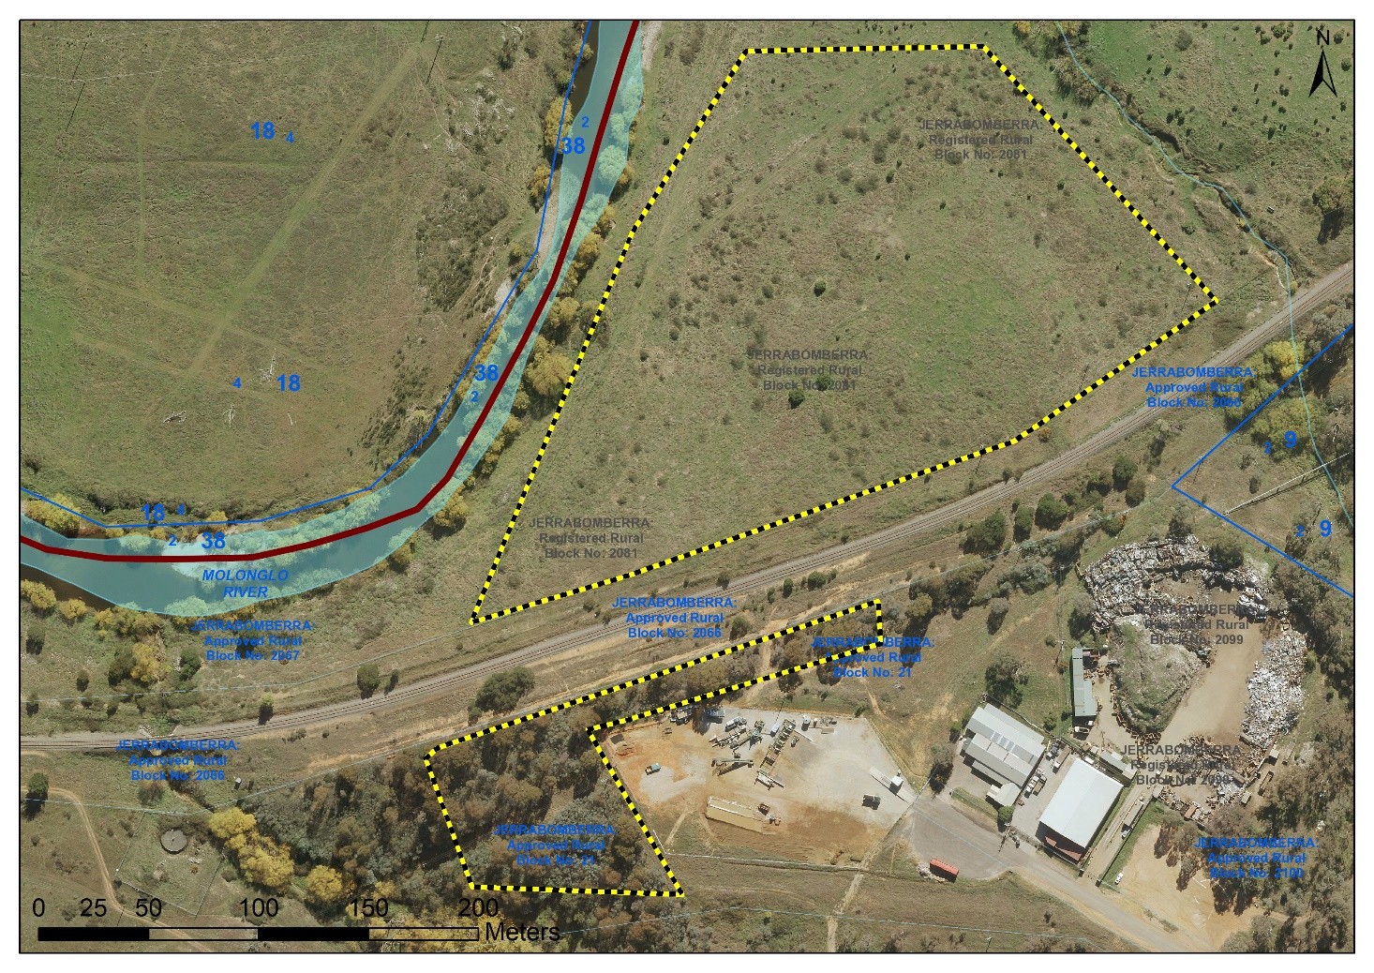
Image 1 Timothy Beard’s Station Site boundary (note: the marked areas indicate the locations that were thoroughly searched for physical evidence of the place)

