Australian Capital Territory
Corrections Management (Aboriginal and Torres Strait Islander Detainee and Offender) Policy Revocation 2020
Notifiable instrument NI2020-767
made under the
Corrections Management Act 2007, s14 (Corrections policies and operating procedures)

1 Name of instrument
This instrument is the Corrections Management (Aboriginal and Torres Strait Islander Detainee and Offender) Policy Revocation 2020.

2 Commencement
This instrument commences on the day after its notification day.
4 Revocation
This instrument revokes the Corrections Management (Aboriginal and Torres Strait Islander Detainee and Offender) Policy 2018 [NI 2018-49].

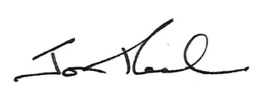

Jon Peach
Commissioner
ACT Corrective Services
5 November 2020

